441/2
HOMESCIENCE
CLOTHING CONSTRUCTION
PAPER 2

CONFIDENTIAL
Instruction to schools
Schools are instructed to provide the following materials
- Plain light weight fabric 55cm long by 90 cm wide.
- Cotton sewing thread to match the fabric

HOMESCIENCE 441/2
(PRACTICAL)
CLOTHING CONSTRUCTION
TIME 2 ¹ /₂ HOURS.

GITHUNGURI SUB-COUNTY JOINT EXAM

Instructions to candidates
- This paper consists of three printed pages.
- Candidates should check the questions paper to ascertain that all pages are printed as indicated and that there are no questions missing.
- Candidates MUST use machine stitches appropriately in the construction of the garment .Hand stitches used INSTEAD OF MACHINE STITCHES WILL NOT BE MARKED.
- Hand stitches will only be allowed where specified.

A pattern of a girl's skirt is provided. You are advised to study the sketches, instructions and layout carefully before you begin the test.
Materials Provided
1 Pattern pieces:
A - skirt back
B - skirt front
C - pocket
D - waistband
2 Plain light weight cotton fabric 55 cm x 90 cm wide.
3 Sewing thread to match the fabric.
THE TEST
Using the materials provided, cut out and make the RIGHT HALF of the skirt to show the following processes:
(a) Making of the back dart. (10mks)
(b) Preparation of pleats on the skirt front. (10mks)
(c) Attachment of front pocket to the skirt front and back pocket to the skirt back. Do not trim or neaten the seam. (5mk)
(d) Making the side seam using an open seam. Neaten above and below the pocket.(13 mks)
(e) Joining of the pocket seam. Do not neaten. (8 ½ mks)
f) Preparation of an interfaced waistband. (4 mks)
(g) Attachment of the waistband, slip-hem the back piece only. (13 mks)
h) Making of the worked loop on the back waistband for a 1 cm wide button. (2 mks)
i) Making of a hem on the lower edge of the skirt and holding it down with even tacking (7mks)
i) Overall presentation (17 ½ mks)
At the end of the examination, firmly sew onto your work, on a single fabric, a label bearing your name and index number. Remove needles and pins from your work, fold your work neatly.

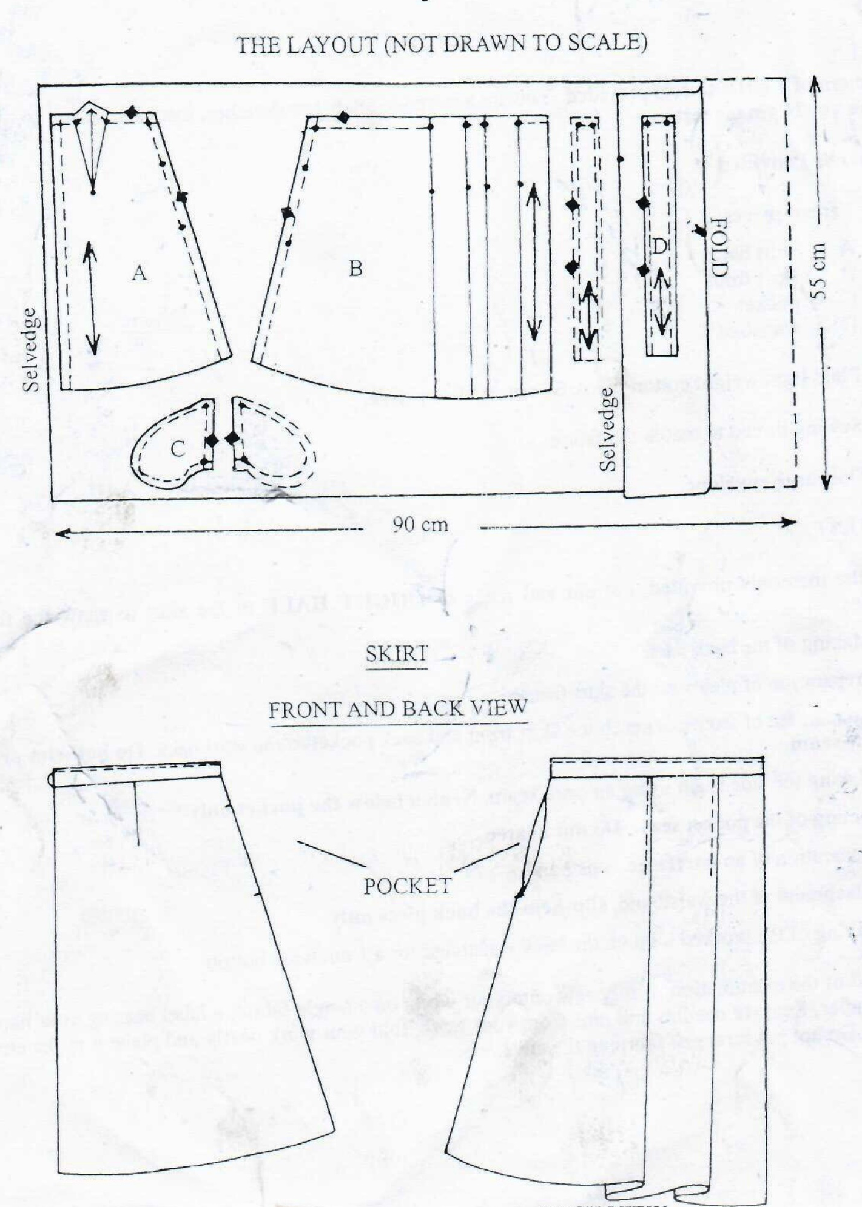

BACK VIEW FRONT VIEW

