END TERM 2 2026
312/2
GEOGRAPHY
PAPER 2

2 $3/4$HOURS

INSRUCTION TO CANDIDATES
- This paper has two sections: A and B
- Answer all the questions in section A.
- Answer question 6 and any other two questions from section B.
- All answers must be written in the answer booklet provided
- Candidate should check the question paper to ascertain that all the pages are printed as indicated and that no questions are missing.
- Candidates should answer the questions in English.

For Examiners use only.
Section | Questions |  | Maximum score | Student score.
A | 1-5 |  | 25
B | 6 |  | 25
 |  |  | 25
 |  |  | 25
 |  | TOTAL SCORE

SECTION A
Answer all the questions in this section.

- a) Name two exotic breeds of commercial beef cattle reared in Kenya. (2marks)
b) State three physical factors that favour commercial beef farming in Nyika plateau(3marks)

- a) Define the term fisheries. (2marks)
b) State three ways in which marine fisheries in Kenya can be conserved. (3marks)

- a) Apart from coniferous forests, name two other types of natural forests. (2marks)
b) State three characteristics of coniferous forests which favour their exploitation. (3marks)

- a) Identify two types of road surfaces. (2marks)
b) Name three Great Lakes on the St. Lawrence sea way. (3marks)

- a) Name two rivers in the low lands of western Rift valley causing seasonal flooding(2marks)
b) State three methods used to control floods in Kenya. (3marks)

SECTION B
Answer question 6 and any other two questions from this section
- Study the photograph below and answer the question that follows.
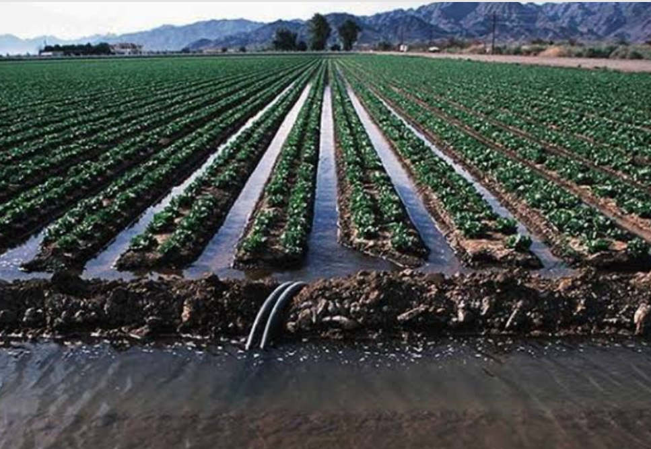
a i)Identify the type of photograph shown above. (1mark)
ii) Give three factors that could have favored establishment of irrigation project shown on the photograph. (3marks)
iii) Draw a rectangle measuring 15 $×$ 10 cm to represent the area shown on photograph. (1mark)
iv) On the rectangle sketch and label four
main features represented on photograph. (4marks)
b i)Apart from furrow name four irrigation methods used in Kenya. (4marks)
ii) State four physical problems experienced by farmers at Mwea Tebere Irrigation Scheme. (4marks)
c i)State two ways in which Salinity of the polder is reduced in the Netherlands. (2marks)
ii) Give three differences between land reclamation in Kenya and the Netherlands. (6marks)

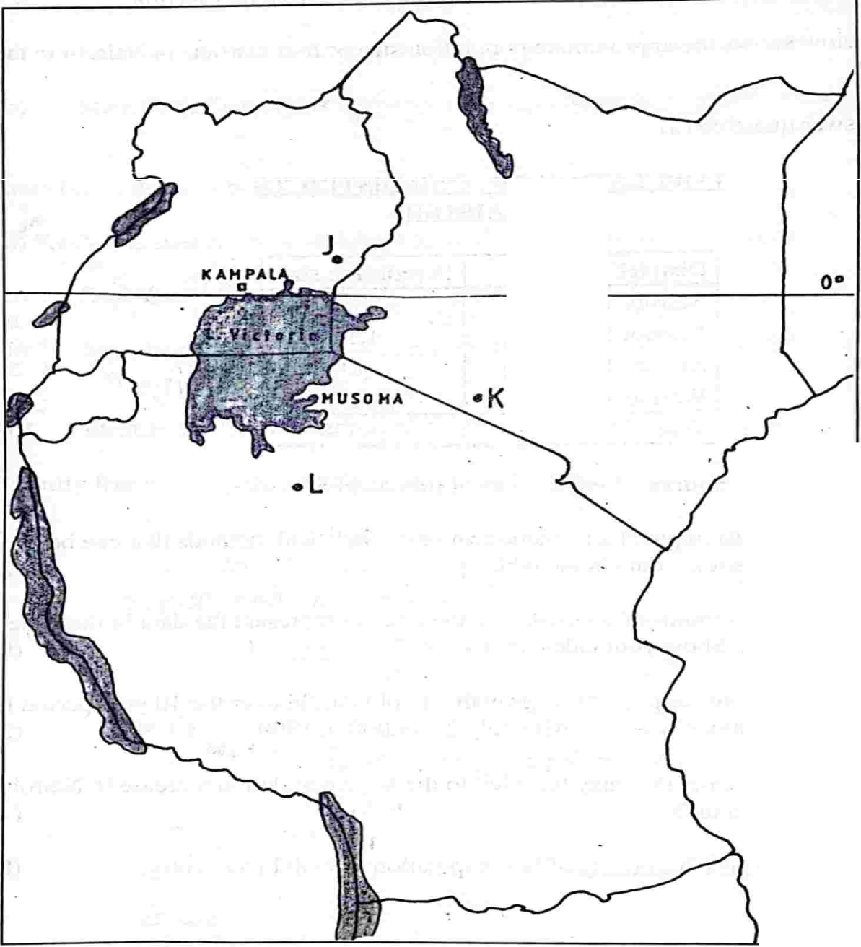
- The Map below shows the location some minerals in East Africa.

- Name the minerals mined in
- The areas marked J, k, and L. (3marks)
b) Explain how the following factors influence the exploitation of minerals.
- Mode of occurrence of minerals. (4marks)
- Transport. (2marks)
c i) Identify three factors that influence occurrence of minerals. (3marks)
ii) State three conditions necessary for the formation of petroleum. (3marks)
d) Describe the opencast method of mining. (4marks)
e) Explain three benefits of petroleum mining to the economies of Middle East countries. (6marks)

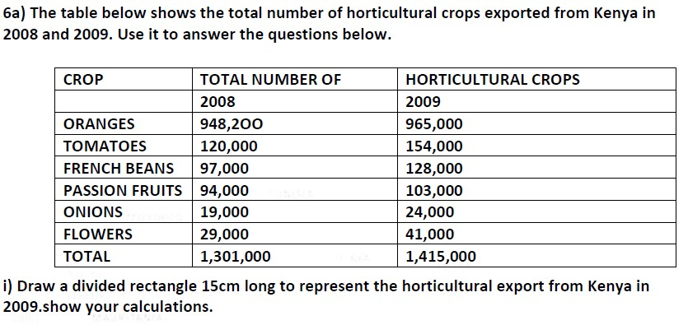
8.

8marks

a) Name two counties in Kenya where tea is grown on large scale (2marks)
b)) State three physical conditions required for growing of tea in Kenya (3marks)

c) Describe the stages involved in processing of sugarcane at the factory. (6marks)
d) Explain three challenges facing sugar farming in Kenya. (8marks)
9.a i)Differentiate between internal and regional trade. (2marks)
ii) Name three major imports from the Europe to Kenya. (3marks)
b) Explain three factors influencing trade in Kenya. (6marks)
c)i) Give any two reasons why the Common Market for Eastern and Southern African (COMESA) WAS formed. (2marks)
ii) Apart from COMESA give any other two trading blocs in Africa. (2marks)
d) State four reasons why Kenya experience unfavorable balance of trade. (4marks)
e) Explain the future of international trade in Kenya can be improved. (6marks)

10.a) Name three national parks in Uganda. (3marks)
b i) Give four benefits of game reserves to local communities. (4marks)
ii) Name three tourist attractions found in the Rift Valley province of Kenya. (3marks)
c i) State three physical conditions that influences that influence distribution of wildlife in East Africa. (3marks)
ii) List four problems experienced by the Kenya Government in its effort to conserve wildlife. (4marks)
d) Explain four physical factors which have made Switzerland a major tourist centre. (8marks)

