NAME ADM CLASS

312/1
GEOGRAPHY
PAPER 1
TIME; 2HRS 45MIN
INSTRUCTIONS TO CANDIDATES
THIS PAPER CONSISTS OF TWO SECTIONS A and B;
ANSWER ALL QUESTIONS IN SECTION A
ANSWER QUESTIONS 6 AND ANY OTHER TWO IN SECTION B
ALL ANSWERS SHOULD BE WRITEN IN THE ANSWER SHEET PROVIDED
FOR EXAMINERS USE ONLY

SECTIONS | QUESTIONS | MAXIMUM SCORE | CANDIDATES SCORE
A | 1-5 | 25
B | 6 | 25
B |  | 25
B |  | 25
B | TOTAL | 100

SECTION A
ANSWER ALL THE QUESTIONS IN THIS SECTION
1a, Identify two areas studied in practical geography (2mks)
B, state three reasons for studying geography (3mks)
2a,What is a line of longitude? (2mks)
B, what is longitude of a point x whose local time is 12:40 pm, when the local time at point A 20 E is 4:00PM. (3MKS)
3, The diagram below represents an instrument found in a weather station, use it to answer question 3 (a(i) and (a(ii)
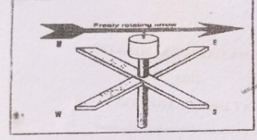
a (i) Identify the instrument (1mk)
(ii) How is the direction of wind determined from the diagram above? (1mk)
b, State 3 characteristics of wind (3mks)
4a, Name two tectonic plates (2mks)
b, Identify 3ways in which the earth’s crust is affected by earthquake (3mks)

5. The diagram below shows a desert land form .use it to answer the question that follows.
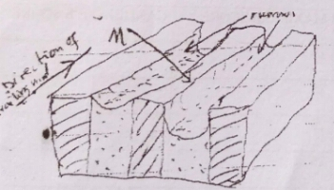

i) Identify the feature marked M (1MK)
II) Describe how the feature marked M is formed (4mks)

SECTION B
ANSWER QUESTION 6 (SIX) AND ANY OTHER TWO QUESTIONS IN THIS SECTION
Study the map of Kisumu East sheet and answer the questions that follow
6a, (i) Give six figure grid difference of Mow camp located along all-weathered road bound surface in the North Western part of the area covered by the map (2mks)

ii) Measure the length of a regional boundary in the North Western part of the area covered by the map. Give your answer in KM. (2mks)

iii) What is the bearing of the trigonometrical station at grid square 0898 from the air photo principle point at grid square 0294
b, Using a scale of 1cm rep 100m draw a cross-section along northing 99 from grid reference 0409902 to grid reference 100990
i) On the cross-section mark and name
* A rock out crop at grid square 0599 (1mk)
* Other tracks and footpaths (1mk)
* A river at grid square 0899 (1mk)
ii) Calculate the vertical exaggeration of your cross-section (2mks)
c, Citing evidence from the area covered by the map, explain 3 factors that influenced the location of Kisumu town (6mks)
d Describe the characteristic of the long profile of Mayenga/Luando (4mks)
7a, i) State 3 factors that influence rock metamorphisn (3mks)
ii) Explain three ways in which brocks may become metamorphic (6mks)
b, i) Give an example of each of the following categories of sedimentary rocks
i) Carbonaceous rocks
ii) Sulphates
iii) Arenaceous
ii) Explain how coral rocks are formed
c, i) Give reasons why coal and petroleum are not referred as minerals
ii) Give 3 characteristics of minerals (3mks)
iii) Explain the significance of rocks under the following fields
- Industry (2mks)

- Agriculture (2mks)

8. a ) What is folding? (2mks)

b) Name the continents in which the following fold mountains are found. (3mks)
i) Andes mountains
ii) Himalayas
iii) Cape ranges
c) Draw a well labelled diagram to show a simple symmetrical fold. (3mks)

d) Apart from fold mountains, name any other three features that are formed through folding. (3mks)

e) Explain four positive effects of fold mountains. (8mks)

f) Form four students in your school are planning to study folded landforms through fieldwork.
i) Give three methods of recording data that can be applied by the students. (3mks)

ii) What are some of the problems they are likely to face during the fieldwork? (3mks)

9.(a) Differentiate between river rejuvenation and river capture. (2mks)
(b) Give three features resulting from:
(i) river rejuvenation. (3mks)
(ii) river capture (3mks)

(c) Explain the four ways through which a river transports its loads. (8mks)

(d) Students from your class conducted a field study on an old stage of a river.
(i) State three reasons why they would require a route map. (3mks)
(ii) Identify three characteristics of the river they would have observed (3mks)
(iii) State three follow up activities they would have involved in after the field study. (3mks)

10. a, i) What is an ocean current ? (2mks)
ii) Explain how the following influences thje occurrence of ocean currents.
- Shape of land masses (2mks)
- Wind (2mks)
b, The diagram below shows some coastal features
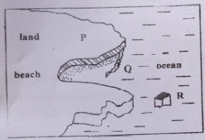
- Name the features marked P,Q,R (3mks)

- Describe how a bay is formed (3mks)

c, Using a well labeled diagram, describe the process through which a Geo is formed (7mks)
d, Explain 3 significances of oceans to human activities (6mks)

