Name……………………………………............................. Index number …………..…..............

Class……………….. Adm no…………….…….Candidate’s signature …………………...........
School ……………………………………………..

233/1
CHEMISTRY
Paper 1
THEORY
AUG. 2026
2 Hours

Kenya Certificate of Secondary Education
CHEMISTRY
Paper 1
THEORY

Instruction to Candidates
- Write your name, index number class and admission number in the spaces provided
- Sign and write the date of examination in the spaces provided.
- Answer all the questions in the spaces provided.
- Mathematical tables and silent electronic calculators may be used.
- All working must be clearly shown where necessary.
- This paper consists of 12 printed pages
- Candidates should check the question paper to ascertain that all the pages are printed as indicated and no questions are missing.
- Candidates should answer the questions in English.

For Examiner’s Use Only
Questions | Maximum Score | Candidates Score
1-27 | 80

- Element A has two isotopes with mass numbers 30 and X. Given that the RAM of element A is 34.5 and the percentage abundance of ³⁰A is 55%, calculate the value of X. (3 marks)

- Describe how you would prepare crystals of copper (II) sulphate starting with copper (II) oxide.
(3 marks)

- 10 grammes of sodium carbonate decahydrate (Na₂CO₃.10H₂O) was left exposed in air for a few days after which the mass was measured again.
  - State and explain the observation made on change of mass taken after some days. (2mks)

  - Give the name of the process demonstrated in question (3)(a) above. (1 Mark)

- Calculate the volume of nitrogen (IV) oxide produced when 10g of lead (II) nitrate was completely decomposed by heating at s.t.p. (Pb= 207, N = 14, O = 16, Molar gas volume at s.t.p. = 22.4dm³)
(3 Marks)

- A solution of hydrogen chloride gas in water conducts an electrical current, while that of hydrogen chloride in methylbenzene does not conduct. Explain. (1Mark)

- a) The electron arrangement of ions X²⁺ and Y3-are 2.8 and 2.8 respectively. In which groups do X and Y belong? (1 Mark)
X.………

Y………

  - Give the formula of compound that would be formed between X and Y, and state the bond present in that compound. (1 Mark)
Formula…….

Bond type……

- The elements nitrogen, phosphorus and potassium are essential for plant growth. Phosphorus in the fertilizer may be in the form of ammonium phosphate. Calculate the mass of nitrogen present in a 50kg bag containing pure ammonium phosphate, (NH₄)₃PO₄ (N=14.0, H=1.0, P=31.0, O=16.0) (3 Marks)

- A mixture consists of iodine and sodium chloride
- By use of diagram illustrate how this mixture can be separated. (3 marks)

- a) What are positional Isomers. (1mk)

b) Draw and name two isomers with molecular formula C₄H₆. (2 marks)

- a) Two samples of water A and B were tested on volume of soap required to lather before and after boiling. The results were recorded in the table below.
b)
  Sample of water | Volume of soap used before boiling (cm³) | Volume of soap used after boiling (cm³)
  A | 30 | 10
  B | 30 | 30
- Explain the observation made in water sample A (1mk)

- Name one cation and one anion that could be present in sample water B. (1mark)
Cation………………
Anion………………
.
- State one use of hard water. (1 mark)

- Use the bond energy value given below for questions that follows

Bond | Bond energy (KJmol⁻¹)
H – H | 432
C = C | 610
C – C | 346
C – H | 413

Determine the enthalpy change for the conversion of propene to propane by hydrogen. (3mks)

- The set up below was used to prepare dry hydrogen gas. Study it and answer the questions that follow.
Cardboard
Hydrochloric
acid
Zinc granules
Liquid Y

- Identify the mistake in the set-up above. (1 mark)

- What would be liquid Y? (1 mark)

- Give two properties that hydrogen gas share with carbon II oxide (1 mark)

\
- Study the diagram below then use it to answer the questions that follow.
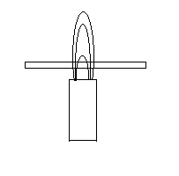
- Draw the wooden splint at the end of experiment, if it was slipped in at that position then removed.
(1 mk)

- Explain the appearance of the wooden splint in a) above. (2 marks)

- Below is the structure of a polymer,
H H H H H H
⎜ ⎜ ⎜ ⎜ ⎜ ⎜
⎯ C ⎯ C ⎯ C ⎯ C ⎯ C ⎯ C ------
⎜ ⎜ ⎜ ⎜ ⎜ ⎜
C₆H₅ H C₆H₅ H C₆H₅ H

- Draw the monomeric unit of the polymer (1mk)

- A sample of this polymer is found to have a molecular mass of 10400. Determine the number of monomers in the polymer.( C=12, H=1) (2marks)

- Determine the oxidation state of element in bracket in the following substances
- KMnO₄ (Mn) (1mk)

(ii) K₂Cr₂O₇ (Cr) (1mk)

- Explain this observation. When acidified hydrogen peroxide is added to pale-green iron (II) sulphate solution the solution turns yellow. (1mk)

- a) State Grahams law (1 mk)

b) A sample of unknown compound gas X is shown by analysis to contain sulphur and oxygen. The gas requires 28.3 seconds to diffuse through a small aperture into a vacuum. An identical number of oxygen molecules pass through the same aperture in 20 seconds. Determine the molecular mass of gas X. (O =16, S = 32) (3marks)

- The diagram below demonstrates two properties of carbon (iv) oxide.
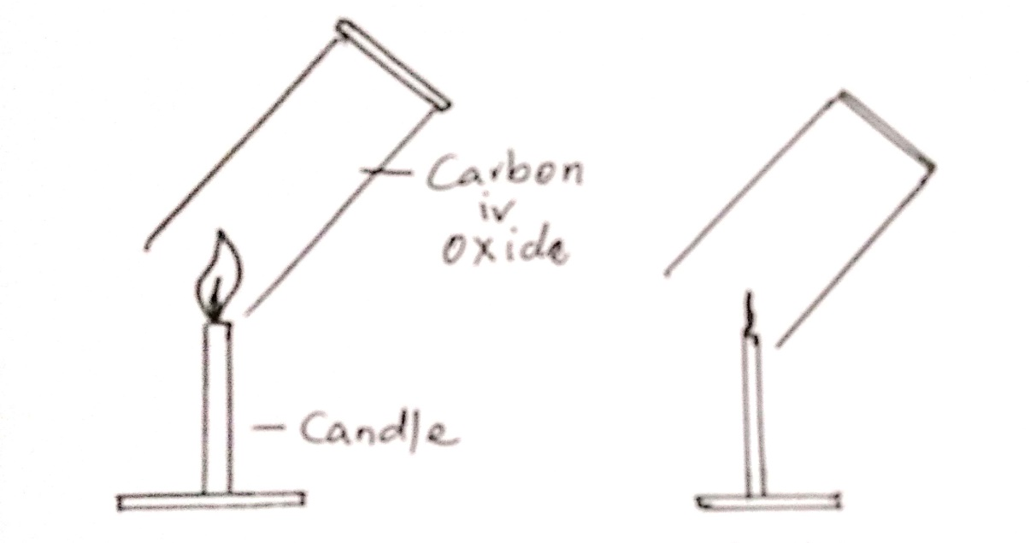

- Identify the two properties demonstrated. (2marks)

- State one use of carbon iv oxide based on other properties apart from the one identified in question 16 (a).
(1mark)

- The molecular formula mass of gas A is 42, and its empirical formula is CH₂.
- Determine the molecular formula of gas A (C = 12.0, H = 1.0). (2mks)

(b) Write the equation of the reaction between A and one mole of chlorine gas. (1mk)

- Hydrogen gas was passed over heated copper (II) oxide in a combustion tube as shown below.
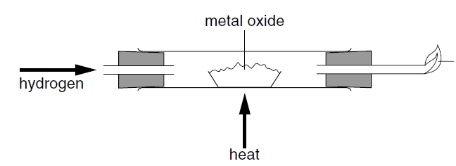
Copper (II) oxide
flame

- State and explain the observations made in the combustion tube. (2 marks)

- Write the equation for the reaction that took place in the combustion tube. ( 1 mark)

- a) Below is a section of an apparatus used to measure accurate volume of liquids in the laboratory
- Identify the apparatus. (1 mark)

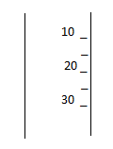

b) Give two reasons why glass is preferred in making of apparatus above in question 19(a) (1 mark)

- a) State Le‘Chatelier’s principle (1mk)

b) When sulphur (VI) oxide is heated the equilibrium shown below is established.

2SO₃(g) 2SO₂(g) + O ₂(g)

How would the position of the equilibrium be affected if the pressure is increased.
Explain (2mks)

- Chlorine gas was bubbled into as solution of hydrogen sulphide as shown in the diagram below.
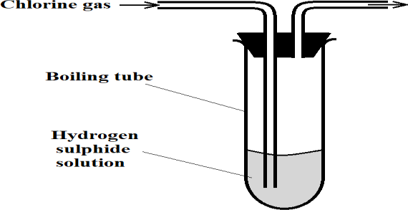
  - Explain the observation made in the boiling tube (2 Marks)

  - State the precaution that should be taken in this experiment? (1 Mark)

.
- A radioactive element X decays as shown below.

${}_{84}^{216}X$ ${}_{82}^{208}{Pb}$ + aα + bβ

- Give the number of neutrons in element X. (1mk)

- Determine the values of a and b in the equation. (2mks)

- The diagram below shows a structure of water molecules.
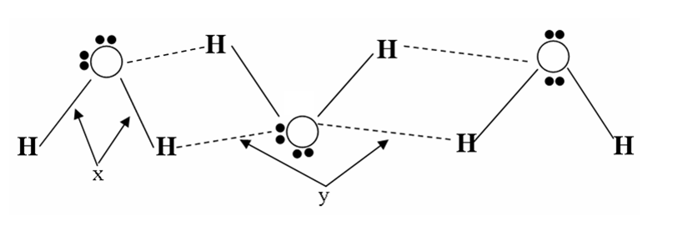
(a) Name the bonds (1mk)
X…………………………………………………………………
Y………………………………………………………………..
b) Using dots () and crosses (X) to represent electrons, draw diagrams to represent the bonding in magnesium chloride. (Mg=12, Cl=17) (2mks)

- The set up below shows the electrolysis of dilute copper (II) chloride. Study it and answer the questions that follow.
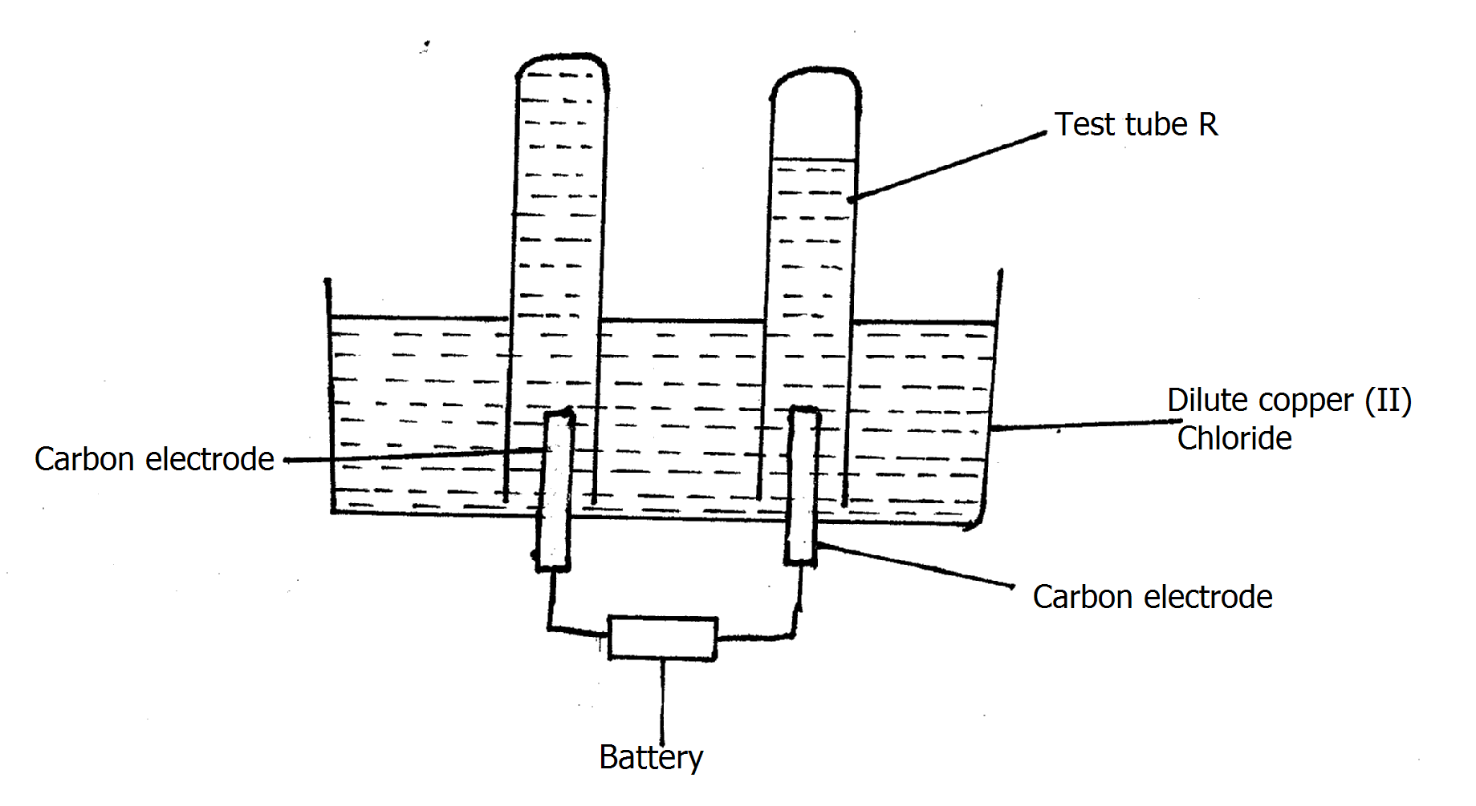

- Label the cathode and anode on the diagram. (1mk)

(b) Write an equation for the reaction responsible for formation of gas in tube R. (1mk)

- 20 cm³ of sodium carbonate solution was reacted completely with 25cm³ of 0.8 M hydrochloric acid. Calculate the concentration of sodium carbonate solutions in moles per litre. (3marks)

- The following diagram represents a section of the plant for the large scale manufacture of hydrochloric acid.
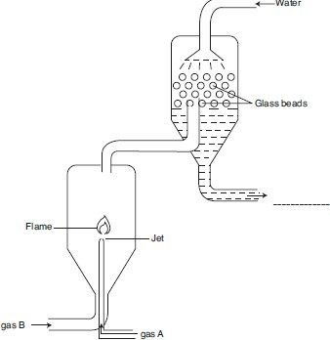
  - Name gases A and B. (1 mark)
A……….
B………..
  - State the role of the glass beads in the plant (1 mark)

  - Why is gas A introduced into the reaction chamber through a jet? (1 mark)

- a) What does the abbreviation PVCs stand for? (1 mark)

b).State one advantage and one disadvantage of PVC over natural polymers.

Advantage……… (1mk)

Disadvantage…… (1mk)

(This is the last printed page)

