Name: ……………………………………………Index no ………....................................

School: ……………………………………………Candidate’s sign…….....…...…........…

Date: ………………………………………

443/2
AGRICULTURE
PAPER 2
JULY/AUGUST 2026
TIME: 2 HOURS

Kenya Certificate of Secondary Education (K.C.S.E.)

INSTRUCTIONS TO CANDIDATES:

- Write your name, index number and the name of your school in the spaces provided.
- Sign and write the date of the examination in the spaces provided.
- This paper consists of three sections; A, B and C.
- Answer all questions in section A and B.
- Answer any two questions in section C in the spaces provided.

For Examiner’s Use Only

SECTION | QUESTION | MAXIMUM  SCORE | CANDIDATE’S SCORE
A | 1 – 15 | 30
B | 16 -19 | 20
C |  | 20
C |  | 20
 | TOTAL SCORE | 90
This paper consists of 9 printed pages. Candidates should check the question paper to ascertain that all pages are printed as indicated and that no questions are missing.

SECTION A( 30mks)
Answer all the questions in this section in the spaces provided.

1. Study the table below and fill in the missing words. (3 marks)

Description | Cattle | Pigs | Poultry
Young from birth/ hatching to weaning |  |  | Chick
Young female before first parturition / laying |  | Gilt
Mature male for breeding | Bull

2. Give two causes of scouring in calves. (1 mark)
………………………………………………………………………………………………………………………………………………………………………………………………………………………………………………………………………
3. Name one intermediate host for each of the following livestock parasites.
a) Liverfluke (Fasciola spp) ( ½ mark)
………………………………………………………………………………………
b) Tapeworm (Taenia spp) ( ½ mark)
………………………………………………………………………………………
4.Why is raddling essential in sheep management ? (1 mark)
………………………………………………………………………………………………………………………………………………………………………………

5. State four limitations of using hydroelectric power on the farm. (2 marks)
………………………………………………………………………………………………………………………………………………………………………………………………………………………………………………………………………
………………………………………………………………………………………………………………………………………………………………………………………………………………………………………………………………………
6. Differentiate between the following tools.
a) Bastard file and rasp file. (1 mark)
……………………………………………………………………………………………………………………………………………………………………………………………………………………………………………………………………….
b) Copying saw and hack saw (1 mark)
………………………………………………………………………………………………………………………………………………………………………………………………………………………………………………………………………
7. State four ways of restraining cattle during routine management. (2 marks)
………………………………………………………………………………………………………………………………………………………………………………………………………………………………………………………………………
………………………………………………………………………………………………………………………………………………………………………………
8.a) Name four breeds of dairy goats. (2 marks)
………………………………………………………………………………………………………………………………………………………………………………………………………………………………………………………………………
………………………………………………………………………………………
b) Mention two distinguishing characteristics of the bactrian camel breed. (1 mark)
………………………………………………………………………………………………………………………………………………………………………………
9.a) Give four symptoms of milk fever. (2 marks)
………………………………………………………………………………………………………………………………………………………………………………………………………………………………………………………………………
………………………………………………………………………………………
b) State two methods of controlling milk fever. (1 mark)
………………………………………………………………………………………………………………………………………………………………………………
10. Name four systems of a tractor engine. (2 marks)
……………………………………………………………………………………………………………………………………………………………………………………………………………………………………………………………………..
………………………………………………………………………………………
11.a) Give two reasons for using litter in a poultry house. (1 mark)
……………………………………………………………………………………………………………………………………………………………………………… b) Name two diseases of poultry that are controlled by vaccination. (1 mark)
………………………………………………………………………………………………………………………………………………………………………………
12. List three types of calf pens. (1 ½ mks)
……………………………………………………………………………………………………………………………………………………………………………………………………………………………………………………………………..
13. Give four reasons for feeding a calf on colostrum. (2 marks)
………………………………………………………………………………………………………………………………………………………………………………………………………………………………………………………………………
………………………………………………………………………………………
14 .Name five qualities of eggs for incubation. ( 2^{1/}₂ marks) ………………………………………………………………………………………………………………………………………………………………………………
15. A deep litter poultry house measures 9m x 3m. Suppose the amount of space allowed for one bird is 0.27m², calculate the number of birds that can be kept comfortably in this house. Show your working. (2 marks)
………………………………………………………………………………………………………………………………………………………………………………………………………………………………………………………………………………………………………………………………………………………………………………………………………………………………………………………

SECTION B(20mks)
Answer ALL questions in the spaces provided.

16. a) Identify each of the livestock parasites shown below. (2 marks)
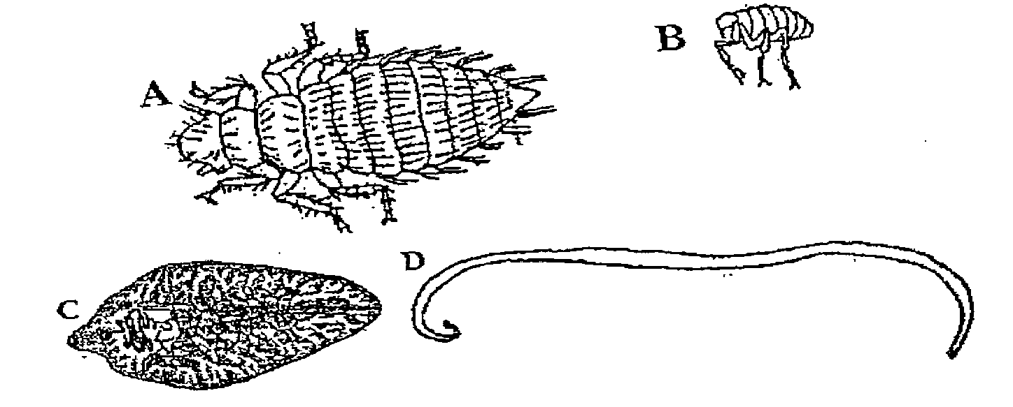

A……………………………………………..
B……………………………………………..
C……………………………………………..
D……………………………………………..

b) State the category of parasites A and C. ( 1 mark) A……………………………………………………………………………………

C…………………………………………………………………………………….

c) Suggest an effective control measure of the parasite labeled C. (1 mark)

……………………………………………………………………………………………………………………………………………………………………………….
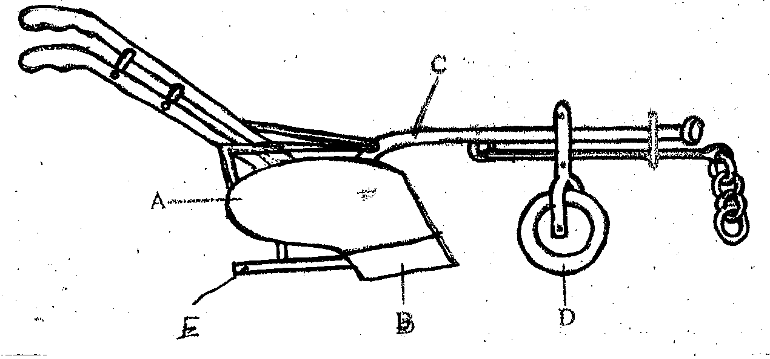
17. Below is a diagram of a farm implement

E
B
D
- Identify the implement ( ½ mark)
………………………………………………………………………………
- Name the parts labeled A,B,C,D and E (2 ½ marks)
A……………………………………………………
B……………………………………………………
C……………………………………………………
D……………………………………………………
E ……………………………………………………
- State the functions of the parts labeled C and E (2marks)
………………………………………………………………………………………………………………………………………………………………
- The diagrams below illustrate the strokes a four stroke cycle engine. Study them and answer the questions that follow.

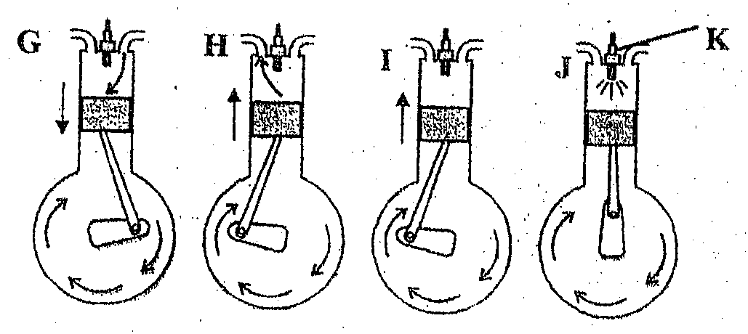

- Name the strokes represented by diagrams G,H,I and J. (2marks)
G………………………………………………………………………………
H………………………………………………………………………………
I………………………………………………………………………………
J………………………………………………………………………………
- Mention two disadvantages of a four stroke cycle engine (2marks)
……………………………………………………………………………………………………………………………………………………………………………………………………………………………………………..
- What is the function of part K (1mark)
………………………………………………………………………………
19.The diagram below shows a livestock production equipment .study it and answer the questions that follow.
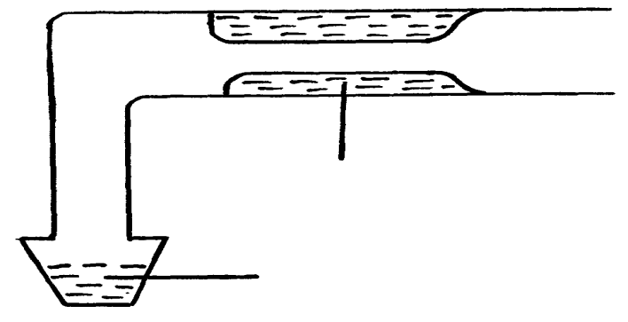

Warm water

Collected semen

- Identify the equipment (1mark)
.....................................................................................................................
b) What is the importance of warm water in the equipment. (1mk)
…………………………………………………………………………………
…………………………………………………………………………………

- Describe the procedure followed when using the equipment in collecting semen. (4mks)
…………………………………………………………………………………………………………………………………………………………………………………………………………………………………………………………………………………………………………………………………………………………………………………………………………………………………………

SECTION C( 40mks)
Answer ONLY TWO questions from this section
20.(a) Discuss Brucellosis under the following sub topics
- Casual organism in cattle. (1mk)
- Symptoms (4mks)
- Control (5mks)
(b) Explain the importance of keeping livestock healthy (10mks)
21. (a) Explain ten factors considered when selecting livestock for breeding: (10mks)
(b) Describe ten management practices carried out on cattle during parturition. (10mks)
22.a)Describe the procedure of constructing a barbed wire fence. (10mks)
(b) Outline the advantages of the battery cage system in poultry rearing. (10mks)
………………………………………………………………………………………………………………………………………………………………………………………………………………………………………………………………………………………………………………………………………………………………………………………………………………………………………………………………………………………………………………………………………………………………………………………………………………………………………………………………………………………………………………………………………………………………………………………………………………………………………………………………………………………………………………………………………………………………………………………………………………………………………………………………………………………………………………………………………………………………………………………………………………………………………………………………………………………………………………………………………………………………………………………………………………………………………………………………………………………………………………………………………………………………………………………………………………………………………………………………………………………………………………………………………………………………………………………………………………………………………………………………………………………………………………………………………………………………………………………………………………………………………………………………………………………………………………………………………………………………………………………………………………………………………………………………………………………………………………………………………………………………………………………………………………………………………………………………………………………………………………………………………………………………………………………………………………………………………………………………………………………………………………………………………………………………………………………………………………………………………………………………………………………………………………………………………………………………………………………………………………………………………………………………………………………………………………………………………………………………………………………………………………………………………………………………………………………………………………………………………………………………………………………………………………………………………………………………………………………………………………………………………………………………………………………………………………………………………………………………………………………………………………………………………………………………………………………………………………………………………………………………………………………………………………………………………………………………………………………………………………………………………………………………………………………………………………………………………………………………………………………………………………………………………………………………………………………………………………………………………………………………………………………………………………………………………………………………………………………………………………………………………………………………………………………………………………………………………………………………………………………………………………………………………………………………………………………………………………………………………………………

