TERM 2 YEAR 20236
AGRICULTURE PAPER 1
443/1
TIME 2 HORUS.

NAME………………………………………………………………………………………………….
ADM NO/INDEX NO…………………………………………………………………………….
CLASS………………………………………………………………………………………………….
INSTRUCTIONS.
a)Write your name and index number in the spaces provided.
b)This paper consists of three sections: A;B; and C.
c)Answer all the questions in sections A and B and any two questions in section C.
d)All answers should be written in the spaces provided on the question paper
e)Confirm no questions are missing as indicated above.

FOR EXAMINERS USE ONLY
SECTIONS | QUESTIONS | MAXIMUM SCORE | CANDIDATE’S SCORE
SECTION A | 1-17 | 30 MKS
SECTION B | 18-22 | 20 MKS
SECTION C | 23-25 | 40 MKS
 |  | TOTAL SCORE

SECTION A (30 MKS)
Answer all the questions in the spaces provided.
1.Give four methods of applying fertilizer in crop fields. (2 mks)

………………………………………………………………………………………………………………………………………………………………………………………………………………………………………………………………………………………………………………………………………………………………………………………………………………………………………………………………………………………………………………………………………………………………………………
2. State four reasons why burning vegetation is discouraged as a land preparation method. (2 mks)
……………………………………………………………………………………………………………………………………………………………………………………………………………………………………………………………………………………………………………………………………………………………………………………………………………………………………………………………………………………………………………………………………………………………………………
3. State four reasons why communal land tenure system is discouraged in farming. (2 mks)

………………………………………………………………………………………………………………………………………………………………………………………………………………………………………………………………………………………………………………………………………………………………………………………………………………………………………………………………………………………………………………………………………………………………………………
4. State four reasons why drainage should be improved on waterlogged land before growing crops. (2 mks)

………………………………………………………………………………………………………………………………………………………………………………………………………………………………………………………………………………………………………………………………………………………………………………………………………………………………………………………………………………………………………………………………………………………………………………

5. State four features of rainfall a farmer need to consider in crop production. (2 mks)
………………………………………………………………………………………………………………………………………………………………………………………………………………………………………………………………………………………………………………………………………………………………………………………………………………………………………………………………………………………………………………………………………………………………………………
6. Give two field practices carried out to obtain optimum plant population in a farm. (1 mk)
………………………………………………………………………………………………………………………………………………………………………………………………………………………………
7. State four characteristics of plants suitable for making green manure. (2 mks)
………………………………………………………………………………………………………………………………………………………………………………………………………………………………………………………………………………………………………………………………………………………………………………………………………………………………………………………………………………………………………………………………………………………………………………
8. Give two methods used to show that soil is made of different sized particles. (1 mk)
………………………………………………………………………………………………………………………………………………………………………………………………………………………………
9. Give four factors determining the stage at which a crop is harvested. (2 mks)
………………………………………………………………………………………………………………………………………………………………………………………………………………………………………………………………………………………………………………………………………………
……………………………………………………………………………………………………………….
10. State four factors contributing to competitive ability of weeds. (2 mks)
……………………………………………………………………………………………………………………………………………………………………………………………………………………………………………………………………………………………………………………………………………………………………………………………………………………………………………………………………………………………………………………………………………………………………………
11. State four factors affecting the quality of hay. (2 mks)
………………………………………………………………………………………………………………………………………………………………………………………………………………………………………………………………………………………………………………………………………………………………………………………………………………………………………………………………
12. Give two examples for each of the following insect pests which have the following mouth parts. (2 mks)
a)Piercing and sucking
…………………………………………
……………………………………………
b) Biting and chewing.
………………………………………………………………………………………………………………………………………………………………………………………………………………………………
13. Differentiate between Olericulture and Pomoculture as used in crop production. (1 mk)

14. Give two ways of lowering acidity in the soil. (1 mk)
………………………………………………………………………………………………………………………………………………………………………………………………………………………………………………………………………………………………………………………………………………
15. State four factors to consider when making a farm plan. (2 mks)
………………………………………………………………………………………………………………………………………………………………………………………………………………………………………………………………………………………………………………………………………………………………………………………………………………………………………………………………………………………………………………………………………………………………………………

16. State any four ways of improving labour productivity in the farm. (2 mks)
……………………………………………………………………………………………………………………………………………………………………………………………………………………………………………………………………………………………………………………………………………………………………………………………………………………………………………………………………………………………………………………………………………………………………………
17. Give four signs of viral infection in crops. (2 mks)
………………………………………………………………………………………………………………………………………………………………………………………………………………………………………………………………………………………………………………………………………………………………………………………………………………………………………………………………
SECTION B (20 MKS)
Answer all the questions in this section in the spaces provided.
18. The diagram below shows a method of irrigation.
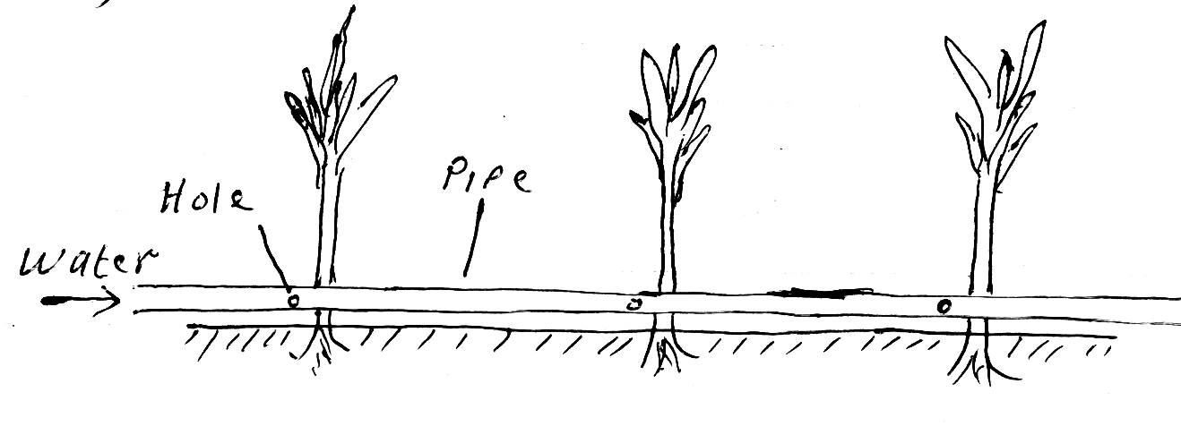
a)Name the type of irrigation shown above. (1 mk)

b) State three advantages of the above irrigation (3 mks)

………………………………………………………………………………………………………………………………………………………………………………………………………………………………………………………………………………………………………………………………………………

19. Study the diagram below showing a tomato fruit infected with a pest.
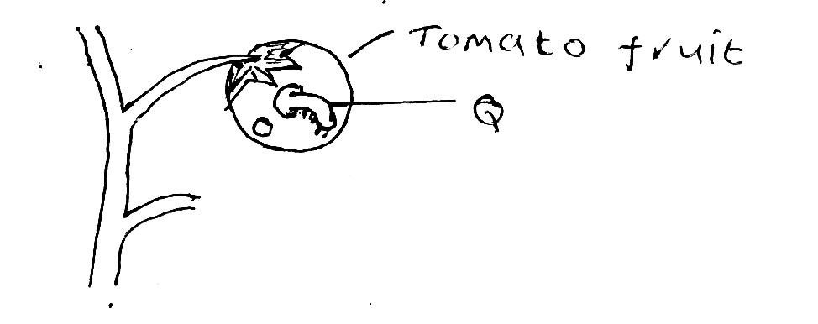

a)Name the pest labelled Q. (1 mk)

…………………………………………………………………………………………………………..
b) State two control measures for the pest. (2 mks)

………………………………………………………………………………………………………………………………………………………………………………………………………………………………………………………………………………………………………………………………………………
20. The diagram below shows a common weed in the farm.
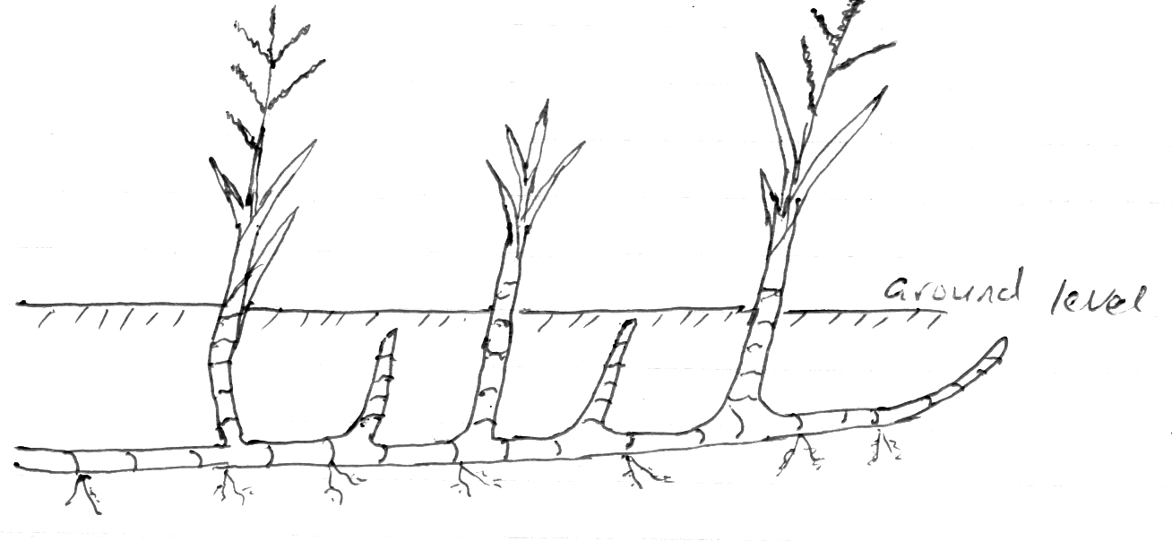
a) Identify the weed illustrated above. (1 mk)

………………………………………………………………………………………………………………

b) Why is the above weed difficult to control by mechanical digging? (1 mk)

………………………………………………………………………………………………………………

c) Name the category of herbicide suitable for controlling the weed. (1 mk)

………………………………………………………………………………………………………………
d) Classify the above weed according to its leaf morphology. (1 mk)

………………………………………………………………………………………………………………
21. The diagram below is used to study certain soil characteristics.

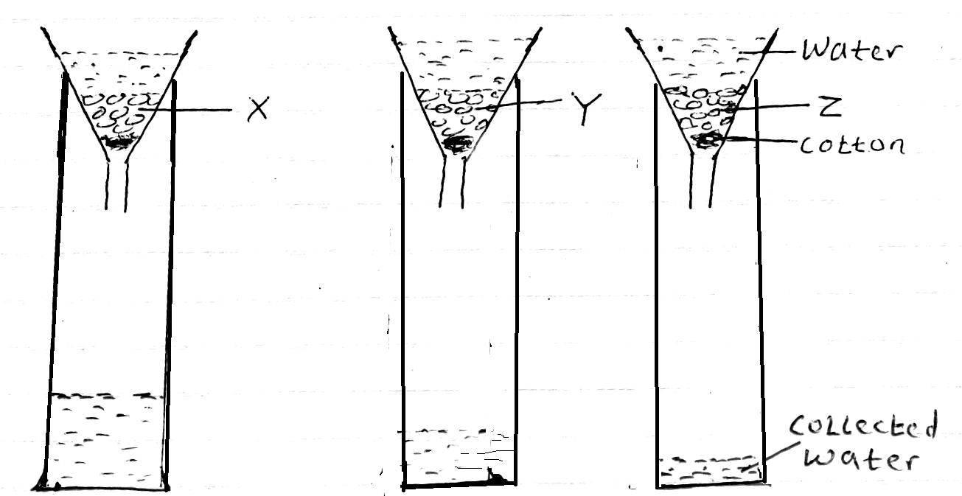

a) Identify the soil types labeled X, Y and Z. (3 mks)

X……………………………………………………………………………………………………………Y……………………………………………………………………………………………………………
Z……………………………………………………………………………………………………………
b) State two soil characteristics being investigated above. (2 mks)

………………………………………………………………………………………………………………………………………………………………………………………………………………………………………………………………………………………………………………………………………………

22. The diagram below shows a 50kg bag of Diammonium Phosphate (18:46:0) fertilizer.
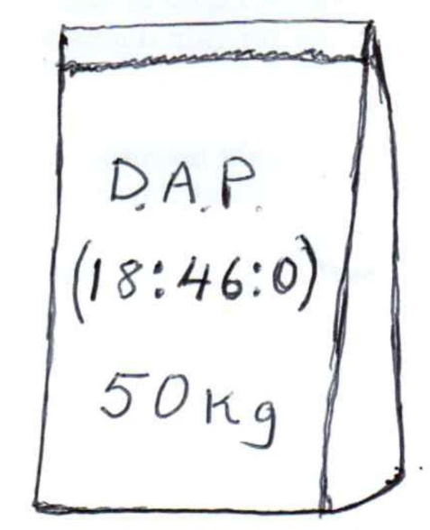

a)Give a reason why the above fertilizer is classified as an incomplete compound fertilizer. (1 mk)

………………………………………………………………………………………………………………

b) Calculate the amount of the following nutrients contained in the 50kg bag. (2 mks)
Nitrogen. (N)

Phosphorus pentoxide (P₂O₅)

c) Based on the nutrients contained, give a reason why the above fertilizer is recommended for planting. (1 mk)

………………………………………………………………………………………………………………

SECTION C (40 MKS)
Answer ANY TWO question.
23. State and explain
a)Five advantages of crop rotation . (10 mks)
b) Five factors which may influence the spacing of crops. (10 mks)

24. a)Give four precautionary measures observed in cotton harvesting. (4 mks)
b) Outline six management practices carried out on vegetable nursery after sowing.
(6 mks)
c) Outline 10 uses of farm records. (10 mks)

25. a)Describe four types of soil erosion by water. (8 mks)
b) Give four ways in which low level of education and technology influence agriculture.
(4 mks)
c) Describe production of maize under the following sub-headings.
i)Seedbed preparation. (3 mks)
ii) Planting. (5 mks)

………………………………………………………………………………………………………………
………………………………………………………………………………………………………………
………………………………………………………………………………………………………………
………………………………………………………………………………………………………………………………………………………………………………………………………………………………
………………………………………………………………………………………………………………
………………………………………………………………………………………………………………
………………………………………………………………………………………………………………………………………………………………………………………………………………………………
………………………………………………………………………………………………………………
………………………………………………………………………………………………………………
………………………………………………………………………………………………………………………………………………………………………………………………………………………………
………………………………………………………………………………………………………………
………………………………………………………………………………………………………………
………………………………………………………………………………………………………………

………………………………………………………………………………………………………………
………………………………………………………………………………………………………………
………………………………………………………………………………………………………………
………………………………………………………………………………………………………………………………………………………………………………………………………………………………
………………………………………………………………………………………………………………
………………………………………………………………………………………………………………
………………………………………………………………………………………………………………………………………………………………………………………………………………………………
………………………………………………………………………………………………………………
………………………………………………………………………………………………………………
………………………………………………………………………………………………………………………………………………………………………………………………………………………………
………………………………………………………………………………………………………………
………………………………………………………………………………………………………………
………………………………………………………………………………………………………………………………………………………………………………………………………………………………
………………………………………………………………………………………………………………
………………………………………………………………………………………………………………
………………………………………………………………………………………………………………………………………………………………………………………………………………………………
………………………………………………………………………………………………………………
………………………………………………………………………………………………………………
………………………………………………………………………………………………………………………………………………………………………………………………………………………………
………………………………………………………………………………………………………………
………………………………………………………………………………………………………………
………………………………………………………………………………………………………………………………………………………………………………………………………………………………
………………………………………………………………………………………………………………
………………………………………………………………………………………………………………
………………………………………………………………………………………………………………………………………………………………………………………………………………………………
………………………………………………………………………………………………………………
………………………………………………………………………………………………………………
………………………………………………………………………………………………………………………………………………………………………………………………………………………………
………………………………………………………………………………………………………………
………………………………………………………………………………………………………………
………………………………………………………………………………………………………………………………………………………………………………………………………………………………
………………………………………………………………………………………………………………
………………………………………………………………………………………………………………
………………………………………………………………………………………………………………………………………………………………………………………………………………………………
………………………………………………………………………………………………………………
………………………………………………………………………………………………………………
………………………………………………………………………………………………………………………………………………………………………………………………………………………………
………………………………………………………………………………………………………………
………………………………………………………………………………………………………………
………………………………………………………………………………………………………………………………………………………………………………………………………………………………
………………………………………………………………………………………………………………
………………………………………………………………………………………………………………
………………………………………………………………………………………………………………………………………………………………………………………………………………………………
………………………………………………………………………………………………………………
………………………………………………………………………………………………………………
………………………………………………………………………………………………………………………………………………………………………………………………………………………………
………………………………………………………………………………………………………………
………………………………………………………………………………………………………………
………………………………………………………………………………………………………………………………………………………………………………………………………………………………
………………………………………………………………………………………………………………
………………………………………………………………………………………………………………
………………………………………………………………………………………………………………………………………………………………………………………………………………………………
………………………………………………………………………………………………………………
………………………………………………………………………………………………………………
………………………………………………………………………………………………………………………………………………………………………………………………………………………………
………………………………………………………………………………………………………………
………………………………………………………………………………………………………………
………………………………………………………………………………………………………………………………………………………………………………………………………………………………
………………………………………………………………………………………………………………
………………………………………………………………………………………………………………
………………………………………………………………………………………………………………………………………………………………………………………………………………………………
………………………………………………………………………………………………………………
………………………………………………………………………………………………………………
………………………………………………………………………………………………………………………………………………………………………………………………………………………………
………………………………………………………………………………………………………………
………………………………………………………………………………………………………………
………………………………………………………………………………………………………………………………………………………………………………………………………………………………
………………………………………………………………………………………………………………
………………………………………………………………………………………………………………
………………………………………………………………………………………………………………………………………………………………………………………………………………………………
………………………………………………………………………………………………………………
………………………………………………………………………………………………………………

