FORM 3 CHEMISTRY CLUSTER TERM II 2026 (100 mks)

1. 3.1g of an organic compound containing Carbon, Hydrogen and Oxygen produce only 4.4g of Carbon (IV) Oxide and 2.0g of water on complete combustion.
a.) Calculate the empirical formula of the compound. (2mks)

b.) Calculate its molecular formula of the compound if its formula mass is 62. (1mks)

2. Below is a diagram of a Bunsen burner flame.
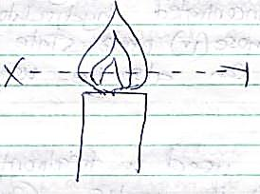

a.) Identify the type of flame. (1 mk)

b.) Under what conditions is it produced? (1 mk)

c.) A splint is placed across point XY for some few seconds and then removed before it burned.
Draw and label the splint to show the observation made. (1 mk)

3. a). The set up below can be used to prepare oxygen gas. Study it and answer the questions that follow.
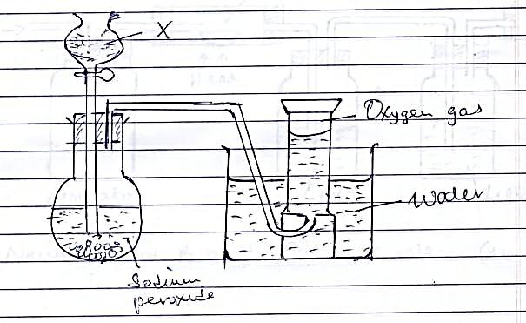

i.) Identify reagent X. (1 mk)

ii.) What property of oxygen makes it possible for it to be collected as shown above? (1 mk)

iii.) Wet red and blue litmus papers were immersed in a gas jar full of oxygen gas. State and explain the observation made. (1 mk)

iv.) State two industrial uses of oxygen gas. (2 mks)

b.) The set up below was used to obtain nitrogen from air.

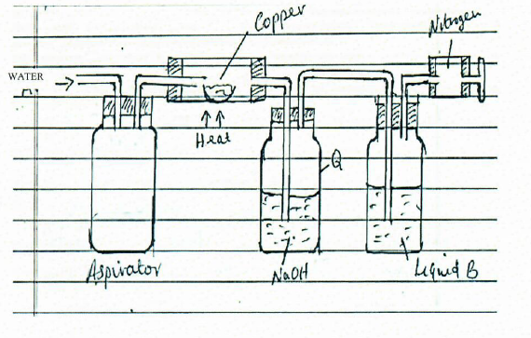
i) Name liquid B and state its role. (1 mk)

ii) Write an equation for the reaction taking place in flask Q. (1 mk)

iii) What observation is made in the combustion tube? (1 mk)

iv) A burning magnesium ribbon was placed in a gas jar full of nitrogen. A product T was formed which was then reacted with water.
I. Identify product T. (1 mk)

II. Write a chemical equation for the reaction between product T and water. (1 mk)

c) Two iron bars were treated as follows and left exposed to the atmosphere for two weeks.

Copper zinc

Iron iron
A B
State and explain the observation made on each set-up after the two weeks. (2 mks)

4. In an experiment to investigate the percentage of oxygen in air, 200cm³ of air was passed over heated Copper turnings repeatedly until a constant volume of air remained. 160cm³ of air remained at the end of the experiment. Determine the percentage of air used up during the experiment. (2mks)

5. 20cm³ Sodium Carbonate solution was reacted completely with 25cm³ of 0.8M hydrochloric acid. Calculate the concentration of Sodium Carbonate in g/litre (Na=23, C=12, O=16) (3mks)

6. An experiment was set-up as shown below.
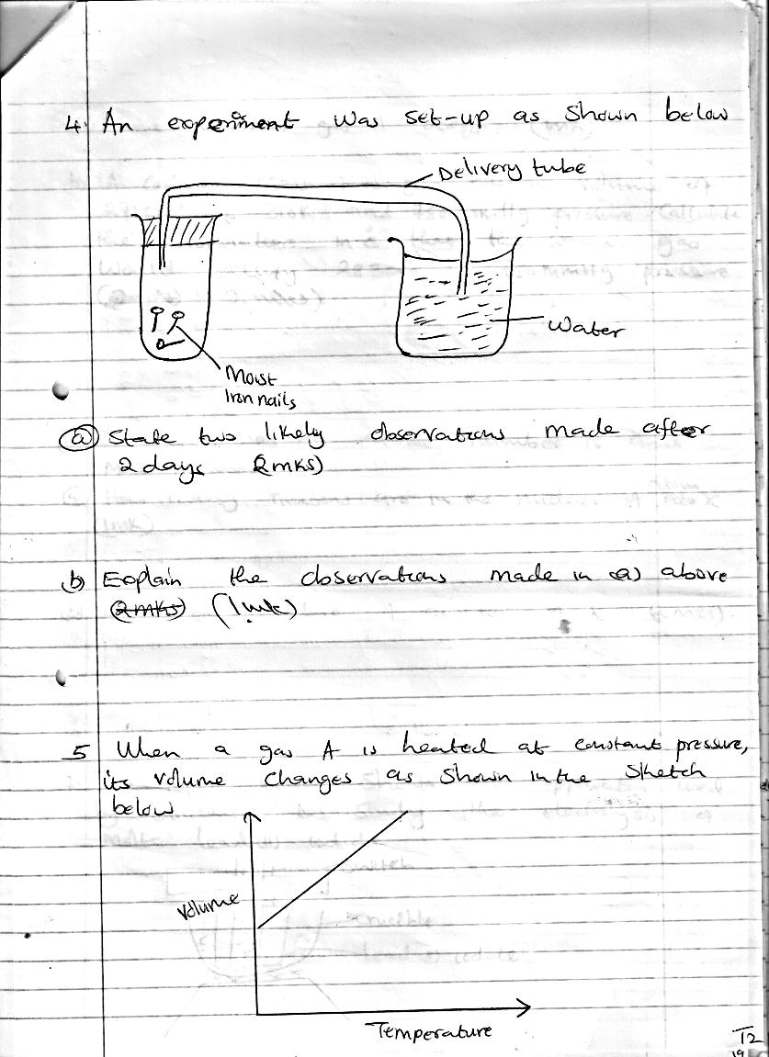

- State two likely observations made after 2 days. (2mks)

- Explain the observations made in (a) above. (1mk)

7. The figure below shows the apparatus used by students to study the electrolysis of lead (II) iodide.
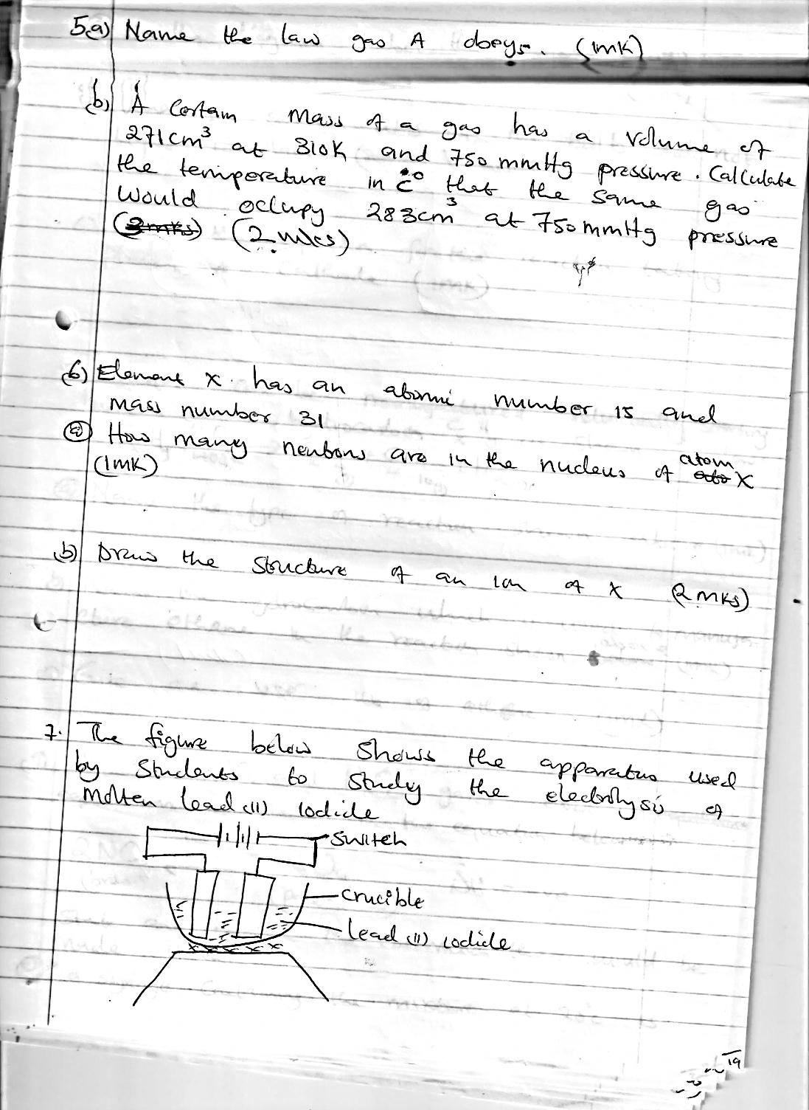

- On the diagram label the anode. (1mk)
- When switched on the bulb did not light. Explain. (1mk)

- Write the equation for the reaction taking place at cathode after rectifying. (1mk)

8. Distinguish between deliquescent and hygroscopic salts. (2mks)

9. You are provided with the following: Copper (II) Oxide, dilute sulphuric (VI) acid and a source of heat. Describe fully how you would prepare Copper (II) sulphate. (3mks)

10. The diagram below represents the extraction of sulphur by Frasch process

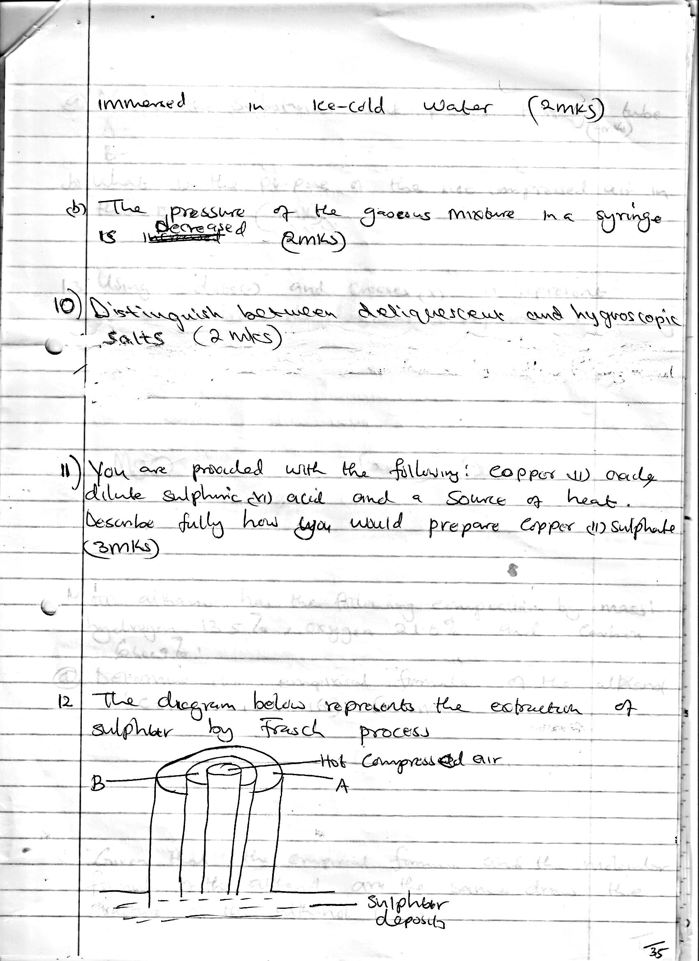
Hot Compressed air
Sulphur deposits

- Name the substances that passes through tube: A , B (2mks)

- What is the purpose of the hot compressed air in the process. (1mk)

11. Using dots (.) and crosses (x) to represent electrons, draw the diagrams to represent the bonding in:-
- PH₄⁺ (2mks)

- MgO (2mks)

12. In an experiment, carbon (IV) Oxide gas was passed over heated coke and the gas produced collected as shown in the diagram below.
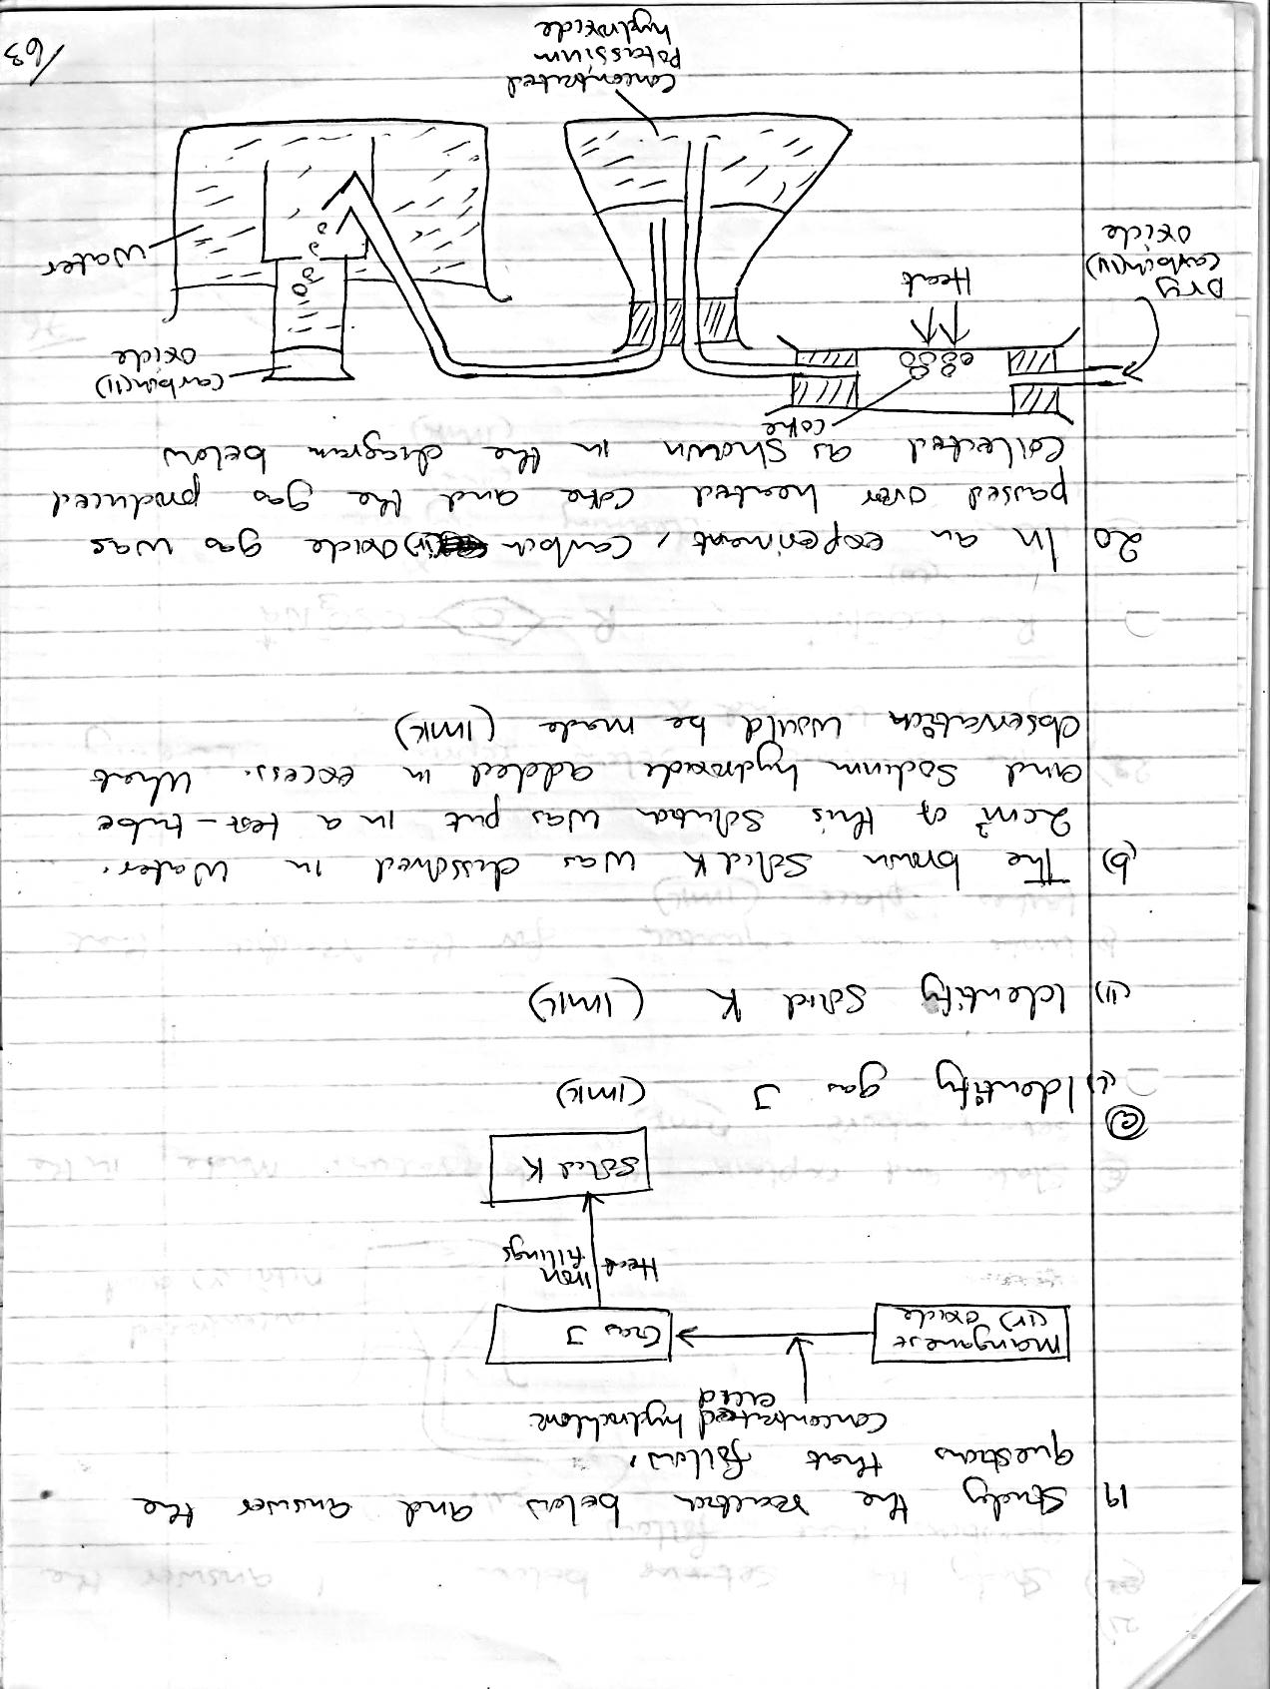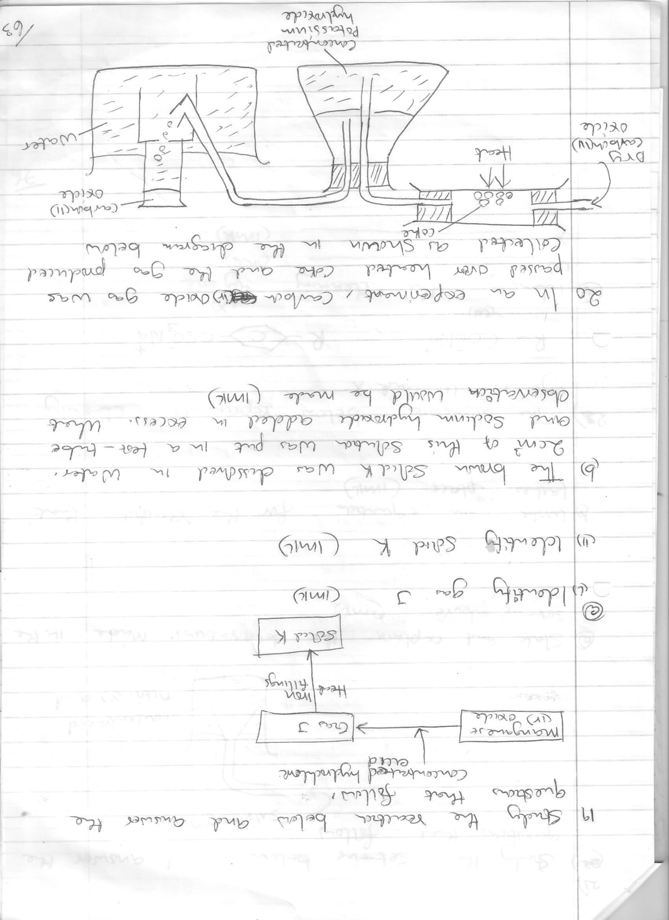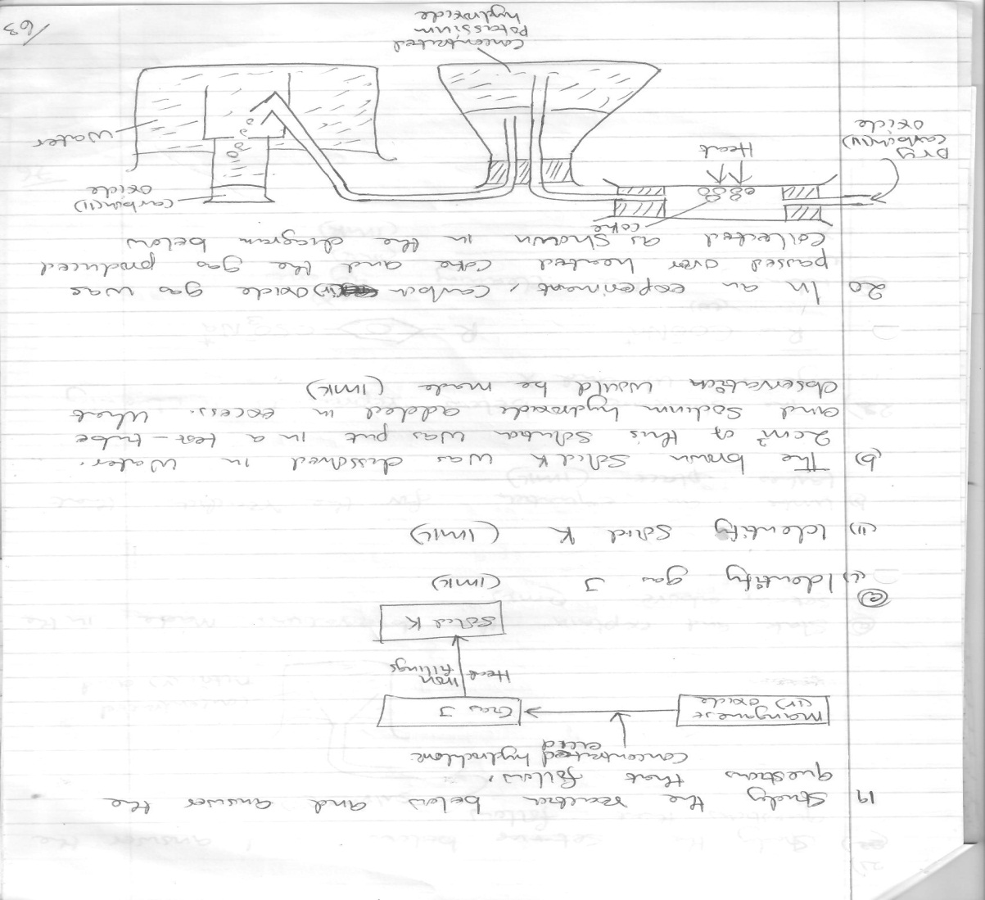
Coke

- Write an equation for the reaction that takes place in the combustion tube. (1 mk)

(b) Name the type of reaction that occurs in the combustion tube. (1 mk)

(C) Give another substance that can be used instead of concentrated potassium hydroxide. (1 mk)

13. If 140cm³ of gas x whose molecular mass is 16 diffuses into air in 72 seconds, how long will it take 210cm³ of gas y whose molecular mass is 64 to diffuse under the same conditions. (3mks)

14. (a) Name the two crystalline forms of sulphur. (1mk)

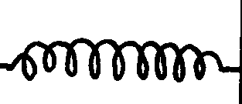(b) The scheme below represents the steps followed in the contact process. Study it and answer the questions that follow:-
Burner
SO₂
Air
Purifier
Dry SO₂ and air
Heat exchanger
Cooler
AbsorptionTower
SO₃
Diluter
Catalytic converter
SO₃
SO₂
Air
Oleum

Conc. H₂SO₄
Conc. H₂SO₄
Solid A
Air

(i) Name two possible identities of solid A. (1mk)

(ii) Name two impurities removed by the purifier. (1mk)

(iii) Why is it necessary to remove impurities? (1mk)

(iv) Write down the equation of the reaction taking place in the catalytic converter. (1mk)

(v) Name the two catalysts that can be used in the catalytic converter. (1mk)

(vi) Which is the most preferred catalysts in contact process? Give two reasons. (1mk)

(vii) Sulphur (VI) Oxide is not dissolved directly into water? Explain. (1mk)

(c) (i) Name the main pollutant in the contact process. (1mk)

(ii) How can the pollution by the pollutant in (c)(i) above be controlled? (1mk)

(iii) Give two uses of sulphuric (VI) acid. (1mk)

15. The diagram below shows the process of manufacturing sodium carbonate using solvay process. Study it and answer the questions below.

a) Name gases A and B. (2 marks)

b) Name solid D. (1 mark)

c) Write equations of the reactions in
Tower P (1 mark)

Chamber R (1 mark)

Chamber G (1 mark)

d) Name the product T formed at chamber R and give one of its uses. (2 marks

16. A student set up the apparatus shown below to prepare ammonia gas and react it with copper (II) sulphate solution.
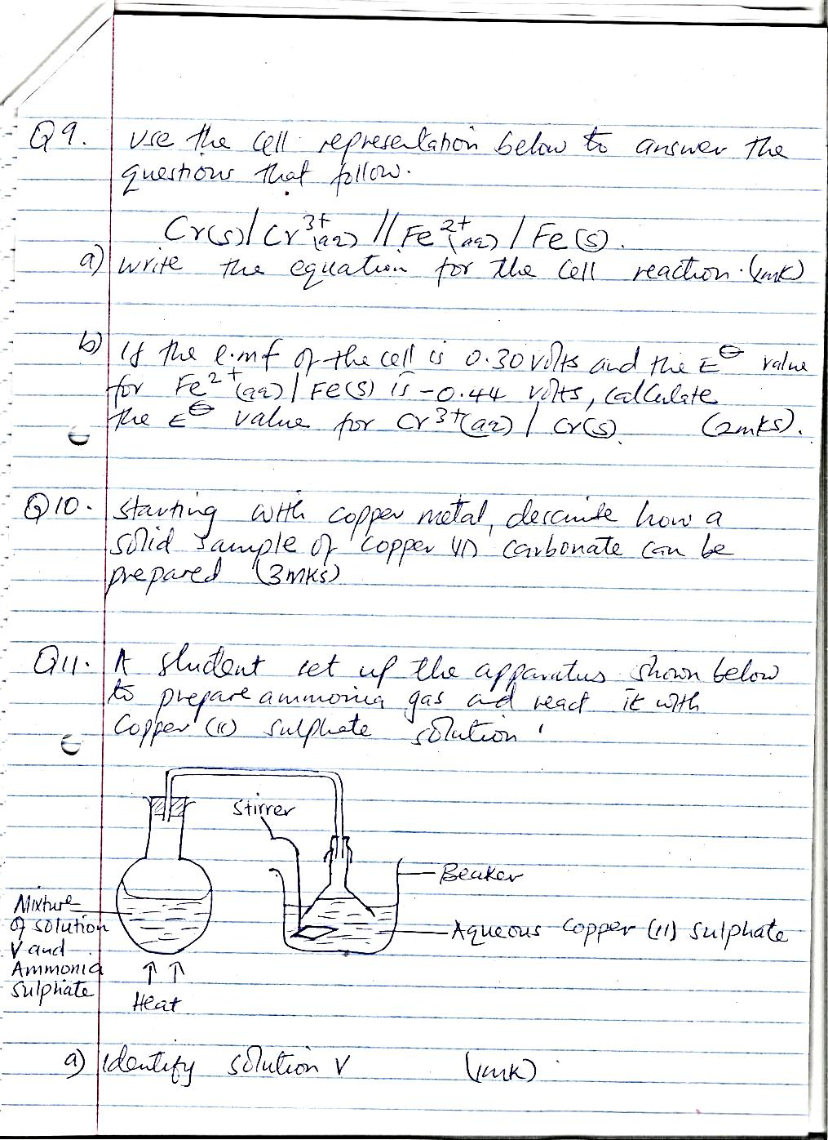

- Identify solution V. (1mk)

- State the observations which were made in the beaker. (2mks)

17. The set-up below was used to separate a mixture of methanol (BP 60ºC) and propanol (BP 120⁰C). Study it and answer the questions that follow.
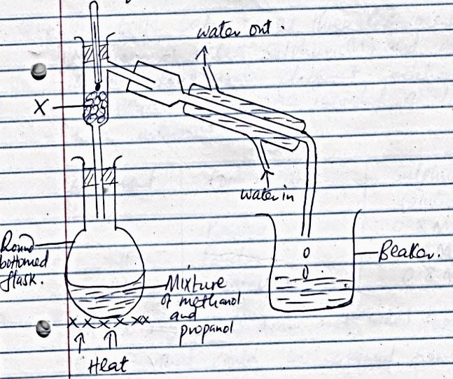

- State the function of X (1mk)

- Which liquid will collect first in the beaker? Give a reason. (2mks)

18. Charcoal is a fuel that is commonly used in cooking. When it burns it forms two oxides.
a) Name the two oxides. (2mks)

b) State one use of the two oxides. (1mk)

19. The diagram below represents a set-up that was used to react lithium with steam. Study it and answer the questions that follow.
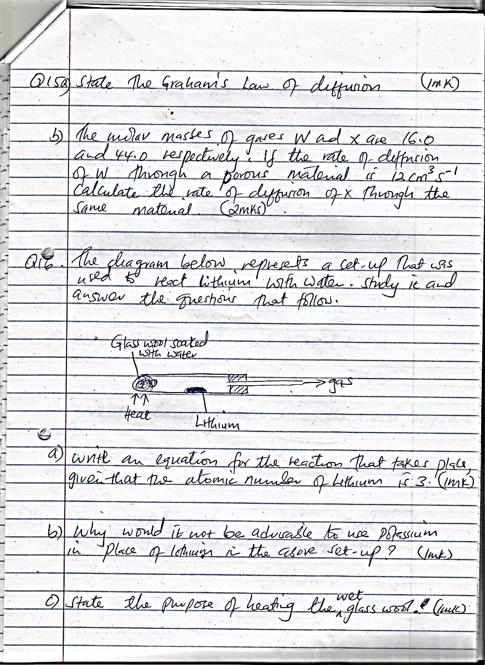

- Write an equation for the reaction that takes place given that the atomic number of lithium is 3. (1mk)

- Why would it not be advisable to use potassium in place of lithium in the above set-up?(1mk)

- State the purpose of heating the wet glass wool. (1mk)

20.Zinc metal and hydrochloric acid reacts according to the following equation.
Zn_{(S)} + 2HCl_{(aq}) → ZnCl_{2(aq)} + H₂(g)
1.96 g of zinc metal were reacted with 100cm³ of 0.2M HCl acid.
a) Determine the reagent that was in excess. (2mks)

b) Calculate the total volume of hydrogen gas that was liberated at s.t.p.
(Zn = 65.4; Molar gas volume = 22.4 litres at s.t.p) (2mks)

21. The first step in the industrial manufacture of nitric (V) acid is the catalytic oxidation of ammonia gas.
a) What is the name of the catalyst used? (1mk)

b)Nitric (V) acid is used to make ammonium nitrate, state two uses of ammonium nitrate. (1mk)

c) Why is nitric (V) acid stored in dark bottles? (1mk)

22. The table below gives some information about the electrical conductivity and the likely bonding in substances N, P, and Q. Complete the table by inserting the missing information in the spaces numbered 1, II,III. (3mks)
Substance | Likely type of bonding present | Electrical conductivity
Substance | Likely type of bonding present | solid | Molten
N | Metallic | I …………………. |  | Conducts
P | II…………………. | Does not conduct |  | conducts
Q | III………………….. | Does not conduct |  | Does not conduct

23. The diagram below is part of a set up used in laboratory preparations of a gas.
Complete the diagram to show how a dry sample of the gas can be collected. (3mks)

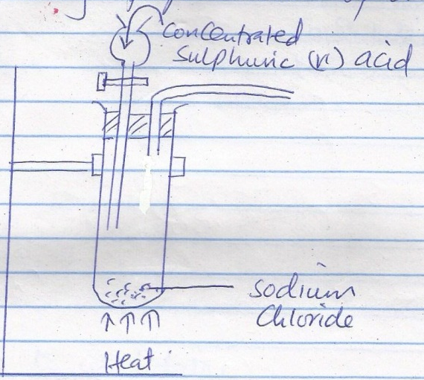

24. The figure below shows the changes that takes place between states of matter. Some of them have been identified and others labeled.
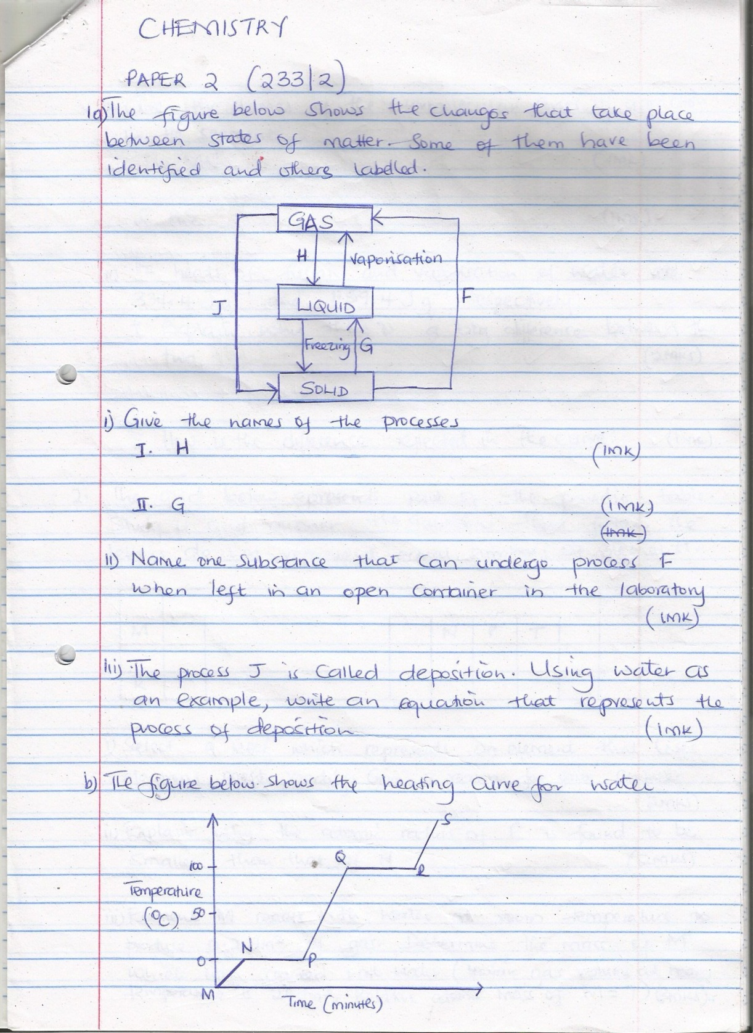

- Give the names of the process.

I . H (1mk)

II. G (1mk)
- Name one substance that can undergo process F when left in an open container in the laboratory. (1mk)

- The process J is called deposition. Using water as an example, write an equation that represents the process of deposition. (1mk)

b) The figure below shows the heating curve for water.
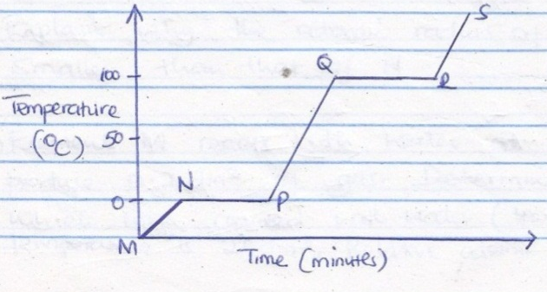

- Give the names of the intermolecular forces of attraction in the segments.
I MN (1mk)

II RS (1mk)
25. The grid below represents part of the periodic table study it and answer the questions that follow. The letters do not represents actual symbols of element.

M |  |  |  | N | P | T
R

- Select a letter which represents an element that loses electrons most readily. Give a reason for your answer. (2mks)

- Explain why the atomic radius of P is found to be smaller than that of N. (2mks)

- Element M reacts with water at room temperature to produce 0.2dm³ of gas. Determine the mass of M which was reacted with water (molar gas volume at room temperature is 24dm³, Relative atomic mass of M=7) ( 3mks)

