Name: _____________________________________________ Adm No: ____________Class: _____

Candidate’s Signature: ________________________ Date: __________________________

PHYSICS
FORM 3
PAPER 3
END TERM 2 EXAMINATION
JULY/AUGUST 2025
Time: 2 ½ HOURS

Instructions to Candidates
Question 1
You are provided with the following;
- a rectangular glass block
- 4 optical pins
- a soft board
- a plain paper
- A vernier calipers

Proceed as follows:
- Measure the breadth b of the glass block
Breadth b =……………………………………………… (1 mark)
- Place the glass block on the plain paper with one of the largest face facing up. Trace round the glass block using a pencil as shown below.
N₁
P₂
P₁
i
b
P₃
P₄
D
A
B
Eye

L
r
r

C

N₂
2

(b) Remove the glass block and construct a normal at B. Construct an incident ray AB of angle of incidence, i = 20⁰

- Replace the glass block carefully to its original position.
- Fix two pins P₁ and P₂ on the line AB in such a way that they are vertical and are a distance away from each other.

- Looking through the glass block through the other side, fix two pins P₃ and P₄so that they are exactly in line with pins P₁ and P₂

- Remove the glass block and draw the path of the ray ABCD using a pencil.

- Measure the angle of refraction r and record it on the table below.

- Repeat the procedure above for the angles of incidence given and use the data to complete the table below. (6 marks)
Angle of incidence i | 20⁰ | 30⁰ | 40⁰ | 50⁰ | 60⁰ | 70⁰
Angle of refraction r
Sin i
Sin r
$$\frac{Sin i}{Sin r}$$
(i) On the graph paper provided, plot a graph of Sin i(y-axis) against Sin r. (5 marks)

(j) Calculate the gradient S of the graph (3 marks)

(k) What does the gradient of the graph represent? (1 mark)

(l) Use the graph to determine the angle of refraction when the angle of incidence is 45⁰ (2 marks)

(m) What is the critical angle of the glass material making up the glass block? (2marks)

Question 2
You are provided with the following
- A pendulum bob
- A stop watch
- A metre rule
- A retort stand, boss and clamp
- A piece of thread about 1.1m long
Proceed as follows.

- Set up the apparatus as shown in figure 1 below.

Fig 1
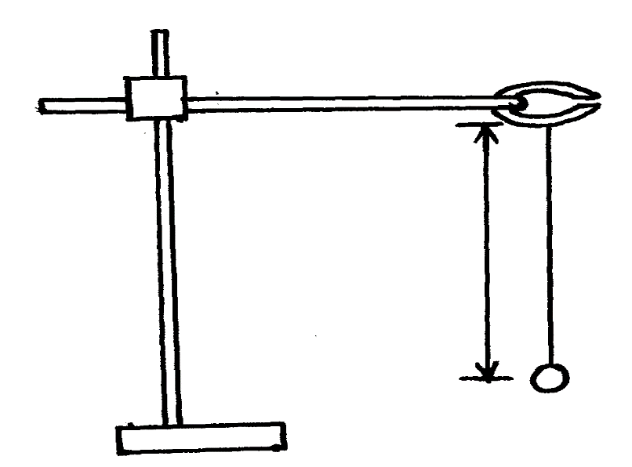

Bob
Thread
L

(b) Set the length, L, to be 1.0m. Displace the bob slightly through a small angle measure and record in table 1 the time, t, for 10 complete oscillations.
(c) Repeat the procedure in (b) for other values of l as shown in table 1. Complete the table
Table below (8 mks)
Length ,L (m) | 1.0 | 0.9 | 0.8 | 0.7 | 0.6 | 0.5
Time t for 10 oscillations (s)
Period, T = t/10s
Frequency, F (Hz)= 1/T
F²(Hz)²
I (m⁻¹)
L

d(i) plot a graph of F² ( y-axis) against 1/L (5 mks)

(ii) Determine the slope of the graph. (3 mks)

(iii) Given that the equation of the graph is
F² = g 0
4²L
Determine the value of g. (4 mks)

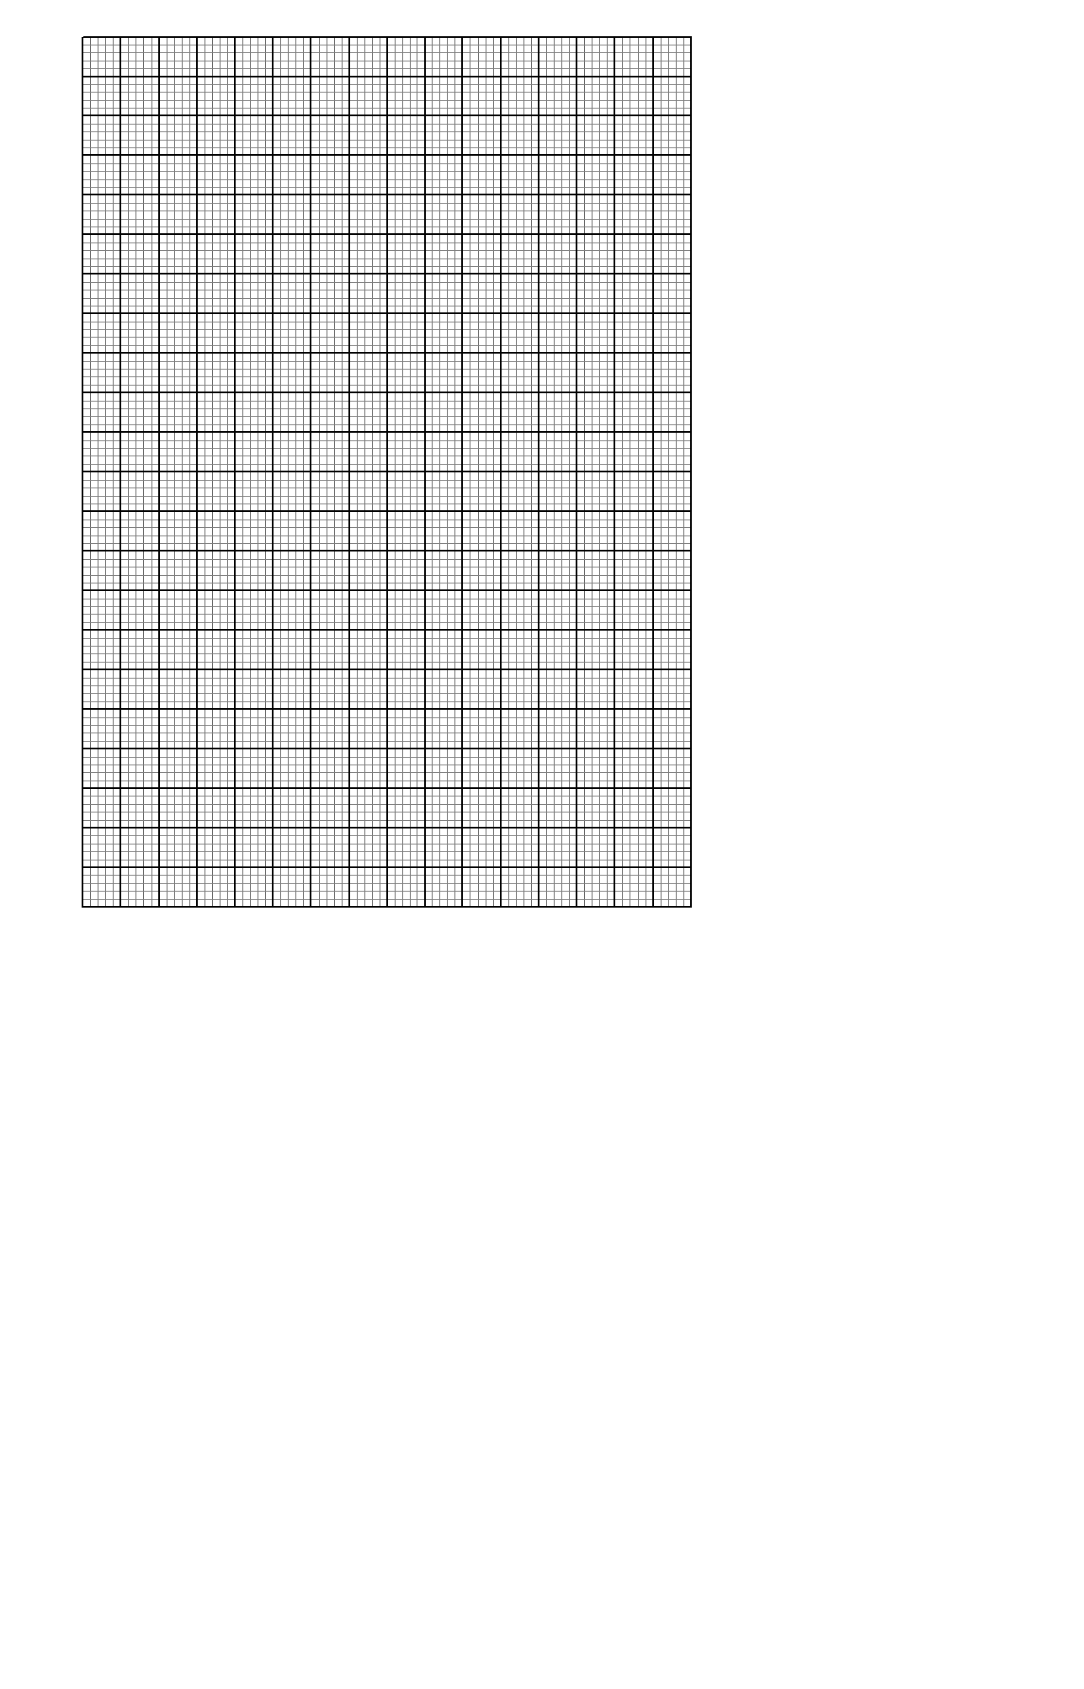

(iv) Use your graph to determine the value of T when I/L = 1.5 m⁻¹ (2mks)

