Name: _____________________________________________ Adm No: ____________Class: _____
Candidate’s Signature: ________________________ Date: __________________________

MATHEMATICS
PAPER 2
FORM THREE
END TERM 2 EXAMINATION
JULY/AUGUST 2025
TIME: 2 ½ HOURS

Instructions to Candidates
1. This paper consists of two sections. Answer all the questions in section 1 and any 5questions in section 2.
2. KNEC mathematical tables and non-programmable calculators may be used when necessary
3. Answer all the questions in the spaces provided.
Section 2 | 1 | 2 | 3 | 4 | 5 | 6 | 7 | 8 | 9 | 10 | 11 | 12 | 13 | 14 | 15 | 16 | Total

Section 2 | 17 | 18 | 19 | 20 | 21 | 22 | 23 | 24 | total
Grand total

SECTION 1
Answer all the questions in this section
1. Evaluate36 –8×–4 –15÷ –3
–3×–3–8(–6+ –2) (3 marks)

2. Simplify a + b – 2a – b
2 3 (3 marks)

3. Find the greatest number which divides 181 and 236 and leaves a remainder of 5 in each case (2 marks)

4. A rectangle measures 20cm by 15cm.If each dimension is increased by 2.5cm, by what percentage is
a) The perimeter of the rectangle increased (2 marks)

b) The area of the rectangle is increased (2 marks)

5. The angle of elevation of the top of a tree from a point P on horizontal ground is 30º. From another point Q 8 metres from the base of the tree, the angle of elevation of the top of the tree is 48º.
a) Calculate to one decimal place the height of the tree. (1 mark)

b) Calculate the distance between P and Q (2 marks)

6. Given that cos θ= –0.8070, find θ for 0≤θ≤720 (3 marks)

7. A piece of wire 40cm is bent to form a right-angled triangle whose hypotenuse is 17cm long. Find the lengths of the other two sides of the triangle (4 marks)

8. Solve for x in log 5–2+log (2x+10) =log(x–4) (3 marks)

9. Solve the quadratic equation by completing of squares giving your answer to 3sf
11x² –13x+3=0 (4 marks)

10. Rationalize the denominator and simplify
4√5+3√2 (4 marks)
2√2–√5

11. A watch which loses a half-minute every hour was set to read the correct time at 0445h on Monday. Determine the time in 12-hour system, the watch will show on the following Friday at 1845h. (3 marks)

12. A tourist from Kenya left for Ethiopia. He exchanged sh 9898 into Ethiopian Birr at the rate of 1 Eth. Birr=ksh7.95. He spent ¾ of the money he got and converted the balance back to Kenyan money at the rate of 1Eth.Birr=ksh7.98 Calculate what he finally got to 2dp (3 marks)
13. Simplify the expression (3 marks)
9t²–25a² 6t²+19at+15a²

14. Given that . (3 marks)

15. A two digit number is such that 4 times the units digit exceeds the tens digit by1. If the digits are reversed, the number formed is decreased by 45. Find the number. (3 marks)

16. A triangular field has dimensions 21m by 52m by 47m.
a) Calculate the area of the field to the nearest m². (2 marks)

b) Calculate the length of a straight ditch dug from the largest angle meeting the opposite side at right angles. (1 mark)

SECTION 2
Answer any 5 questions in this section
17. A bookseller bought a number of cartons of books at a cost of ksh 57600 from Kagumo bookstore. Had he bought the same books from Kerugoya bookstore, it would have cost him ksh 480 less per carton. This would have enabled him to buy 4 extra cartons of books for the same amount of money. By taking x to be the number of cartons of books he actually bought
;a) Write an expression in x
i) For the cost of each carton he bought at Kagumo books (1 mark)

ii) For the cost of each carton had he bought from Kerugoya bookstore? (1 mark)

b) Find the value of x . (6 marks)

c) The bookseller later sold all the books he had bought each carton at ksh. 720 more than he had paid for it. Determine the percentage profit he made. (2 marks)

18. A cylindrical metal bar of diameter 14cm and length 2m is melted and moulded into spherical balls. In the process, 5% by volume of metal is lost and what remains makes balls of radius 3.5cm.
a) Calculate the volume of metal used to make the balls. (3 marks)

b) Find to the nearest whole number the number of balls made (3 marks)

c) Find the total surface area of the metal bar (2 marks)

d) Find the total surface area of the balls made (2 marks)

19. a) Complete the table for the function y = 1 – 2x – 3x2 - 3 ≤ x ≤ 3. (2 marks)
X | -3 | -2 | -1 | 0 | 1 | 2 | 3
-3x² | -27 |  | -3 | 0 |  | -12
-2x |  | 4 |  | 0 |  |  | -6
1 | 1 | 1 | 1 | 1 | 1 | 1 | 1
Y | -20 |  |  | 1 |  | -15

Using the table above, draw the graph of y = 1 – 2x – 3x²(Scale 1 cm represent 0.5 units on x-axis and 1 cm rep 2 units on the y – axis on the grid provided. (4 marks)
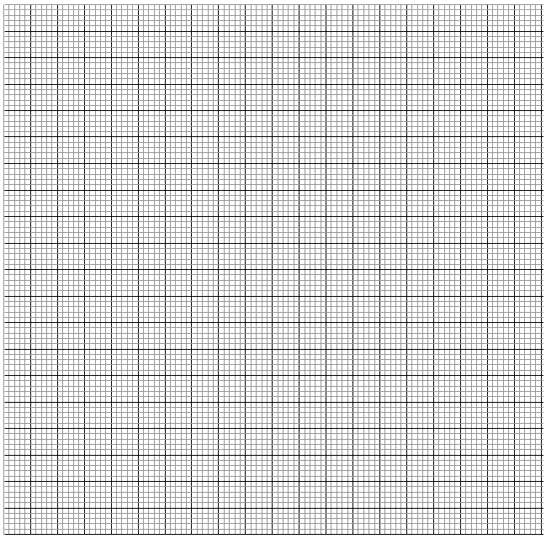

c) Use the graph in (b) above to solve.
(i) 1 – 2x – 3x² = 0 (2 marks)

(ii) 2 – 5x – 3x² = 0 (2 marks)

20. Three business ladies Wanjiku, Muthoni and Njoki decided to buy a lorry. The .marked price of the lorry was 2.8million shillings. The dealer agreed that the ladies could pay a deposit of 60% of the marked price and the rest to be paid within a year. The ladies raised the deposit in the ratio of 3:2:5 respectively. At the end of the year the lorry had realized 2.08million shillings which the three shared in the ratio of their contribution. However, they were required to contribute for the balance of the lorry from these earnings again in the ratio of their original contributions.
a) Calculate amount to be paid as deposit (1 mark)

b) How much did each contribute to pay for the deposit? (3 marks)

c) How much did Njoki receive at the end of the year? (1 mark)

d) Calculate the total amount Muthoni and Njoki contributed to pay for the balance. (3 marks)

e) How much money did Wanjiku remain with after paying her share of the balance? (2 marks)

21.Two tanks are similar in shape. The capacity of the tanks are 1,000,000 litres and
512, 000 litres respectively.
(a) Find the height of the smallest tank if the larger is 300cm tall (4 marks)

(b) Calculate the surface area of the larger tank if the smaller tank has a surface area of
1200m² (3 marks)

(c) Estimate the mass of the smaller tank if the mass of the larger one is 800kg (3 marks)

22 .A piece of wire can be folded into a rectangle whose dimensions are such that its length is 3cm
longer than its width. The area of the rectangle so formed is 28cm².
(a) Determine;
(i) The dimensions of the rectangle. (4 marks)

(ii) Perimeter of the rectangle. (2 marks)

(b) The wire can also be folded into a circle. Taking л = $\frac{22}{7}$, find the radius of the circle
and hence calculate its area. (4 marks)

23. A rectangular sheet of metal which measures 120cm by 0.8m is 1.5mm thick and is made of material whose density is 2.2 g/cm³. From each of the four corners of the rectangle, a square of side 10cm is cut off and the remaining part folded to form an open cuboid.
a) Calculate
i) The capacity of the cuboid in cm³ to the nearest whole number (3 marks)

ii) The mass of the empty cuboid in kg to the nearest whole number (3 marks)

b) The cuboid is filled with a liquid whose density is 0.75g/cm³. Calculate the mass in kg of the cuboid when full of the liquid. (2 marks)

c) Calculate the mass of metal lost in kg. (2 marks)

24. The beginning of the year 2000, Kanyora bought two houses, one in Thika and the other in Nakuru each at 1,240,000. At The value of the house in Thika appreciated at a rate of 12% p.a.
a) Calculate the value of the house in Thika after 9 years to the nearest shilling. (2 Marks)

  - After $n$ years, the value of the house in Thika was 2,741,245 while the value of the house in Nakuru was 2,917,231.
- Find $n$ (4 Marks)

- Find the annual rate of appreciation of the house in Nakuru. (4 Marks)

