Name: _____________________________________________ Adm No: ____________Class: _____
Candidate’s Signature: ________________________ Date: __________________________

MATHEMATICS
FORM 3
PAPER 1
END TERM 2 EXAMINATION
JULY/AUGUST 2025
Time: 2 ½ HOURS

Instructions to Candidates
- Write your name and admission number in the spaces provided at the top of this page.
- This paper consists of two sections: Section A and Section B
- Answer All Questions In Section A And 5 Questions In Section B
- Show all the steps in your calculations, giving your answers at each stage in the spaces below each question.
- Marks may be given for correct working even if the answer is wrong.
- KNEC Mathematical tables may be used.
For Examiner’s Use Only
1 | 2 | 3 | 4 | 5 | 6 | 7 | 8 | 9 | 10 | 11 | 12 | 13 | 14 | 15 | 16 | Total

17 | 18 | 19 | 20 | 21 | 22 | 23 | 24
Grand
Total

SECTION A (50 MARKS)

- Without using calculators and mathematical tables find the value of
$\frac{0.08×0.05×124×0.5}{200×0.8×25}$ 3mks

- Three bells rings at intervals of 30mins,40mins and 45mins. If they ring together at 9.30AM. Find the time they will ring again together 3mks

- A line A passes through points D (2,3) and F (5,8). Find the equation of the line perpendicular to line A at point F 3 mks

- The lengths of two similar cubes A and B are 4cm and 6 cm respectively. If the volume of the smaller cube 200cm³ find the volume of the larger one in M³ 3mks

- Convert the following into degrees. 4mks
- 2.36^{c}

- 0.456^{c}

- Point A is (2,4) and point B (-3,-6). Find the length of line AB in two decimal places. 3mks

- Solve the following simultaneous equations using matrix method 4mks
2n+3m=12
4m-2n=5.

- The scale drawing of a map is 1:200,000. Find the actual area of a desert of 120cm² in KM^{2.} 2mks

- Given that a=3.0 ,b=4.24 and c= 3.654, find the percentage error of 3mks
$\frac{a+b}{c+a}$

- Simplify the following without using the calculators or mathematical tables
Log ₂8+2log₂16 - 3 - log₂256+ 2 3mks

- The circle below whose area is 18.05cm² circumscribes triangle ABC where AB=6.3cm,BC=5.7 and AC=4.2cm. find the area of the shaded region 4mks

- Solve the following simultaneous equations 4mks
xy = 4
x + y = 5

- Solve for the value of x given that 2^{2x}-18 × 2^{x} =40 3mks

- Oketch sells his car to Jane at a profit of 20%. Then Jane sells the same car to Issack at 180,000 shillings making a loss of 10%. Determine the price which Oketch had bought the car 3mks

- Given that sin θ=$\frac{2}{3}$ find the value of tan θ and cos θ without using calculators and mathematical tables. 3mks

- A regular polygon is such that its exterior angle is one eighth the size of interior angle. find the number of sides of the polygon 3mks

- Solve the following inequalities and state the integral values 3mks
2x- 2≤3x+ 1<x+11

SECTION B (50 MARKS)

- The table shows the heights of seedlings in a Nursery bed.
Height in cm | 10-19 | 20-29 | 30-39 | 40-49 | 50-59
Frequency | 10 | 19 | 16 | 12 | 3

- Calculate the mean 3mks

- The median of the data 3 mks

- Draw a frequency polygon for the above data 4mks

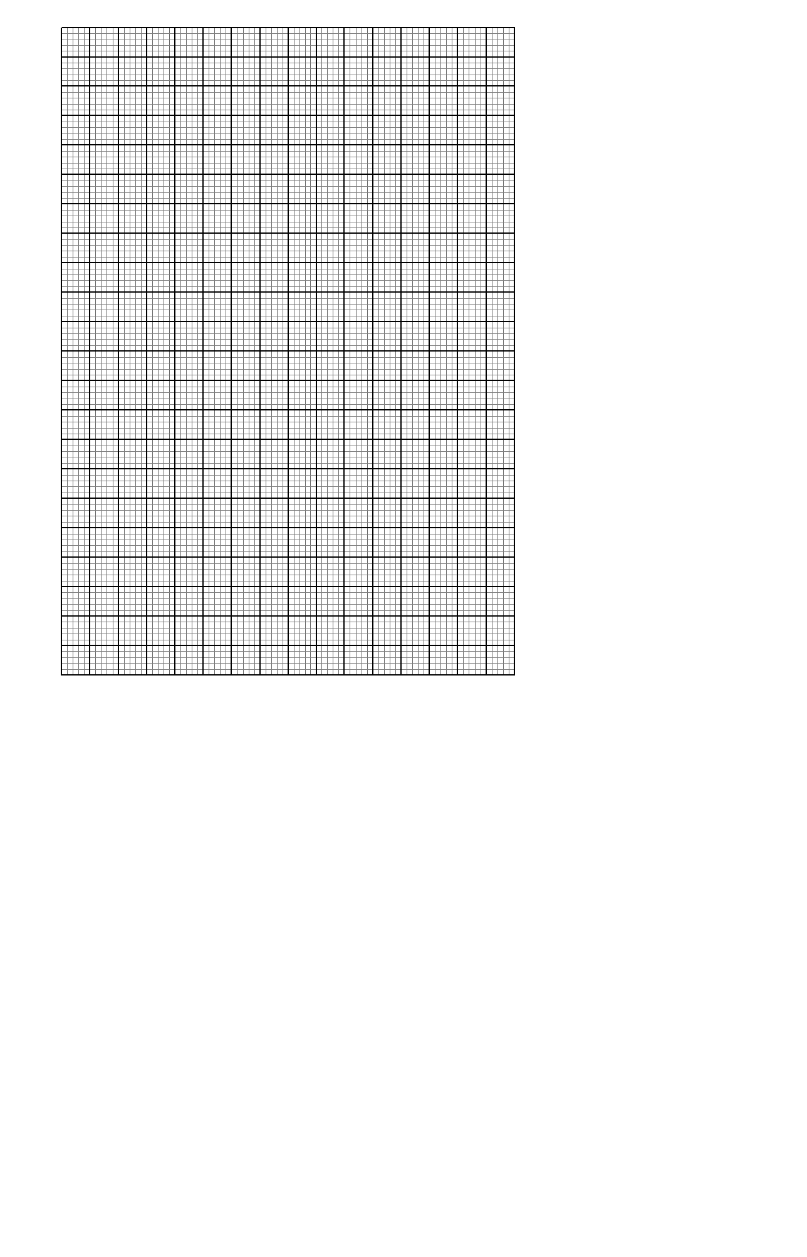

- A bucket in form of a frustrum has the upper radius as 21cm and the bottom radius as 14cm. if the slanted height of the bucket is $√149$, find
- The vertical height of the bucket 2mks

- The surface area of the material used to make the bucket. 4 mks

- The capacity of the bucket 4mks

- The vertices of a triangle ABC are gives as A (2,1), B (5,2) and C (4,6). On the graph provided,
- Draw the triangle ABC 2mks
- Draw the image A’B’C’ triangle ABC under reflection on the line y=-x and state its coordinates 4mks
- The triangle A’’B’’C’’ is the image of ABC under rotation +90ᴼ through center Q(0,-2). draw the image and state its coordinates 4mks

- Kiarie’s plot measures 200m by 100m. if it’s similar to that of Kamau, which has a length of 400m. Find
- The area of Kamau’s plot in hectares 4mks

- The total number of posts Kamau needs to fence the plot at an interval of 2m. 3mks

- Total cost he used on fencing if one post costs 200 shillings and two rolls of barbed wire if each role costs 800 shillings. 3mks

- Star boys uses 12,000 litres of water daily. $1/3$ is used for cooking,$1/{5 }$for washing, and $2/3$ 0f the remainder for drinking, find in litres the amount of water used for
- Drinking 3mks

- On a certain day the tank leaked out $1/8$ of the water. The remain water was shared in in the ratio 3:4:1 for cooking, washing and drinking respectively. Find the volume of water used for washing. 4mks

- If one litre costs 12.50 shillings calculate the total cost of cooking water for the month of April. 3mks

- A straight line L₁ has a gradient of - $\frac{1}{2}$ and passes through points P (-1,3). Another line L₂ passes though point Q (1, -3) and R (4,5). Find
- The equation 0f line L₁ 2mks

- The gradient of L₂ 1mks

- Equation of L₂ 2mks

- The equation of a line passing through point S(0,5) and perpendicular to L₂ 3mks

- The equation of line through R parallel to L₁ 2mks

- A leaves town X from town Y a distance of 120km at an average speed of 70km/hr. at 8.00am. At the same time a bus leaves town Y for X at an average speed of 50km/hr. at 8:15 am a cyclist leaves town Y for X at an average speed of 30km/hr.
- Calculate the time when the bus meets the car 3mks

- Calculate the distance between the car and the bus by the time the cyclist meets the car 4mks

- If the bus upon reaching town X rests for 10 minutes, then starts its journey back to Y calculate how far from X the bus meets the cyclist 3mks

