NAME…………………………………………………….CLASS…………………..ADM……………
CANDIDATE’S SIGNATURE………………………………….DATE……………………

END TERM 2 EXAMINATION
JULY/AUGUST 2025
312/2
GEOGRAPHY PAPER TWO
FORM THREE
TIME: 2 HOURS 45 MINUTES.
INSTRUCTIONS TO CANDIDATES
- This paper has two sections: A and B
- Answer all the questions in both section A and B.
- All the answers must be written on the foolscaps provided.
- Candidates must answer the questions in English.

FOR EXAMINER’S USE ONLY
Section | Questions | Maximum  Score | Candidate’s  Score
A | 1-5 | 25
B | 6 | 25
B |  | 25
B |  | 25
Total Score

This paper consists of 4 printed pages. Candidates should check the question paper to ascertain that all pages are printed as indicated and that no questions/pages are missing.

SECTION A

- (a) Distinguish between human and physical Geography. (2marks)

(b) Explain how Geography and Economics are related. (2marks)

- (a) List three main categories of natural forest. (3marks)

(b) State four factors favouring the exploitation of softwood forest in Canada.
(4marks)

- (a) Define the term aerial photograph. (2marks)

(b) State three characteristics of ground oblique photographs. (3marks)

- (a) Give three examples of minerals that occur as beds and seams. (3marks)

(b) State three ways in which mining contributes to pollution. (3marks)

- (a) The diagram below shows shaft mining. Use it to answer the following questions;
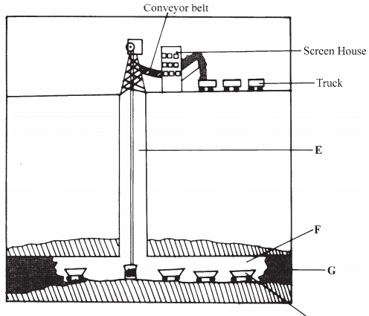

- Name the parts marked E, F and G. (3marks)

SECTION B
(ANSWER ALL THE QUESTIONS IN THIS SECTION)
- The table below shows the total number of dairy cattle reared in Kenya Highlands in the years 2021 and 2022. Use it to answer the following questions;

Type of dairy cattle | 2021 | 2022
Friesian | 942000 | 965000
Ayrshire | 120000 | 154000
Jersey | 97000 | 128000
Guernsey | 94000 | 103000
Simmental | 19000 | 24000
Sahiwal | 29000 | 41000
TOTAL

- State the type of dairy cattle with the highest increase between 2021 and 2022. (1mark)

- Calculate the percentage increase of Friesian cattle between 2021 and 2022. (2marks)

- Calculate the difference in the total number of dairy cattle reared in Kenyan Highlands between years 2021 and 2022. (2marks)

- Draw a divided rectangle 15cm long to represent the data above for the year 2021. (11marks)

- State four advantages of using divided rectangle to represent geographical data. (4marks)

- Apart from simple divided rectangle, give two other statistical methods that can be used to represent data above. (2marks)

- State three conclusions that can be derived from the rectangle drawn in (d) above. (3 marks)

- (a) (i) What is forestry? (2marks)

(ii) Name three examples of secondary forest products. (3marks)

(b) Explain how the following factors have influenced distribution of natural forest.
(i) Climate. (2marks)
(ii) Human activities. (2marks)
(iii) Aspect. (2marks)

(c) Compare forestry in Kenya and Canada under the following sub-headings.
- Maturity of trees. (2marks)
- Mode of exploitation. (2marks)
- Tree species. (2marks)

(d) Explain four factors that limit the exploitation of tropical rainforest in Africa. (8marks)
- (a) Define the term alluvial mining. (2marks)

(b) (i) Name three areas where diamond is mined in South Africa. (3marks)

(ii) Explain the stages involved in processing of gold in South Africa. (6marks)

(iii) Explain four problems facing gold mining in South Africa. (8marks)

(c) Explain three contributions of petroleum production in the Middle East countries.(6marks)

