Name: _____________________________________________ Adm No: ____________Class: _____
Candidate’s Signature: ________________________ Date: __________________________

COMPUTER STUDIES
FORM 3
PAPER 1
END TERM 2 EXAMINATION
JULY/AUGUST 2025
Time: 2 ½ HOURS

Instructions to Candidates
- Write your name and index number in the spaces provided above.
- This Paper consists of two sections A and B.
- Answer ALL the questions in section A.
- Answer question 16 (compulsory) and any other THREE questions from section B.
- All answers should be written in the spaces provided.
- This paper consists of 12 printed pages. Candidates should check to ensure that all pages are printed as indicated and no questions are missing

FOR EXAMINER’S USE ONLY
Section | Questions | Candidate’s score
A | - 15
B | 16
B | 17
B | 18
B | 19
B | 20
B | TOTAL SCORE

SECTION A: Answer All the Questions in this section in the spaces provided (40MARKS)

- a) Distinguish between optical and magnetic scanners (2marks)
………………………………………………………………………………………………………………………………………………………………………………………………………………………………………………………………………………………………………………………………………………
b) Differentiate between hardware and software portability (2marks)
………………………………………………………………………………………………………………………………………………………………………………………………………………………………………………………………………………………………………………………………………………
- a) Name two special purpose memories found either inside or outside the microprocessor (2marks)
………………………………………………………………………………………………………………………………………………………………………………………………………………………………………………………………………………………………………………………………………………
b) Distinguish between an accumulator and an address register (2marks)
………………………………………………………………………………………………………………………………………………………………………………………………………………………………………………………………………………………………………………………………………………
- Differentiate between formatting and editing as used in word processor (2marks)
……………………………………………………………………………………………………………………………………………………………………………………………………………………………………………………………………………………………………………………………………………
- State four functions of operating system (2marks)
………………………………………………………………………………………………………………………………………………………………………………………………………………………………………………………………………………………………………………………………………………
- a) Identify the type of interfacing cables represented give an example of device that uses it in
Figure 1 and 2 (2marks)

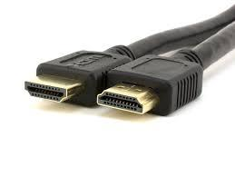  Figure 1 | 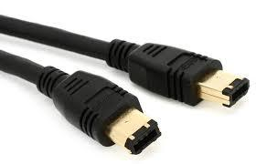  Figure 2
………………………………………………………………………………………………………………………………………………………………………………………………………………………………………………………………………………………………………………………………………………

- Mention TWO emerging issues that affects the use internet (2marks)
………………………………………………………………………………………………………………………………………………………………………………………………………………………………………………………………………………………………………………………………………………
- Name four tools in Word processor that would help a user to minimize spelling mistakes when creating a document (2marks)
………………………………………………………………………………………………………………………………………………………………………………………………………………………………………………………………………………………………………………………………………………
- Describe two methods used to secure data in a database (2marks)
………………………………………………………………………………………………………………………………………………………………………………………………………………………………………………………………………………………………………………………………………………
- Explain the meaning of the following terms as used with DTP (4marks)
- Crop
………………………………………………………………………………………………………………………………………………………………………………………………………………………………
- Embedded object
………………………………………………………………………………………………………………………………………………………………………………………………………………………………
- Master page
………………………………………………………………………………………………………………………………………………………………………………………………………………………………
- Tool box
………………………………………………………………………………………………………………………………………………………………………………………………………………………………
- Make a clear difference between a website and web portal (2marks)
………………………………………………………………………………………………………………………………………………………………………………………………………………………………………………………………………………………………………………………………………………
- a) What is a protocol (1mark)
………………………………………………………………………………………………………………………………………………………………………………………………………………………………
b) Write the following in full (2marks)
- TCP/IP
………………………………………………………………………………………………………………………………………………………………………………………………………………………………
- HTML
………………………………………………………………………………………………………………………………………………………………………………………………………………………………

- HTTP
………………………………………………………………………………………………………………………………………………………………………………………………………………………………
- FTP
………………………………………………………………………………………………………………………………………………………………………………………………………………………………
- Explain the following as used in data security (3marks)
- Fraud
………………………………………………………………………………………………………………………………………………………………………………………………………………………………
- Eavesdropping
………………………………………………………………………………………………………………
………………………………………………………………………………………………………………
- Information security
………………………………………………………………………………………………………………
………………………………………………………………………………………………………………
- State four stages in data processing (2marks)
………………………………………………………………………………………………………………………………………………………………………………………………………………………………………………………………………………………………………………………………………………
………………………………………………………………………………………………………………
- Describe three electrical safety precaution rules that should be observed in a computer room(3marks)
………………………………………………………………………………………………………………………………………………………………………………………………………………………………………………………………………………………………………………………………………………

- a) What is a speech input (1mark)
………………………………………………………………………………………………………………………………………………………………………………………………………………………………
b) State two disadvantages of using this method of data input (1mark)
………………………………………………………………………………………………………………………………………………………………………………………………………………………………
- Name two solid state storage devices (1mark)
………………………………………………………………………………………………………………
………………………………………………………………………………………………………………
SECTION B (60MARKS)
Answer question 16 (compulsory) and any other THREE question from this section
- Use the Spreadsheet below to answer the questions that follows
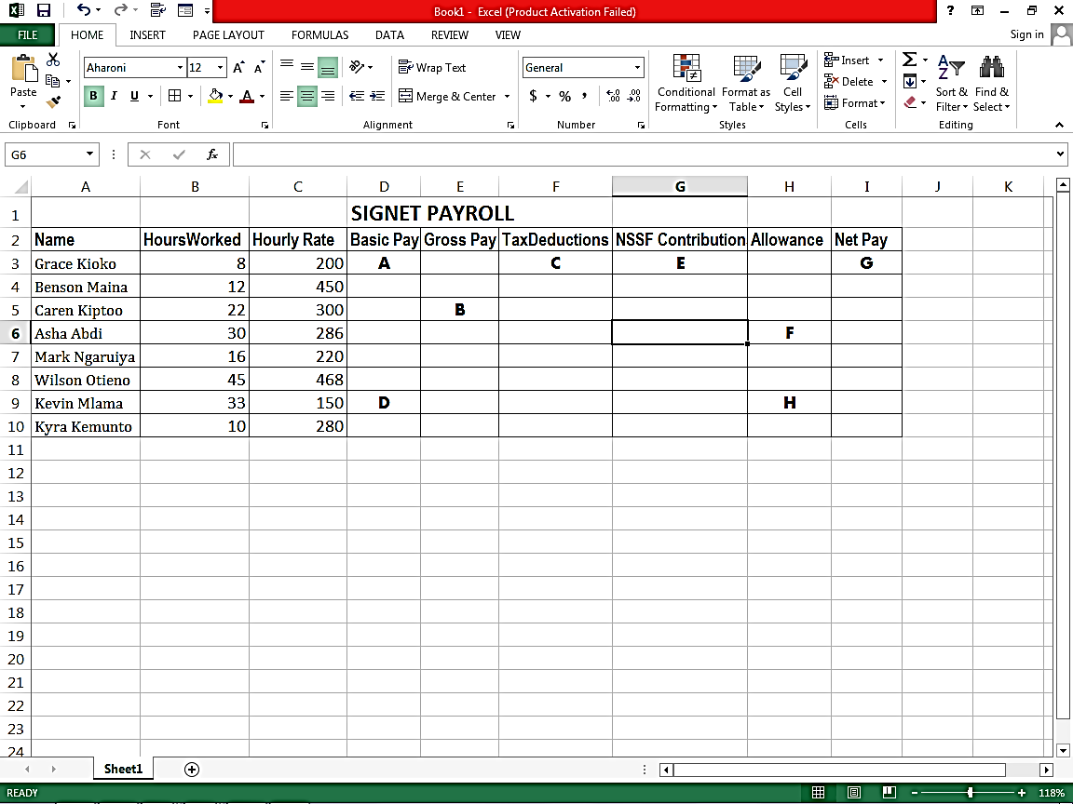

Additional information
(i)Basic pay = Hours worked x Hourly rate.
(ii)Allowances are allocated at 10% of the Basic pay.
(iii)Gross pay = Basic pay + Allowances.
(iv)Tax deduction is calculated at 20% of the Gross pay.

- Identify two data types used to represent data in the worksheet above (2mark)
- State how cell E7 will be presented using R1C1 style (1mark)
……………………………………………………………………………………………………………………………………………………………………………………………………………………………………
- Identify the active cell in the worksheet (1mark)
……………………………………………………………………………………………………………………………………………………………………………………………………………………………………
- Write down the formula used to calculate in the following cells (1mark each)
- A: …………………………………………………………………………………………………
- B …………………………………………………………………………………………………
- C …………………………………………………………………………………………………
- D …………………………………………………………………………………………………
- E …………………………………………………………………………………………………
- F …………………………………………………………………………………………………
- G …………………………………………………………………………………………………
- H …………………………………………………………………………………………………
- Highlight three differences between an electronic spreadsheet and a manual spreadsheet (3marks)
……………………………………………………………………………………………………………………………………………………………………………………………………………………………………
……………………………………………………………………………………………………………………………………………………………………………………………………………………………………
- a) Write the following acronyms in full
- EBCDIC (1mark)
………………………………………………………………………………………………………………………………………………………………………………………………………………………………
- ASCII (1mark)
………………………………………………………………………………………………………………………………………………………………………………………………………………………………
- Explain why computes use binary numbers in data representation (2marks)
………………………………………………………………………………………………………………………………………………………………………………………………………………………………………………………………………………………………………………………………………………
- Convert the following values to the stated number system
- 20.2₁₆ to denary (2marks)
………………………………………………………………………………………………………………………………………………………………………………………………………………………………………………………………………………………………………………………………………………………………………………………………………………………………………………………………
………………………………………………………………………………………………………………………………………………………………………………………………………………………………

- 7.125₁₀ to base 2 (2marks)
………………………………………………………………………………………………………………………………………………………………………………………………………………………………………………………………………………………………………………………………………………………………………………………………………………………………………………………………
………………………………………………………………………………………………………………………………………………………………………………………………………………………………
- Perform the following binary arithmetic
- 11100111₂ + 00101110₂ (1.5mark)
………………………………………………………………………………………………………………………………………………………………………………………………………………………………………………………………………………………………………………………………………………
………………………………………………………………………………………………………………………………………………………………………………………………………………………………
- 10101₂-110₂ (1.5mark)
………………………………………………………………………………………………………………………………………………………………………………………………………………………………………………………………………………………………………………………………………………
………………………………………………………………………………………………………………………………………………………………………………………………………………………………

- Use Two’s compliment to subtract 101₂ from 1000₂ (2marks)
………………………………………………………………………………………………………………………………………………………………………………………………………………………………………………………………………………………………………………………………………………
………………………………………………………………………………………………………………………………………………………………………………………………………………………………………………………………………………………………………………………………………………………………………………………………………………………………………………………………
- Convert 57.4₁₀ to its octal equivalent (2marks)
………………………………………………………………………………………………………………………………………………………………………………………………………………………………………………………………………………………………………………………………………………………………………………………………………………………………………………………………………………………………………………………………………………………………………………

- a) Describe each of the following data processing methods and give an example of where used. (3marks)
- Online processing
………………………………………………………………………………………………………………………………………………………………………………………………………………………………………………………………………………………………………………………………………………

- Batch processing
………………………………………………………………………………………………………………………………………………………………………………………………………………………………………………………………………………………………………………………………………………
- Real time
………………………………………………………………………………………………………………………………………………………………………………………………………………………………………………………………………………………………………………………………………………
b) Make a clear difference between (6marks)
- Logical file and physical file
………………………………………………………………………………………………………………………………………………………………………………………………………………………………………………………………………………………………………………………………………………
- Master file and back up file
………………………………………………………………………………………………………………………………………………………………………………………………………………………………………………………………………………………………………………………………………………
- Random and indexed sequential file organization methods
………………………………………………………………………………………………………………………………………………………………………………………………………………………………………………………………………………………………………………………………………………
- An organization is facing threats to data integrity. Explain three ways on of how the threats can be
minimized (3marks)
………………………………………………………………………………………………………………………………………………………………………………………………………………………………………………………………………………………………………………………………………………
………………………………………………………………………………………………………………
- Highlight three disadvantages of serial file organization (3marks)
………………………………………………………………………………………………………………………………………………………………………………………………………………………………………………………………………………………………………………………………

- a) One of the functions of an operating system is job scheduling. Explain what is meant by job scheduling (2marks)
………………………………………………………………………………………………………………………………………………………………………………………………………………………………………………………………………………………………………………………………………………

b) Recently on Kenya went on election in which the results were to be transmitted Electronically using mobile phones from all polling stations to the main server. But the system (server) failed to work.
- Give two security threats that the system was prone to (2marks)
………………………………………………………………………………………………………………………………………………………………………………………………………………………………………………………………………………………………………………………………………………
- State control measures that the IEBC should take in future to ensure and safe tallying of votes (2marks)
………………………………………………………………………………………………………………………………………………………………………………………………………………………………………………………………………………………………………………………………………………
- The principal of Chebloch primary school wants to acquire a new operating system for his computer. Advise him stating the 2 advantages of graphical user interface over command line interface. (2marks)
………………………………………………………………………………………………………………………………………………………………………………………………………………………………………………………………………………………………………………………………………………
d) Explain the meaning of the following terms used in data processing (6marks)
- Truncated
………………………………………………………………………………………………………………………………………………………………………………………………………………………………
- Transposition
………………………………………………………………………………………………………………………………………………………………………………………………………………………………
- Transcription
………………………………………………………………………………………………………………………………………………………………………………………………………………………………………………………………………………………………………………………………………………
e) Explain why the processor of a micro computer is referred to as micro processor. (1mark)
………………………………………………………………………………………………………………………………………………………………………………………………………………………………………………………………………………………………………………………………………………

20. a) List and explain the functions of each computer bus (6marks)
………………………………………………………………………………………………………………………………………………………………………………………………………………………………………………………………………………………………………………………………………………………………………………………………………………………………………………………………………………………………………………………………………………………………………………………………………………………………………………………………………………………………………………………………………………………………………………………………………………………………………………………………………………………………………………………………………………………………………………………………………………………………………………
b) The formula = &B2 + C&4 is entered in cell C5 and then copied to D10. Write down the formula as it appears in the destination cell (2marks)
………………………………………………………………………………………………………………………………………………………………………………………………………………………………………………………………………………………………………………………………………………………………………………………………………………………………………………………………………………………………………………………………………………………………………………
c) Give two reasons why smaller computers like laptops tend to be more expensive than desktop
computer (2marks)
………………………………………………………………………………………………………………………………………………………………………………………………………………………………………………………………………………………………………………………………………………
d) Define the term program documentation (1mark)
………………………………………………………………………………………………………………………………………………………………………………………………………………………………………………………………………………………………………………………………………………
e) Briefly explain the terms parallel running and direct changeover as used in system implementation
(2marks)
………………………………………………………………………………………………………………………………………………………………………………………………………………………………………………………………………………………………………………………………………………
f) Differentiate between a primary key and a foreign key as used in designing a database (2marks)
………………………………………………………………………………………………………………………………………………………………………………………………………………………………………………………………………………………………………………………………………………

