Name: _____________________________________________ Adm No: ____________Class: _____
Candidate’s Signature: ________________________ Date: __________________________

CHEMISTRY
FORM 3
PAPER 2
END TERM 2 EXAMINATION
JULY/AUGUST 2025
Time: 2 HOURS

Instructions to Candidates
- Write your name and index number in the spaces provided above
- Answer ALL the questions in the spaces provided
- Mathematical tables and electronic calculations may be used
- All working must be clearly shown where necessary
FOR EXAMINER’S USE ONLY:

Questions | Max. Score | Candidates Score
1
2
3
4
5
6
7
8
TOTAL SCORE | 80

1. (a) Study the following part of periodic table chart and use it to answer the questions that
follow. The letters are not the actual symbols of the elements.

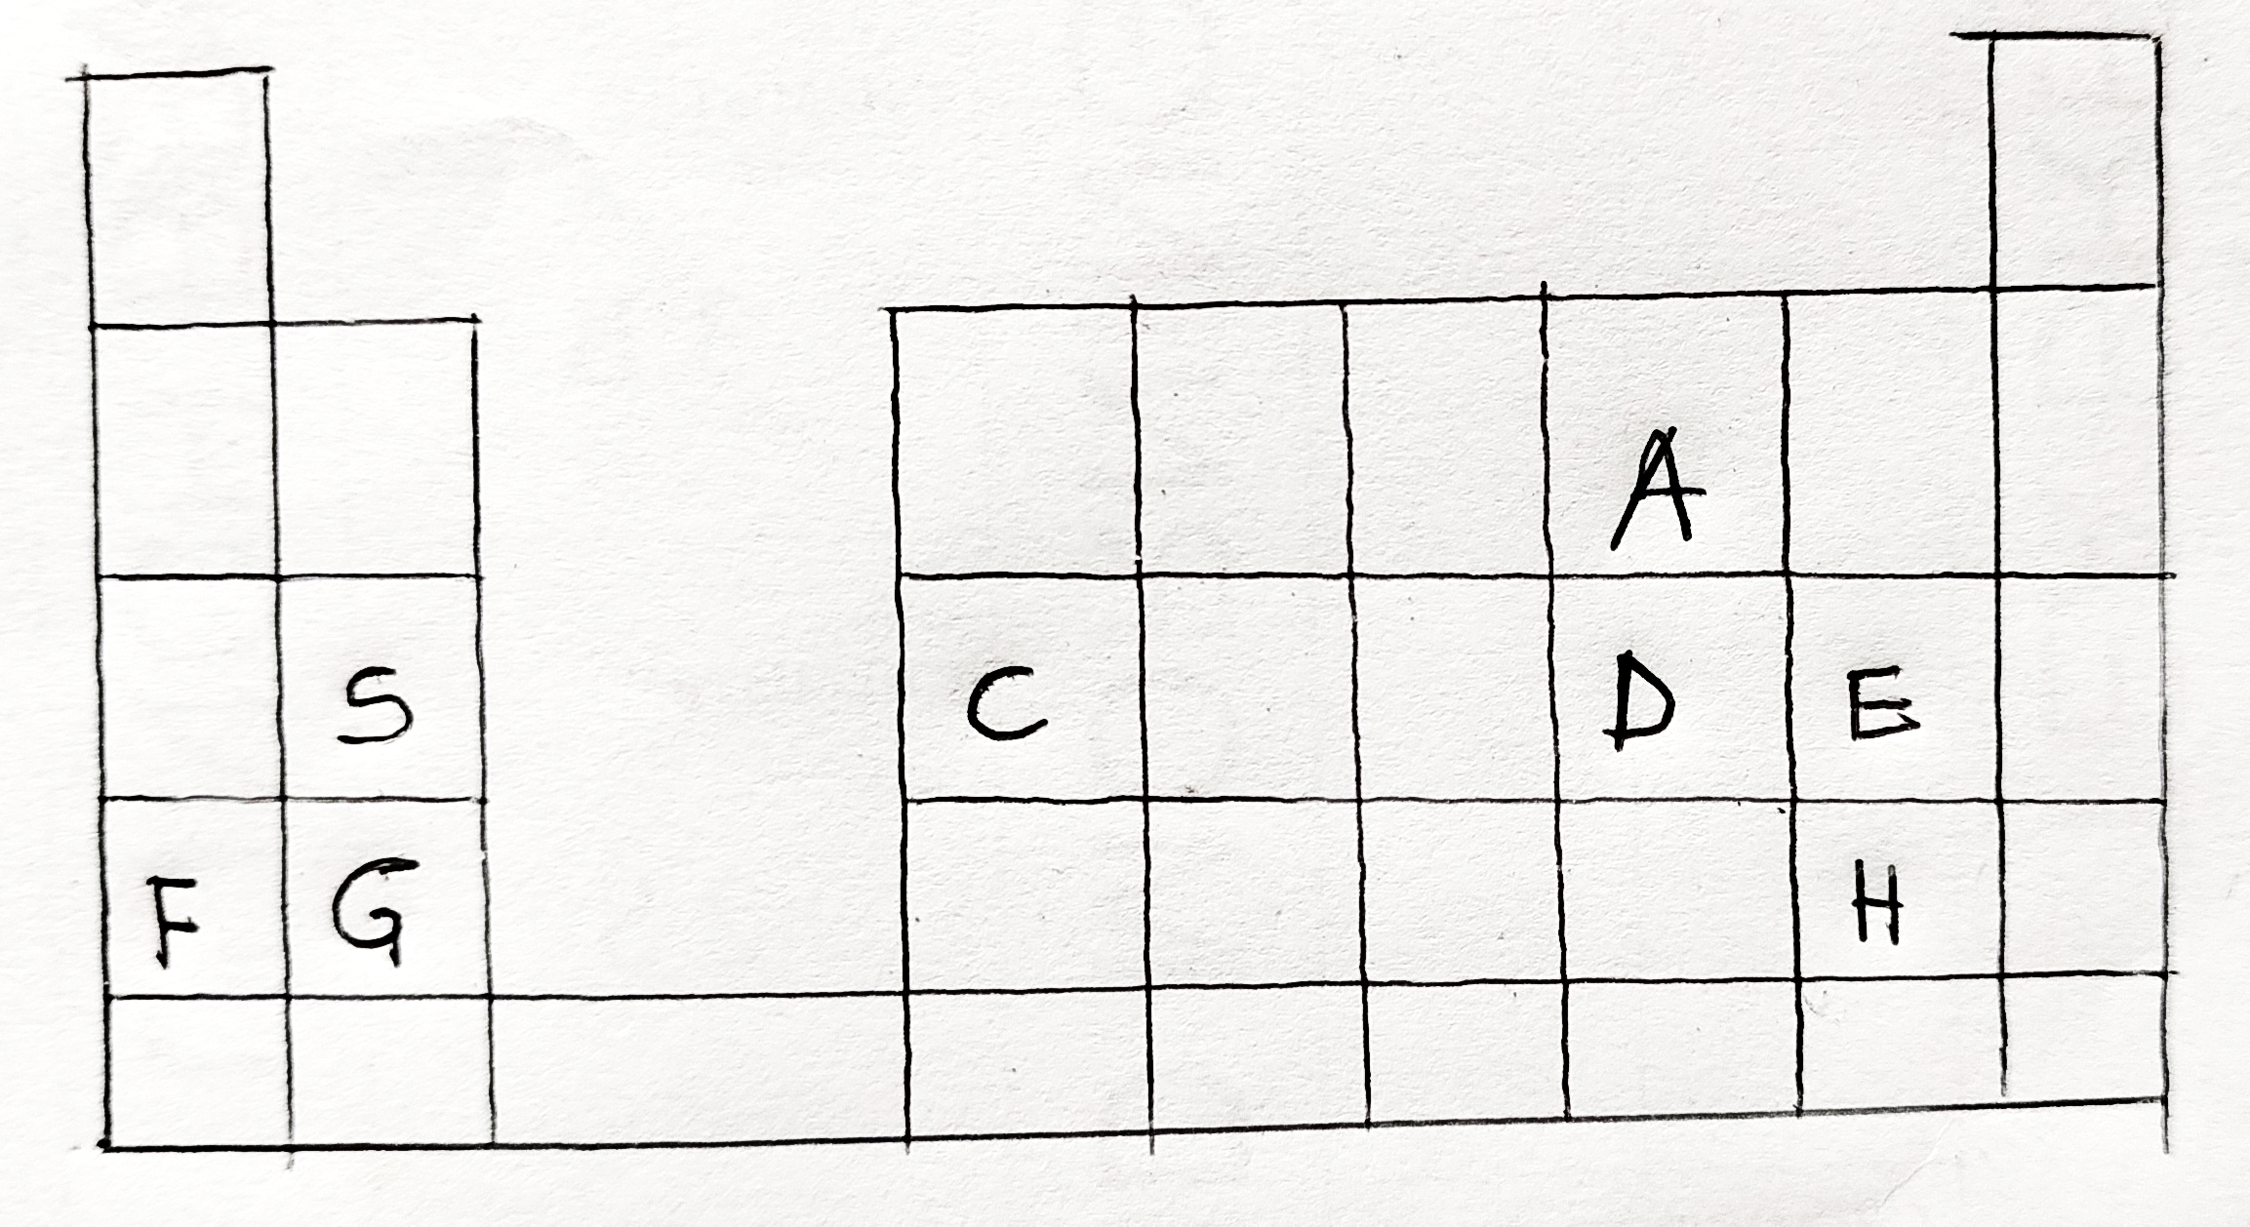

- Which elements form ions with charge of -2?Explain (2marks)

- If the oxides of B and D are separately dissolved in water, what effect will their aqueous solution have on litmus. (2marks)

- How would you expect the ionic reactions of C and E to compare? Explain (2marks)

- Write the formula of the compounds formed between elements G and H (1mark)

- In terms of structure and bonding, explain why the oxide of D has a lower melting point than the oxides of B. (2marks)

- Write an equation to show the action of heat on the carbonates with element G (1mark)

(b) When 1.5litres of chlorine gas were completely reacted with element B 5.937g of the product were formed. Determine the relative atomic mass of element B. (Atomic mass of chlorine = 35.5 Molar gas volume = 24litres) (3marks)

2.The scheme below shows the manufacture of sodium carbonate by the Solvay process. Study it and use it to answer the questions that follow.
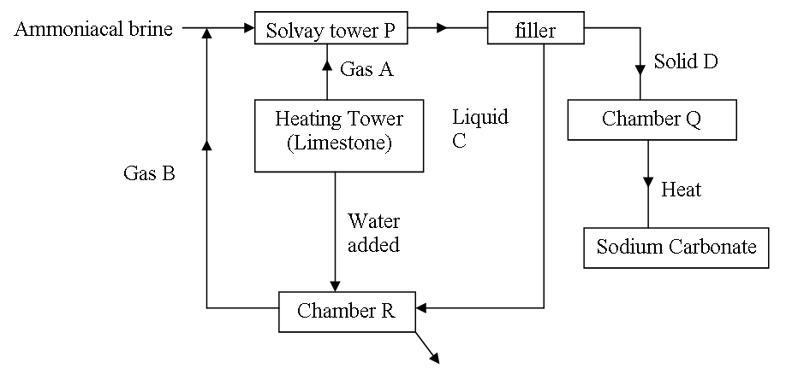
(a) Name gases A and B (1mark)

(b) Name liquid C and Solid D (1mark)

(c) Write equations for the reactions taking place in tower P and chamber R (2marks)

(d) Name the product formed in chamber at chamber R and give one of its uses (2marks)

(c) State three uses of sodium carbonate (2marks)

3. A student left some crushed fruit mixture with water for some days. He found the mixture
had fermented. He concluded that the mixture was contaminated with water and ethanol with boiling point of 100ºC and 78ºC respectively. The set-up of apparatus below are used to separate the mixture.

A
Thermometer
B
Mixture
Conical
flask
Distillate
Apparatus W

(i) Name the piece of apparatus labelled W (1mark)

(ii) What is the purpose of the thermometer in the set-up? (1mark)

iii) At which end of the apparatus W should tap water be connected? (1mark)

(iv) Which liquid was collected as the first distillate? Explain (2mark)

(v) What is the name given to the above method of separating mixture? (1mark)

vi)State two applications of the above method of separating mixtures (1mark)

(vi) What properties of the mixture make it possible for the component to be separated
by the above methods? (2mark)

- (a) The set up below demonstrates the oxidation of copper to an oxide of copper by nitrogen(I)oxide. Study the diagram and the data below it to answer the questions that follow.
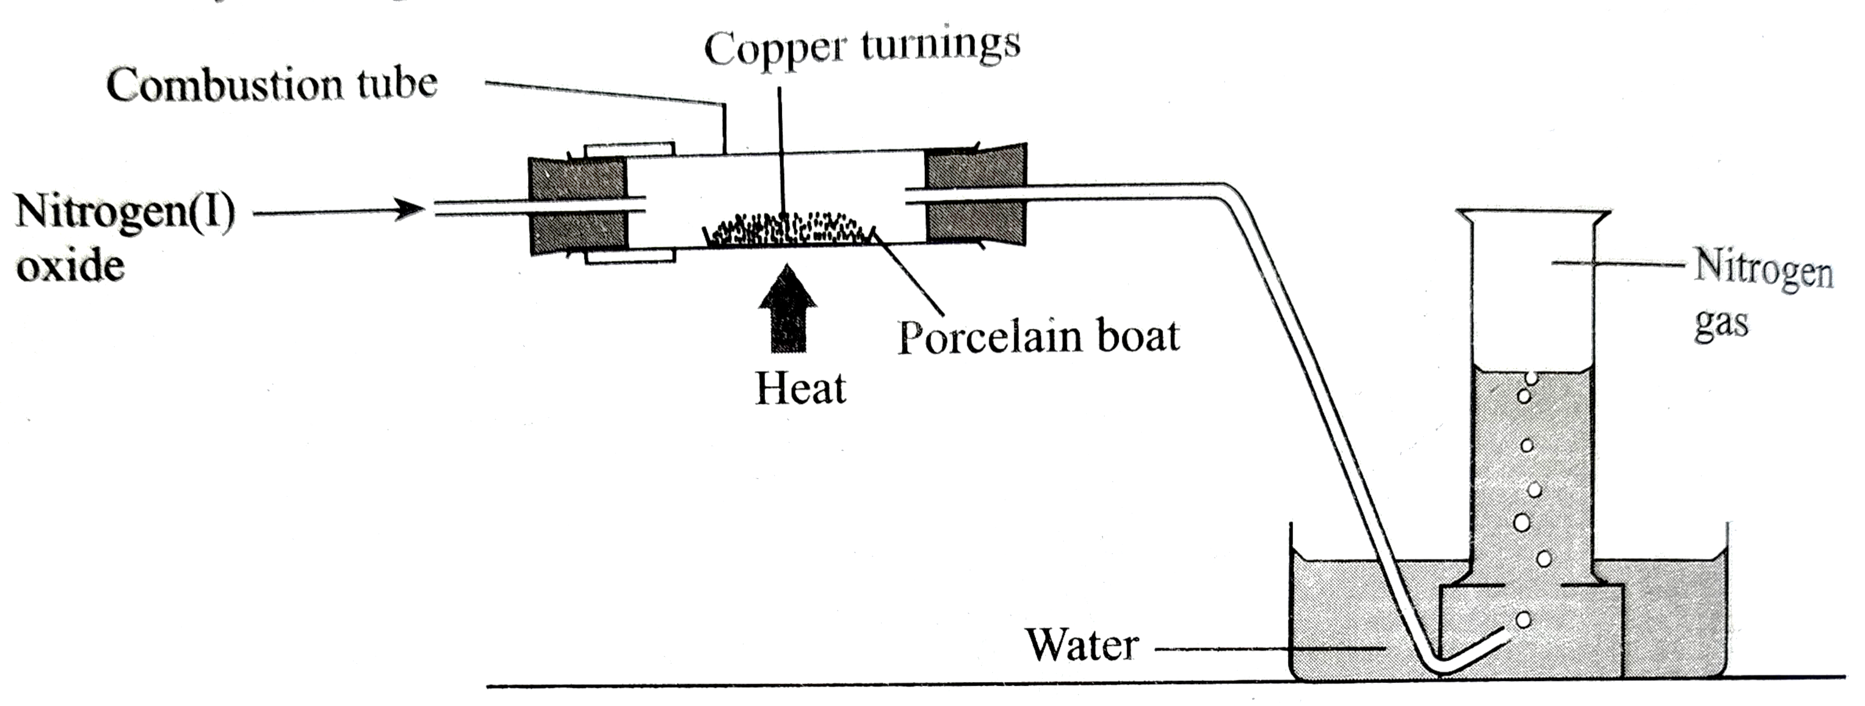

Mass of porcelain boat=14.6g
Mass of boat+copper turnings =24.2g
Mass of boat+oxide of copper=26.6g

- Determine the formula of the oxide of copper. (3marks)

- Write an equation for the reaction that occurred in the boat. (1mark)

- Calculate the volume of nitrogen formed at r.t.p. (3marks)

(b) when 5.025g hydrated sodium carbonate were reacted with excess hydrochloric acid,450cm³ carbon(iv)oxide were produced at r.t.p. calculate the number of moles of water of crystallization in one mole of the salt. (3marks)

5. a) The set-up below was used by a form three student to prepare a dry sample of gas M. Study
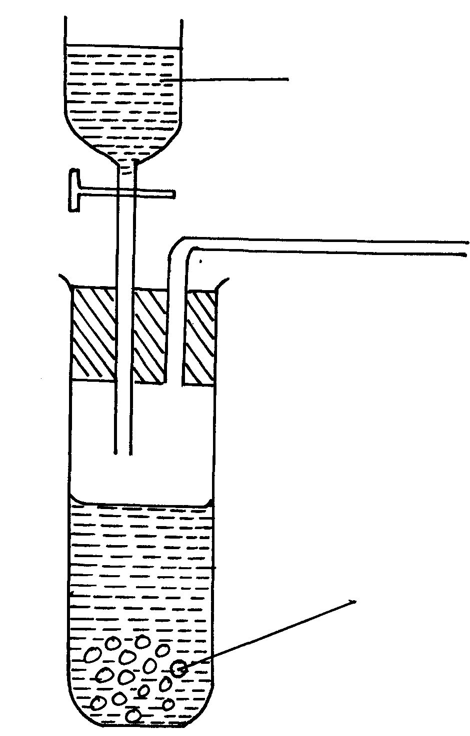
it and use it to answer the questions that follow:-
Zn_{(s)}
Dilute. HCl

- Complete the diagram to show how a dry sample of gas M can be collected (3marks)

(ii) State the identity of gas M (1mark)

iii) state two industrial uses of gas M.(2marks)

b) What property of concentrated Sulphuric acid is being employed in the above preparation? (1mark) The set-up below was used to investigate the properties of hydrogen
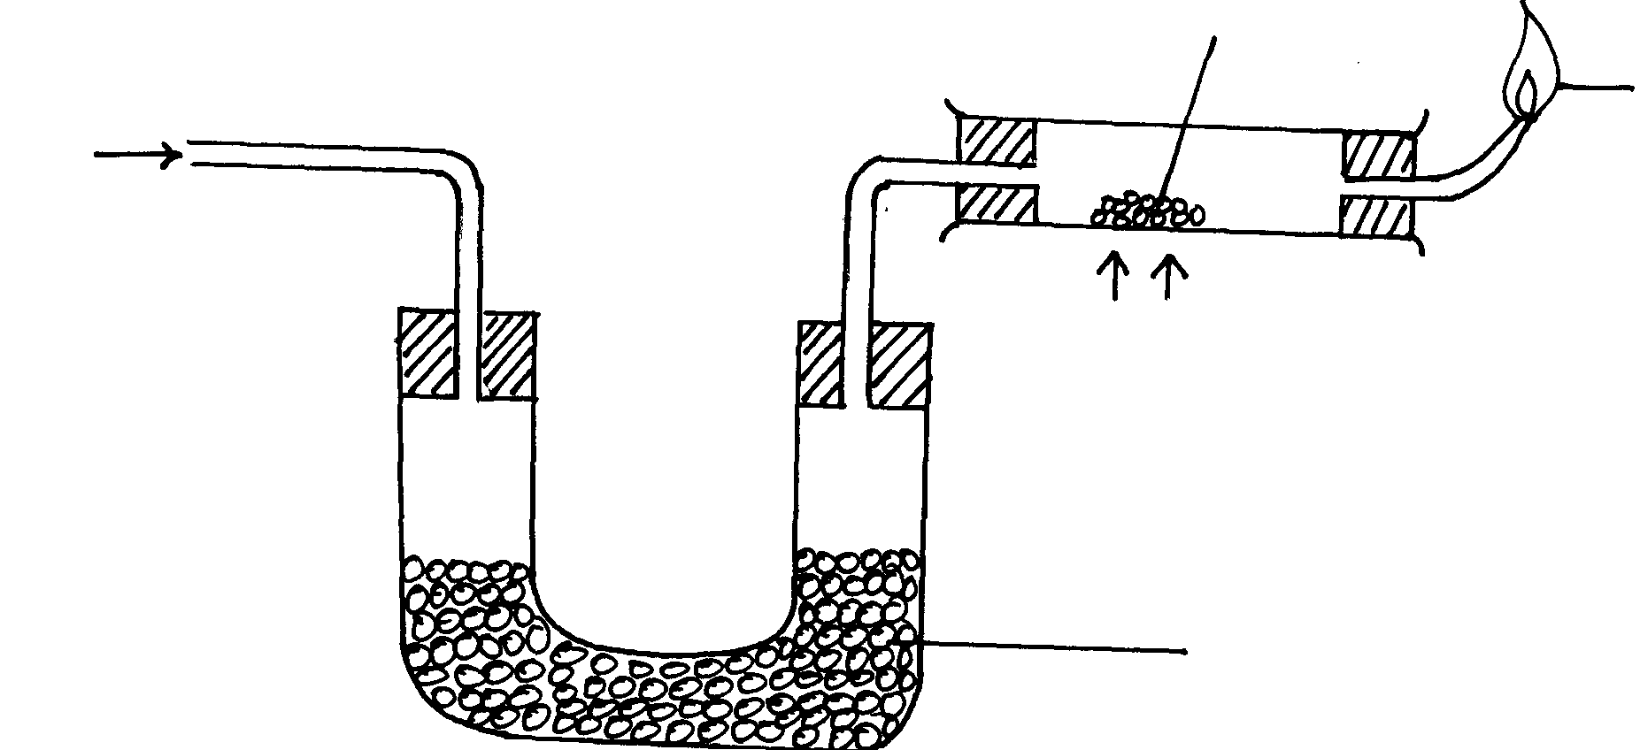
Dry hydrogen
Heat
Anhydrous Calcium Chloride
Blue flame
Lead (II) oxide

(i) State and explain the observations that was made in the combustion tube as the reaction progressed
to completion (2marks)

(ii) Write equations for the reactions;
I) In the combustion tube (1mark)

II) At the jet of the delivery tube (1mark)

6). (I) Naturally occurring boron exists as two isotopes, boron-10 B with a relative abundance of 20% and boron-11 B with a relative abundance of 80%.
(a) How many electrons does each atom of boron contain? (1mark)

(b) How many neutrons does each atom of the most abundant isotope contain? (1mark)

(c) Calculate the relative atomic mass of boron. (3marks)

(d) Make a diagrammatic representation of an atom of the least abundant isotope of boron
showing the distribution of electrons and composition of the nucleus. (2marks)

II. Air was passed through several reagents as shown below:
Concentrated sodium hydroxide solution
Air
Excess copper turnings hydroxide solution
Escaping
gases
Excess heated magnesium powder

(a) Write an equation for the reaction which takes place in the chamber containing
Magnesium powder (1mark)

(b) Name one gas which escapes from the chamber containing magnesium powder.
Give a reason for your answer (1mark)

(c) State two industrial uses of hydrogen gas (2marks)

7. In the preparation of magnesium carbonate, magnesium was burnt in air and the product collected. Dilute Sulphuric acid was then added and the mixture filtered and cooled. Sodium carbonate was added to the filtrate and the contents filtered. The residue was then washed and dried to give a white powder.
(a) Give the name of the product (1mark)

(b) Write the chemical equation for the formation of the product (1mark)

(c) (i) Name the filtrate collected after sodium carbonate was added. (1mark)

(ii) Write down the chemical formula of the white powder (1mark)

(d) Write a chemical equation for the reaction between product in (a) and the acid (1mark)

(e) Write an ionic equation to show the formation of the white powder (1mark).

(f) Write an equation to show what happens when the white powder is strongly heated. (1mark)

(g) Identify the ions present in the filtrate after addition of sodium carbonate. (1mark)

(h) What is the name given to the reaction that takes place when sodium carbonate was
added to the filtrate? (1mark)

- In an experiment, a piece of magnesium ribbon was cleaned with steel wool. 2.4g of the clean magnesium ribbon was placed in a crucible and completely burnt in oxygen. After cooling,the product weighed 4.0g.
- Explain why it was necessary to clean the magnesium ribbon. (1mark)

- What observation was made in the crucible after burning? (1mark)

- Why was there an increase in mass? (1mark)

- Write the equation for the reaction which took place at the crucible (1mark)

- The product in the crucible was shaken with and filtered. Explain the observation which was made when blue and red litmus papers were dropped into the filtrate. (2marks)

- Calculate the volume of oxygen gas during the burning. (O=16.0; Molar volume of a gas =24,000 cm3 at room temperature) (3marks)

