Name: _____________________________________________ Adm No: ____________Class: _____
Candidate’s Signature: ________________________ Date: __________________________

CHEMISTRY
PAPER 1
FORM 3
END TERM 2 EXAMINATION
JULY/AUGUST 2025
Time: 2 HOURS

Instructions to Candidates

- Write your Name, Adm Number and Class in the spaces provided above.
- Answer all the questions in the spaces provided after each question.
- KNEC Mathematical tables and silent non-programmable electronic calculators may be used.
- ALL working must be clearly shown where necessary.
- Candidate should check the question paper to ascertain that all the pages are printed and that no questions are missing.
- Candidates should answer the questions in English.
FOR EXAMINER’S USE ONLY

QUESTIONS | MAX SCORE | CANDIDATE’S SCORE
1 – 27 | 80

This paper consists of 9 printed pages. Candidates should check to ascertain that all pages are printed as indicated and that no questions are missing.

1. Element P3+ and Q2- belong to period three of the periodic table.
(i)Write the electronic arrangement of their atoms. (2mks)

ii) Write the formula of the compound formed by P and Q. (1mk)

2) The combustion of a hydrocarbon compound gave 4.4g carbon (IV) oxide and 2.25g water.
i)Calculate the mass of carbon and hydrogen in the hydrocarbon sample. (2 mrks)

ii) Calculate the empirical formula and hence determine the molecular formula of the
hydrocarbon given that it has a molecular mass of 58. (C=12.0, H=1.0) (2 marks)

3. (i) State Graham's law of diffusion (1mk)

ii). A given mass of gas T diffuses through a porous plug in 48 seconds while a similar mass of gas R diffuse in 70 seconds. Given that the density of gas T is 0.6g/cm3, find the density of gas R [2mks]

4. Using dots (●) and crosses (x) diagrams to represent electrons, show bonding in:
(i) the compound formed when fluorine and nitrogen combine. (2 mark)
(Atomic numbers N =7. fluorine = 9)

(ii) potassium oxide. (Atomic numbers K = 19, O=8) (2 marks)

iii) Carbon (iv) oxide (Atomic number C=12, O=16) (2mks)

5. In an experiment to investigate the conductivity of substances, a student used the set up
shown below.

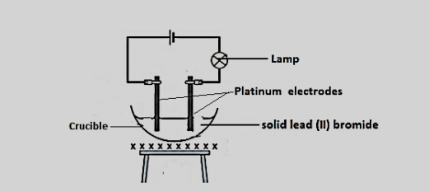
The student noted that the bulb did not light.
a) What had been omitted in the set up. (1mk)
b) Explain why the bulb lights when the omission is corrected? (2mks)

c) State all the observations that would be made when the omission is corrected (3mks)

6. Define the following terms as used in Chemistry
i) Flame (1 mark)

ii) Allotropy (1 mark)

iii)End point of a reaction(1 mark)
7. Why is solid carbon (IV) Oxide (Dry ice) preferred in cool boxes than the normal ice (solid water)?(2mks)

8 . Name the following processes;
a) When anhydrous calcium chloride is left in an open beaker overnight a solution was formed. (1mk)

b) When sodium carbonate decahydrate crystals are left in an open beaker for some days it turned into a powder. (1mk)

9. Study the table below and answer the questions that follow.
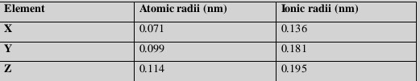
a) Do the elements represent a metallic or non-metallic group? Explain. (2 marks)
b) Compare atomic and ionic radii of the elements. Explain. (2mark)

c) Identify the strongest oxidizing agent. (1mark)

10. Give one use of graphite and diamond and relate the use to properties of each. (4 marks)
I. Graphite: Use
Property

II. Diamond: Use

Property

11. A crystalline sample of sodium carbonate, Na2CO3. XH2O was heated until there was no
further change. The mass of the residue reduced by 14.5%. Determine the value of X in the
formula. (3marks)

12.(i) State the most effective method of preventing rusting?(1mark)

(ii) Write an equation for the formation of rust (1mk)

13. A certain metal carbonate, QCO3 , reacts completely with 20 cm3 of 1M hydrochloric acid
according to the equation below.
QCO3(s) + 2 HCl(aq) QCl2(aq)+ CO2(aq)+ H2O(l)
Determine the relative atomic mass of Q if 1g of the carbonate reacted completely.
(C=12, O = 16) (3mks)

14. Two miscible liquids K and H have boiling points of 58oC and 93oC.If the liquids are mixed
accidentally,
a) Suggest a method used to separate the mixture. (1mark)
b) Which liquid will be collected first? Explain.(1mark)
c) State two industrial applications of the method identified in (a) (2mark)

15. The set-up below was used in the laboratory preparation of carbon (II) oxide.
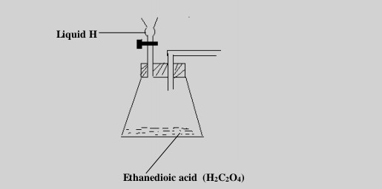
(i)Complete the set up to show how carbon (II) oxide was collected. (2mks)
(ii)Identify liquid H and state its function (2 mks)
(iii) Write an equation for the reaction producing carbon (II) oxide gas. (1mk)

16. Lead (II) nitrate was heated completely.
a) Write an equation for heating lead (II) nitrate. (1mk)
b) Calculate the mass of the oxide formed given that 0.2 moles of the nitrate was heated. (Pb = 207, O = 16) (2mks)

17) When excess lead (II) nitrate solution was added to a solution of sodium chloride, the precipitate was found to weigh 5.56g, determine the amount of sodium chloride in the solution. (Na=23, Pb=207, Cl=35.5, N=14, O=16) (3mks)

18. Describe how a solid sample of copper (II) carbonate can be prepared starting with
copper metal. (3 marks)

19. What is the role of the following parts during the fractional distillation of a mixture of water and ethanol?
(i)Fractionating column(1 mark)
(ii) Glass beads in the fractionating column(1 mark)

20. Carbon (IV) oxide does not support combustion but burning magnesium continues to
burn in carbon (IV) oxide. Explain. (2 marks)

(b) Write an equation for the reaction in (a) above.(1 mark)

21. (a) Give the meaning of the term prescription. (1 mark)

(b) A patient was given tablets with prescription 2 x 3 on the envelope. Clearly outline how
the patient should take the tablets. (1 mark)
(c) State two long-term effects of drug abuse.(2 mark)

22. a) Distinguish between strong and concentrated acid ( 1mk)
23. The diagram below shows the heating curve of a pure substance. Study it and answer the questions that follow.

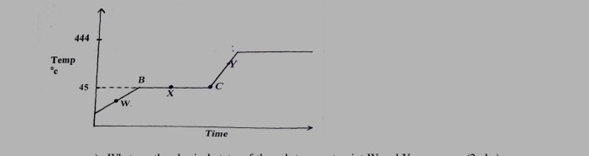

a) What are the physical states of the substances at point W and Y.(2mks)

b) Explain why the temperature remains constant between point B and C.(2mks)

c) Draw the expected curve for an impure substance on the curve above ( 2mks)

