Name: _____________________________________________ Adm No: ____________Class: _____
Candidate’s Signature: ________________________ Date: __________________________
BIOLOGY
PAPER 2
FORM 3
END TERM 2 EXAMINATION
JULY/AUGUST 2025
Time: 2 HOURS

Instructions to Candidates
SECTION A (40 MARKS) ANSWER ALL QUESTIONS
- A biological washing powder contains an enzyme. The enzyme removes stain such as blood from clothes by digestion when the clothes are soaked in water with powder.
- What is an enzyme? (1 Mark)

………………………………………………………………………………………………………………………………………………………………………………………………………………………………
- Identify two possible enzymes that are found in the washing powder above. (2 Marks)

………………………………………………………………………………………………………………………………………………………………………………………………………………………………c) Would the stains be removed faster with the powder in water at 30ºC or 15⁰C. (1 Mark)
………………………………………………………………………………………………………………………………………………………………………………………………………………………………
- Explain your answer in (c ) above (2 Marks)
……………………………………………………………………………………………………………………………………………………………………………………………………………………………………………………………………………………………………………………………………………………………………………………………………………………………………………………………… (e) Why would boiling the clothes soaked with the washing powder does not remove the stains? (2 Marks)………………………………………………………………………………………………………………………………………………………………………………………………………………………

2. (a) Distinguish between pyramid of numbers and pyramid of biomass. (2 Marks)
………………………………………………………………………………………………………………….…………………………………………………………………………………………………………………………………………………………………………………………………………………………
b) From an ecological study, students formed the following food web.
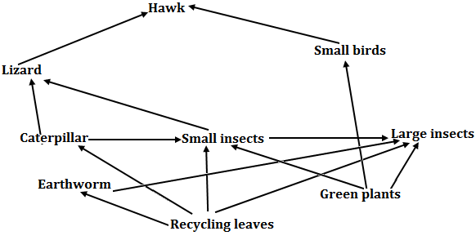

- From the food web, construct two food chains with lizard as a tertiary consume.(2 Marks)

………………………………………………………………………………………………………………………………………………………………………………………………………………………………
(ii) Which organism has the least biomass in the ecosystem. (1 Mark)
………………………………………………………………………………………………………………………………………………………………………………………………………………………………
(iii) Give reasons for your answer (3 Marks)
………………………………………………………………………………………………………………………………………………………………………………………………………………………………………………………………………………………………………………………………………………………………………

- The diagram below shows how blood sugar in mammalian body is regulated.

Corrective mechanism P
Rise Fall

Normal glucose level
Normal glucose level

Fall Rise
Corrective mechanism Q

- Explain what happens during corrective mechanism P. (3 Marks)
……………………………………………………………………………………………………………………………………………………………………………………………………………………………………………………………………………………………………………………………………………………………………………………………………………………………………………………………
b) Name two organs involved in corrective mechanisms P and Q. (2 Marks)

………………………………………………………………………………………………………………………………………………………………………………………………………………………………
- State the reasons why glucose level should be maintained constant. (2 Marks)
…………………………………………………………………………………………………………………………………………………………………………………………………………………………………………………………………………………………………………………………………………………………………………………………………………………………………………
- What is osmoregulation? (1 Mark)
………………………………………………………………………………………………………………………………………………………………………………………………………………………………………………………………………………………………………………………………………………………

4 The diagram below represents a plant cell.
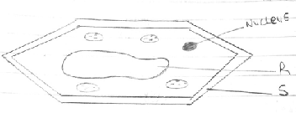
- Name a carbohydrate which forms part of the structure labelled S. (1mk)

- State two functions of the part labelled R (2mks)

- Name two structures present in the diagram but absent in an animal cell (2mks)

(d) Name the organelles that perform each of the following functions (3mks)
- Excretion in amoeba

- Carries out digestion and destruction of worn out cell organelles

- Movement in paramecium

- The diagram below represents a plant in the division Bryophyta.

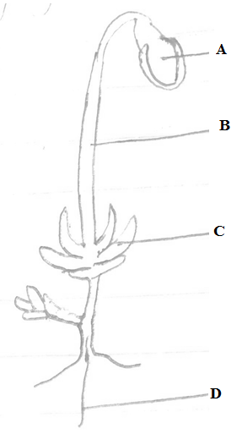
- Name the parts labeled B and D (2mks)
B -
D -
- State one function for each of the parts labelled A and C (2mks)
A -
B -
- To which phylum and class does the following organism belong ? (2mks)
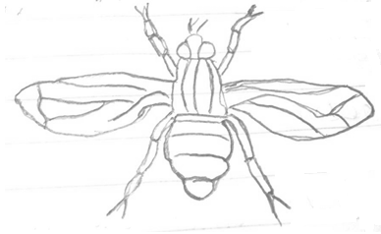
Phylum -
Class -
(b) Using observable features in the diagram, give two reasons for the phylum you have stated in (a) above (2 marks)

SECTION B (40MKS)
Answer question 6 and any other one
6. An experiment was set up to investigate the effect of light on the rate of photosynthesis in the shoot of a water plant. The gas given off by the shoot was collected for 5 minutes at different light intensities and the volume measured. The results obtained are shown on the table below.
Light intensity (units | Gas collected (cm³ / 5min)
1 | 0.35
2 | 0.60
3 | 0.85
5 | 1.20
10 | 1.55
20 | 1.70
30 | 1.80
40 | 1.79
50 | 1.79

- Using the data given in the table, plot a graph of the volume of the gas collected against light intensity. (7mks)
- Account for the rate of gas production in the following intervals of light intensity.
- 1 - 10 (2mks)

- 30 – 50 (2mks)

- Write a word equation for the process of photosynthesis (2mks)

- State the products of the light stage of photosynthesis (3 mks)

- State the role of light in photosynthesis. (2 mks)

- Other than light intensity, name two other factors that affect the rate of photosynthesis. (2 mks)

- Explain the economic importance of the organisms of each of the following kingdoms.
- Monera (10mks)
- Fungi (10mks)
- Explain how abiotic factors affect plants. (20 Marks)

………………………………………………………………………………………………………………………….………………………………………………………………………………………………………………….………………………………………………………………………………………………………………………………………………………………………………………………………………………………………………………………………………………………………………………………………………………………………………………………………………………………………………………………………….………………………………………………………………………………………………………………….………………………………………………………………………………………………………………………………………………………………………………………………………………………………………………………………………………………………………………………………………………………………………………………………………………………………………………………………………….………………………………………………………………………………………………………………….………………………………………………………………………………………………………………………………………………………………………………………………………………………………………………………………………………………………………………………………………………………………………………………………………………………………………………………………………….………………………………………………………………………………………………………………….……………………………………………………………………………………………………………………………………………………………………………………………………………………………………………………………………………………………………………………………………………………………………………………………………………………………………………………………………………………………………………………………………………………………………………………………………………………………………………………………………………………………………………………………………………………………………………………………………………………………………………………
…………………………………………………………………………………………………………………….………………………………………………………………………………………………………………….………………………………………………………………………………………………………………………………………………………………………………………………………………………………………………………………………………………………………………………………………………………………………………………………………………………………………………………………………….………………………………………………………………………………………………………………….………………………………………………………………………………………………………………………………………………………………………………………………………………………………………………………………………………………………………………………………………………………………………………………………………………………………………………………………………….………………………………………………………………………………………………………………….………………………………………………………………………………………………………………………………………………………………………………………………………………………………………………………………………………………………………………………………………………………………………………………………………………………………………………………………………….………………………………………………………………………………………………………………….…………………………………………………………………………………………………………………………………………………………………………………………………………………………………………………………………………………………………………………………………………………………………………………………………………………………………………………………………………………………………………………………………………………………………………………………………………………………………………………………………………………………………………………………………………………………………………………………………………………………………………………………
………………………………………………………………………………………………………………………………………………………………………………………………………………………………………………………………………………………………………………………………………………………………………………………………………………………………………………………………………….………………………………………………………………………………………………………………….………………………………………………………………………………………………………………………………………………………………………………………………………………………………………………………………………………………………………………………………………………………………………………………………………………………………………………………………………….………………………………………………………………………………………………………………….………………………………………………………………………………………………………………………………………………………………………………………………………………………………………………………………………………………………………………………………………………………………………………………………………………………………………………………………………….………………………………………………………………………………………………………………….…………………………………………………………………………………………………………………………………………………………………………………………………………………………………………………………………………………………………………………….………………………………………………………………………………………………………………….…………………………………………………………………………………………………………………………………………………………………………………………………………………………………………………………………………………………………………………………………………………………………………………………………………………………

