Name: ________________________________ Adm No: ____________Class: _____
Candidate’s Signature: __________________Date__________________________

BIOLOGY
FORM 2
END TERM 2 EXAMINATION
JULY/AUGUST 2025
Time: 2 HOURS

Instructions to Candidates:
- ANSWER ALL THE QUESTIONS IN THE SPACES PROVIDED.
1. Suggest a biological tool that is most suitable for collecting each of the following organisms. (3mks)
- Scorpions.

- Safari ants on a tree

- Butterfly in a coffee farm

2. Identify the discipline of biology that deals with the following.
- The relationship between organisms and their environment. (1mk)

- Study of development of living organisms. (1mk)

- Study of body functions of living organisms. (1mk)

3. Name two supportive tissues in plants that are lignified. (2marks)

4.Name the polysaccharide which offers mechanical support in
(i)Arthropods(1mark)

(ii)Plants(1mark)

5. a) State the muscle that regulates entry of food bolus into the stomach. (1mark)

b) How is parotid gland important in starch digestion. (2marks)
6. Name the cell structures that synthesize the following cell organelles
(i) Ribosomes. (1mark)

(ii) Lysosomes. (1mark)

- A solution of sugarcane was boiled with hydrochloric acid then cooled. Sodium carbonate was added then Benedict’s solution. The solution was boiled and an orange precipitate was formed.
- Why was the solution boiled with hydrochloric acid? (1mark)

- To which class of carbohydrates does sugarcane belong? (1mark)

- Name the type of reaction that takes place when:
(i) Simple sugars combine to form complex sugars (1mark)

(ii) A complex sugar is broken down into simple sugars (1mark)

7. Identify two scientific skills acquired through the study of biology (2mark)

8. The illustration shown below is a graph of enzymatic reaction 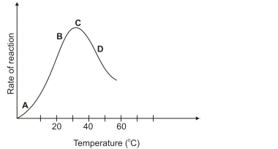
- Account for the rate of reaction shown at D. (2marks)

- Why is the rate of reaction maximum at C? (1mark)

9. Use the diagram shown below to answer questions that follow
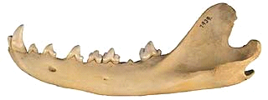
a) Give TWO reasons why the jaw shown above is of a carnivorous animal (2marks)

b) Use X to label the tooth used in seizing prey on the diagram above. (1mark)

c) A certain animal has no incisors, no canines, 6 premolars and 6 Molars in its upper jaw. In the lower jaw there are 6 incisors, 2 canines, 6Premolars and six molars. Write its dental formula. (2mks)

10. Below is a diagram of a cell organelle. Study it and answer the questions that follow.
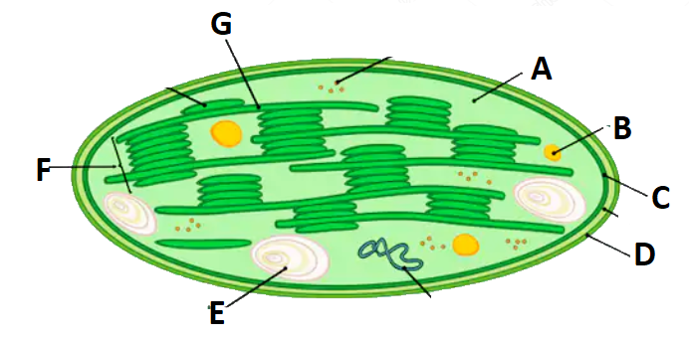
i)Identify the organelle. (1mk)

ii)Name the part labelled A and C.(2mks)
A –

C –

iii) State the letter that represent the part where light stage of photosynthesis occurs. (1mk)

iv)State two adaptations of the organelle to its function. (2marks)

v)What happens to the end products of light stage? (2 marks)

11. The diagram shown below shows a leaf that was used to study photosynthesis. After the experiment, drops of Iodine solution were placed on the processed leaf

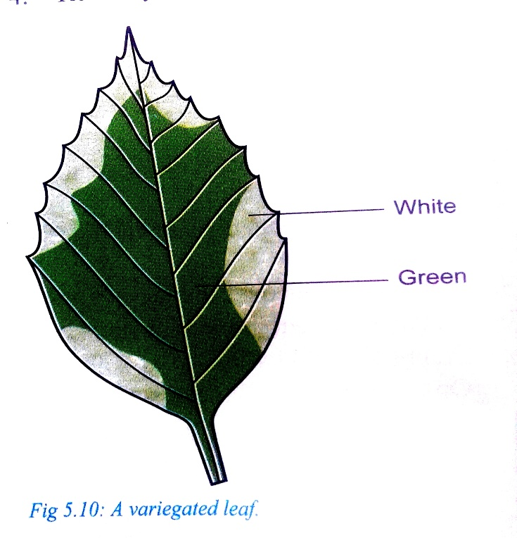
- Which food substance was being tested for? (1mark)

- Fill in the table below to show the colors observed in the following regions (2marks)
Region | Colour
White
Green

- Account for observation made on white part of the leaf. (2marks)

12. The experiment set up shown below was used to investigate a physiological process
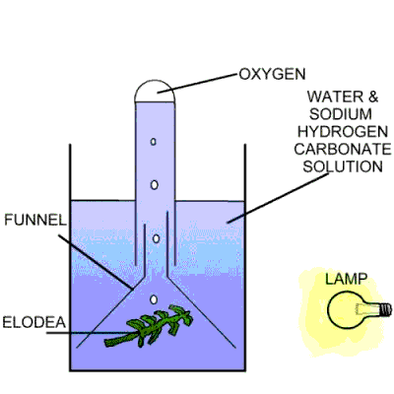
- What was the aim of the experiment? (1mark)

- Why was Sodium Hydrogen Carbonate added in the water (2marks)

- How can one confirm that the gas released in the experiment is Oxygen. (1mark)

13.State 3 functional differences between arteries and veins(3marks)

14.Excessive blood loss can be rectified by blood transfusion in which blood from one person, the donor, is transferred into the patient’s blood system.
(i) Complete the table below(4marks)
Blood group | Can donate blood to | Can receive blood from
A |  | A, O
B | A and AB
AB |  | A, AB, B, O
O | A, B, AB, and O

(ii)What are the advantages and disadvantages of having blood group O.(2marks)

(iii)What is the advantage of having blood group AB. (1mark)

15. (a)Heart muscles are myogenic. Explain(1mark)

(b)Name the nerve that slows down the rate of the heart(1marks)

16. (a)What factors contribute to the formation of tissue fluid at the capillaries(2marks)

(b)State the function of the tissue fluid(1mark)

(c)State 3 adaptations of capillaries to their functions(3marks)

17.State and explain 4 environmental factors that affect the rate of transpiration in plants(8marks)

