NAME: _______________________________ADM NO: __________CLASS: ________
DATE: ______________________________ SIGN: _______________________
PHYSICS
FORM: 3
TERM 2 2025
OPENER EXAMINATION

INSTRUCTIONS: Answer all the Questions TIME: 1 HR 15 MIN

- (a) Distinguish between distance and displacement (2 marks)

(b) A body accelerates from the initial velocity U to the final velocity V in time t, the distance travelled is S. if the acceleration is a. Show that

- V=u +at (3 marks)

- S=ut+¹/₂at² (3 marks)

- V²=U²+2as (3 marks)

(c) A ball is thrown vertically upwards and returns to its starting point after 6 seconds. Calculate the maximum height reached (3 marks)

(d) A ball is thrown from the top of a cliff 30m high with a horizontal velocity of 15m/s. Calculate
- The time taken by the ball to strike the ground (3 marks)

- The distance from the foot of the cliff to where the ball strikes the ground (3 marks)

- The vertical velocity at the time it strikes the ground(take g=10ms⁻²(2
marks)

(d) The figure below shows a tape obtained from ticker-timer of frequency 50HZ. Calculate

- The initial velocity of the trolley (2 marks)

- The final velocity of the trolley (2 marks)

- The acceleration of the trolley (2 marks)

2.(a) State Newton’s first law of motion (1 mark)

(b) A car of mass 1200kg moving at a speed of 90km/h is brought to rest in 10 seconds over a distance 20m. Calculate the breaking force required ? (3 marks)

(c) State the two factors that determine the amount of breaking force required in (b) above (2 marks)

(d) When a soldier fires a bullet from a gun, he is pushed backwards. Explain (2 marks)

3. (a) Locate the center of gravity in the diagram below (1 mark)



(b) The figure below shows a metre rule in equilibrium
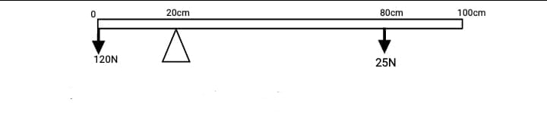

- Calculate the weight of the metre rule (2 marks)

- What is the reaction at the pivot (1 mark)

4. The figure below shows a current carrying conductor in a magnetic field direction of force on the wire as shown by the arrow. State the polarities of A and B
A----------------------------- (1 mark)

B------------------------------ (1 mark)

5. (a) A horse rider bends forward when the horse is on speed. Explain(2 marks)

(b) The diagram below shows a Bunsen burner. Explain how air is drawn into the burner (2 marks)


THIS IS THE LAST PRINTED PAGE

