NAME: _______________________________ADM NO: __________CLASS: ________

DATE: ______________________________ SIGN: _______________________
MATHEMATICS
FORM THREE
TERM 2 2025
OPENER EXAMINATION

INSTRUCTIONS: Answer all the Questions in section I and only TWO in section II TIME: 1 HR 30 MIN

SECTION 1

1. Solve the following inequalities and represent the solution on a number line hence state the integral values. 7x – 4 ≤ 9x + 2 < 3x + 14 (3 Marks)

2. The diagram below shows a circle with a chord PQ= 3.4cm and angle PRQ=40º.
Calculate the area of the shaded segment. (4 Marks)
O
Q
P
R
40º
3.4cm

3. Given that a = $\left({2 \atop 1}\right)$ and b = $\left({-3 \atop 4}\right)$ find : | a + b|. (3 Marks)

4. Use completing square method to solve 2x² – 4x – 5=0 (3 marks)

5. A rectangular room has length 12.4 metres and width 8.8 metres. Find the percentage error in estimating the perimeter of the room. (3 marks)

6. The expression ax-30x+9 is a perfect square, where a is a constant. Find the value of a. (3 Marks)

7.The perimeter of a rectangle is 48cm² while it volume is 108 cm². Form a quadratic equation to represent the above situation and find its width. (3 Marks)

8. Find the value of θ, given that ½ sinθ = 0.35 for 0º ≤ θ ≤ 360º (2 Marks)

9. The marks obtained by 10 students in a maths test were:-
26, 24, 22, 23,26, 26, 21, 23, 22 and 27. Calculate the value of mean and the modal mark. (3 Marks)

10. Two trucks A and B travelling at 28km/hr and 26km/hr respectively approach one another on a straight road. Truck A is 10m long, while truck B is 15m long. Determine the time in seconds that elapses before the trucks completely pass each other. (3 Marks)

SECTION II
11(a) Complete the table below for the equation :- y = x² + 5x – 6 for -8 ≤ x ≤ 3 (2 Marks)
x | -8 | -7 | -6 | -5 | -4 | -3 | -2 | -1 | 0 | 1 | 2 | 3
y | 18 |  |  | -6 | -10 |  | -12 |  | -6 |  |  | 18
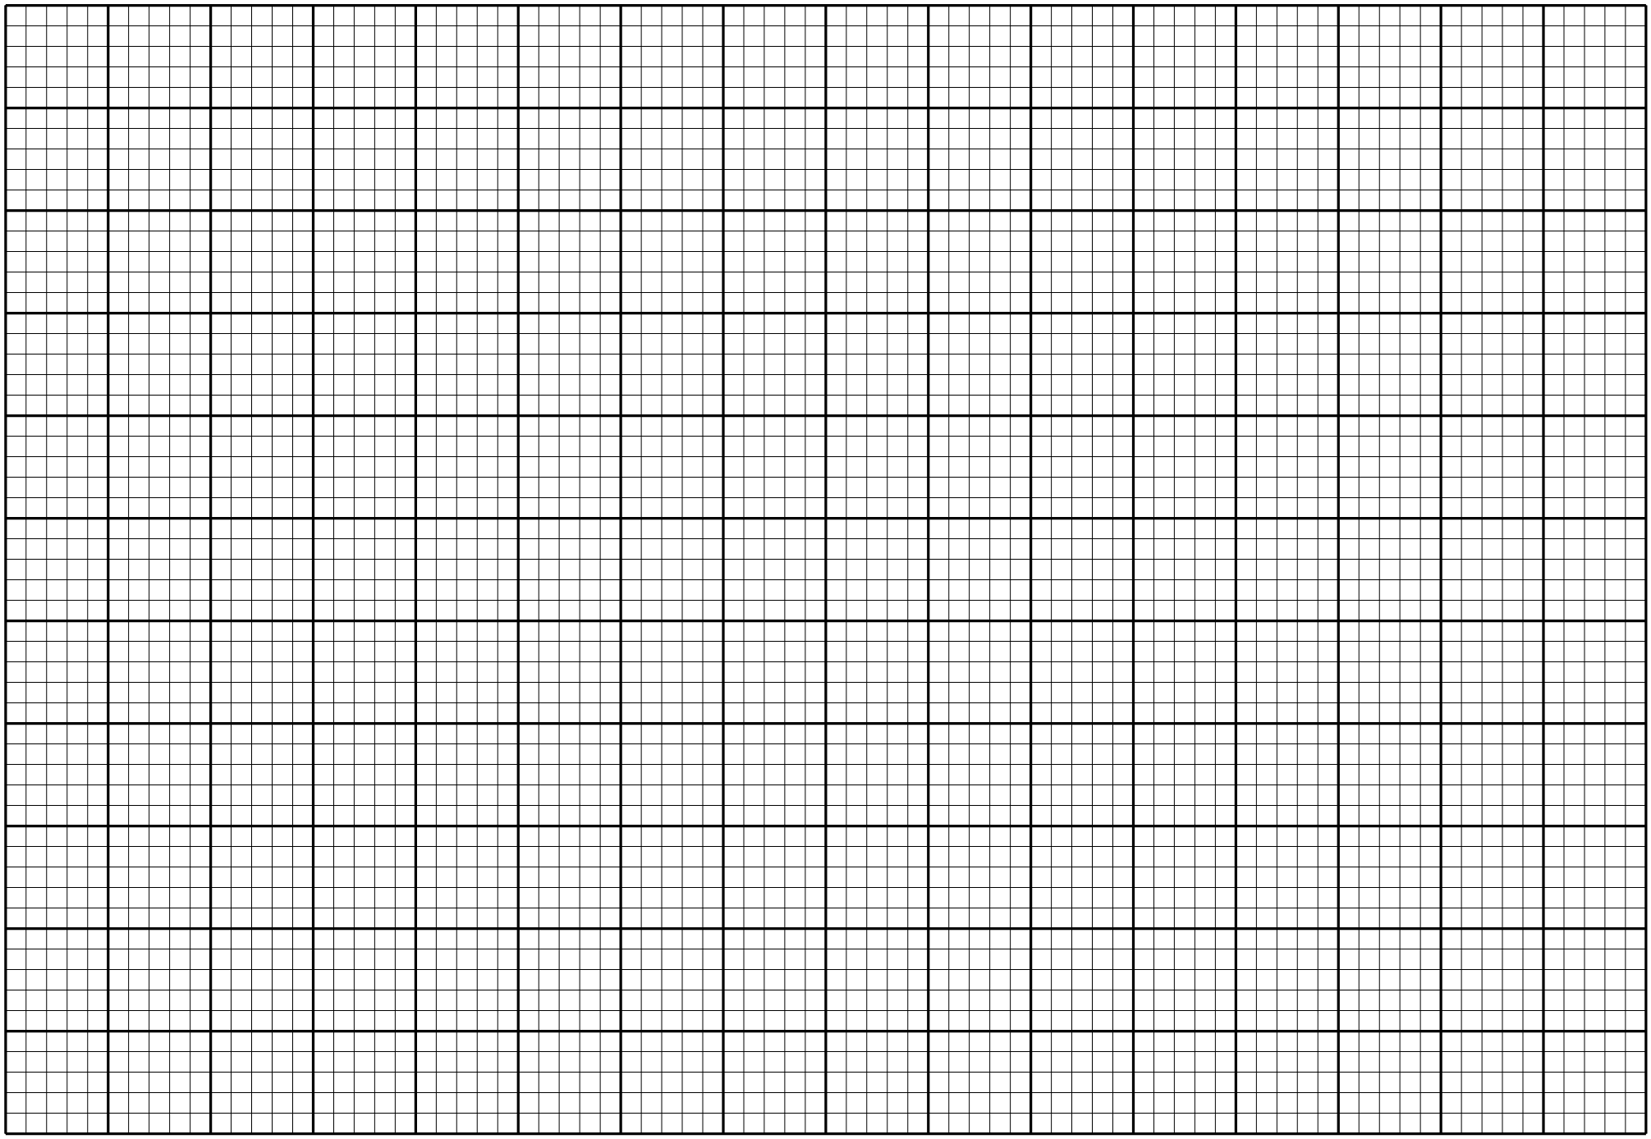

(b) Using a scale 1cm to represent 1 unit in x axes and 1 cm to represent 2 units on y axis, draw the graph of y = x² + 5x – 6. (3 Marks)

(c) Use your graph to solve:-
(i) X² + 5X- 6 = 0 (2 Marks)

(ii) X² + 3X – 4 = 0 (3 Marks)

12. The figure below represents a triangular plot ABC. The lengths of AB = 50m, AC = 80m
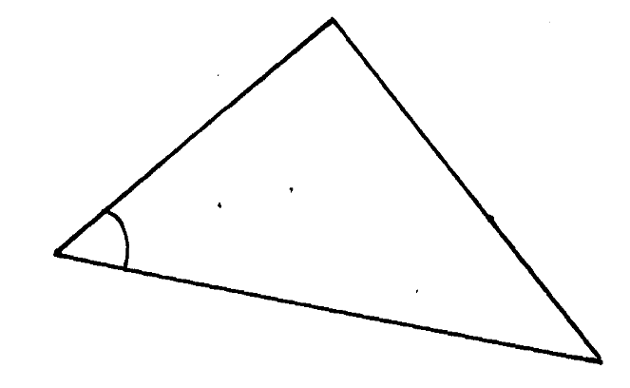
and angle BAC =30º
50m
A
30º

80m

C

- Find the length of BC to 2 significant figures. (3 marks)

(b) Find the area of the plot in hectares. (3 Marks)

(c) The plot is fenced using 4 strands of barbed wire. The length of one roll of barbed
wire is 600m and it costs shs.4000. Calculate;
- The length of fencing wire required. (2 Marks)

(ii) The number of complete rolls to be bought. (1 Mark)

(iii) The cost of the rolls. (1 Mark)

- The table below shows marks obtained by 60 students in a test.
Marks | 10-19 | 20-29 | 30-39 | 40-49 | 50-59 | 60-69 | 70-79 | 80-89 | 90-99
No. of pupils | 2 | 2 | 3 | 8 | 23 | 13 | 6 | 2 | 1

- State the modal class. (1 Mark)

- Calculate the mean height. (5mks)

- State the median class. (1 Mark)

- Calculate the median mark. (3 Marks)

