NAME……………………………………………………………...CLS……………….ADM…………
TERM 2 2025
OPENER EXAMINATION
FORM TWO GEOGRAPHY. DURATION: 1HR 15 MINUTES
Answer ALL questions in the spaces provided
1. (a) What are earth movements? (2 marks)
………………………………………………………………………………………………………………………………………………………………………………………………………………………………………………………………………………………………………………………………………………………………………………………………………………………………………………
(b) Apart from Isostatic adjustment, give three other causes of earth movements. (3 marks)
………………………………………………………………………………………………………………………………………………………………………………………………………………………………………………………………………………………………………………………………………………………………………………………………………………………………………………………………………………………………………………………………………………………………………………………………
(c) Explain how Isostatic adjustment causes earth movements. (4 marks)
………………………………………………………………………………………………………………………………………………………………………………………………………………………………………………………………………………………………………………………………………………………………………………………………………………………………………………………………………………………………………………………………………………………………………………………………………………………………………………………………………………………………………………………………………………………………………………………………………………………………………………………………………………………………………………………………………………………………………………………………………………………………………………………………………………………………………………………………………………………………………………………………………………………………………………………………………………………………………………………………………………
2. (a) Name three types of tectonic plate boundaries. (3 marks)
………………………………………………………………………………………………………………………………………………………………………………………………………………………………………………………………………………………………………………………………………………………………………………………………………………………………………………………………………………………………………………………………………………………………………………………………
(b) State four reasons why it is important to study plate tectonics theory. (4 marks)
………………………………………………………………………………………………………………………………………………………………………………………………………………………………………………………………………………………………………………………………………………………………………………………………………………………………………………………………………………………………………………………………………………………………………………………………………………………………………………………………………………………………………………………………………………
3. Describe the continental drift theory. (6 marks)
………………………………………………………………………………………………………………………………………………………………………………………………………………………………………………………………………………………………………………………………………………………………………………………………………………………………………………………………………………………………………………………………………………………………………………………………………………………………………………………………………………………………………………………………………………………………………………………………………………………………………………………………………………………………………………………………………………………………………………………………………………………………………………………………………………………………………………………………………………………………………………………………………………………………………………………………………………………………………………………………………………………………………………………………………………………………………………………………………………………………………………………………………………………………………………………………………………………………………………………………………………………………………………………………………………………………………………………………
4. (a) Differentiate between folding and faulting. (2 marks)
………………………………………………………………………………………………………………………………………………………………………………………………………………………………………………………………………………………………………………………………………………………………………………………………………………………………………………………………………………………………………………………………………………………………………………………………………………………………………………………………………………………………………………………………………………
(b) State three factors that determine the degree of folding. (3 marks)
………………………………………………………………………………………………………………………………………………………………………………………………………………………………………………………………………………………………………………………………………………………………………………………………………………………………………………………………………………………………………………………………………………………………………………………………

5. The diagram below shows some types of folds
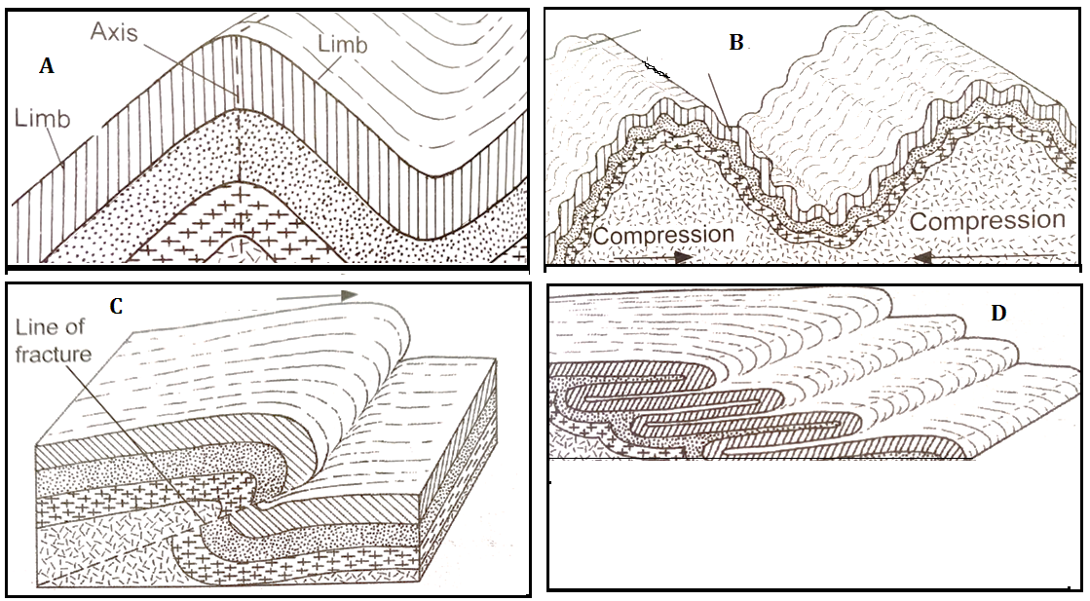
(a) Identify the types of folds marked A, B, C and D. (4 marks)
………………………………………………………………………………………………………………………………………………………………………………………………………………………………………………………………………………………………………………………………………………………………………………………………………………………………………………………………………………………………………………………………………………………………………………………………………………………………………………………………………………………………………………………………………………
(b) Apart from the plate tectonics theory, give three other theories of Fold Mountain formation. (3 marks)
………………………………………………………………………………………………………………………………………………………………………………………………………………………………………………………………………………………………………………………………………………………………………………………………………………………………………………………………………………………………………………………………………………………………………………………………
(c) Explain plate tectonics theory as a theory of Fold Mountain formation. (6 marks)
………………………………………………………………………………………………………………………………………………………………………………………………………………………………………………………………………………………………………………………………………………………………………………………………………………………………………………………………………………………………………………………………………………………………………………………………………………………………………………………………………………………………………………………………………………………………………………………………………………………………………………………………………………………………………………………………………………………………………………………………………………………………………………………………………………………………………………………………………………………………………………………………………………………………………………………………………………………………………………………………………………………………………………………………………………………………………………………………………………………………………………………………………………………………………………………………………………………………………………………………………………………………………………………………………………………………………………………………
6. (a) Name a country where the following fold mountains are found:
(i) Alps Mountains (1mark)
………………………………………………………………………………………………………………………………………….
(ii) Himalayas Mountains (1mark)
…………………………………………………………………………………………………………………………………………..
(b) Explain four economic importance of Fold Mountains. (8 marks)
………………………………………………………………………………………………………………………………………………………………………………………………………………………………………………………………………………………………………………………………………………………………………………………………………………………………………………………………………………………………………………………………………………………………………………………………………………………………………………………………………………………………………………………………………………………………………………………………………………………………………………………………………………………………………………………………………………………………………………………………………………………………………………………………………………………………………………………………………………………………………………………………………………………………………………………………………………………………………………………………………………………………………………………………………………………………………………………………………………………………………………………………………………………………………………………………………………………………………………………………………………………………………………………………………………………………………………………………………………………………………………………………………………………………………………………………………………………………………………………………………………………………………………………………………………………………………………………………………………………………………………………………………………………………………………………………………………………………………………………………………………………………………………………………

