NAME: _______________________________ADM NO: __________CLASS: ________
DATE: ______________________________ SIGN: _______________________

COMPUTER STUDIES
FORM FOUR
TERM 2 2025
OPENER EXAMINATION

INSTRUCTIONS: Answer all the Questions TIME: 1 HR 15 MIN

- Explain the meaning of following terms as used in networking (6 marks)
- Modulation and Demodulation.
………………………………………………………………………………………………………………………………………………………………………………
- Computer network.
………………………………………………………………………………………………………………………………………………………………………………
- Bandwidth.
………………………………………………………………………………………………………………………………………………………………………………
- One of the biggest challenges of data transmission in networks is attenuation.
- What is attenuation. (1 mark)
………………………………………………………………………………………………………………………………………………………………………………

- Give any two possible causes of attenuation. (2 marks)
………………………………………………………………………………………………………………………………………………………………………………
- State two ways through which the effects of attenuation can be reduced. (2 marks)
………………………………………………………………………………………………………………………………………………………………………………………………………………………………………………………

- Distinguish between packet switching and circuit switching transmission techniques. (4 marks)
…………………………………………………………………………………………………………………………………………………………………………………………………………………………………………………………………………………………………………………………………………………………………………

- Explain two ways in which computer networks have negatively affected the society. (4 marks)
…………………………………………………………………………………………………………………………………………………………………………………………………………………………………………………………………………………………………………………………………………………………………………

- Give four advantages of using fibre optic cables for data transmissions. (4 marks)
…………………………………………………………………………………………………………………………………………………………………………………………………………………………………………………………………………………………………………………………………………………………………………

- While downloading news reports from the school resource center, Bahari, BBI group experienced slow page loading from their browser. Their teacher explained that one of the possible causes for this in networks is “packet loss”. Explain the meaning of this and state two possible causes of packet loss in networking. (4 marks)
…………………………………………………………………………………………………………………………………………………………………………………………………………………………………………………………………………………………………………………………………………………………………………
- The following diagram shows one of the physical network topologies used to set up networks.
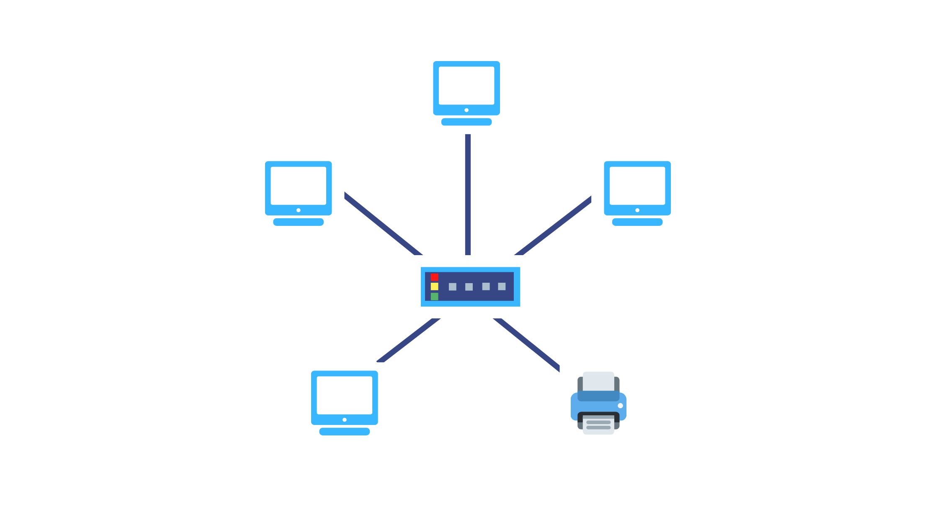
- Identify the network topology above. (1 mark)
…………………………………………………………………………………
- Briefly explain how data can be transmitted from one computer to another in the above topology. (3marks)
……………………………………………………………………………………………………………………………………………………………………………………………………………………………………………………………………………………………………………………………………………………………………………………………………………………………

- Name any two devices that can function as the device at the center of the diagram. (2 marks)
……………………………………………………………………………………………………………………………………………………………………
- Amplitude modulation (AM) and Frequency Modulation (FM) are two types of multiplexing technologies used for radio broadcasts. What do you understand by the terms multiplexing and demultiplexing? (2 marks)
…………………………………………………………………………………………………………………………………………………………………………………………………………………………………………………………………………………………………………………………………………………………………………
- Explain two ways in which ICT has been applied in then following areas. (6 marks)
- Banking systems.
………………………………………………………………………………………………………………………………………………………………………………………………………………………………………………………
- Transport systems.
………………………………………………………………………………………………………………………………………………………………………………………………………………………………………………………
- Education systems.
………………………………………………………………………………………………………………………………………………………………………………………………………………………………………………………
- Write the following abbreviations in full. (4marks)
- DTE
…………………………………………………………………………………
- IP/TCP
…………………………………………………………………………………
- LAN
…………………………………………………………………………………
- OTG
…………………………………………………………………………………
- What is broadcast storm? (1marks)
……………………………………………………………………………………………………………………………………………………………………………………
- Explain the advantage of using hubs over hubs in networking. (2 marks)
……………………………………………………………………………………………………………………………………………………………………………………
- Name any two physical transmission media used in networks. (2 marks)
……………………………………………………………………………………………………………………………………………………………………………………

