NAME: _______________________________ADM NO: __________CLASS: ________
DATE: ______________________________ SIGN: _______________________
CHEMISTRY
FORM: 4
TERM 2 2025
OPENER EXAMINATION
INSTRUCTIONS: Answer all the Questions TIME: 1 HR 15 MIN

233/2
CHEMISTRY
PAPER 2
(THEORY)

Q1=10 marks
Q2=10 marks
Q3=10 marks
Q4=12 marks
Q5=8 marks

Q1. grid below shows part of the periodic table. Study it and answer the questions that follow. The letters do not represent the true symbols of the elements.
 |  |  |  |  |  | A
I | B |  | C |  | D |  | E
F | G |  |  |  |  |  | H

- Which element forms an ion of charge - 2? Explain your answer 2marks
………………………………………………………………………………………………………………………………………………………………………………………………………………………………………………………………………………………………………………………………………………
- What is the nature of the oxide formed by element C? 1mark
………………………………………………………………………………………………………………
- How does the reactivity of H compare with that of E? Explain. 2marks

- Write the chemical equation for the reaction between B and chlorine? 1mark
………………………………………………………………………………………………………………………………………………………………………………………………………………………………
- Explain how the atomic radii of the following compare; 2marks
- F and G
………………………………………………………………………………………………………………………………………………………………………………………………………………………………
- B and G
………………………………………………………………………………………………………………………………………………………………………………………………………………………………
- The oxides of B and D are separately dissolved in water. State the effect of each product on litmus paper. 2marks
………………………………………………………………………………………………………………………………………………………………………………………………………………………………………………………………………………………………………………………………………………

Q 2. The diagram below shows an experiment set-up to investigate a property of carbon (ii) oxide. Study it and answer the questions that follow.

Copper (ii) oxide

Blue flame of gas X

CO

- Name one condition that is missing in the set up that must be present if the experiment to proceed. 1mark
………………………………………………………………………………………………………………………………………………………………………………………………………………………………
- If the experiment was carried out properly. What observation would be made in the combustion tube? 1mark
………………………………………………………………………………………………………………………………………………………………………………………………………………………………
- Give an equation for the reaction that occurs in the combustion tube. 1 mark
………………………………………………………………………………………………………………………………………………………………………………………………………………………………
- Give an equation for the reaction that takes place as gas x burns. 1 marks
………………………………………………………………………………………………………………………………………………………………………………………………………………………………
- Why is it necessary to burn gas x? 1mk
………………………………………………………………………………………………………………………………………………………………………………………………………………………………
- Name the reducing and oxidizing agent. 2marks
- Reducing
- Oxidising agent
- Identify any other substance that would have the same effect on copper (ii) oxide as carbon (ii) oxide. 1mark

- What would happen if copper (ii) oxide was replaced with sodium oxide? Explain 2mark

Q3. Fractional distillation of air is used in the industrial manufacture of oxygen. The diagram below shows the process.

A
B
M
Compressor

R

Fractional distillation
Y
Nitrogen boiling point- 196⁰C
Argon boiling point -186⁰C

Oxygen boiling point - 196⁰C

Substance T

Dry air

Sodium Carbonate solution

Dust particles

Liquid S

Air
D
X

- What processes are taking place in chamber A,B,M and D 2marks
A
…………………………………………………………………………………………..……..…………..

B
…………………………………………………………………………………………….………………..

M
……………………………………………………………………………………………..…....………….

D
…………………………………………………………………………….………………..…...………….

- Name;
- Liquid S
……………………………………………………………………………………….……….……………
- Substance T
…………………………………………………………………………….…….…………………………
- Explain why part Y in chamber D is curved? 1mark
………………………………………………………………………………………………………………………………………………………………………………………………………………………………
- Give two industrial uses of oxygen gas? 2marks
……………………………………………………………………………………………………………………………………………………………
- In the laboratory preparation of oxygen, manganese (iv) oxide and hydrogen peroxide are used. Write an equation to show how oxygen gas is formed. 1mark
………………………………………………………………………………………………………………………………………………………………………………………………………………………………
- An investigation was carried out using the set-up below. Study it and answer the questions that follow.
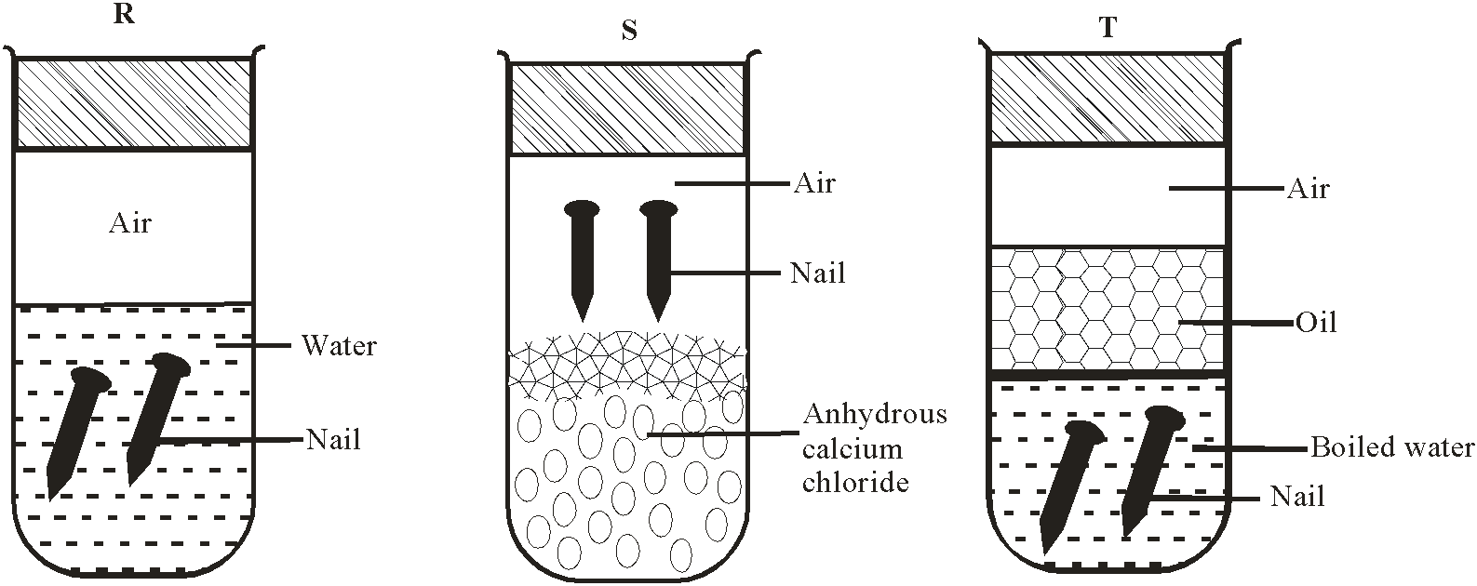

- State and explain what will happen in the three test-tubes R, S and T after seven days. 3marks
………………………………………………………………………………………………………………………………………………………………………………………………………………………………………………………………………………………………………………………………………………
- Give one reason why some metals are electroplated. 1mark
………………………………………………………………………………………………………………
4. The formula of three organic compounds each having two carbon atoms are;
Compound | A | B | C
formula | C₂H₄ | C₂H₂ | C₂H₆

The compound belong to different homologous series.
a) State what is meant by the term homologous series (1mk)

b) Compound B is the first member of a homologous series, write the formula of the fifth member of the same series. (1mk)

c) Explain why compound A is described as being unsaturated. (1mk)

d) The flow chart below shows reaction involving B.
CaC₂
Step I

C₂H₄ Step II C₂H₂ Step III
B C₂H₃Cl
Step IV
Step V [Excess Bromine]
C₂H₅OH
Y

i) Name the reagent used in step I. (1mk)
Step II

ii) Identify the type of reaction taking place in
Step III. (1mk)

Step IV (1mk)
iii) State the conditions necessary in carrying out step II. (2mks)

iv) Draw the structure of compound Y. (1mk)

e) The following is a structure of soap.
CH₃(CH₂)_{n}C O O Na
i) Give the name of the main raw material used in making soaps. (1mk)

ii) Given two soaps, one with n=16 and another n = 10, explain which of the soap is more effective in washing clothes. (2mks)

5. a) i) Name the two types of hardness. (2mk)

ii) Name the compound responsible for each type of hardness. (2mk)

iii) State one source of calcium ion in river water. (1mk)

iv) Name two methods of removing permanent hardness. (2mks)

v) Write the chemical formula of the two complex ion formed when ammonium solution reacts with cation. (2mks)

