NAME: _______________________________ADM NO: __________CLASS: ________
DATE: ______________________________ SIGN: _______________________
CHEMISTRY
FORM: 3
TERM 2 2025
OPENER EXAMINATION
INSTRUCTIONS: Answer all the Questions TIME: 1 HR 15 MIN
- The data given below was recorded when metal M was completely burnt in air. M is not the actual symbol of the metal. (R.A.M; M=56, O=16)
Mass of empty crucible and lid =10.240g
Mass of crucible, lid and metal M =10.352g
Mass of crucible, lid and metal oxide = 10.400g
  - Determine the mass of:
  - Metal M (¹/₂ mark)

  - Oxygen (¹/₂ mark)

  - Determine the empirical formula of the metal oxide. (2 marks)

- The grid given below represents part of the periodic table. Study it and answer the questions that follow. The letters do not represent the actual symbol of the element.
M |  |  |  | N | P | T | Z
R

- Select a letter that represents an element that losses electron most readily. Give a reason for your answer. (2 marks)

- Explain why the atomic radius of P is found to be smaller than that of N (2 marks)

- Select any two elements that can form an ionic bond. (1mk)

- Distinguish between empirical and molecular formula of a compound. (1 mark)

- The set up shown below was used to investigate a property of hydrogen gas.
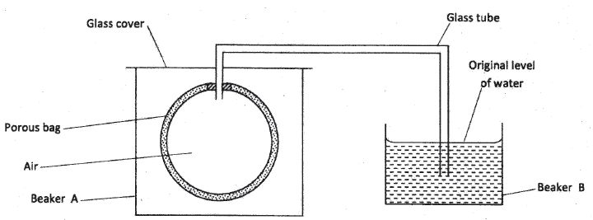
State and explain the observation that would be made in the glass tube if beaker A was filled with hydrogen gas. (3 marks)

- (a) State the Charles’ law. (1 mark)

(b). A certain mass of gas occupies 146 dm³ at 20°C and 98.31 Pa. What will be its temperature if its volume is reduced to 133 dm³ at 101.325 Pa? (2 marks)

- 140cm³ of nitrogen gas diffuses through a membrane in 70 seconds. How long will it take 200 cm³ of carbon (IV) oxide gas to diffuse through the same membrane under the same conditions of temperature and pressure? (N=14, C=12, O=16) (3 marks)

- The graph below shows the relationship between pressure and the temperature of a gas in a fixed volume container.

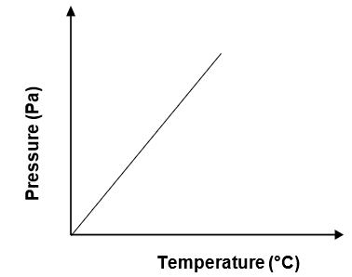
- State the relationship between pressure and temperature that can be deduced from the graph. (1 mark)

- Using kinetic theory, explain the relationship shown in the graph. (2 marks)

- Convert the following temperature into absolute scale. (1mk)
    - 25°C

    - 127°C

- The diagram below shows chromatograms for five different dyes.

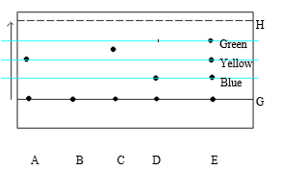
- Name the technique used to separate the dyes. (1mark)

- What is meant by the term solvent front? Indicate its position in the diagram.(2marks)

- Which chromatograms were present in dye E? (2marks)

- Which dye is pure? Explain (2marks)

- Which dye is
i. Insoluble. (1mk)

ii. Most soluble (1mk)

g) Give one condition required to separate the chromatograms present in a dye. (1mark)

- Use the table below to answer the questions that follow.
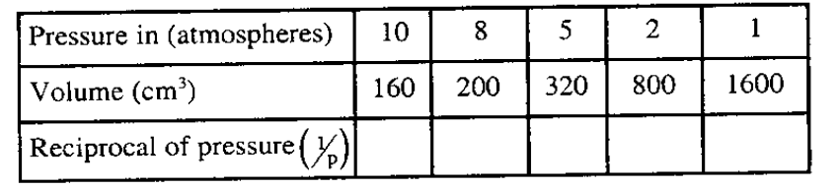
a. Complete the table. (4mks)
b. Plot a graph of volume against reciprocal of pressure. (3mks)

c. use the graph to determine the volume of a gas at a pressure of 3.2 atm. (1mk)

d. What is the relationship between the volume and reciprocal of pressure? (1mk)

- (a). The table below shows some properties of chlorine, bromine and iodine.
Element | Formula | Colour and state at (R.T.P) | Solubility in water
Chlorine | Cl₂ | (i) | Soluble
Bromine | Br₂ | Brown liquid | (ii)
Iodine | I₂ | (iii) | Slightly soluble
Complete the table by giving the missing information in (i), (ii) and (iii) above. (3mks)
i)
ii)
iii)
(b). Chlorine gas is prepared by reacting concentrated hydrochloric acid with either Manganese (IV) oxide or Potassium permanganate.
(i). Write the equation for the reaction between concentrated hydrochloric acid and Manganese (IV) oxide. (1mk)

(ii). What is the role of manganese (iv) oxide in this reaction? (1mk)

(iii). When potassium permanganate is used instead of manganese (iv) oxide, heating is not required. Explain. (1mk)

(iv). Give one advantage of using potassium permanganate over manganese (IV) oxide. (1mks)

(v). Iron metal reacts with chlorine to form substance E. Identify substance E. (1mk)

(vi). Write a chemical equation to represent the reaction in (V) above. .(1mk)



