NAME: _______________________________ADM NO: __________CLASS: ________
DATE: ______________________________ SIGN: _______________________
CHEMISTRY
FORM 2
TERM 2 2025
OPENER EXAMINATION
Time: 1 ¼ Hours
Instructions: Answer all the Questions in the spaces provided
- a) What is rust? (1mk)

b) Give two methods that can be used to prevent rusting (2mks)

- In an experiment to separate a mixture Q of two miscible liquids, Liquids N (B.P 56$°C$) and liquid M (B.P 118$°C$) a student set up the apparatus as shown.
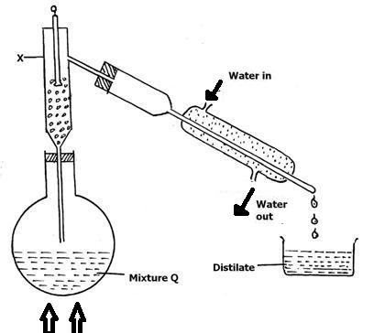
HEAT
- What makes it possible to separate substances using this method? (1mark)

- Name X (1mark)

- What is the purpose of the apparatus labelled X? (1mark)

- Identify one mistake in the set up (1mark)

- Which liquid was collected in the beaker as the first distillate? (1mk)

- Give any two industrial application of this method of separation of mixtures. (2mks)
3. Sports of pure pigments A and B and a mixture Z were placed on a filter paper and allowed
to dry. The paper was then dipped in a solvent. The results obtained were as on the
paper chromatogram.

X
Y
C
W
D
A
B
Z

(a) Which line is the: (2mks)
(i) base line –

(ii) Solvent front –

(b) Which of the pure pigments was a component of Z? Explain. (2mks)

(c) (i) Name a solvent that is used in paper chromatography. (1mk)

(ii) Why is water not a suitable solvent in paper chromatography? (1mk)

(d) Write a chemical equation for the reactions between
(i) Carbon and oxygen - (1mks)

4.Write down the correct chemical equations for the word equation below and then balance them fully
a) sodium oxide +water→ sodium hydroxide (1mk)

b) Copper +oxygen→ Copper (ii) oxide (1mk)

c) Carbon +oxygen→ Carbon (ii) oxide (1mk

5. Define the following terms. (2mks)
- Atomic number

- Radical
6. The grid below represents part of the periodic table. Study it and answer the questions that follow. The letters are not the actual symbols of the elements
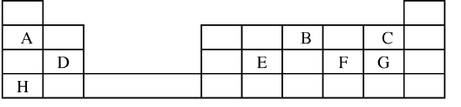
- Select the most reactive metal. Explain (2 mks)

- Select an element that can form an ion with a charge of 3⁻ (2mks)

- Select an alkaline earth metal (1 mks)

iv) Which group 1 element has the highest first ionization energy? Explain
(2mks)
7. The electron arrangement of ions X3 + and Y-2 are 2:8 and 2:8:8 respectively.
a) Write the electron arrangement of elements “X” and “Y” (2mks

b) Write the formula of the compound that would be formed between X and Y. (2mk)
8. An element Y has the electronic configuration of 2:8:5
a) Which period of the periodic table does the element belong. (1mk)

b) Write the formula of the most stable anion formed when element Y ionizes. (2mks)
c) Explain the difference between the atomic radius of element Y and ionic radius. (2mks)

9.The table below shows the relative atomic masses and the percentage abundance of the isotopes L_{1,} L2 of element L
 | Relative atomic masses | % abundance
L₁ | 62.93 | 69.09
L₂ | 64.93 | 30.91
Calculate the relative atomic mass of element L. (3mks)

10. Use the information in the table below to answer questions that follows. That follows. The letters do not represent the actual symbols of the elements.
Elements | B | C | D | E | F
Atomic numbers | 18 | 5 | 3 | 5 | 20
Mass Numbers | 40 | 10 | 7 | 11 | 40
a) Which two letters represent the same element? Give a reason
(2mks)

b) Give the number of neutrons in an atom of element D (1mk)

- a) What is an isotope? (1mk)

b) Determine the relative atomic mass of argon (whose atomic number is 18) and whose isotope mixture is ³⁶ Ar (0.34%) ³⁸Ar (0.06%) ⁴⁰Ar (99.6%) (2 marks)

12. An element “z” has a mass number of 33 and has 18 neutrons
a) What is the atomic number of element Z? (1mk)

b) Write an equation to show how atom of “z” forms an ion. (2mk)

