NAME: _______________________________ADM NO: __________CLASS: ________
DATE: ______________________________ SIGN: _______________________

BIOLOGY
FORM: THREE
TERM 2 2025
OPENER EXAMINATION

INSTRUCTIONS: Answer all the Questions TIME: 1 HR 15 MIN

- Explain the meaning of the following branches of biology ( 2 marks)
- Cytology

b) Mycology
2. Name the hormone involved in stimulating (2marks)
a) Conversion of glycogen to glucose

- Regulation of blood sodium ions levels.

3 . A man weighing 90kg requires 200KJ per gram of body weight while a rat weighing 50g requires 2500KJ per gram of body weight. Explain (2marks)

5. The diagram below represents a plant in a particular division. Use it to answer the question that follow.

a) i) Identify the sub division to which the plant belongs (1 mark)

ii) Give two observable characteristics that support your answer in 5(a) i) above. (2 marks) …
b) State the class to which the above plant belong (1 mark)

6. Name the structures for locomotion in the following organisms (2 marks)
ii) Chlamydomonas
ii) Amoeba
7. Form three students from Riverside High School collected the plant shown below during an education trip.
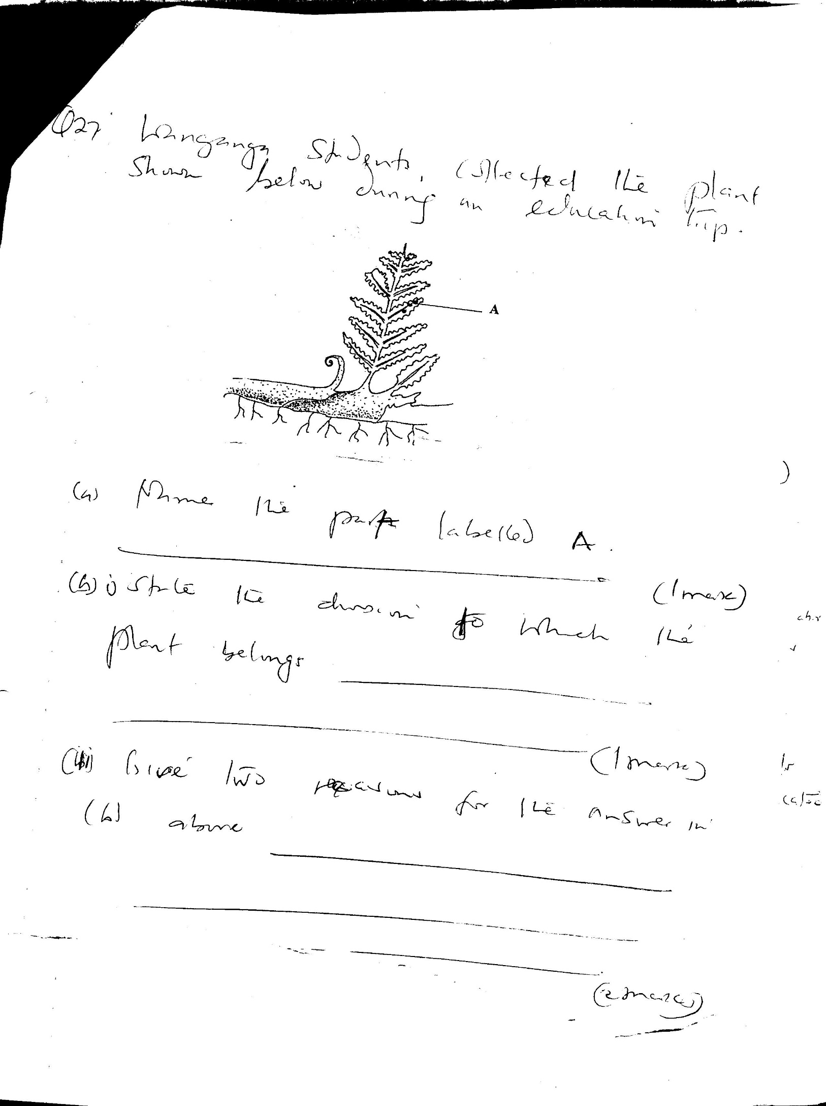

a) Name the part and the functions of structured labelled A. (1 mark)

- State the division to which the plant belongs. (1 mark)

- Give two reasons for the answer in b (i) above. (2 marks)

9. A student discovered the organism below moving about on the teacher’s desk
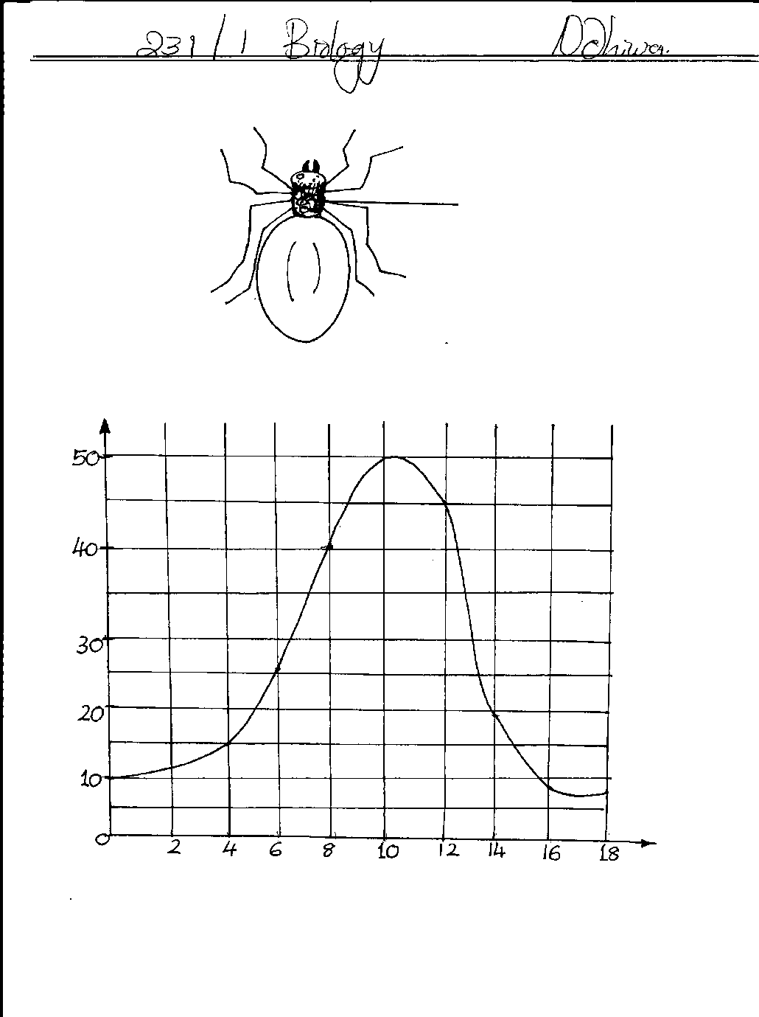
B

- Name the class of which the organism belongs. (1mk)

- Name the part labelled B. (1mk)

10. What is alternation of generation? (1 mark)

11. Differentiate between prokaryotic cells and eukaryotic cells (2marks)

12. Based on the arrangements of vascular bundles (vascular tissues in a transverse section of a root), differentiate between class Dicotyledonae and class Monocotyledonae (2marks)

13. Give three structural differences between class Chilopada and Diplopoda. (3marks)

14. Liver damage leads to impaired digestion of fats. Explain this statement. (2 marks)

15. What is the function of sodium hydrogen Carbonate that is added to test solution of non-reducing sugar
(1mark)
16. A student heated a sample of urine from a person with Benedict's solution. Colour changed to Orange .What conclusion did the student make regarding the health of the person? ( 1 mark)

17. Give four general characteristics of phylum Arthropoda ( 4 marks)

18. Explain why fresh water Protozoa have contractile vacuole while marine protozoa do not ( 2 marks)

19. A certain plant was found to have the following features. Parallel vexation in leaves, sheath like petiole and flower parts in multiples of three.
(a Name the class to which the plant belongs (1 mark)

(b suggest the arrangement of vascular bundles in the stem of the plant. ( 2 marks)

20. Give three economic importance of Kingdom Fungi ( 3 marks)

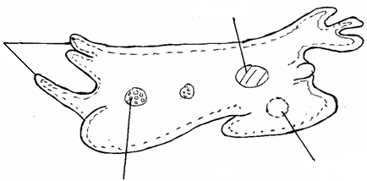
21. The diagram below represents a certain organism.
P
vavacuole
W
M

(a) Identify the kingdom to which the organism belongs. (1mark)

(b) Identify the part labeled P. (1mk)

(c) What is the function of contractile vacuole, part W? (1mk)

22. Other than carbon (IV) oxide, name other products of anaerobic respiration. (2mks)

23. Name the fluid that is produced by sebaceous glands. (1mk)

24 State two characteristics that are used to divide the phylum Arthropoda into classes. (2mks)

