NAME: _______________________________ADM NO: __________CLASS: ________
DATE: ______________________________ SIGN: _______________________
BIOLOGY
FORM: 2
TERM 2 2025
OPENER EXAMINATION

INSTRUCTIONS: Answer all the Questions TIME: 1 HR 15 MIN
- (a)What is a single circulatory system (1mks)

(b)Name an organism which has single circulatory system(1mks).

(c)Name the opening to the chamber of the heart of an insect(1mks).

- Explain the following;
i) When transplanting seedling it’s advisable to remove some of the leaves. (1mk)

ii) Leaves are darker on the upper side than the lower side (1mk)

- Distinguish between cohesion and adhesion force in the movement of water up the xylem vessels. (2mks)

- Give three adaptation of root hair cell to its function. (3mks)

- Highlight three roles played by the stem in a plant. (3mks)

- The diagram below represents a transverse section of a young plant.
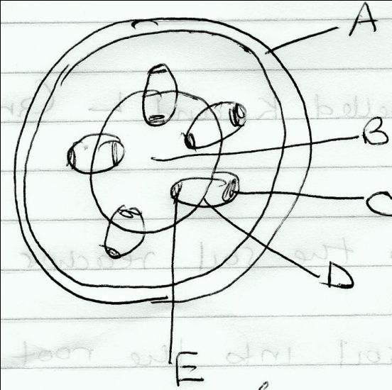
a) From which plant organ was the plant obtained. (1mk)

b) Name the parts labeled A and B. (2mks)

c)List 3 differences between the section shown above and one that would be obtained from the root of the same plant(3mks)

- Name two structures where water loss from plants occurs. (2mks)

- Define translocation. (1mk)

b) Name the vessel in which translocation occurs in plants. (1mk)

- State two significance of transpiration. (3mks)

- Highlight four structural factors that affect transpiration rate. (4mks)

- Name any four forces that are involved in transpiration of water and mineral salts. (4mks)

- Study the equation below and answer the question that follows.
x
C₆H₁₂O₆ + C₆H₁₂O₆ C₁₂H₂₂O₁₁ + H₂O
Y
i) Identify processes x and y. (2mks)

ii) Why are monosaccharide referred to as reducing sugars? (1mk)

iii) Give two other properties of monosaccharide. (2mks)

- The diagram below represents the pathways of water from the soil into the plant.
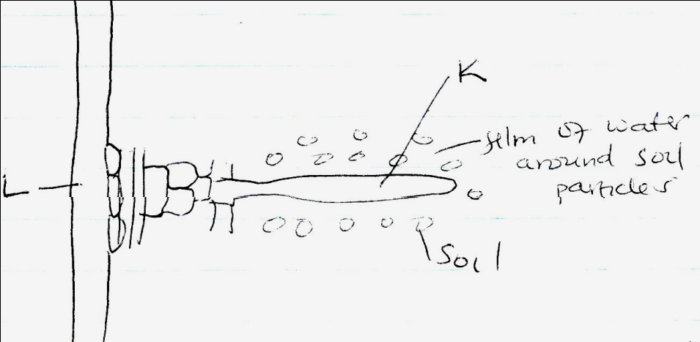
a) Name the structures labeled K and L. (2mks)

b) Explain how water from the soil reaches the structure labeled L. (5mks)

c) Name the process by which mineral salts enter into the plant. (1mk)

- Give the role of the following vascular bundles. (2mks)

i) xylem -

ii) phloem -

- Define the following terms as used in Biology Transpiration(2mks)
i)Transport

ii)Transpiration

