NAME: _______________________________ADM NO: __________CLASS: ________

DATE: ______________________________ SIGN: _______________________

AGRICULTURE
FORM: 3
TERM 2 2025
OPENER EXAMINATION

INSTRUCTIONS: Answer all the Questions TIME: 1 HR 15 MIN

Answer ALL the questions

1. State three reasons why agriculture is important in Kenya’s economy (3mks)

2. List four methods of farming. (2mks)

3. Differentiate between apiculture and aquaculture. (1mk)

4. State 2 human factors that influence agriculture. (2mks)

5. Give 2 reasons why burning of land is discouraged. (2mks)

6. A farmer applied 200kg of CAN (20%) per hectare on his five-hectare maize crop. Calculate the amount of nitrogen the farmer applied on his crop, show your working. (4mks)

7. A farmer is required to prepare 100kg dairy meal containing 20% DCP. Using the Pearson’s square method, calculate the quantity of soya beans (40% DCP) and rice (16% DCP) the farmer requires for the dairy meal. (4mks)

8. Outline the factors to consider when selecting livestock for breeding. (5mks)

9. Differentiate between mothering ability and prolificacy in livestock breeding. (1mk)

10. Name three methods that are in selection of breeding stock in livestock production. (1 ½ mks)

11. Give four disadvantages of inbreeding in livestock. (2mks)

12. State the gestation period or each of the following.
a) Cow ( ½ mk)

b) Sow ( ½ mk)

c) Ewe ( ½ mk)

d) Rabbit ( ½ mk)

13. Give the meaning of the following terms as used in livestock breeding.
a) Close breeding ( ½ mk)

b) Line breeding ( ½ mk)

c) Inbreeding ( ½ mk)

d) cross breeding ( ½ mk)

14. State five signs of heat in cattle. (5mks)

15. The diagram below shows the reproductive system of a hen
a) Name the part labeled K. (1mk)
Ovary

G

^{G}
J

K

b) State one function of each of the parts labeled
G (1mk)

J (1mk)

c) (i) What is the maximum number of eggs a hen can lay in a day. (1mk)

ii) Give a reason for your answer in (i) above. (1mk)

16. State Four disadvantages of natural mating in livestock breeding. (4mks)

17. State four signs of heat in pigs. (2mks)

18. The diagram below shows calf presentations during parturition.

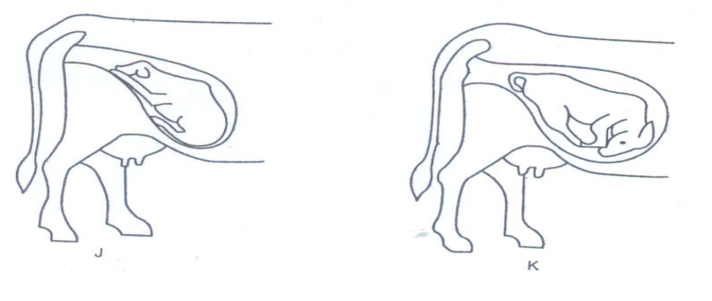
M N
- Name the presentation labeled
M – (1mk)
N – (1mk)
- Which one the two presentations require the services of a qualified stock man. (1mk)

c) State two signs of parturition observed on the vulva. (2mks)

