**NAME: _________________________________ADM NO: ___________CLASS: __________**

**DATE: ______________________________ SIGN: _______________________**

**PHYSICS**

**FORM: 4**

**TERM 1 2025**

**OPENER EXAMINATION**

**INSTRUCTIONS: *Answer all the Questions* TIME: 1 HR 30 MIN**

1. (a) Define electric resistance. (1mk)

(b) Figure below shows a network of three resistors

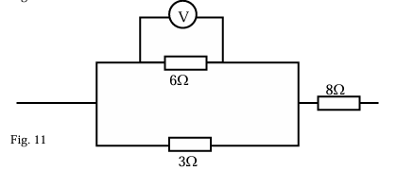

If the voltmeter reads 4V, find the

(i) Effective resistance (2mks)

(ii) Current through the 3Ω resistor (3mks)

(iii) Potential difference across the 8Ω resistor. (3mks)

(c) Explain the difference between **pd** and **emf** (2mks)

2. (a) State the basic law of electrostatics. (1mk)

(b) The distance of separation between the plates of a certain capacitor is reduced. Explain how this affects the capacitance of a capacitor. (2mks)

c) You are provided with the following apparatus used for studying charging of a capacitor. An uncharged capacitor, voltmeter, milliammeter, 6V battery, connecting wires, a switch and a load resistor R.

(i) Draw a circuit diagram that can be used to charge the capacitor. (3mks)

(ii) Use the circuit diagram drawn above to explain how the capacitor gets charged. (3mks)

(iii) State the purpose of resistor R. (1mk)

3. (a) The figure below shows dots which were made by a ticker timer – tape attached to a trolley. The trolley was moving in the direction shown.

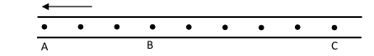

If the frequency used was 60Hz, distance AB = 7.2cm and BC = 12cm, determine

(i) The velocities between AB and BC (2mks)

(ii) The acceleration of the trolley. (2mks)

(b) An object is projected horizontally with a velocity of 40m/s at the top of a cliff 100m from the ground. (Take g = 10m/s2)

(i) Calculate the time taken for the object to hit the ground (2mks)

(ii) What is the range of the object from the foot of the cliff (2mks)

4. (a) Explain the reason why the inside of a helmet is lined with sponge. (2mks)

(b) The figure below shows a balloon filled with air.

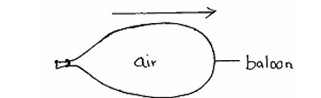

When the mouth is suddenly opened, the balloon moves in the direction shown above by the arrow. Explain that observation. (2mks)

(c) A rock of mass 150kg moving at 10m/s collides with a stationary rock of mass100kg. They fuse after collision. Determine the:

(i) Total momentum before collision. (2mks)

(ii) Total momentum after collision. (2mks)

(iii) Their common velocity after collision. (2mks)

5.(a) Distinguish between evaporation and boiling (1mk)

(b) A jet delivering 0.44g of dry steam per second, at 100°C is directed on to crushed ice at 0.0° C contained in an unlagged copper can which has a hole in the base. 4.44g of water at 0.0°C flow out of the hole per second

(i) How many joules of heat are given out per second by condensing steam and cooling to 0.0oC of water formed? (Latent heat of vaporization of steam = 2.26 x 106JKg-1, c for water = 4200JKg-1K-1) (3mks)

(ii) How much heat is taken in per second by the ice which melts? (2mks)

(iii) Suggest why these amounts above are different (2mks)

(c) Form three students carried out an experiment to determine the specific heat capacity of a metal block using mixture method. Explain three measures they can take in order to enhance accurate findings (3mks)