**NAME: _________________________________ADM NO: ___________CLASS: __________**

**DATE: ______________________________ SIGN: _______________________**

**PHYSICS**

**FORM: 3**

**TERM 1 2025**

**OPENER EXAMINATION**

**INSTRUCTIONS: *Answer all the Questions* TIME: 1 HR 30 MIN**

1. Mercury on a clean glass slide collects into small spherical balls as shown in figure 2 below. Explain why (4mks)

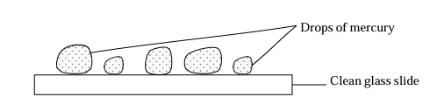

2. State and explain one factor that affects the speed of sound in a solid. (2mks)

3. A policeman standing between two high walls fires a gun. He hears the first echo after 3 seconds and the next 2 seconds later. What is the distance between the wall. (Take velocity of sound = 330m/s). (2mks)

4. A student shouts and hears an echo after 0.6 seconds. If the velocity of sound is 330m/s. Calculate the distance between student and reflecting surface. (2mks)

5. A soldier standing some distance from a wall blows a whistle and hears its echo 3.6 seconds later. How far is the wall from the soldier? (Speed of sound in air is 360m/s) (3mks)

6. One method of producing a weak magnet is to hold a steel rod in the North -South direction and then hammer it continuously for some time. Using domain theory of magnetism explain how this method works. (3mks)

7. Use domain theory to differentiate between magnetic and non-magnetic materials. (2mks

8. An electromagnet is made by winding insulated copper wire on an iron core. State three changes that could be made to increase the strength of the electromagnet. (3mks)

9. A steel ball of mass 0.05kg was placed on top of a spring on a level ground. The spring was then compressed through a distance of 0.2m.

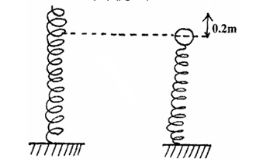

If the spring constant is 15N/m. Calculate the maximum height reached when the spring is released. (4mks)

10. A fathometer produces sound in a ship and receives two echoes where there is a raised sea bed. One after 2.5 seconds and the other after 3.0 seconds. Find the height of the raised sea bank if the velocity of sound in water is 1460m/s. (4mks)

11. The figure below shows a uniform metal rod of mass 100g balanced over a pivot using a spring balance and a mass of 300g. Calculate the tension in the spring. (4mks)

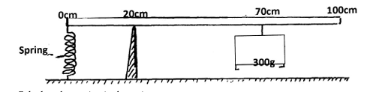

12. Water waves are produced in a ripple tank. The following is an example of the wave from that was observed.

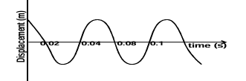

a) (i) From the graph determine the frequency of the wave. (2mks)

(ii) Derive an equation relating velocity of a wave, frequency and wavelength. (3mks)

(b)Ultrasound scanning can be used by doctors to obtain information about internal structure of human body without the need of surgery. Pulses of ultrasound are sent into the body from the transmitter placed on the skin.

(i) The ultrasound used has a frequency of 4.5MHz. State why waves of this frequency are called ultrasound. (1mk)

(ii) A pulse of ultrasound enters the body and its reflection returns to the transmitter after a total time of 1.6×10 $-4$ S. Calculate how far the reflecting surface is given that the average speed of ultrasound in a body = 1500ms-1 (3mks)

(iii) State why the ultrasound sources are transmitted in pulses. (1mk)

13. a) State the principle of transmission of pressure in liquids. (1 mk)

b) A mass of 80kg is being lifted by a force F applied on the other piston of the machine as shown in figure below

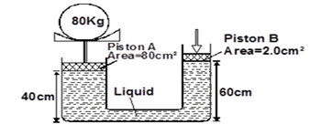

Determine the value of F needed to just lift the 80kg mass given the density of the liquid is 1.2g/cm³. (3 marks)

14. Figure 2 shows two identical thermometers. Thermometer A has a blackened bulb while thermometer B has a silvery bulb. A candle is placed equidistant between the two thermometers

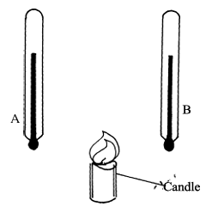

State with a reason the observations made after some time (3mks)