**NAME: _______________________________ADM NO: _________CLASS: __________**

**DATE: ____________________________ SIGN: ____________________**

**MATHEMATICS**

**FORM: FOUR**

**TERM 1 2025**

**OPENER EXAMINATION**

***ANSWER ALL QUESTIONS IN SECTION A AND THREE QUESTIONS IN SECTION B***

1. Find the value of *x* in the equation. *(3 marks)*

2. A businessman deposited Ksh. 80,000 in a savings account at the beginning of the year, which pays $10.5\%$ interest per annum compounded quarterly. Find the amount in the account at the beginning of 5th year. *(3 marks)*

1. Two quantities $Q$ and $R$ are such that $Q$ varies partly as $R$ and partly varies as the square root of R. Determine the equation connecting Q and R given that $Q=500$ when $R=16$ and $Q=800$ when $R=25.$*(3 marks)*
2. The position vectors of points Aand B are $a=3i-2j+4k$ and $b=-2i+j$ respectively. A point R divides line AB externally in the ratio $3:1$. Find the position vector of R in terms of $i, j and k.$*(4 marks)*

6. Find the radius and the coordinates of the center of the circle whose equation is $\frac{ 1}{2}x^{2}+\frac{1}{2}y^{2}=3x-5y-9$ and hence draw the circle in the grid below. *(4 marks)*



1. Simplify $\frac{\sin{{45}^{0}}}{1-Cos {30}^{0}}$ leaving your answer in the form $a\sqrt{b}+\sqrt{c}$ where a, b and c are rational numbers. *(3 marks)*

1. Solve the simultaneous equations given $\begin{matrix}x+3y=10 \\ x^{2}-xy=8\end{matrix}$*(4 marks)*
2. Expand the expression ${\left(x-\frac{1}{2x}\right)}^{6}$ in ascending powers of *x* and hence state the constant term. *(2 marks)*

**SECTION II (30MARKS)**

9. Mr. Moneyman earns a basic salary of sh 12560 and house allowance of sh 2,800 per month. Being a civil servant, he is deducted ksh 2640 for National housing which is exempted from taxation. He has also another tax exemption of ksh. 360 which is deducted for the National Social Security Fund and he is entitled to a monthly personal relief of sh. 1056.

(a) Calculate his taxable income per annum *(3 marks*)

(b) The table below shows the tax rates during that year. Use the table to calculate his PAYE. *(5 marks)*

|  |  |
| --- | --- |
| Taxable income per year (sh) | Rate (sh for every sh. 20) |
| 1 – 72600 | 2 |
| 72601 – 145 200 | 3 |
| 145 201 – 217 800 | 5 |
| 217 801 – 290 400 | 7 |

(c) The following deductions are also made from his monthly income:

Co-operative shares Ksh. 750.00

Co-operative loan Ksh. 575.50

Service charge Ksh. 185.00

Determine Mr. Moneyman’s net monthly salary *(2 marks)*

1. In the figure below **OP** *= $\frac{1}{2}a+b, OR= \frac{7}{2} a-b, RQ= \frac{3}{2}kb+ \frac{1}{2}ma,$* where *k* and *m* are scalars 2PS = 3SR

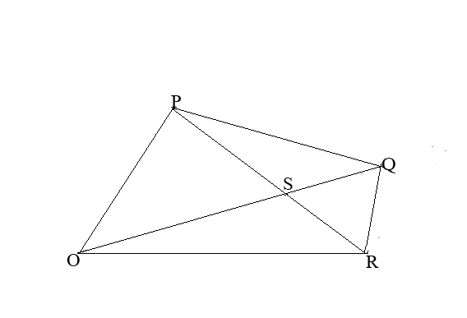

1. Express as simply as possible in terms of **a** and **b** each of the following vectors.
2. **PR** (1 mark)
3. **PS** (1 mark)
4. **OS** (1 mark)
5. Express **OQ** in terms of **a, b,** *k*and*m* (2 marks)
6. If Q lies on **OS** produced with $OQ :OS= 5 :4$, find the value of *k* and *m*. (5 marks)
7. A football match is such that a win garners three points a draw garners one point and a match lost earns no point. The probability of team winning is 40% lose is 45% and a draw 15% if the team plays two games:
8. Draw a probability tree diagram to represent all the possible outcomes. (2marks)
9. The probability that:
10. They earn six points. (2 marks)
11. They win at least one match. (2 marks)
12. They will have at most two points. (2 marks)
13. They will gain more than one points. (2 marks)

11. Three business partners Abila, Bwire and Chirchir contributed Ksh. $120,000$ Ksh $180,000$ and Ksh $240,000$ respectively to boost their business. They agreed to put 20% of the profit accrued back into the business and to use 35% of the profits for running the business. The remainder was to be shared among the business partners in the ratio of their contribution. At the end of the year, a gross profit of Ksh. $225,000$ was realised.

1. Calculate the amount.
2. Put back into the business. (2marks)
3. Used for official operations. (1marks)
4. Calculate the amount of profit each partner got. (4marks)
5. If the amount put back into the business was added to individual’s shares proportionately of their initial contributions, find the amount of Chirchir’s new shares. (3marks)

12. Two lines L1:2y – 3x -6 = 0 and L2 = 3y + x – 20 = 0 intersect at a point A.

1. Find the coordinates of A (3 marks)
2. A third line L4 is perpendicular to L2 at point A. Find the equation of L3 in the form y = mx + c, where m and c are constants. (3 marks)
3. Another line L4 is parallel to L1 and passes through (-2, 3). Find the x and y intercepts of L4  (4 marks)