**NAME: _______________________________ADM NO: _________CLASS: __________**

**DATE: ____________________________ SIGN: ____________________**

**MATHEMATICS**

**FORM: THREE**

**TERM 1 2025**

**OPENER EXAMINATION**

**INSTRUCTIONS: *Answer all the Questions* TIME: 1 HR 30 MIN**

1. Evaluate (3mks)



1. Convert the recurring decimal 12.18 into a fraction. (3mks)
2. The G.C.D of two numbers is 12 and their L.C.M is 240. If one of the numbers is 60. Find the other number. (3mks)
3. A straight line passes through A(-2,1) and B(2,-K). This line is perpendicular to the line 3y+2x=5. Determine the value of k. (3mks)
4. Given that 35x-2y =243 and 32y-y =3; Find value of x and y (4mks)
5. Find all the integral values of x which satisfy the inequality

3(1+ x) < 5x – 11 < x + 45 (4mks)

1. Find the area of a triangular piece of land whose sides are 7m, 9m and 14m. (3mks)
2. Solve the following simultaneous equations. (3mks)

3x + 2y = 13

5x + 3y = 15

1. Calculate surface area of the rectangular based pyramid below. (4mks)

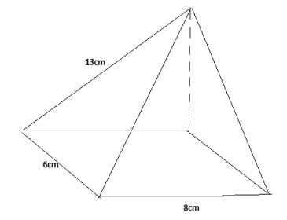

**SECTION II.**

1. The velocity time graph below represents the motion of a car for 10 seconds

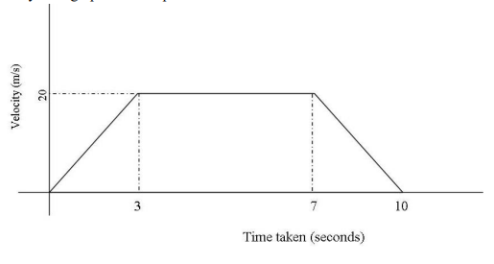

1. Rate of acceleration and the rate of retardation (2mks)
2. Total distance travelled (2mks)
3. The total distance travelled during the first 4 seconds (2mks)
4. The average speed maintained during the entire journey (2mks)
5. The distance travelled at the constant speed. (2mks)
6. The table below shows the distribution of marks obtained by some candidates in a mathematics test.

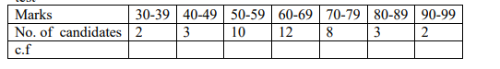

1. State the modal class, calculate the mean mark and the median mark. (6mks)
2. On the graph paper provided, draw a histogram to represent this information. (4mks)