**NAME: _______________________________ADM NO: ___________CLASS: __________**

**DATE: ______________________________ SIGN: _______________________**

**CHEMISTRY**

**FORM: 4**

**TERM 1 2025**

**OPENER EXAMINATION**

**INSTRUCTIONS:**

***Answer all the Questions* TIME: 1 HR 30 MIN**

1.You are provided with the following:- solid lead (II) nitrate, magnesium oxide powder,

dilute sulphuric (VI)acid and distilled water. Describe how you can prepare a dry sample

of lead (II) sulphate (3mks)

2. Study the diagram below and use it to answer the questions that follow:-

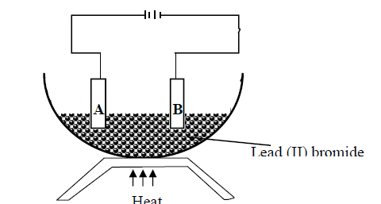

(a) Identify electrodes **A** and **B (2mks)**

(b) Name the product formed at the anode (1mk)

(c) Write the electrode half equation of reaction at electrode **A (1mk)**

3.Below is a simplified scheme of Solvay process. Study it and answer the questions that follow.

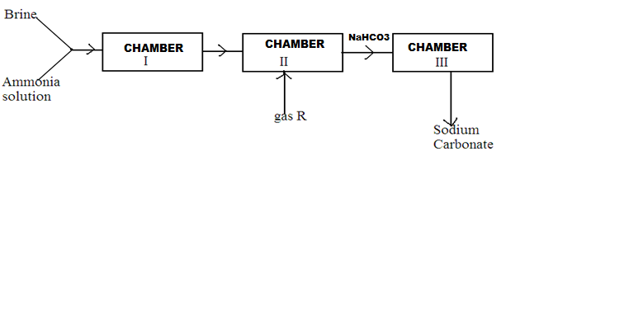

**(a).Identify** gas R. (1mk)

**(b)Write** an ionic equation for the process in chamber III. (1mk)

**(c).Give** **two** uses of sodium carbonate. (2mks)

**1**1. The set up below was used to collect gas **K,** produced by the reaction between water and

calcium metal**.**

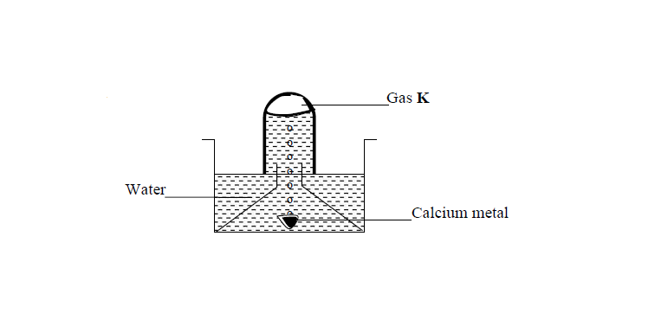

(a) Name gas **K** (1mk)

(b) At the end of the experiment, the solution in the beaker was found to be a weak base. Explain

Why

12. Name the process which takes place when (2mks)

(a) Solid Carbon (Iv) Oxide (dry ice) changes directly into gas

(b) A red litmus paper turns white when dropped into chlorine water

13.A student left some crushed fruit mixture with water for some days. He found the mixture

had fermented. He concluded that the mixture was contaminated with water and ethanol with boiling point of 100oC and 78oC respectively. The set-up of apparatus below are used to separate

the mixture.

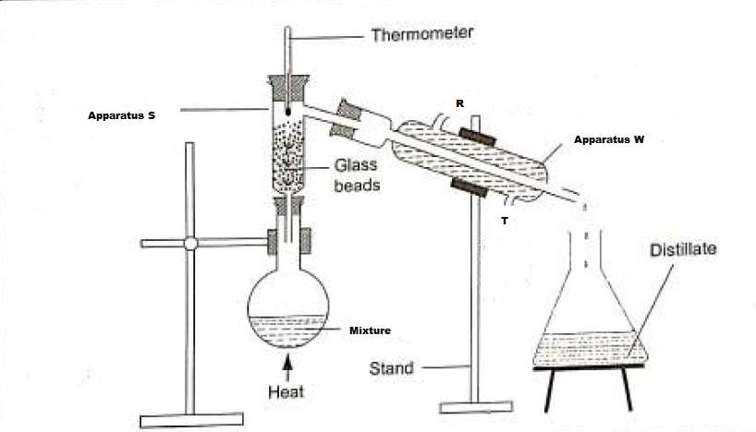

(i) Name the piece of apparatus labelled **W (1mk)**

(ii) What is the purpose of the thermometer in the set-up? (1mk)

iii) At which end of the apparatus **W** should tap water be connected? (1mk)

(iv) Which liquid was collected as the first distillate? Explain (1mk)

(v) What is the name given to the above method of separating mixture? (1m

(vi) State two applications of the above method of separating mixtures (1mk)

(vi) What properties of the mixture makes it possible for the component to be separated

by the above methods? (1mk)

14.The following diagram shows a paper chromatogram of substances A, B, C, and D which

are coloured



(a) Indicate the solvent front on the chromatogram (1mk)

(b) Which substance is pure? (1mk)

(c) Substance **E** is a mixture of **C** and **D**. Indicate its chromatogram in the diagram (1mk)

15.The diagram below shows students set-up for the preparation and collection of oxygen gas

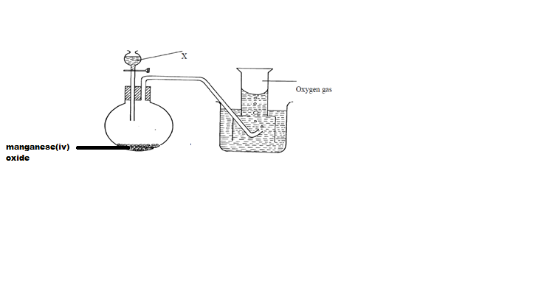

(a) Name substance **X** used (1mk)

(b) Write an equation to show the reaction of sodium peroxide with the substance named in (**1m**

15. A student set-up the experiment as shown below to collect a gas. The wet sand was heated before

heating zinc granules

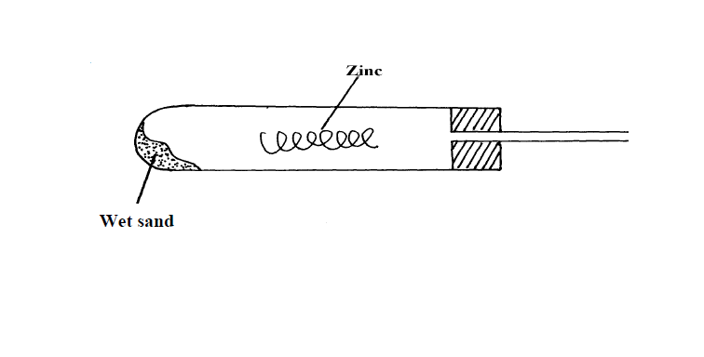

(a) Complete the diagram for the laboratory preparation of the gas (3mks)

(b) Why was it necessary to heat wet sand before heating Zinc granules? (1mks)

16.Below are PH values of some solutions.

|  |  |  |  |  |
| --- | --- | --- | --- | --- |
| Solution | A | B | C | D |
| PH | 6.7 | 13.0 | 2.1 | 7.0 |

**i)** Which solution is likely to be

I. rain water (1 mark)

II. Sodium hydroxide (1 mark)

**ii)** Which substances will be formed when magnesium reacted with solution C?(1 mark

17**.**An experiment was set up using chlorine water as shown below.



(i) Identify gas X. (1mk)

(ii) Write an equation for the production of gas X. (1mk)

(iii)State any TWO uses of chlorine gas. (2mks)

18.The set-up below was used to collect gas **F** produced by the reaction between sodium

peroxide and water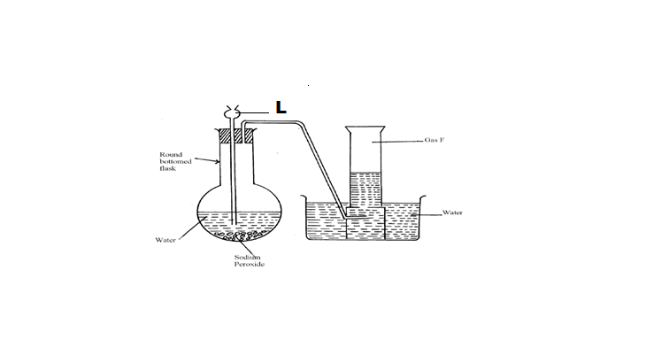

(i) Name gas  **(1mk)**

(ii) At the end of the experiment, the solution in the round bottomed flask was found to be

a strong base. Explain why this was so. (1mk)

(iii) Which property of gas **F** makes it be collected by the method used in the set-up? (1mk

(iv) Give **one** industrial use of gas  **(1mk)**

**19.** Complete the following table to show the colour of the following indicators in acidic and basic solution (2mks)

|  |  |  |
| --- | --- | --- |
| indicator | Colour in |  |
|  | Acidic solution | Basic solution |
| Phenolphthalein |  |  |
| Methyl orange |  | Yellow |
| Litmus solution | Red |  |

20.Define the following terms (2mks)

i) Cation

**ii**)Isotopes

21. The diagram below represents an allotrope of carbon.



a) name the allotrope. (1mk)

b)Explain why:- (2mks)

(i) its slipperly

(ii) Conducts an electric current