**NAME: _________________________________ADM NO: ___________CLASS: __________**

**DATE: ______________________________ SIGN: _______________________**

**CHEMISTRY**

**FORM: TWO**

**TERM 1 2025**

**OPENER EXAMINATION**

**INSTRUCTIONS: *Answer all the Questions* TIME: 1 HR 30 MIN**

1. From the following list of compounds; zinc oxide, solid carbon (IV) oxide, sodium carbonate, nitric (V) acid, iron (III) chloride;

(i)Identify two that sublime. (2 mks)

(ii)Identify a pair that react to form salt and water only. (2 mks)

(iii)Write a word equation for the reaction between sodium carbonate and nitric (V) acid. (2 mk)

1. In an experiment to investigate the percentage of oxygen in air,200cm³ of air was passed over heated copper turning repeatedly until a constant volume of air remained.160 cm³ of air remained at the end of the experiment.

(i)Name one gas remaining in the 160 cm³ of air. (1 mk)

(ii)Determine the percentage of air used up during the experiment. (2 mks)

(iii)What observation would be made during the experiment. (1 mk)

(iv)Write a word equation for the reaction between copper and oxygen. (1 mk)

1. Name the best method to use to separate the following mixtures. (4 mks)

(i)Common salt and water.

(ii)Coloured dyes in ethanol.

(iii)Ammonium chloride and sodium chloride.

(iv)Ethanol and water.

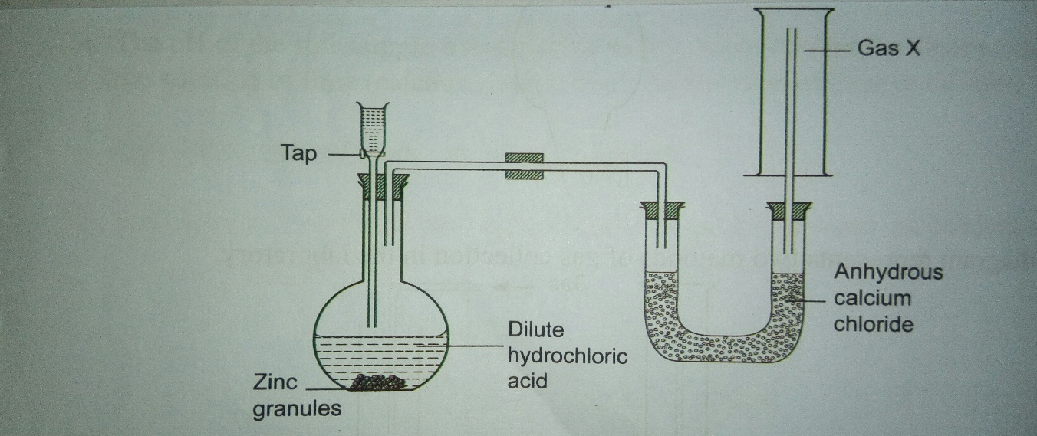

1. Study the set up below and answer the questions that follow.

(a)Identify gas X.(1 mk)

(b)Name the method used to collect gas X and give the property of the gas that enables it to be collected using the method. (2 mks)

(c)Write a word equation for the reaction liberating gas X. (1 mk)

(d)Why is it not advisable to use the following in this method of preparing hydrogen;

(i)Calcium and dilute sulphuric acid (1 mk)

(ii)Zinc and Nitric (V) acid. (1mk)

(e)What is the purpose of anhydrous calcium chloride in the U-tube? (1mk)

(f)Name another compound that could serve the same purpose as anhydrous calcium chloride. (1 mk)

1. When magnesium is burnt in air,it reacts with oxygen and nitrogen gas giving a white ash.Write two equations for the two reactions that take place. (2 mks)
2. 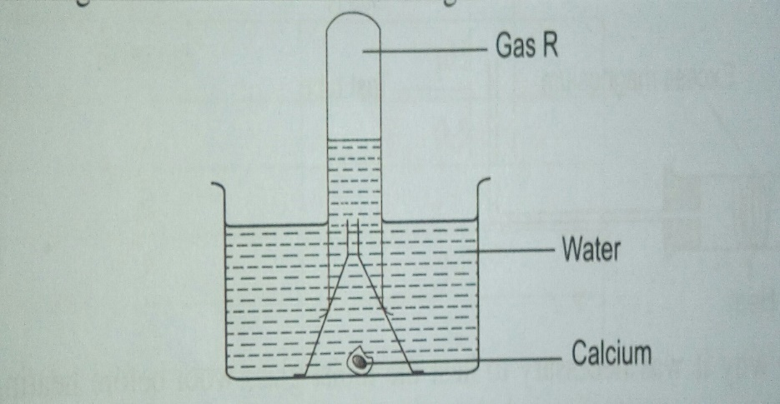The diagram below was used to investigate the action of water on calcium metal.

(a)Identify gas R. (1 mk)

(b)The remaining solution in the beaker changes red litmus paper to blue. What does this suggest about the resulting solution. (1 mk)

(c)Write a word equation for the reaction. (1 mk)

(d)What would be observed if Carbon(IV)oxide is bubbled through the solution. (1 mk)

7 .a) Name the particles that are found in an atom. (3 mks)

b)Atoms are said to be electrically neutral. Explain. (2 mks)

c)Element Q has 18 neutrons and a mass number of 34.

i)How many protons are present in element Q? (1 mk)

(ii)Write the electron arrangement of element Q. (1 mk)

(iii)To which period and group does Q belong? Explain your answer. (2 mks)

8.(a)In an experiment to investigate what happens when steam is passed over heated magnesium, wet sand or cotton wool soaked in water is heated first before heating magnesium. Why is it necessary? (1 mk)

(b) Write a word equation for the reaction between magnesium and steam. (1 mk)

(c)Write a word equation for the reaction between iron and steam. (1 mk)

9.(a)What is the chemical name of rust?(1 mk)

(b)A form one student in attempt to stop rusting put copper and magnesium in contact with iron as shown.

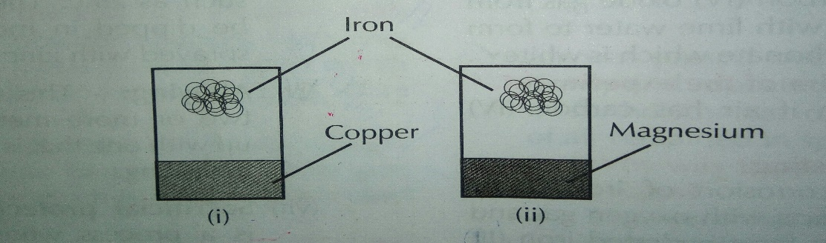

(i)The set ups were left outside for two weeks. Where did rusting occur? Explain. (2 mks)

(ii)Name the method used by the student to prevent rusting. (1mk)

(iii)How does painting prevent rusting? (2 mk)

10.State the use of the following apparatus as used in the laboratory.

(a)Pipe-clay triangle (1 mk)

(b)Desiccators (1 mk)

(c)Wire gauze (1 mk)