**NAME: _________________________________ADM NO: ___________CLASS: ______**

**DATE: ______________________________ SIGN: _______________________**

**BIOLOGY**

**FORM: 4**

**TERM 1 2025**

**OPENER EXAMINATION**

**INSTRUCTIONS: *Answer all the Questions* TIME: 1 HR 30 MIN**

1. (a) State **three** ways through which excessive use of pesticides may affect soil fertility

(3 marks)

(b) Give **three** control measures of schistosomiasis (Bilharzia). (3 marks)

(c) Name the method that would be used to estimate the population of blackjack in a

garden. (1mark)

1. Name the organism that;

(a) causes malaria. (1mark)

(b) Transmits malaria. (1 mark)

(c) State four control measures for malaria. (4 marks)

1. Study the diagram below and answer the questions that follows.

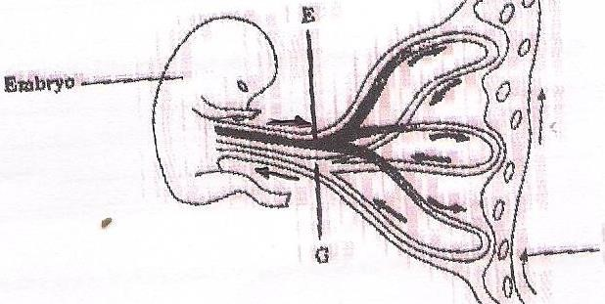

**Maternal blood flow**

**G**

**E**

**Embryo**

(a) Give the names of the parts labeled **E** and **G**

(2marks)

(b)Name one substance that is at high concentration in **E**. (1mark)

(c) i) In which organ does this kind of exchange shown above occur?

(1mark)

ii) How is the structure you have named in c) i) above adapted to its function. (4 marks)

1. a) Which substance surrounds the embryo during its development. (1mark)

b) State **two** roles of the substance you have named in 4(a) above. (2 marks)

1. Below is a graphical representation of the concentration of hormones involved in the

menstrual cycle against time. Study it and answer the questions that follow

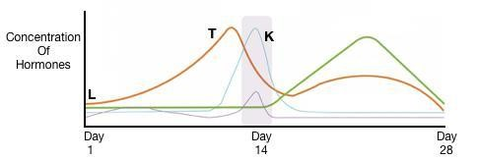

a)

Name hormone K.

(1

mark

)

* + 1. Did pregnancy occur based on the cycle above? Explain your answer. (2 marks)
    2. Name the organ that secretes hormone T. (1 mark)
    3. Identify the process that occurs during the time labelled L. (1 mark)

1. Name **two** types of curves obtained during measurement of growth in living things.

(2 marks)

1. Name the chemical substances in plants that; (3 marks)

a) Promote ripening of fruits

b) Flowering in plants

c) Leaf fall in plants

1. State the functions of the following parts of a germinating seed. (2 marks)

a) Coleorhiza;

b Coleoptile;

1. The diagram below represents a stage of growth in two different seeds.

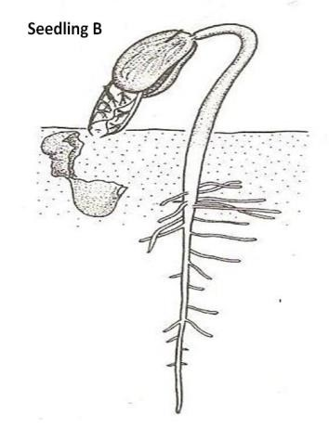

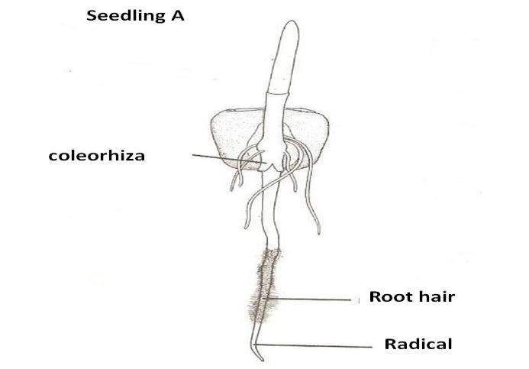

a) Identify the type of germination exhibited by seedlings A and B. (2 marks)

Seedling A

Seedling B

b) Distinguish between the two types of germination stated in (a) above. (3 marks)

c) State the role of oxygen during germination. (3 marks)

d) Account for the loss of weight in cotyledons in germinating seeds. (2 marks)

1. Define seed dormancy. (1mark)
2. What causes seed dormancy in a seed? (3marks)