**NAME: _________________________________ADM NO: ___________CLASS: __________**

**DATE: ______________________________ SIGN: _______________________**

**BIOLOGY**

**FORM THREE**

**TERM 1 2025**

**OPENER EXAMINATION**

**INSTRUCTIONS: *Answer all the Questions* TIME: 1 HR 30 MIN**

1. Animals have complex excretory organs as compared to the plants. Explain. (2 marks)

2. Name two parts in the kidney nephron where re-absorption of water takes place. (2 marks)

3. a) What is meant by the term taxonomy? (1mark)

(b) The scientific name of a rat is Rattus norvegicus (2marks)

(i) Write the name correctly

(ii) Identify the genus and species names

(5)The figure shown below represents a mammalian structure. Use it to answer the questions that

follow

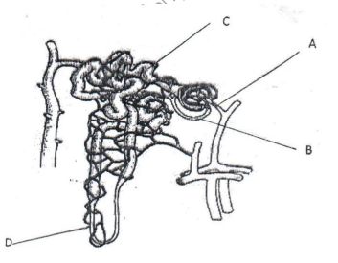

(a) Name parts labelled A, C, and D on the diagram (3 marks)

(b) (i) State structural difference between Part A and B (1mark)

(ii) State the importance of the above difference in (b) (i) above (1 mark)

(c) Explain how part D is adapted to its function (2 marks)

(d) Name two materials found in B and absent in D (2 marks)

(7)State one way certain plants get rid of the following metabolic wastes: (2mks)

(12) A certain organ K was surgically removed from a rat. It was later found that there was a drastic increase in glucose level in the blood. When substance Q was injected into the animal the glucose in the blood went back normal. Identify (2 marks)

i) Organ K:

ii) Substance Q:

c) Explain why a person discharges urine more often when the environmental temperatures are low than when they are high. (2 marks)

(16) State three adaptations of the proximal convoluted tubule to its function. (3 marks)

(20) Explain why a rat, though small eats more frequently than an elephant (2marks)

(22) (a) State two functions of the kidney (2marks)

(b) Name two substances that are not found in urine of a healthy person (2marks)

(c) Name two diseases that affect the kidney (2marks)

(23) (a) State two structural modifications of the kidneys of deserts animals like kangaroo rat. (2marks)

(24) Below is an organism, study it and answer questions that follow:

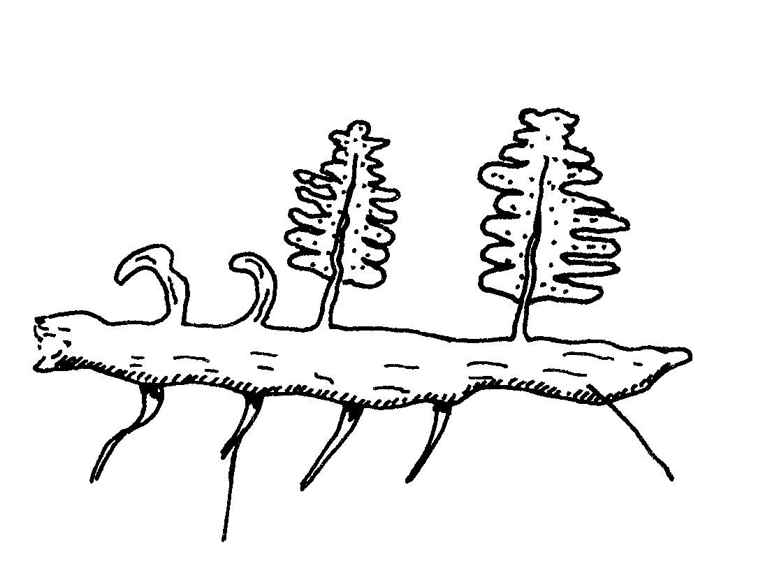

Rhizome

Adventitious roots

1. With reasons identify the division into which the students classified the plant. (2marks)

Division:

Reasons:

b) (i) Name the structure that produces spores in this plant. (1mark)

c) State the features of this plant that made the student classify it in the kingdom Plantae. (2marks)

16. In summary, describe structure and function of the skin. (10marks)