**NAME: _________________________________ADM NO: ___________CLASS: __________**

**DATE: ______________________________ SIGN: _______________________**

**BIOLOGY**

**FORM 2**

**TERM 1 2025**

**OPENER EXAMINATION**

**INSTRUCTIONS: *Answer all the Questions* TIME: 1 HR 30 MIN**

1. The equation below represents a physiological process that occur in plants.

6CO2 + 6H2O C6H12O6 + 6O2

(a) Name the process and state two conditions necessary for the process to occur (3mks)

(b) Identify two adaptations of the leaf for the process indicated by the equation above.(2mks)

2 (a) Identify the function following parts of a microscope (3marks)

(i)Diaphragm

(ii)Condenser

(iii)Fine adjustment knob

(b)Differentiate the term resolution and magnification as used in microscopy(2mark)

**3**. The diagram shown below shows a leaf that was used to study photosynthesis. After the experiment, drops of Iodine solution were placed on the processed leaf

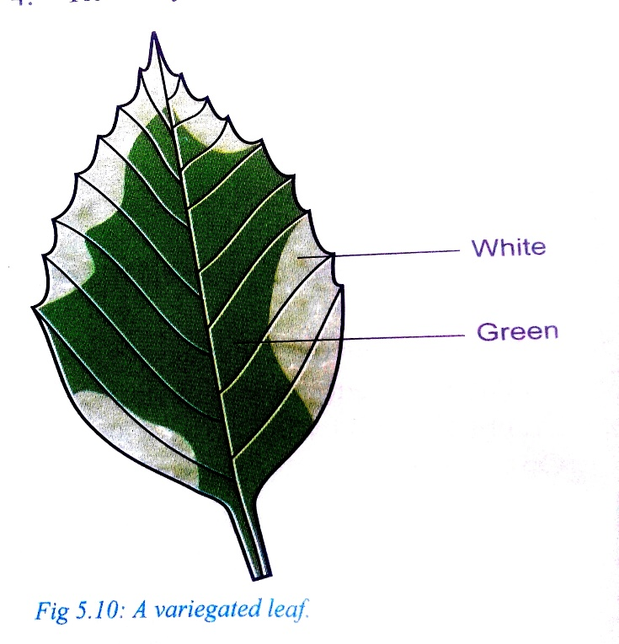

1. Which food substance was being tested for? (1mark)
2. Fill in the table below to show the colors observed in the following regions

(2marks)

|  |  |
| --- | --- |
| **Region** | **Color** |
| **White** |  |
| **Green** |  |

1. Account for observation made on white part of the leaf (2marks)

**4.** A solution of sugar cane was boiled with hydrochloric acid and sodium hydrogen carbonate was added to the solution, which was then boiled with Benedict’s solution. An orange precipitate was formed.

a)Why was the solution boiled with hydrochloric acid and sodium hydrogen carbonate added(2mks)

b) To which class of carbohydrates does sugar cane belong to (1mk)

c) State the form in which carbohydrates are;

(i) Stored in plants (1mk)

(ii) Stored in animals (1mk)

5. (a) A cell was found to have the following under a light microscope; cell membrane, irregular in shape and small vacuoles. Identify the type of the cell above (1mk)

(b)Name the organelle that performs the following functions;

(i)Osmoregulation in amoeba (1mk)

(ii) Digestion and destruction of worn out cells (1mk)

(iii)Transport of packaged glycoproteins. (1mk)

**6**. The diagram alongside was drawn by a student after observing a human cheek cell under a microscope.

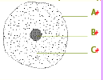

(a) Suggest the type of microscope the student used. Give a reason. (2 marks)

(b) Name the parts labelled A, B and C. (3 marks)

(c) State the functions of parts A, B and C. (3 marks)

(d) State two features which make this cell different from a plant cell (2 marks)

**7**. Differentiate between hemolysis and crenation (2marks)

8. State the importance of the following processes in preparation of temporary slides (2mks)

(a)Staining

(b)Making thin sections

9. State the functions of the following parts of a microscope (2marks)

a) Condenser

b) Diaphragm

10. The experiment set up shown below was used to investigate a physiological process

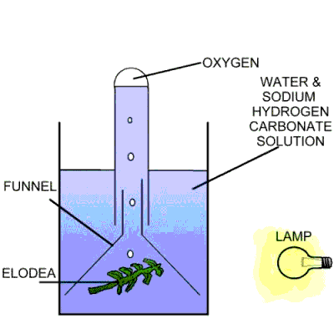

1. What was the aim of the experiment(1mark)
2. Why was Sodium Hydrogen Carbonate added in the water (2marks)
3. How can one confirm that the gas released in the experiment is Oxygen(1mk)

11. State 2 roles of active transport in living organisms(2mks)

12. A student counted 20 cells across a field of view whose diameter was 3mm. Calculate the size of one cell in micrometers (3marks)