**NAME: _________________________________ADM NO: ___________CLASS: __________**

**DATE: ______________________________ SIGN: _______________________**

**AGRICULTURE**

**FORM FOUR**

**TERM 1 2025**

**OPENER EXAMINATION**

**INSTRUCTIONS: *Answer all the Questions* TIME: 1 HR 30 MIN**

1. Name **two** diseases that affect female animals only (2mks)
2. What is a vaccine? (1mk)

1. a) Define the term notifiable disease in cattle (1mk)
2. Name **four** notifiable diseases of livestock (4mks)
3. State **three** signs of anthrax disease observed in the carcass of cattle (3mks)

1. Differentiate between active immunity and acquired passive immunity (1mk)
2. State **one** chemical used in relieving a ruminant animal of bloat (1/2mk)

1. Name **two** diseases of poultry that are controlled by vaccination (2mks)
2. Name the casual organism for foot rot disease (1/2mk)
3. Give **four** pre disposing factors of foot rot disease in sheep (4mks)
4. Give **two** symptoms of foot rot in sheep (2mks)
5. Discuss black quarter under the following sub-headings:-
   1. Animal affected (1mk)
   2. Casual organism (1mk)
   3. Symptoms of disease (3mks)

* 1. Control measures (2mks)

1. The illustration below shows a dairy cow suffering from a disease three days after calving down. The cow went down with its head turned back and was unable to stand.

- 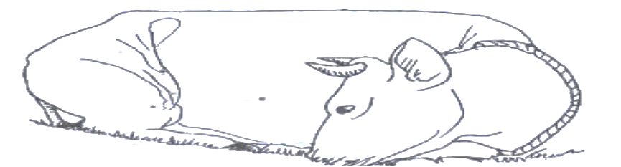

a) Which disease did the cow suffer from? (1mk)

b) State **two** ways of preventing the disease you have identified in (i) above. (2mks)

**13.** Differentiate between antibiotics and antibodies. (1mk)

14. List four routes through which pathogens can enter the body of an animal. (4 mks)

15. Give **two** conditions that reduce the quality of eggs for hatching. (2mks)

16. Study the diagram of an egg be1ow and answer the questions that fol1ow:

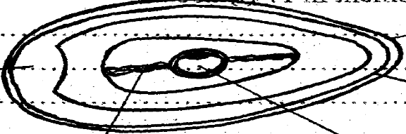

***M***

***N***

***P***

***L***

***O***

1. Name the parts labeled **M,L, N, O** and **P** (5mks)
2. State the functions of the parts **M** and **L** (2mks)

1. Why should the egg be turned during incubation (1mk)

1. State **three** abnormalities of eggs that can be detected during egg candling. (3mks)