**NAME: _________________________________ADM NO: ___________CLASS: __________**

**DATE: ______________________________ SIGN: _______________________**

**AGRICULTURE**

**FORM 2**

**TERM 1 2025**

**OPENER EXAMINATION**

**INSTRUCTIONS: *Answer all the Questions* TIME: 1 HR 30 MIN**

1. List four methods of farming (4mks)

2. Name three underground water sources on the farms (3mks)

3 State four aspects of rainfall that a crop farmer should consider when choosing what to grow in certain regions. (4mks)

4. Name three surface irrigation methods (3mks)

5. a. State three benefits of rolling as a tertiary operation in seed bed preparation. (3mks)

b. State three methods of land clearing. (3mks)

6. State three types of spanners that can be found in a farm. (3mks)

7. State four dairy goats that are kept in farms. (4mks)

8. Name the appropriate tool for the following uses.

i. Cutting thin sheets of metal when constructing a farm structure (1mk)

ii. Measuring length of timber when constructing (1mk)

9. State four practices on the farm that makes agriculture to be viewed as an art. (4mks)

10. Name the branch of horticulture involved in the production of the following crops

i. Cabbages ________________________________ (1mk)

ii. avocado _________________________________ (1mk)

11. State three factors influencing soil formation (3mks)

12. State two advantages of mixed farming (2mks)

13. Below is a land preparation operation. Study it and answer the questions that follow.

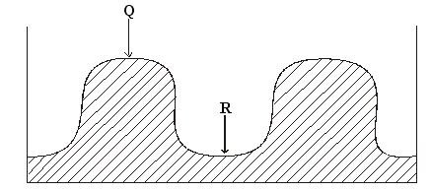

a) Identify the operation. (1mk)

b) Name the parts Q and R. (1mk)

c) Name one crop that can be planted in part labeled R.(1mk)

d) What is the advantage of planting the crop named in (c) above in the part labeled R. (1mk)

14.Name two types of inventory records . (1mk)

15. Use the diagram below to answer the questions that follow

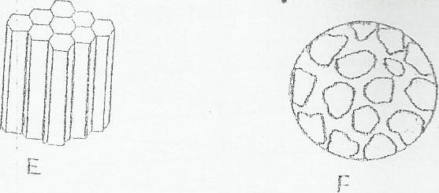

a) Identify each of the soil structures labeled E and F (1mark)

b) Give one place where the soil structure labeled F can be found. (1mark)

c) State three ways in which a farmer can improve the structure of waterlogged

clay soil. (3marks).