NAME: ADM No:
CLASS: SIGN:
232/1
PHYSICS FORM 4
PAPER 1
OPENER EXAMINATION: TERM 2 2024
TIME 2 HRS

INSTRUCTIONS
i) Answer All questions in the spaces provided.
ii) Use the following CONSTANTS where applicable.
iii) All working must be clearly shown for numerical questions.
iv) Candidates should check to ascertain that all questions are printed as indicated in the table below.
Constants
i) Density of water = 1g/cm³ or 1000kg/m³.
ii) Gravitational acceleration = 10m/s².

SECTION A (25 MARKS)
- The figure below shows a Vernier caliper scale.

If the Vernier calipers used had a zero error of -0.02 what is the actual reading of the scale. (2mks)

- Find the total pressure experienced by a diver 8 meters below the sea surface. (3mks)
Take; Atmospheric pressure = 103360N
Density of sea water = 1030 kg/m³

- The figure below shows an electric heater placed midway between flask A and B. flask A is shinny on the outside and flask B is blackened on the outside.
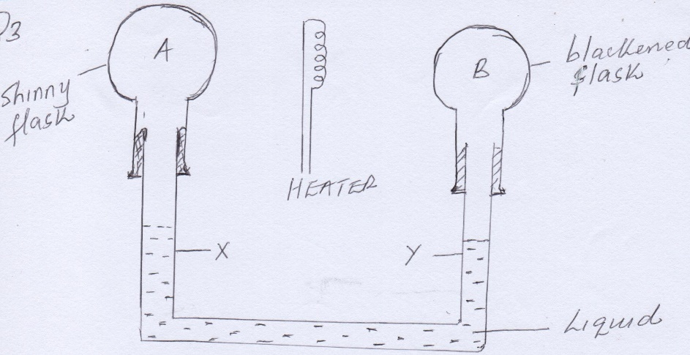
- Name the process by which heat travels from heater to the flask. (1mk)

- State the observation that will be made. (1mk)

- The following is a graph of force against extension for a spring

Force (N)

Extension (cm)
On the same axes, sketch a graph of force against extension for a spring double the length, same thickness, same material as the spring above (1mk)

- Water flows steadily along a horizontal pipe at a volume rate of 8.0 x 10⁻³ m³/s. if the area of cross section of the pipe is 20cm². Calculate the velocity of the fluid. (3mks)

- Two parallel forces are acting on a body of mass 0.7 kg as shown in the figure below.

12 N 0.7 Kg 25 N
Calculate the acceleration of the 0.7Kg mass (3mks)

- (a) State pressure law. (1mk)

- Air is compressed at a constant temperature until its pressure rises from 82cmHg to 140cmHg. If the initial volume of air is 85cm³, find the final volume of air. (3mks)

- Explain the cause of random motion of particles as observed in Brownian motion in a smoke cell experiment. (1mk)

- The figure below shows a machine being used to raise a load. Use the information given in the figure to answer questions below.
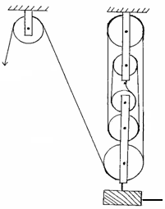
Effort
Load

(a) Determine the velocity ratio (V.R) of the machine. (1 mark)

- If a load of 800N is raised by applying an effort of 272N, determine the efficiency of the machine. (3 mark)

- Figure below shows a liquid in a long cylindrical tube closed at one end with a cork. The cork is tight fitting but movable.
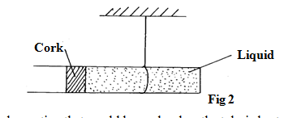
State and explain the observation that would be made when the tube is heated uniformly. (2mks)
SECTION B (55 MARKS)
- A) state Archimedes principle. (1mk)

- Figure below shows an experiment used to determine the density of an irregular piece of metal. The mass of metal in air is 200g.
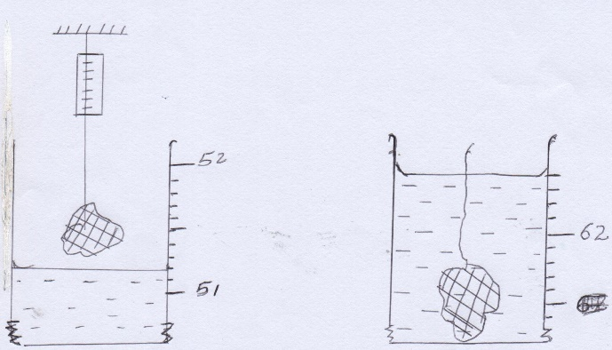
- Determine the volume of the stone in cubic metres. (2mks)

- Calculate the density of the metal to 3 significant figure. (2mks)

- Given that the density of water is 1g/cm³, determine;
- The mass of water displaced. (2mks)

- The upthrust acting on water. (2mks)

- The relative density of the metal. (2mks)

- A solid displaces 5.5cm3 of paraffin when floating and 20.5cm³ when fully immersed. Given that the density of paraffin is 800kg/m³, determine the density of the solid. (3mks)

- a) State one factor that affect the boiling point of a liquid. (1mk)

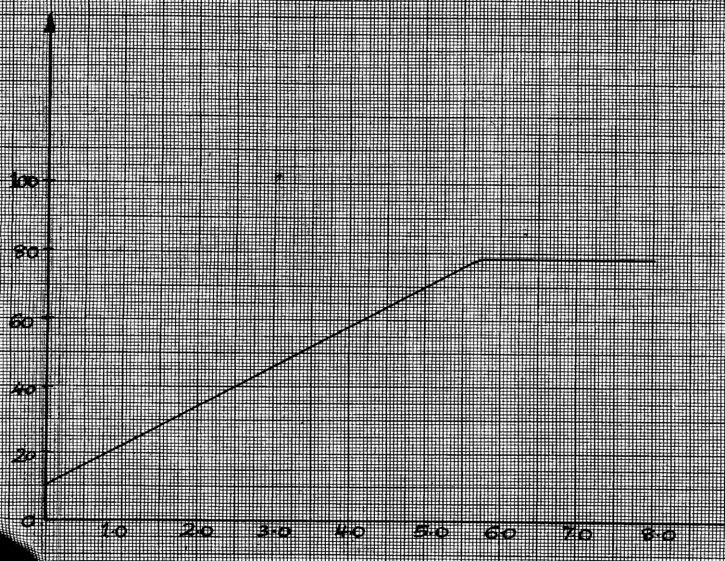
b) 100g of a liquid at a temperature of 10°C is poured into a well lagged calorimeter. An electric heater rated 50W is used to heat the liquid. The graph in Figure 8 below shows the variation of the temperature of the liquid with time.

Time, t (minutes)
Temp (⁰c)
kelvin (minutes)

- From the graph, determine the boiling point of the liquid. (1mk)

- I) Determine the heat given out by the heater between the times t=0.5 minutes and
t=5.0 minutes. (2mk)

II) From the graph determine the temperature change between the times t=0.5 minutes and t=5.0 minutes.

(1mk)
III) Hence determine the specific heat capacity of the liquid. (3mk)

- 1.8g of vapor was collected from the liquid between the times t=6.8 minutes and t=7.3 minutes. Determine the specific latent heat of vaporization of the liquid. (4mks)

- a) Define angular velocity. (1mk)

b) The diagram below shows an object of mass 2.0kg whirled in a vertical circle of radius 0.8m at a uniform speed of 50ms⁻¹.
2.0Kg
r=0.8m
A
O
B

Determine;
i) The centripetal force on the object. (3mks)

ii) The tension in the string when the object is at A. (2mks)

iii) The tension in the string when the object is at B. (2mks)

- The speed of rotation is gradually increased until the string snaps. At what point is the string likely to snap? Explain. (2mks)

- a) State the principle of parallel forces. (1mk)

- A uniform plank of wood weighing 50N and of length 5m is suspended by two ropes A and B, 1.5m a part A is 2m from end and B is 1.5m from the other end, as shown in fig. 1 below. A concrete block of weight 100N is suspended from the center of the plank.

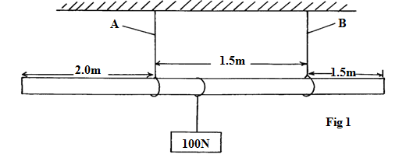
Calculate the tension, T_{A} on the string A (3mks)

- I) state two ways in which the stability of a body can be increased. (2mks)

II) State one way in which vehicle assembling companies enhances stability in vehicles. (1mks)

- The figure below shows a ball of mass 50kg being thrown from a top of wall 20m high with a horizontal velocity of 20m/s. It stuck the piston A of hydraulic lift and no water splashed out. The other piston B had a weight of 25200N placed on it. Assuming the tap was opened at the time the ball stuck the piston A.

Determine;
- The time taken by the ball to strike the surface of piston A. (3 mks)

- The distance from the foot of the wall to where it hit piston A. (2 mks)

- The vertical velocity with which the ball struck piston A. (2 mks)

- The force with which the ball struck piston A. (2 mks)

- The area of piston B if the load on the piston B did not move and that the two pistons were initially at the same level. (3 mks)

