**NAME: …………………………………………………………………………………. ADM. NO……… SCHOOL………………………………………………………………………..DATE………………**

**232**

**PHYSICS(THEORY)**

**OPENER EXAMINATION: TERM 2 2024**

**TIME: 2½ HOURS**

**PHYSICS FORM 2**

**INSTRUCTIONS TO CANDIDATES:**

* *Write* ***your name, admission number****,* ***date*** *of examination in the spaces provided above.*
* *This paper consists of sections:* ***A*** *and* ***B.***
* *Answer* ***all*** *the questions in section* ***A*** *and* ***B*** *in the spaces provided.*
* *All working* ***must*** *be clearly shown in the spaces provided.*

**For Examiner’s Use Only**

|  |  |  |  |
| --- | --- | --- | --- |
| **SECTION** | **QUESTION** | **MAXIMUM SCORE** | **CANDIDATE’S SCORE** |
| **A** | 1 – 17 | 40 |  |
| **B** | 18 | 6 |  |
| 19 | 13 |  |
| 20 | 11 |  |
| 21 | 6 |  |
| 22 | 8 |  |
| 23 | 10 |  |
| 24 | 6 |  |
| **TOTAL SCORE** |  | **100** |  |

**SECTION A (40 MARKS)**

1. A mass of 7.5 kg has weight of 30N on a certain planet. Calculate the acceleration due to gravity on this planet. (3mks)

………………………………………………………………………………………………………………………………………………………………………………………………………………………………………………………………………………………………………………………

1. The diagram below shows the scale of the vernier callipers. If the vernier calliper has a zero error of + 0.03 cm. Determine the correct reading. (2mks)

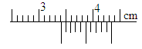

……………………………………………………………………………………………………………………………………..………………………………………………………………………..

1. Explain the cause of random motion of smoke particles as observed in Brownian motion experiment using a smoke cell. (2 mks)

………………………………………………………………………………………………………………………………………………………………………………………………………………………………………………………………………………………………………………………

1. When a Bunsen burner is lit below a wire gauze, it is noted that the flame initially burns below the gauze as shown in the figure below. After sometime the flame burns below as well as above the gauze.

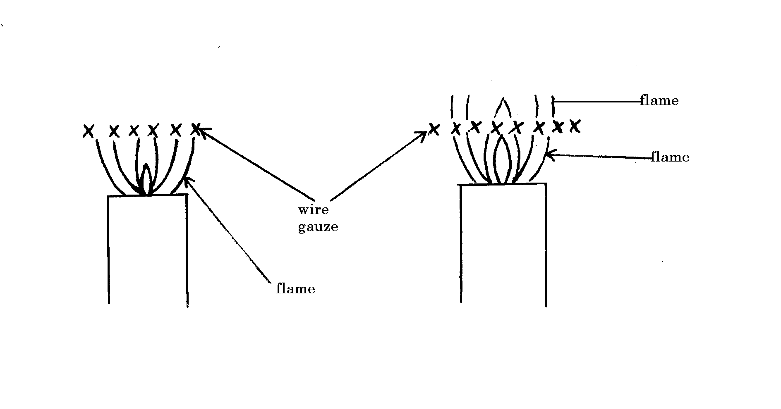

Explain this observation (2 mks)

………………………………………………………………………………………………………………………………………………………………………………………………………………………………………………………………………………………………………………………

1. A small chain is often seen hanging at the back of a petrol carrying lorry. State and explain its significance. (2mks)

………………………………………………………………………………………………………………………………………………………………………………………………………………………………………………………………………………………………………………………

1. (a) State the right hand grip rule. (1mk)

………………………………………………………………………………………………………………………………………………………………………………………………………………………………………………………………………………………………………………………

(b) What is an electromagnet? (1 mk)

………………………………………………………………………………………………………………………………………………………………………………………………………………………………………………………………………………………………………………………

1. The diagram below shows a flask fitted with a glass tube dipped into a beaker containing water at room temperature. The cork fixing the glass tube is tight.

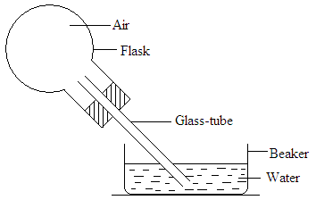

State with reason what would be observed if cold water is poured on to the flask. (2mks)

………………………………………………………………………………………………………………………………………………………………………………………………………………………………………………………………………………………………………………………

1. State t**wo** conditions under which a pinhole camera may form an image on its screen which has the same size as the object. (2mks)

………………………………………………………………………………………………………………………………………………………………………………………………………………………………………………………………………………………………………………………

1. The figure below shows two identical thermometers. Thermometer A has a blackened bulb while thermometer R has a silvery bulb. A candle is placed equidistant between the two thermometers

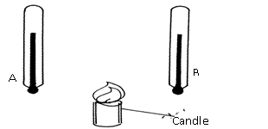

* 1. State the thermometer which records a higher temperature after sometime (1 mk)

………………………………………………………………………………………………………

* 1. Give reason for (a) above (1mk)

………………………………………………………………………………………………………………………………………………………………………………………………………………

1. Name two factors that affect stability of a body. (2mks)

………………………………………………………………………………………………………………………………………………………………………………………………………………

1. Explain how an increase in temperature affect surface tension of a liquid. (2 mks)

………………………………………………………………………………………………………………………………………………………………………………………………………………………………………………………………………………………………………………………

1. The figure below shows a u-tube manometer containing oil of density 0.9g/cm3. One end is connected to a gas tap.

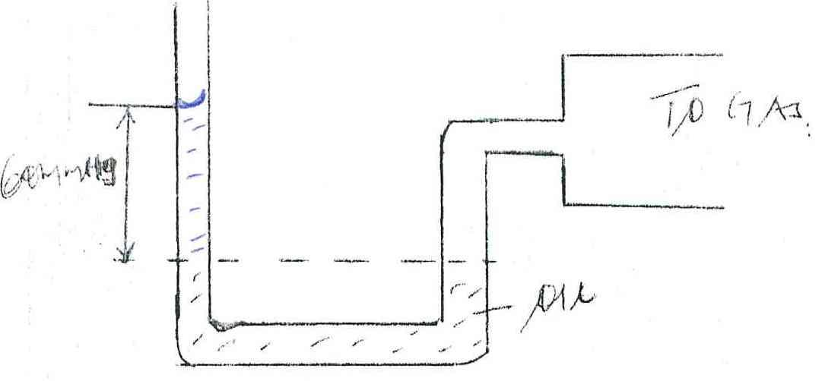

Gas

60mmHg

Oil

If atmospheric pressure is 1.0 x105 pa, find the pressure of the gas. (3 mks)

……………………………………………………………………………………………………………………………………………………………………………………………………………………………………………………………………………………………………………………………………………………..……………………………………………………………………….*.*

1. (a) A form one student has the following apparatus two cells, a switch, connecting wires and two bulbs. Draw a possible circuit diagram that will show parallel arrangement of the bulbs. (2mks)

(b) State the two defects of a simple cell. (2mks)

………………………………………………………………………………………………………………………………………………………………………………………………………………

1. You are provided with a boiling tube, a string and a ruler. Describe using a diagram how you would estimate the circumference of the boiling tube. (4mks)

……………………………………………………………………………………………………………………………………………………………………………………………………………………………………………………………………………………………………………………………………………………..………………………………………………………………………..

1. (a) Convert each of the following from 35 Kelvin into degree Celsius. (1mk)

………………………………………………………………………………………………………………………………………………………………………………………………………………

(b) Name the two parts of a clinical thermometer that make it special compared to the other thermometers. (2mks)

………………………………………………………………………………………………………………………………………………………………………………………………………………

1. The diagram below shows three identical springs which obey Hooke’s law.

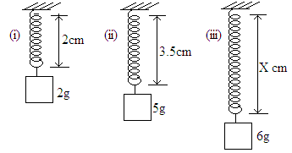

Determine the length X. (3 marks)

……………………………………………………………………………………………………………………………………………………………………………………………………………………………………………………………………………………………………………………………………………………..………………………………………………………………………..

**SECTION B (60 MARKS)**

1. The mass of a density bottle of 50cm3 is 7.5g when empty. Aluminium turning are poured into the bottle and the total mass is 57.5g. Water is then added into the turnings till the bottle is full. If the total mass of the bottle and its contents is 87.5g.

(density of water = 1g/cm3)

calculate; (i) the mass of aluminium turning. (1mk)

…………………………………………………………………………………………………

(ii) the volume of the water added. (2mks)

………………………………………………………………………………………………………………………………………………………………………………………………………………………………………………………………………………………………………………………

(iii) the volume of aluminium (1mk)

………………………………………………………………………………………………………………………………………………………………………………………………………………

(iv) the density of Aluminium. (2mks)

……………………………………………………………………………………………………………………………………..………………………………………………………………………..

1. (a) Define the term pressure and state its SI unit. (2mks)

……………………………………………………………………………………………………………………………………………………………………………………………………………………………………………………………………………………………………………………………………………………..………………………………………………………………………..

(b) Explain why a camel is able to walk on deserts and cannot sink in sand. (2mks)

……………………………………………………………………………………………………………………………………………………………………………………………………………………………………………………………………………………………………………………………………………………..………………………………………………………………………..

(c) A brick 30cm long 20cm and 5cm thick has a mass of 500g. Determine the;

1. Greatest pressure that can be exerted by the brick on the flat surface. (3mks)

……………………………………………………………………………………………………………………………………………………………………………………………………………………………………………………………………………………………………………………………………………………..………………………………………………………………………..

1. Least pressure exerted by the brick. (3mks)

……………………………………………………………………………………………………………………………………………………………………………………………………………………………………………………………………………………………………………………………………………………..………………………………………………………………………..

(d) ) State the three properties of hydraulic brake fluid (3mks

………………………………………………………………………………………………………………………………………………………………………………………………………………………………………………………………………………………………………………………

1. (a) The oil level in a burette is 10.0cm3. 50 drops of the oil are run off the burette. If the radius of 1 drop is 0.35cm.
2. Calculate the volume of one drop. (3 mks)

……………………………………………………………………………………………………………………………………………………………………………………………………………………………………………………………………………………………………………………………………………………..………………………………………………………………………..

1. What is the final reading of the burette. (3 mks)

………………………………………………………………………………………………………………………………………………………………………………………………………………………………………………………………………………………………………………………

(b) The 50 drops oil was made to spread on a surface of water forming a circular patch of radius 21cm.

1. Calculate the area of the oil patch. (2 mks)

………………………………………………………………………………………………………………………………………………………………………………………………………………………………………………………………………………………………………………………

1. Calculate the thickness of the oil molecule. (3 mks)

……………………………………………………………………………………………………………………………………………………………………………………………………………………………………………………………………………………………………………………………………………………..………………………………………………………………………..

1. a) What is rectilinear propagation of light (1mk)

………………………………………………………………………………………………………………………………………………………………………………………………………………

b) Find the number of images formed when mirrors are inclined at 40o (3mks)

……………………………………………………………………………………………………………………………………………………………………………………………………………………………………………………………………………………………………………………………………………………..………………………………………………………………………..

c) State 2 characteristics of images formed by the plane mirrors. (2mks)

………………………………………………………………………………………………………………………………………………………………………………………………………………

1. The diagram below shows a solar heater.



* 1. state reason why;

1. the pipe is fixed to a dark-colored collector plate. (1mk)

………………………………………………………………………………………………………………………………………………………………………………………………………………

1. the pipe is made of copper. (1mk)

………………………………………………………………………………………………………………………………………………………………………………………………………………

1. the pipe is coiled several times. (1mk)

………………………………………………………………………………………………………………………………………………………………………………………………………………

1. the collector plate is fixed to an insulator (1mk)

………………………………………………………………………………………………………………………………………………………………………………………………………………

1. the panel front is covered with glass (1mk)

………………………………………………………………………………………………………………………………………………………………………………………………………………

b) Liquid expand when heated and contract when cooled. However this is not true for water

i. state the name given to this behavior of water (1mk)

………………………………………………………………………………………………………

ii.State two importance of this behavior of water. (2mks)

………………………………………………………………………………………………………………………………………………………………………………………………………………

1. a) Define moment of force and state its SI unit (2mks)

……………………………………………………………………………………………………………………………………………………………………………………………………………………………………………………………………………………………………………………………………………………..………………………………………………………………………..

b) Name two factors that affect moment of a force. (2mks)

………………………………………………………………………………………………………………………………………………………………………………………………………………………………………………………………………………………………………………………

c ) Find the moment of the force about the pivot in the figure below (3mks)



……………………………………………………………………………………………………………………………………………………………………………………………………………………………………………………………………………………………………………………………………………………..………………………………………………………………………..

d)A uniform meter rule pivoted at its center is balanced by a force of 50N at 20cm mark and some other two forces ,F and 20 N on the 70 cm mark and 90 cm marks respectively. Calculate the force F. (3mks)

……………………………………………………………………………………………………………………………………………………………………………………………………………………………………………………………………………………………………………………………………………………..………………………………………………………………………..

1. (a) State two properties of magnets. (2mks)

………………………………………………………………………………………………………………………………………………………………………………………………………………

(b) A soft iron ring is placed between two magnets. Draw the magnetic field pattern between the two magnets. (2mks)



(c) Figure below shows a U-shaped magnet is stored with a keeper.



Explain how this method helps to retain magnetism longer. (2mks)

*.*……………………………………………………………………………………………………………………………………………………………………………………………………………………………………………………………………………………………………………………

**THIS IS THE LAST PRINTED PAGE**