PHYSICS
FORM THREE
OPENER EXAMINATION: TERM 2 2024

TIME: 2 HOURS

Name………………………………… Adm No; ………… Class……… …..

INSTRUCTIONS TO CANDIDATES
- This paper consists of two sections A and B.
- Answer all the questions in the two sections in the spaces provided after each question • All working must be clearly shown.
- Electronic calculators, mathematical tables may be used.
- All numerical answers should be expressed in the decimal notations.
- You may use ‘g’ as 10m/s²

For Examiner use only
SECTION | QUESTION | MAX MARKS | SCORE
A | 1 – 13 | 25
B | 14 | 13
 | 15 | 13
 | 16 | 14
 | 17 | 07
 | 18 | 08
 | TOTAL | 80

SECTION A (25 MARKS)
- The figure below shows a vernier caliper being used to measure the diameter of a cylindrical metal of mass 250g and length 20cm. The reading on the calipers when the jaws were fully closed without the metal was + 0.08cm.
Metal
Main scale

0
10
Small scale

0
1
2
3

5
4

(a) What is the diameter of the cylindrical metal? (2mk)

(b) Calculate the volume of the cylindrical metal. (2mk)

- State one factor that affects the turning effect of a force on a body. (1 mark)

- Figure 2 shows some air trapped by mercury in a glass tube. The tube is inverted in a dish containing mercury.
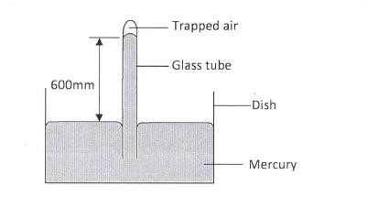
Given that the atmospheric pressure is 760 mmHg and the height of mercury column in the tube is 600 mm, determine the pressure of the air trapped in the tube in mmHg. (2 marks)

- Figure 3 shows drops of mercury and water on a glass surface, Explain the difference in the shapes of the drops. (2marks)
Mercury water
Glass surface

- A ball is thrown from the top of a cliff 20m high with a horizontal velocity of 10ms⁻¹. Calculate the distance from the foot of the cliff to where the ball strikes the ground. (3 marks)

- Explain one advantage of mercury over alcohol as a thermometric liquid. (1mark)

- A body of mass M is allowed to slide down an inclined plane. State two factors that affect its final velocity at the bottom of the inclined plane. (2marks)

- A stopwatch reads 08:10:84 and 09:10: 90 before and after an experiment respectively.
Determine the duration of the event in SI units. (2marks)

- Explain the meaning of thermodynamics as a branch of physics. (1 mark)

10.
(a) State the Hooke’s Law. (1mark)

- Figure 4 shows identical spiral springs supporting a load of 90N. Each spring has a spring constant k = 200N/m
90
N
springs

Determine the total extension of the system (take the weight of the cross bars and springs to be negligible) (2 marks)

- Figure 5 shows a rectangular loop with a thin thread loosely tied and dipped into a soap solution. Draw on the space provided what is observed when point A is
punctured. (1mark)

A

B

thread

- Two horizontal strings are attached to a block, resting on a frictionless surface, as shown in figure 6.
F

100
N

support

A force of 100N pulls on one string. The block does not move. Find the value of the force, F on the other string. (1 mark)

13. A wooden bench feels neither warm nor cold when touched by your bare hands. Explain this observation. (2 marks)

SECTION B (55 MARKS)
14 (a )A hole of area 2.0cm² at the bottom of the tank 2.0M deep is closed with a cork. Determine the force of the cork when the tank is filled with water.(density of water is 1000kg/m³ and acceleration due to gravity is 10m/s²) 4mks

(b)The total weight of car with passengers is 25,000N.The area of contact of each of the four tyres is 0.025m² . Determine the minimum pressure (3mks)

(c).A cyclist initially at rest moved down a hill without peddling .He applied brakes and continually stopped. State the energy changes as he cyclist moved down a hill. (1mk)

- State the principle of conservation of linear momentum (1 mark)

- A bullet of mass 60g is fired horizontally with a velocity of 200 m/s into a suspended stationary wooden block of mass 2940g. Determine:
- Common velocity of both the bullet and the block, if the bullet embedded into the block. (2 marks)

- Height to which the block rises. (2 marks)

15. The diagram below shows two trolleys, A and B connected to each other by an elastic strip of negligible mass. The trolleys are pulled apart on a smooth plane till tension in the elastic strip is 4.0N and are then released suddenly

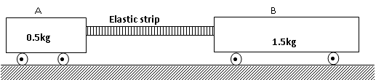

(a) State with reason the total momentum of the trolleys when they are just released (2mks)
…………………………………………………………………………………………………
……………………………………………………………………………………………………
(b) Calculate the initial acceleration of trolley A when released (3mks)

(c) The velocity of the trolley B is 0.9ms⁻¹ just before it collides with A. Determine the velocity of A just before the collision (3mks)

(d) Which trolley covers a longer distance before collision? Explain (2mks)
…………………………………………………………………………………………………
…………………………………………………………………………………………………
(e) Explain why the elastic strip may not stretch to the same original length after impact (2mks)
……………………………………………………………………………………………………
……………………………………………………………………………………………………

16. (a) A car starts from rest accelerates uniformly for 5seconds to reach 30m/s. It continues at this speed for the next 20 seconds and then decelerates uniformly to come to stop in 10 seconds. On the axis provided, draw the graph of the velocity against time for the motion of the car and hence calculate its total displacement (.4mk)
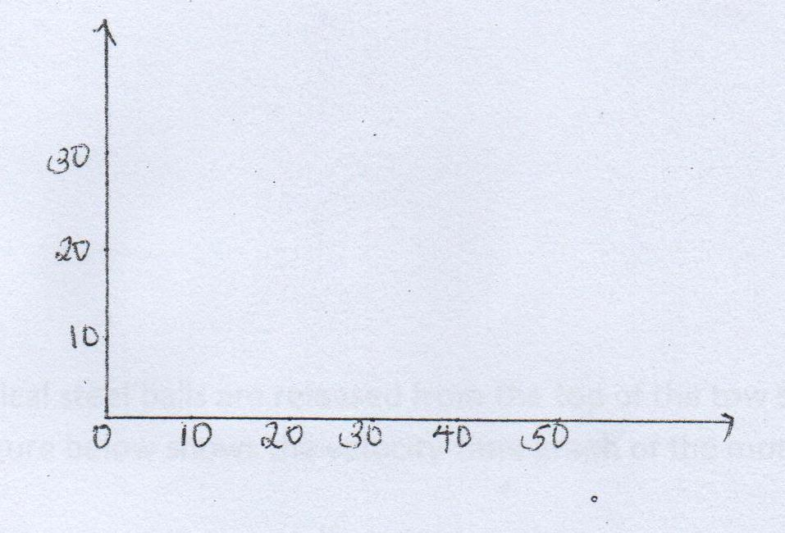
(b) A ball is thrown horizontally from the top of vertical tower and strike the ground at A point 50 m from bottom of the tower. Given that the height of the tower is 45m determine
(i) The time taken by the ball to hit the ground. 2mks

(ii )the initial horizontal velocity of the ball. 2mks

(iii) Vertical velocity of the ball just before striking the ground (take acceleration due to gravity, g, as 10ms^{-2. (3mks)}

17. (a) State Hooke’s Law. (1mk)
…………………………………………………………………………………………………………
…………………………………………………………………………………………………………
(b) The figure below shows the variation force with extension for a steel coil spring.
(i) On the same axes, sketch the variation of force with extension for a wire from which the spring is made. (1mk)

Force N
Extension cm

Explain the difference between the two lines drawn (2mks)
…………………………………………………………………………………………………………
…………………………………………………………………………………………………………

(c) A stone of mass 5g is released from a catapult. The catapult is stretched by 10cm. If the constant of elasticity is 100N/cm. Calculate;
(i) The horizontal velocity with which the stone is released (2mks)

(ii) Sketch a graph of horizontal velocity against time from the time the stone is released to when it reaches the ground. (1mk)
(d) The following results were obtained in a experiment to verify Hooke’s law when a spring was extended by hanging various loads on it.
Load (N) | 0.00 | 1.00 | 2.00 | 3.00 | 4.00 | 5.00 | 6.00
Length of spring in cm | 10.00 | 11.50 | 13.00 | 14.50 | 16.00 | 18.00 | 24.00
Extension | 0.00
(I) Complete the table for the extension e above. (1mk)
(II) Plot a graph of load (y-axis) against extension 3mks (3mks)

(III) From the graph determine the springs constant. (2mks)

(IV) Calculate the energy stored when the spring is stretched to 16 cm. (2mks)

- (a) Define the term velocity ratio of a machine (1 mark)

- The figure 11, below shows part of the hydraulic lift system. State any one property of the liquid under which the hydraulic system works (1 mark)
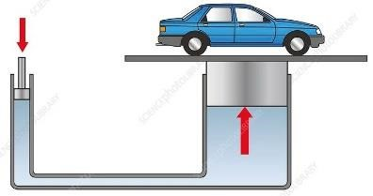
- The hydraulic lift machine above has velocity ratio 45 and it overcomes a load of 4500 N when an effort of 135 N is applied. Determine:
- The mechanical advantage of the machine (2 marks)

- Efficiency of the machine (2marks)

- The percentage of work that goes to waste (1 mark)

