OPENER EXAMINATION: TERM 2 2024
GEOGRAPHY
FORM 3
TIME: 2 ¾ HOURS
NAME: __________________________________________ ADM: ________ CLASS: _________

1a. Define forestry 2mks
b. Give 3 factors that determine the type and distribution of forests 3mks
2a.Name two rivers that supply water to Mwea Tebere irrigation scheme 2mks
b. State the significance of an irrigation scheme 3mks
3 a .Define the term fishing 2mks
b. State any 3 factors influencing fishing 3mks
4a What is a game sanctuary 2mks

b. Name three marine national park at the coast of Kenya 3mks
5a What is land dereliction 2mks
b State 3 measures that the Kenya government has undertaken to rehabilitate derelict land in the country 3mks
6. SECTION B
ANSWER QUESTION 6 AND ANY OTHER TWO QUESTIONS FROM THIS SECTION
- The table below shows the production of maize in tones between 2010 and 2014 in four divisions of Baringo County.
Division | 2010 | 2011 | 2012 | 2013 | 2014
Bartabwa | 200 | 240 | 250 | 280 | 285
Barwesa | 116 | 135 | 138 | 170 | 275
Kabartonjo | 100 | 80 | 60 | 50 | 45
kipsaraman | 40 | 30 | 45 | 30 | 25

(a)(i) Calculate the percentage increase of the total maize production in the four divisions between 2012-2013. 2mks

(ii) What is the difference in kilograms between the highest production and the lowest in five years. 2mks

(b)(i) Using a vertical scale of 1cm represents 50 tonnes, draw a group line graph to represent the data above. 7mks

ii) state three advantages of using group line graph. 3mks

(c) State three climatic conditions favoring the growing of maize. 3mk
(d) Explain four problems facing small scale maize farmers in Kenya. 8mks

7. a I what are derived forests 2mks

ii state the characteristics of planted forests 4mks
b..Explain 4 the similarities between soft wood forests in kenya and Canada 8mks

C .Explain 4 preblems facing forestry in both kenya and canada 8mks

d.state measures taken by the government of kenya to conserve forests 3mks

8. The map below shows the location of some minerals in East Africa.

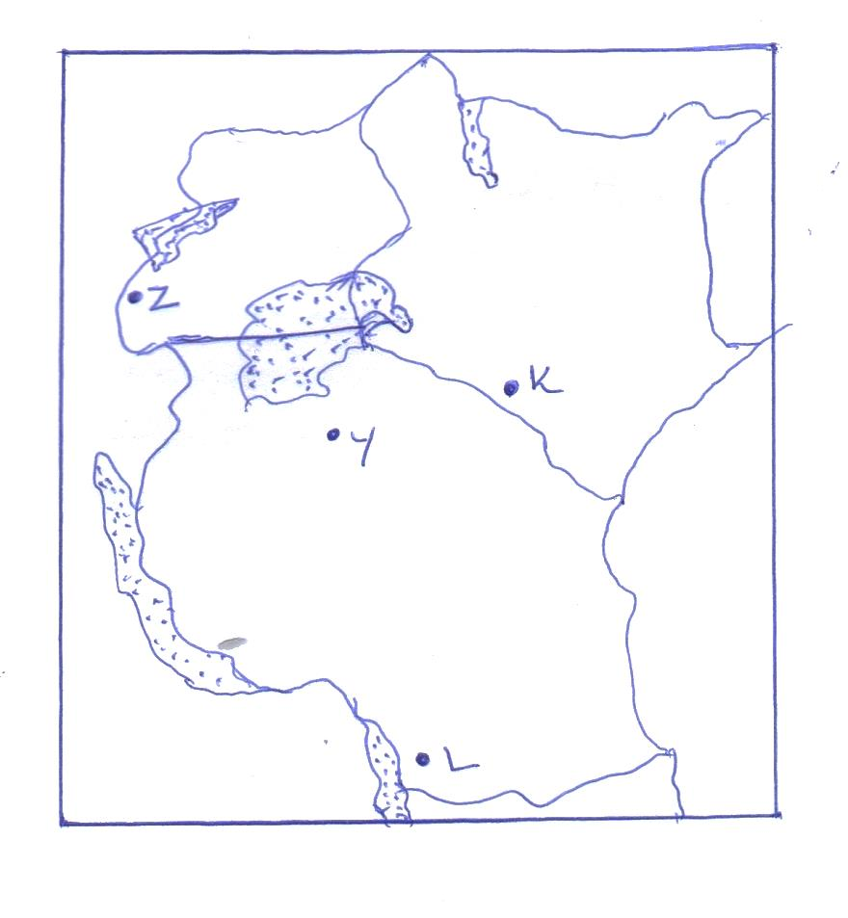

a.Name the minerals mined in the areas marked K,L,Y. and Z. 4mks
(i) State two conditions that are necessary for the formation of petroleum. 2mks
(ii) List three ways in which open cast mining affects the environment. 3mks
- (i) Give two uses of diamond. 2mks
(ii) Explain three ways in which mining promotes industrialization in Kenya. 6mks
- Apart from industrialization, explain four ways in which mining contributes to the economy of Kenya. 8mks

9. Define industrial inertia 2mks
b. Explain 5 importance of industrialization to the economy of the country 10mks

C.Explain any 4 negaive effects of industrialization 8mks

d Your class intends to have a field study in one of the industries,outline ways in which you will prepare for the study 5mks

10.a i. Define Agriculture 2mks
ii. Give the characteristics of dairy farming 5mks.

iii. state the advantages of mixed farming 3mks

b. Explan how the following factors influence Agriculture 8mks
Variation in Temperature
Sunshine
Winds
Variation in rainfall
b. Describe the cultivaton of cocoa 7mks

