NAME………………………………………………………………CLASS…… ADM.NO………...
BIOLOGY
FORM TWO
OPENER EXAMINATION: TERM 2 2024
TIME 2 HOURS

ANSWER ALL QUESTIONS

- (a) (i) Name the blood vessel that supplies the cardiac muscles with its requirements.(1mk)
………………………………………………………………………………………………
………………………………………………………………………………………………
- State the corgenical defect of the above blood vessel resulting from prolonged large intake of cholesterol in the blood. (1mk)
………………………………………………………………………………………
………………………………………………………………………………………
(b) What is the importance of the thicker muscular wall of the left ventricle of a mammalian heart? (2mks)
…………………………………………………………………………………………………...................................................................................................................................................................
- The diagram below illustrates part of phloem tissue.
X

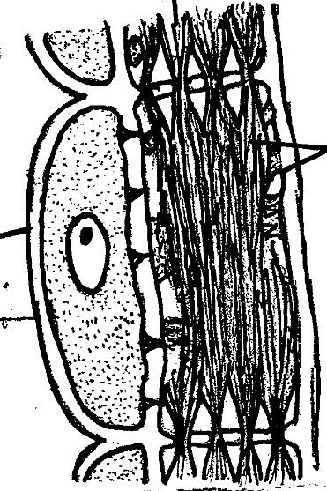

Y

Z

- Name the parts labeled. (2mks)
X………………………………………………
Y………………………………………………
(b)State the function of the part labeled Z (1mk)
………………………………………………………………………………
- Name the monosaccharides that make up the disaccharides below
(a) Sucrose (1mk)
………………………………………………………………………………………………
(b) Lactose (1mk)
……………………………………………………………………………………………
(c) Maltose (1mk)
………………………………………………………………………………………………

- State the importance of the following
(i) Reversed stomatal rhythm to desert plants (1mk)
………………………………………………………………………………………………........................................................................................................................................................
(ii) Closing of stomata on a hot dry sunny day (1mk)
…………………………………………………………………………………………………….................................................................................................................................................
(iii) How does wind affect transpiration rate? (1mk)
……………………………………………………………………………………………………....................................................................................................................................................

- The diagram below represents the pathway of water from soil into the plant.
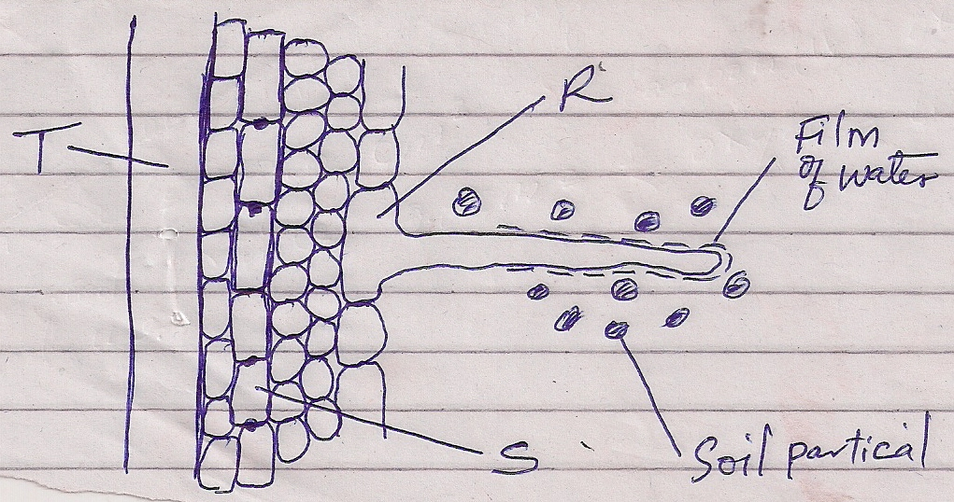
    - Name the structures labeled T and S.
T:……………………………………………………………………………………(1mk)
S:……………………………………………………………………………………(1mk)
    - State two ways in which the structure labeled R is adapted to its functions.
(2mks)
…………………………………………………………………………………………………………………………………………………………………………………………
- A student added equal amounts of blood to equal volumes of salt of different concentrations. She observed and counted the red blood cells at the beginning of the experiment and at end of the experiment. The results were as shown:-
Set up | Concentration of salt | Beginning | After 30 mins
A | 0.1mol | 500 | 500
B | 0.01mol | 500 | 250
Account for the results in:
- Set up A (2mks)
………………………………………………………………………………………………………………………………………………………………………………………………
- Set up B (2mks)
………………………………………………………………………………………………………………………………………………………………………………………………
- Below is a dental formula of certain organisms. Use it to answer the questions that follow.
I ⁰/₃, C ⁰/₁, PM ³/₂, M ³/₃
- Calculate the total number of teeth in the mouth of the organisms. (2mks)

- Name the organisms. (1mk)
……………………………………………………………………………………………
- Identify the mode of nutrition of the organisms. (1mk)
…………………………………………………………………………………………
- a) State two functions of the blood other than transport. (2mks)
…………………………………………………………………………………………………
…………………………………………………………………………………………………
(b) Name one defect of the circulatory system in humans. (1mk)
…………………………………………………………………………………………………
- (a) State two ways in which human body is naturally protected against harmful
bacteria. (2mks)
………………………………………………………………………………………………………………………………………………………………………………………………
(b) State one way in which the composition of blood in the pulmonary artery and that
of pulmonary vein differ. (1mk)
……………………………………………………………………………………………….
- Describe the path taken by Carbon (IV) Oxide released from the tissues of a cockroach into the atmosphere. (2mks)
…………………………………………………………………………………………………………………………………………………………………………………………………………………………………………Form One student set up an experiment shown below to investigate a certain physiological process. The set up was left for 30 minutes.
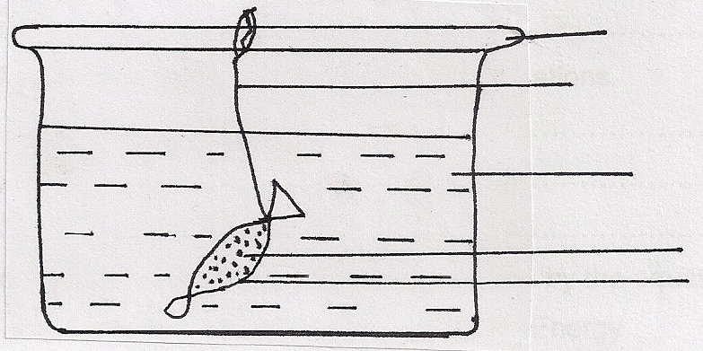
Glass rod
Thread

Distilled water
Sucrose solution
Visking Tubing

- Name the process under study. (1mk)
………………………………………………………………………………………………
- State the expected results after 30 minutes. (1mk)
………………………………………………………………………………………………
- Explain your answer in (b) above. (3mks)
………………………………………………………………………………………………………………………………………………………………………………………………………………………………………………………………………………………………

- Explain why it is important to stain specimen to be observed under a light microscope. (2mks)
………………………………………………………………………………………
…………..……………………………………………………………………………
- What is wilting? (2mks)
……………………………………………………………………………………………………………………...................................................................................................................................
- State the significance of the following steps while testing for disaccharides in food sample. (2mks)
(a) Addition of dilute hydrochloric acid
……………………………………………………………………………………………………………………...................................................................................................................................
(b) Addition of sodium bicarbonate.
…………………………………………………………………………………………………………………….......................................................................................................................................
- Outline three functions of colon. (3mks)
……………………………………………………………………………………………………………………....................................................................................................................................................................................................................................................................................................
17. The diagram below represents a transverse section of a young stem.

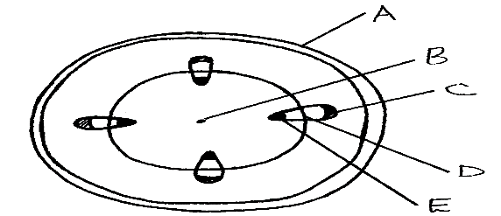

- Name the parts labelled A, B and D (3mrks)

- State the functions of the parts labelled C and E (2mrks)

- List three differences between the section above and the one that would be obtained from roots of the same plant. (3mrks)

18. Distinguish between guttation and transpiration (2mrks)

19. Other than transport, state one other function of xylem tissue in plants (1mrk)

20. Identify the part of the heart that initiates the heart beat (1mrk)

22. State the forms in which carbon (IV) oxide is transported in the blood (1mks)

23. Explain how the following adaptation reduce transpiration in xerophytes
(a) Sunken stomata (2mrks)

(b) Thick waxy cuticle (1mrk)

  - Name the:
24. (a) Material that strengthens xylem tissue (1mrk);

(b) Tissue that is removed when the bark of a dicotyledonous plant is ringed (1mrk)

25. Why is it dangerous to sleep in an enclosed room with a burning jiko(3mrks)?

