Name……………………………………………..….Index Number……………..Class………….…
Candidate’s Signature………………………Date………………

BIOLOGY
PAPER 1
231/1
FORM THREE.
OPENER EXAMINATION: TERM 2 2024
TIME: 2 HOURS.

BIOLOGY THEORY

For examiner’s use only
QUESTION | MAXIMUM SCORE | CANDIDATE’S SCORE
1 - 25 | 80

This paper consist of 7 printed pages. Candidates should check the questions to ascertain that all the pages are printed as indicated and no questions are missing.

INSTRUCTIONS TO CANDIDATES:
- Answer ALL the questions
- Answers should be written in the spaces provided

1. The equation bellows shows a chemical reaction that takes place in green plants under certain conditions

Carbon (IV) Oxide + Water Glucose + X

a) Name the; (2mks)
i) Process represented by the equation…………………………………………………………

ii) Substance represent by X………………………………………..……………….…………

b) Other than the reactants, state two conditions necessary for this reaction to occur. (2mks)
………………………………………………………………………………………………………………………………………………………………………………………………………………………………………………………………………………………………………

c) Name three types of cells in which the process occurs (3mks)
…………………………………………………………………………………………………………………………………………………………………………………………………………………………………………………………………………………………………………………………………………………………………………………………………………

2. Name one example of the specialized cells in plants and one example in animals.
(i)Plants……………………………………………………………………………………. (1mk)
(ii) Animals………………………………………………………………………………….(1mk)

3. Identify the following apparatus and state its functions.
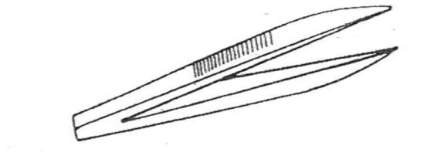
i) Name…………………………………………………….(1mk)

ii) Function (1mk)
………………………………………………………………..………………….……………………………………………………...…….
4. A student measured the length of a mitochondrion on a photomicrograph whose magnification was X 40000 and found it to be 1mm. Calculate the actual size of the mitochondrion. (3mks)

5. State the type of solution that makes the plant cell. (2mks)
i) Flaccid………….......……………………….……………………………………………………
ii) Turgid……………………………………………………………………………………………

6. Name the carbohydrate stored in:
i) Cell wall. ……………………………………………………………………………. (1mk)
ii) Mammalian liver. …………………………………………………………………. (1mk)

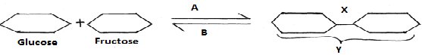
7. Study the reaction below and answer the questions that follow.

a) What biological processes are represented by A and B? (2mk)
A ................................................................................................................................
B .................................................................................................................................

b) Identify the product Y……………………………………………………………… (1mk)
c) State the bond represented by X …………………………………….......……………(1mk)
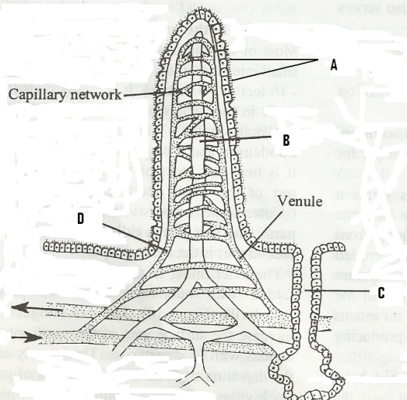
8. The figure below represents a structure obtained from the ileum of a mammal.

a) Give the identity of the structure. (1 mk)
………………………………………………………………..
b) What is the importance of the structure named in (a) above? (1 mk)
..………………………………………………………………............................................................................................……
c) Name the parts labeled A, B and D. (3mks)
A…………………….…………………………………………….
B………………….……………………………………………….
D…………….…………………………………………………….

9 (i) Name the juice secreted by the part labeled C. (1mk)
……………………………………....................................................................................................................................................……………………………………………………………………………..

(ii) List two enzymes present in the juice named in d (i) above. (2mks)
………………………………………………………………………………………………………………………………………………………………………………………………………………………………………………………………………………………………………………………………
10. What are the structural differences between veins and arteries? (3mks)
………………………………………………………………………………………………………………………………………………………………………………………………………………………………………………………………………………………………………………………………
……………………………………………………………………………………………………………………………………………………………………………………………………………………
11. State three differences between aerobic and anaerobic respiration. (3mks)
………………………………………………………………………………………………………………………………………………………………………………………………………………………………………………………………………………………………………………………………
…………………………………………………………………………………………………………
12. (i) Name the type of immunity developed by the body when one is vaccinated against a certain disease (1mk)
……………………………………………………………………………………………………………………………………………………………………………………………………………………
ii)Name the blood groups of a person whose blood plasma has antibody b (2mks)
………………………………………………………………………………………………………………………………………………………………………………………………………………………………………………………………………………………………………………………………
iii)State the role of thrombin in blood clotting (1mk)
……………………………………………………………………………………………………………………………………………………………………………………………………………………………………………………………………...............................................………………………….
13.a)Define respiration (1mk)
…………………………………………………………………………………………………………………………………………………………………………………………………………………………………………………………………………………..............................................…………….
b)Study the equation below. Identify the process represented below (1mk)
C₆H₁₂O₆ 2C₂H₅OH +CO₂+ 210KJ
……………………………………………………………………………………………………………………………………………………………………………………………………………………
c)Name an organism this process may occur……………………………………………….(1mk)

d)Identify the food substrate of whose respiratory quotient (RQ) was found to be 0.7 (1mk)
………………………………………………………………………………………………………………........................................................................................................………………………………

14.State the functions of the following hormones
a)Antidiuretic hormone (2mks)
……………………………………………………………………………………………………………………………………………………………………………………………………………………
b)Glucagon (2mks)
………………………………………………………………………………………………………………………………………………………………………………………………………………………………………………………………...............................................……………………………….15. Outline three ways in which the gills of Tilapia fish are modified to perform their function (3 mks)
………………………………………………………………………………………………………………………………………………………………………………………………………………………………………………………………………………………………………………………………
……………………………………………………………………………………………………………………………………………………………………………………………………………………

16. a) Calculate the respiration quotient (RQ) from the equation below:- (3 mks) 2C₅₁H₉₈O6+145O₂ 102 CO₂ + 98H₂O + Energy
………………………………………………………………………………………………………………………………………………………………………………………………………………………………………………………………………………………………………………………………
……………………………………………………………………………………………………………………………………………………………………………………………………………………
b) Identify the substrate being respired in the above equation (1 mk)
……………………………………………………………………………………………………………………………………………………………………………………………………………………
17. a) Explain what is meant by the term oxygen debt in human beings (2 mark)
………………………………………………………………………………………………………………………………………………………………………………………………………………………………………………………………………………………………………………………………
…………………………………………………………………………………………………………
b) What are the end products of anaerobic respiration in animals (2 mrks)
………………………………………………………………………………………………………………………………………………………………………………………………………………………………………………………………………………………………………………………………
…………………………………………………………………………………………………………
18. i) Where in a cell does glycolysis take place? (1mrk)
……………………………………………………………………………………………………………………………………………………………………………………………………………………

(ii) Name the product of the above process (1mrk)
……………………………………………………………………………………………………………………………………………………………………………………………………………………
19. The equation below summarizes a metabolic process in plants.
Glucose Ethanol + carbon (IV) oxide+ Energy
State two industrial applications of the above equation. (2mks)
………………………………………………………………………………………………………………………………………………………………………………………………………………………………………………………………………………………………………………………………
20. Explain why a rat, though small eats more frequently than an elephant (2mks)
……………………………………………………………………………………………………………………………………………………………………………………………………………………
…………………………………………………………………………………………………………
21. Give the conditions necessary for the second phase of aerobic respiration (3mks)
……………………………………………………………………………………………………………………………………………………………………………………………………………………
……………………………………………………………………………………………………………………………………………………………………………………………………………………
22. Name any three respiratory diseases (3mks)
……………………………………………………………………………………………………………………………………………………………………………………………………………………
…………………………………………………………………………………………………………
23.The diagram below is that of a gill of a fish.
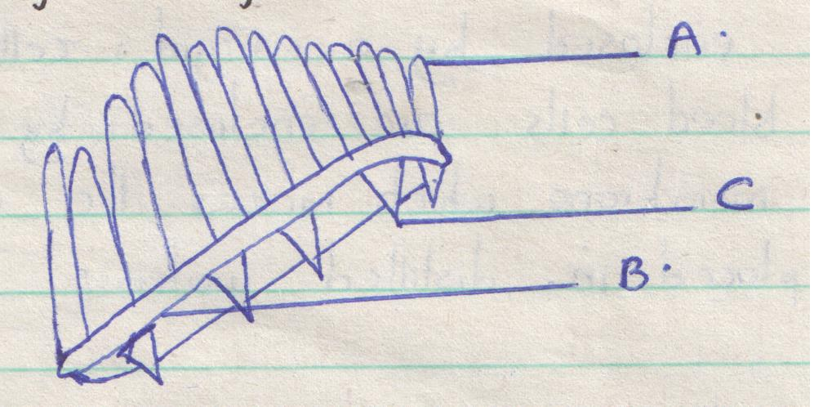
- Name the parts labeled A and B. (2mks)

- State the function of part lab eled C. (1mk)

- Explain how structure labeled A is adapted to its function. (2mks)

- A student examining pond water came across a certain living organisms which he drew as shown below.
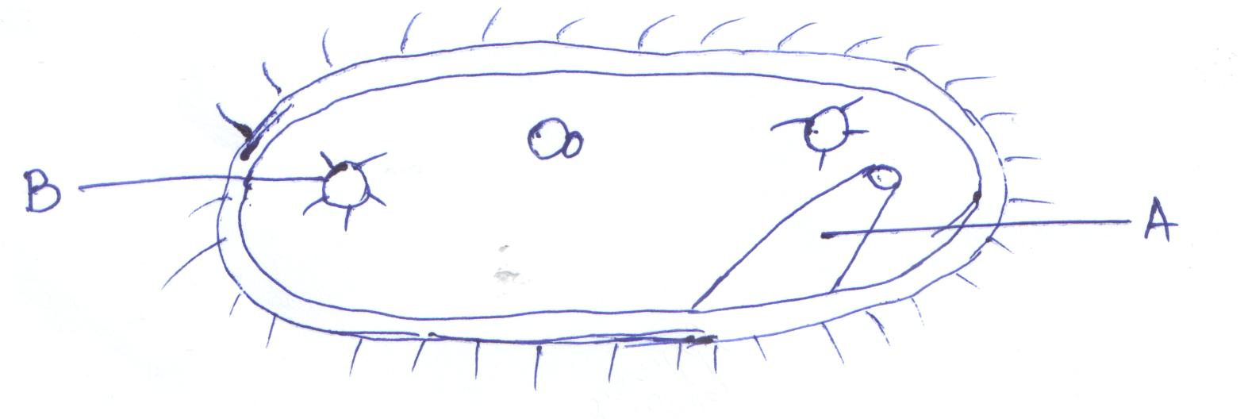
- Identify the organism shown above. (1mk)

- State the kingdom of the above organism. (1mk)

- Name the structure labeled A. (1mk)

- State the function of the part labeled B. (1mk)

- Define the following terms as used in ecology. (3mks)
- Carrying capacity.

- Biosphere.

- Ecological niche.

