NAME: ………………………………….…….ADM No: ………CLASS…………....
AGRICULTURE FORM ONE
OPENER EXAMINATION – TERM 2 2024
2 HOURS
INSTRUCTIONS. ANSWER ALL THE QUESTIONS.
1. Define the term following terms as used in agriculture. (3mks)
a) Soil profile
……………………………………………………………………………………………………………………………………………………………………………………………………
b) Organic farming
……………………………………………………………………………………………………………………………………………………………………………………………………
c) Agroforestry
……………………………………………………………………………………………………………………………………………………………………………………………………

2. Give three activities that justify the fact that Agriculture is a science: (3mks
…………………………………………………………………………………………………………………………………………………………………………………………………………………………………………………………………………………………………………………………………………………………………………………………………………
3. Give four characteristics of large scale farming system. (4mks)
…………………………………………………………………………………………………………………………………………………………………………………………………………………………………………………………………………………………………………………………………………………………………………………………………………
4. State two conditions under which shifting cultivation is favourable. (3mks)
…………………………………………………………………………………………………………………………………………………………………………………………………………………………………………………………………………………………………………………………………………………………………………………………………………
5. Give two characteristics of intensive farming system. (3mks)
…………………………………………………………………………………………………………………………………………………………………………………………………………………………………………………………………………………………………………………………………………………………………………………………………………

6. Identify any five methods of farming (5mks)
…………………………………………………………………………………………………………………………………………………………………………………………………………………………………………………………………………………………………………………………………………………………………………………………………………
7. The diagram below shows an experiment set up using soil type Q, R, S, and observations made after 24 hours. Study the diagram below and answer the questions that follow.
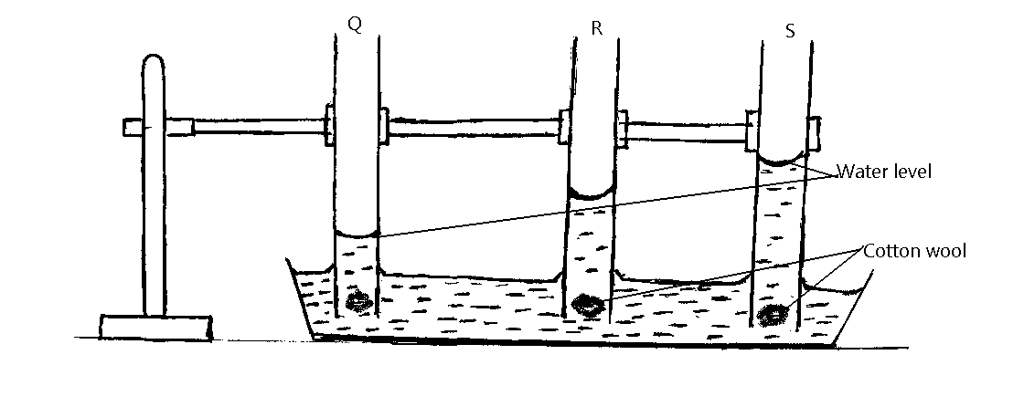
(a) The experiment set up above is designed to study what? (1mk)
(b) Name the three soil types Q, R, S. (3mks)
…………………………………………………………………………………………………………………………………………………………………………………………………………………………………………………………………………………………………………………………………………………………………………………………………………
` (c) What are the characteristic texture of soil type R and S?
R (1mk)
S (1mk)
8. State three aspects of light that affect agriculture. (3mks)
…………………………………………………………………………………………………………………………………………………………………………………………………………………………………………………………………………………………………………………………………………………………………………………………………………
9. The illustration below represents types of soil structures. Study them carefully and answer questions that follow.
C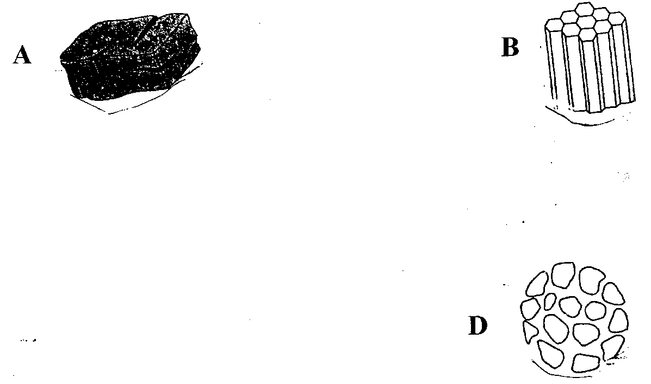
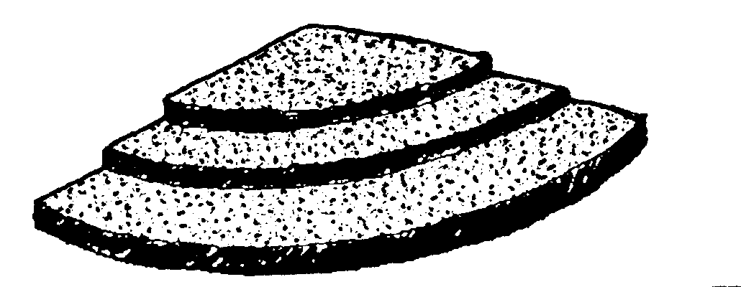

a) Identify the soil structures labeled. (4mks)
A………………………………………………………………………………………
B………………………………………………………………………………………
C………………………………………………………………………………………
D

b) State ONE method of improving soil structure labelled D. (1mk)

10. List any four ecological factors that affect crop production in Kenya (4mks)
…………………………………………………………………………………………………………………………………………………………………………………………………………………………………………………………………………………………………………………………………………………………………………………………………………
11. Name three classes of crops based on light duration. (3mks)
…………………………………………………………………………………………………………………………………………………………………………………………………………………………………………………………………………………………………………………………………………………………………………………………………………

12. State four negative effects of strong winds in agriculture. (4mks)

…………………………………………………………………………………………………………………………………………………………………………………………………………………………………………………………………………………………………………………………………………………………………………………………………………

13. Outline Four practices in agriculture that destroy soil structure (4mks)
…………………………………………………………………………………………………………………………………………………………………………………………………………………………………………………………………………………………………………………………………………………………………………………………………………
14. State any four factors that should be considered when choosing tools and equipment to use in the farm. (4mks)

…………………………………………………………………………………………………………………………………………………………………………………………………………………………………………………………………………………………………………………………………………………………………………………………………………

15. Below are diagrams of farm tools and equipment. Study them and answer the questions that follow.
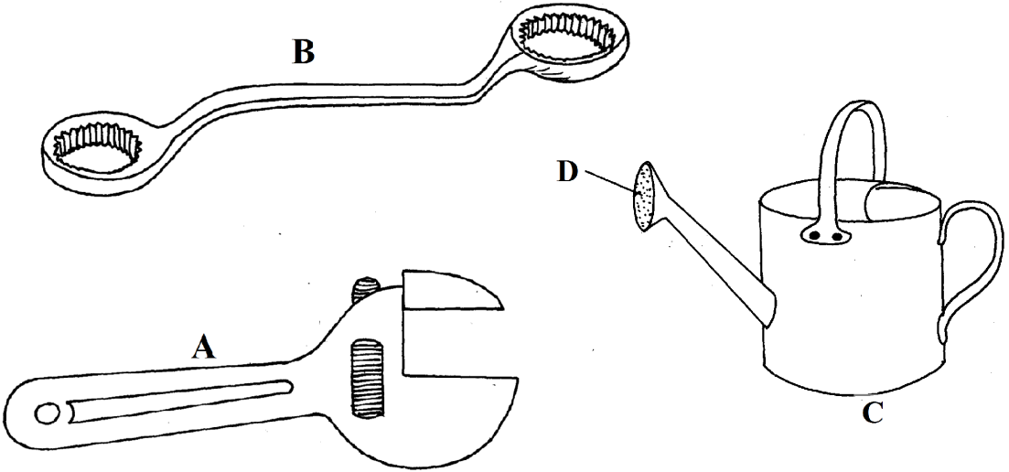

(i) Identify tools A, B and C (3mks)
…………………………………………………………………………………………………………………………………………………………………………………………………………………………………………………………………………………………………………………………………………………………………………………………………………

(ii) Use of equipment C. (1mk)
16. State Four categories of farm tools and equipment. (4mks)
…………………………………………………………………………………………………………………………………………………………………………………………………………………………………………………………………………………………………………………………………………………………………………………………………………

17. Explain four importance’s of agriculture in the economy. (8mks)
…………………………………………………………………………………………………………………………………………………………………………………………………………………………………………………………………………………………………………………………………………………………………………………………………………
…………………………………………………………………………………………………………………………………………………………………………………………………………………………………………………………………………………………………………………………………………………………………………………………………………
…………………………………………………………………………………………………………………………………………………………………………………………………………………………………………………………………………………………………………………………………………………………………………………………………………
………………………………………………………………………………………………………………………………………………………………………………………………………………………………………………………………………………………………………………………………………………………………………………………………………

