**NAME: ……………………………………………. ADM NO.…………… CLASS: ……...**

**OPENER EXAMINATION: TERM 1 2024**

**PHYSICS**

**FORM 4**

**232/1**

**Time: 2 Hours**

**INSTRUCTIONS TO CANDIDATES: -**

* *Write your name, Admission number and class in the spaces provided above.*
* *This paper consists of two sections; A and B*
* *Answer all the questions in section A and B in the spaces provided*
* *All working must be clearly shown.*
* *Mathematical tables and electronic calculators may be used*
* *This paper consists of 12 printed pages. Candidates should check to ascertain that all pages are printed as indicated and that no questions are missing.*
* *Candidates should answer the questions in English.*
* *Take g=10N/kg*

**For Examiner’s Use Only:**

|  |  |  |  |
| --- | --- | --- | --- |
| **Section** | **Question** | **Maximum**  **Score** | **Candidate’s**  **Score** |
| **A** | **1 – 12** | **25** |  |
|  | **13** | **8** |  |
|  | **14** | **10** |  |
| **B** | **15** | **11** |  |
|  | **16** | **13** |  |
|  | **17** | **13** |  |
| **Total Score** | | **80** |  |

**SECTION I (25 MKS)**

1. Name the instrument that would be most suitable for measuring the thickness of one sheet of this question paper . (1mk):

**………………………………………………………………………………………………………………………………………………………………………………………………………………**

2. Figure below shows a measuring cylinder which contains water initially. A solid of mass 10g is immersed in water, the level rises to a new level as shown.

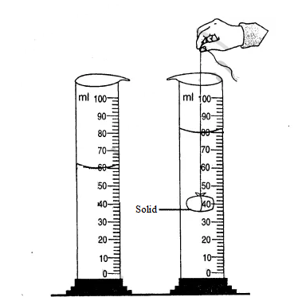

Determine

i) Volume of solid in cm3 (1mk)

**………………………………………………………………………………………………………………………………………………………………………………………………………………**

ii) Density of the solid in SI unit (give your answer to 1 decimal place) (2mks)

………………………………………………………………………………………………………………………………………………………………………………………………………………

3. Water is known to boil at 1000C. A student heated some water and noticed that it boiled at 1010C. State one possible reasons for this observation. (1mk)

………………………………………………………………………………………………………………………………………………………………………………………………………………

4. A steel needle when placed when place carefully on water can be made to float. When a detergent is added to the water it sinks. Explain this observation. (2mks)

**……………………………………………………………………………………………………………………………………………………………………………………………………………………………………………………………………………………………………………………..**

5. Figure below shows a uniform cardboard in the shape of a parallelogram.

Locate the centre of gravity of the cardboard. . (1mk).

6. Figure below shows a uniform metre rule pivoted at 30cm mark. It is balanced horizontally by a weight of 2N suspended at the 5cm mark.

5cm 30cm

2N

Determine the weight of the metre rule. (2mks) .

………………………………………………………………………………………………………………………………………………………………………………………………………………………………………………………………………………………………………………………

7. A bottle containing a smelling gas is opened at the front bench of a classroom. State the reason why the gas is detected throughout the room. (1mk)

**………………………………………………………………………………………………………………………………………………………………………………………………………………**

8. Figure below shows a spring balance . Its spring constant is 125N/m. The scale spreads over a distance of 20cm.

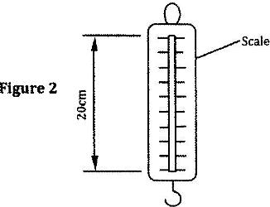

Determine the maximum weight that can be measured using this spring. (3mks)

………………………………………………………………………………………………………………………………………………………………………………………………………………………………………………………………………………………………………………………

9. Figure below shows some air trapped by mercury in a glass tube. The tube is inverted in a dish containing mercury.

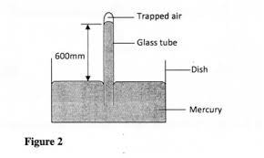

Given that the atmospheric pressure is 760mHg and the height of mercury column in the tube is 600mm, determine the pressure of the air trapped in the tube in mmHg. (2mks)

**…………………………………………………………………………………………………………………………………………………………………………………………………………………………………………………………………………………………………………………….**

10. Figure below shows a glass tube with water fitted with two identical thermometers A and B. it is heated as shown.

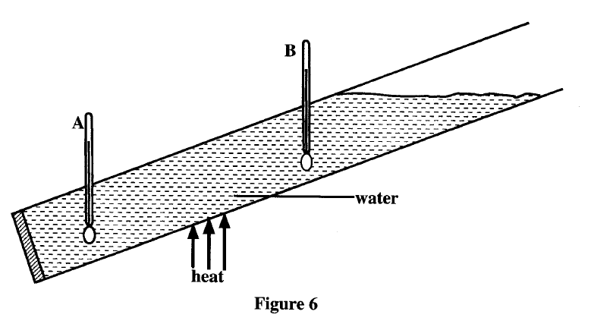

a) State which of the two thermometers shows higher temperature. (1mk)

**………………………………………………………………………………………………….**

b) Give a reason for your answer in (a). (2mks)

**……………………………………………………………………………………………………………………………………………………………………………………………………………..**

11. Figure below shows water drops on two surfaces. In (a) the glass surface is smeared with wax while in (b) the glass surface is clean.

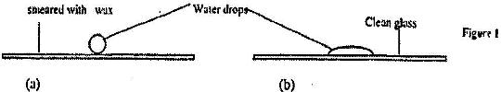

Explain the difference in the shapes of the drops. (2mks)

**………………………………………………………………………………………………………………………………………………………………………………………………………………**

12. A pipe of radius 6mm is connected to another pipe of radius 9mm. if water flows in the water pipe at the speed of 2m/s what is the speed in the narrower pipe. (3mks)

**……………………………………………………………………………………………………………………………………………………………………………………………………………………………………………………………………………………………………………………………………………………………………………………………………………………………..**

**Section B(55mks)**

13. a) In an experiment to determine the size of oil molecule. Oil drop is placed on the surface of water after sprinkling lycopodium powder on it.

i) State one reason why oil is used (1mk)

……………………………………………………………………………………………………………………………………………………………………………………………………………..

(ii) State the function of lycopodium powder. (1mk)

…………………………………………………………………………………………………….

(iii) State two assumptions that are made in this experiment (2mk)

**………………………………………………………………………………………………………………………………………………………………………………………………………………**

(iv) Explain why oil spread on the surface of water . (1mk)

………………………………………………………………………………………………………………………………………………………………………………………………………………

b) The following data was obtained from an experiment to determine the size of an oil molecule.

- Volume of 100 drops = 15mm3

- Area of the patch = 8 x 104 mm2

i) Determine the volume of one drop. (1mk)

……………………………………………………………………………………………………………………………………………………………………………………………………………………………………………………………………………………………………………………..

ii) Determine the thickness of oil molecule . (3mks)

……………………………………………………………………………………………………………………………………………………………………………………………………………………………………………………………………………………………………………………

14 a) Define the term efficiency as used in machines (1mk).

………………………………………………………………………………………………………………………………………………………………………………………………………………

b) A block and tackle system has 3 pulleys in the upper fixed block and 2 in the lower movable block. The system is used to lift a load L using effort E.

Draw a well labeled diagram to show the arrangement of system where the effort E is used to lift load L. (3mks)

……………………………………………………………………………………………………………………………………………………………………………………………………………………………………………………………………………………………………………………………………………………………………………………………………………………………………………………………………………………………………………………………………………………………………………………………………………………………………………..

(ii) Determine the velocity ratio of the system. (1mk)

……………………………………………………………………………………………………..

c) A machine of velocity ratio 4.5 overcome a load of 4.5 x 103 N. When on effort of 135N is applied. Determine.

i) Mechanical advantage of the machine. (2mks)

……………………………………………………………………………………………………………………………………………………………………………………………………………………………………………………………………………………………………………………..

ii) Efficiency of the machine. (2mks) .

…………………………………………………………………………………………………………………………………………………………………………………………………………………………………………………………………………………………………………………………………………………………………………………………………………………………….

iii) Percentage of work that goes to waste. (1mk)

………………………………………………………………………………………………………………………………………………………………………………………………………………

15. a) State two quantities that must be kept constant in order to verify Boyles Law. (2mks)

………………………………………………………………………………………………………………………………………………………………………………………………………………

b) An air bubble at the bottom of a container full of water becomes larger as it rises to the surface. State reasons why:

i) The bubble rises to the surface. (1mk)

**……………………………………………………………………………………………………………………………………………………………………………………………………………..**

ii) The bubble comes larger as it rises . (1mk).

………………………………………………………………………………………………………………………………………………………………………………………………………………

c) The diagram below shows an experiment to investigate the relationship between volume and temperature of a fixed mass of a gas at constant pressure.

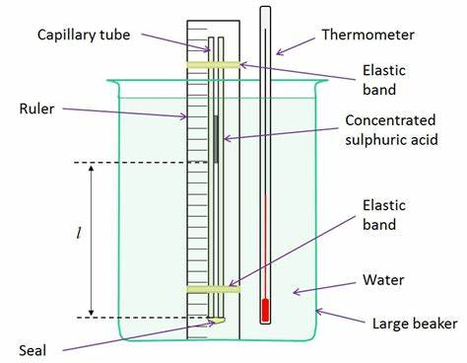

i) Explain the function of concentrated sulphuric acid. (2mks) .

………………………………………………………………………………………………………………………………………………………………………………………………………………

ii) State two measurements taken in the above experiment. (2mks)

……………………………………………………………………………………………………………………………………………………………………………………………………………………………………………………………………………………………………………………..

d) A mass of air of volume 750cm3 is heated at constant pressure from 100 C to 1000 C. determine the final volume of the air. (3mks)

……………………………………………………………………………………………………………………………………………………………………………………………………………………………………………………………………………………………………………………..

16. a) Distinguish between the terms heat capacity and specific heat capacity. (2mks).

……………………………………………………………………………………………………………………………………………………………………………………………………………………………………………………………………………………………………………………………………………………………………………………………………………………………..

b) The diagram below shows a set up used to determine the specific heat capacity of a metal block.

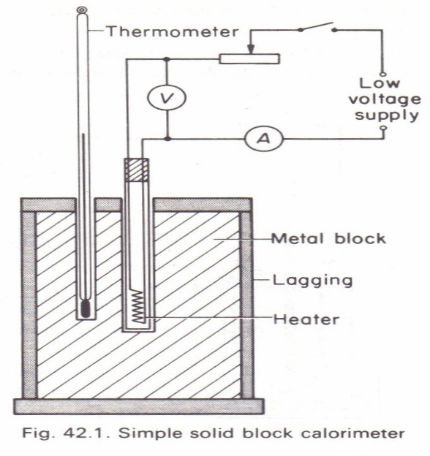

1. State 2 measurements that should be taken in the experiment to determine specific heat capacity of the block. (2mks)

……………………………………………………………………………………………………………………………………………………………………………………

1. Indicate on the diagram where oil should be put and state the purpose of oil in the set up. (2mks) .

………………………………………………………………………………………………………………………………………………………………………………………………………………

c) A metal block of mass 2.0kg is heated electrically. The voltmeter read 12 volts and ammeter 4.0A. temperature of the metal block increased from 250C to 750C in 10 minutes. Assuming no heat loss to the surrounding. Determine:

i) Heat supplied by the heater. (2mks)

……………………………………………………………………………………………………………………………………………………………………………………………………………..

ii) Heat gained by the metal cylinder (1mk) .

……………………………………………………………………………………………………………………………………………………………………………………………………………………………………………………………………………………………………………………..

iii) Specific heat capacity of the metal block. (2mks)

………………………………………………………………………………………………………………………………………………………………………………………………………………………………………………………………………………………………………………………………………………………………………………………………………………………………

d) State 2 factors that affect the rate of evaporation of a liquid. (2mk)

……………………………………………………………………………………………………..

17**.**a) i) State the newton first law of motion . (1mk)

………………………………………………………………………………………………………………………………………………………………………………………………………………………………………………………………………………………………………………………

ii) a vehicle of mass 2 tonnes travelling at a velocity Vm/s has a momentum of 7.2 x 104 Kg m/s determine its velocity V. (3mks)

………………………………………………………………………………………………………………………………………………………………………………………………………………………………………………………………………………………………………………………

b) Two bodies of masses 10 kg and 16 kg moving in the same direction with velocities 20 m/s and 15m/s respectively collide in elastically. Determine the common velocity of the bodies after collision.(3 marks)

………………………………………………………………………………………………………………………………………………………………………………………………………………

………………………………………………………………………………………………………………………………………………………………………………………………………………

c) the figure below shows a section of Tape after passing through a ticker timer operated at a frequency of 50 Hz.The tape is attached to a trolley moving in the direction shown**.**

,A .B ,C .D .E

5cm 15 cm

Determine

time taken for one tick interval (1 mk).

1. ……………………………………………………………………………………………………………………………………………………………………………………..

**ii**) velocities between points AB and DE. (2mks)

………………………………………………………………………………………………………………………………………………………………………………………………………………………………………………………………………………………………………………………

iii)Acceleration of the body over interval AE (2 mks)

……………………………………………………………………………………………………………………………………………………………………………………………………………………………………………………………………………………………………………………………………………………………………………………………………………………………..

**END**