NAME: ……………………………………………. ADM NO.…………… CLASS: ……...
OPENER EXAMINATION: TERM 1 2024
PHYSICS
FORM 3

Time: 2 Hours 30 mins

INSTRUCTIONS TO CANDIDATES:-
- Write your name, Admission number and class in the spaces provided above.
- This paper consists of two sections; A and B
- Answer all the questions in section A and B in the spaces provided
- All working must be clearly shown.
- Mathematical tables and electronic calculators may be used
- This paper consists of 12 printed pages. Candidates should check to ascertain that all pages are printed as indicated and that no questions are missing.
- Candidates should answer the questions in English.
- Take g=10N/kg

For Examiner’s Use Only:

Section | Question | Maximum  Score | Candidate’s  Score
A | 1 – 16 | 40
 | 17 -22 | 60
Total Score |  | 100

SECTION A (40 MARKS)
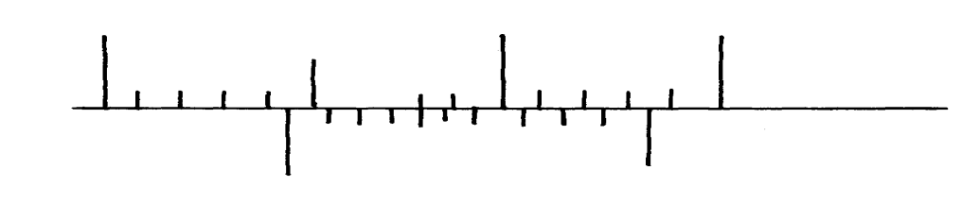
- The figure below shows part of scale of vernier calipers.
7cm
8cm
0
10

What is the reading indicated on the scale ………………………………………….. (1mk)

- Distinguish between mass and weight of a body in terms of definition, stating the S.I units for each. (2mks)
…………………………………………………………………………………………………………………………………………………………………………………………………………………………………………………………………………………………………………………………………………………….
- 180cm³ of fresh water of density 100kg/m³ is mixed with 2200cm³ of sea water of density 1025kg/m³. Calculate;
a) The mass of fresh and sea water. (2mks)
…………………………………………………………………………………………………………………………………………………………………………………………………………………………………………………………………………………………………………………………………………………….
- The density of the mixture (2mks)
……………………………………………………………………………………………………………………………………………………………………………………………………………………………………………………………………………………………………………………………..
- Explain why fish can survive under water when the surface is already frozen (2mks)
……………………………………………………………………………………………………..
……………………………………………………………………………………………………..
- Two inflated balloons are at the same level while suspended from threads a short distance apart as shown below;
Air blown

Some air is blown gently in the space between the balloon in horizontal direction as shown by the arrow. Explain what happens to the balloons. (2mks)
……………………………………………………………………………………………………..
……………………………………………………………………………………………………..
- State one advantage of an alkaline battery over a lead acid battery. (1mk)
……………………………………………………………………………………………………..
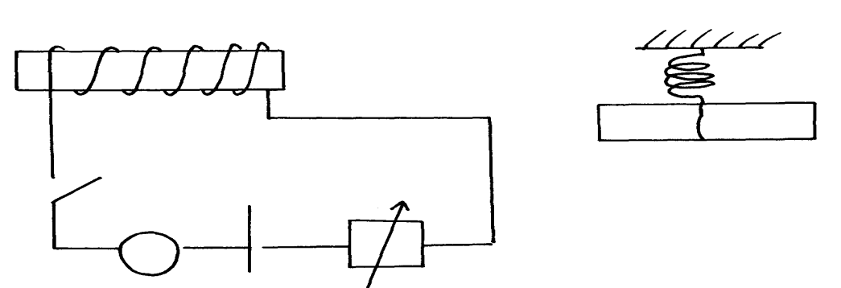
- The diagram below shows a permanent magnet suspended by a spring. State with reason the behaviour of the magnet when the switch is closed. (2mks)
Spring
S
A
Y
N S
X
+ -

……………………………………………………………………………………………………..
……………………………………………………………………………………………………..
- Convection and diffusion both involve motion of fluids. Distinguish between the two. (2mks)
……………………………………………………………………………………………………..
……………………………………………………………………………………………………..
……………………………………………………………………………………………………..
……………………………………………………………………………………………………..
- Indicate on the diagram below, the level of mercury in the tubes X and Y (2mks)
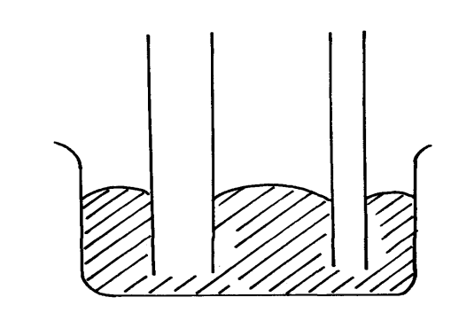
Mercury
X
Y

- An object weighs 1200N on a certain planet. What is the gravitational field strength of this
planet if the object is 60kg? (3mks)
………………………………………………………………………………………………………………………………………………………………………………………………………………………………………………………………………………………………………………………………………………….
- State two properties of a good thermometric liquid. (2mks)
……………………………………………………………………………………………………..
……………………………………………………………………………………………………..
- The figure below, ammonia gas and an acid gas diffuse and react to form a white deposit on the walls of the glass tube, the deposit forms nearer end B.
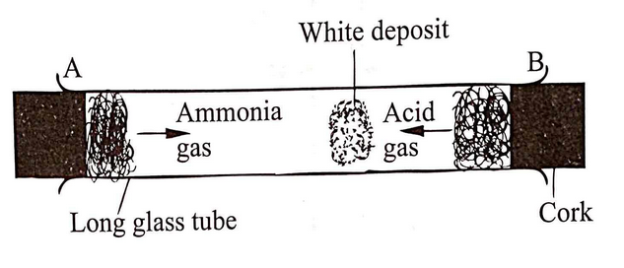
- State which gas diffused faster. (1mk)
………………………………………………………………………………………………….
- Explain how the rate of diffusion depends on the density of a gas. (2mks)
………………………………………………………………………………………………………………………………………………………………………………………………………………………………….

- Explain the effect of performing the experiment above at a higher temperature. (2mks)
……………………………………………………………………………………………………………………………………………………………………………………………………………………………………
- a)What is the purpose of a translucent screen on the Pinhole camera. (1mk)
………………………………………………………………………………………………………………………………………………………………………………………………………………………………….
- Give two characteristics of image formed by a pinhole camera. (2mks)
……………………………………………………………………………………………………………………………………………………………………………………………………………………………………………………………………………………………………………………………………………………..
- The distance between the pinhole and screen of a pinhole camera is 10cm. the height of the screen is 20cm. at what minimum distance from the pinhole must a man 1.6m tall stand if a full length image is required? (3mks)
……………………………………………………………………………………………………………………………………………………………………………………………………………………………………………………………………………………………………………………………………………………..
- State any two forces that act between two objects not in contact. (2mks)
………………………………………………………………………………………………………………………………………………………………………………………………………………………………………………………………………………………………………………………………..
- When a metal cube is heated state what happens to the following. (2mks)
- Mass………………………………………….
- Density……………………………………….
- The diagram below shows jets from two holes at the side of a tank filled with water. Explain why Jet A is longer than B (2mks)
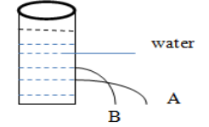

SECTION B (60 MARKS)
- (a) State the basic law of electrostatic charges (1mk).

…………………………………………………………………………………………………………

…………………………………………………………………………………………………………

(b) A form 2 student charged a polystyrene ball positively by contact method as shown.
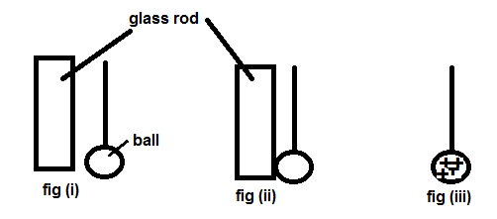

Indicate the charges on glass rod and ball in fig (I) and fig (ii) (2mks)

(c) State two (2) uses of an electroscope (2mks)

…………………………………………………………………………………………………………

…………………………………………………………………………………………………………

- (a) Define ELECTRIC CURRENT , stating its SI units (2mks)

…………………………………………………………………………………………………………

…………………………………………………………………………………………………………

(b) A battery circulates charge Round a Circuit for 1.5 Minutes. If The Current Is Held at 2.5 A, determine the quantity of charge passing through the wire. (3mks)
…………………………………………………………………………………………………………

…………………………………………………………………………………………………………

…………………………………………………………………………………………………………

(c) State two (2) disadvantages of alkaline accumulators over lead acid accumulators (2mks)

…………………………………………………………………………………………………………

…………………………………………………………………………………………………………

………………………………………………………………………………………………………
(d) What do you understand by a closed circuit? (1mk)

…………………………………………………………………………………………………………

…………………………………………………………………………………………………………

- A soft iron ring is placed between a north and a south pole of two bar magnets as shown. Show by drawing how the magnetic lines of force between the N and S Poles Interact With The Soft Iron Ring(2mks)

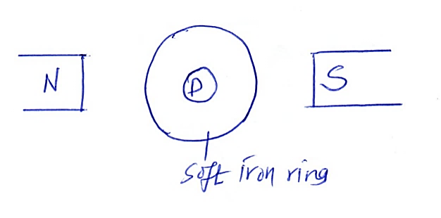
(b) The diagram below shows the magnetic field pattern between two magnets P and Q
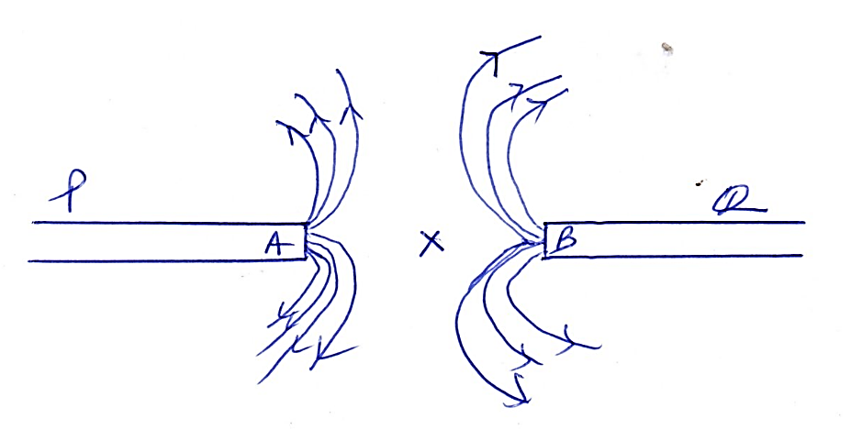
  - Identify poles A and B (2mks)
…………………………………………………………………………………………………………

…………………………………………………………………………………………………………

  - State which of the two magnets P and q is stronger and explain (2mks)

…………………………………………………………………………………………………………

…………………………………………………………………………………………………………
- (a) The figure below shows a current carrying conductor in a magnetic field
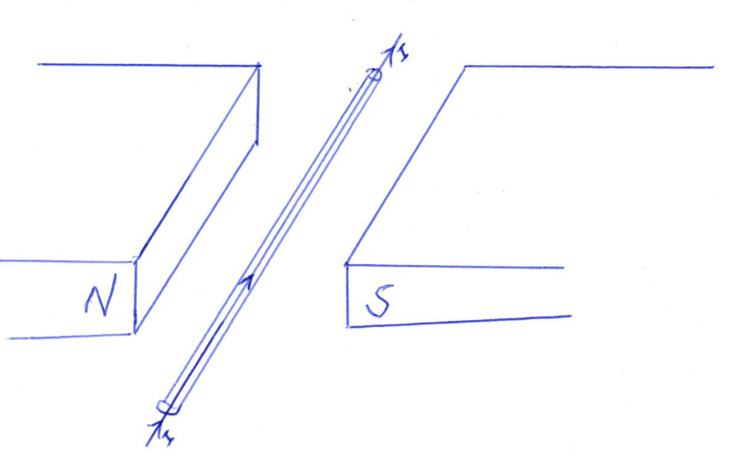
- Mark on the figure the direction of the forces acting on the conductor (1 mks

- State two ways of increasing the force on the conductor. (2mks)

…………………………………………………………………………………………………………

…………………………………………………………………………………………………………

(c) The figure below shows a nail on which a wire is to be wound to make an electromagnet.
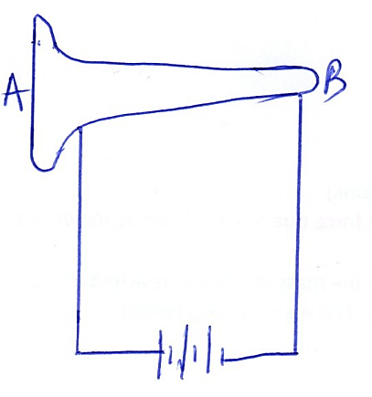
By drawing, show how the wire should be wound around the nail so that the ends A becomes a north pole and end B South Pole (1mk)

- (a) Define moment of a force (1mk)
…………………………………………………………………………………………………………

…………………………………………………………………………………………………………

(b) The figure below shows a beam of negligible weight balanced by constant forces
P and R. derive the relationship between X and Y (2mks)
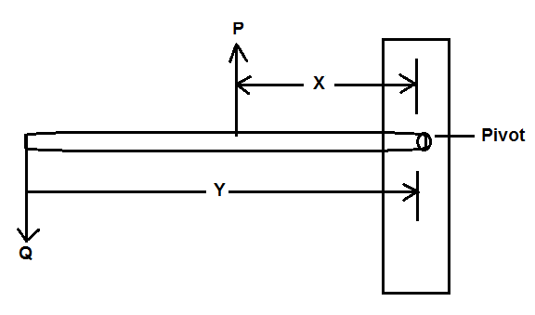
- (a) State what is meant by centre of gravity of a body (1mk)
…………………………………………………………………………………………………………

…………………………………………………………………………………………………………

(b) State the principle of moment (1mk)

…………………………………………………………………………………………………………

…………………………………………………………………………………………………………

(c) A uniform metal bar 100cm balances at 20cm when the mass of 1.5kg is attached at 0cm mark as shown below. Determine the weight of the bar. (Take g = 10N/kg) (3mks)
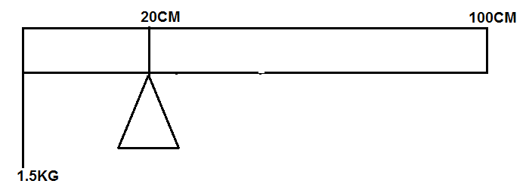

(d) State two (2) factors which affect the stability of a body (2mks)

…………………………………………………………………………………………………………

…………………………………………………………………………………………………………

(e) The figure below shows a rectangular block of wood with a hollow section (inside) at the position shown. The block is resting on a horizontal bench.
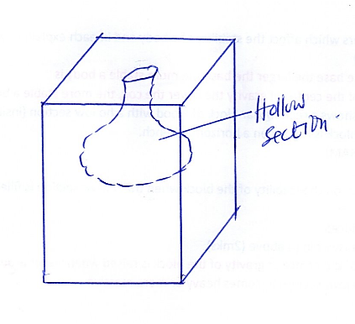
  - State the effect on the stability of the block when the hollow section is filled with water (1mk)

…………………………………………………………………………………………………………

…………………………………………………………………………………………………………

  - Explain your answer in (i) above (2mks)

…………………………………………………………………………………………………………

…………………………………………………………………………………………………………

- (a) Define the following terms as used in curved mirrors:
  - The POLE (1mk)

…………………………………………………………………………………………………………

…………………………………………………………………………………………………………

  - Centre of CURVATURE (1mk)

…………………………………………………………………………………………………………

…………………………………………………………………………………………………………

  - PRINCIPAL FOCUS for a concave mirror (1mk)

…………………………………………………………………………………………………………

…………………………………………………………………………………………………………

(b) An object pin of height 3cm is placed 11 cm in front of a concave mirror of focal length 3cm. by scale drawing determine
- Image distance (2mks)
…………………………………………………………………………………………………………

…………………………………………………………………………………………………………

- Height of the image (2mks)

…………………………………………………………………………………………………………

…………………………………………………………………………………………………………

- Magnification of the image (2mks)
…………………………………………………………………………………………………………

…………………………………………………………………………………………………………

(c) Give two advantages of convex mirror (2mks)

…………………………………………………………………………………………………………

…………………………………………………………………………………………………………

- (a) Differentiate between electromagnetic waves and mechanical waves (1mk)
…………………………………………………………………………………………………………

…………………………………………………………………………………………………………

(b) A long slinky spring is attached to a vibrating blade as shown in the figure below.
(i) State the type of mechanical wave generated by the set up (1mk)

…………………………………………………………………………………………………………

…………………………………………………………………………………………………………

(ii) Mark alongside the coil, the length corresponding to the wavelength of the wave (1mks)
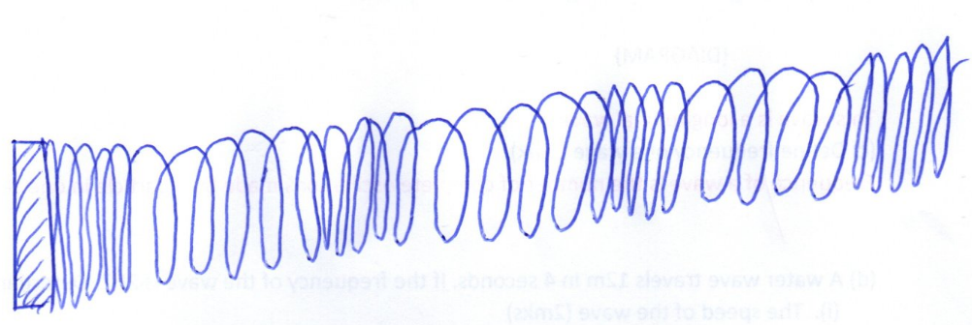

(c) Define frequency of a wave (1mk)

…………………………………………………………………………………………………………

…………………………………………………………………………………………………………

(d) A water wave travels 12m in 4 seconds. If the frequency of the wave is 2HZ. Determine:
  - The speed of the wave (2mks)

…………………………………………………………………………………………………………

…………………………………………………………………………………………………………

  - The wavelength of the wave (2mks)

…………………………………………………………………………………………………………

……………………………………………………………………………………………………
- (a) State two (2) sources of sound (2mks)

…………………………………………………………………………………………………………

…………………………………………………………………………………………………………

(b) A girl standing 600m away from a cliff bangs two pieces of wood together and hears an echo 3.5 seconds later. Determine the speed of sound in air at that place. (3mks)

…………………………………………………………………………………………………………

…………………………………………………………………………………………………………

…………………………………………………………………………………………………………

(c) State one factor that affects the speed of sound in a solid (1mk)

…………………………………………………………………………………………………………

