Name:……………………………………………………………..Class:………Adm No……..
TIME: 2 ¾ HOURS
OPENER EXAMINATION: TERM 1 2024
FORM 4
PAPER 1

INSTRUCTIONS.
- The paper has two sections A and B.
- Answer all questions in section A.
- In section B answer number 6 and any other two questions.
- Answers to be written on foolscaps to be provided

Section A (25mks)
Answer all questions in this section.
- a) Name the first two planets of the solar system. (2mks)
b) State three effects of the rotation of the earth on its axis. (3mks)

- a) Define the term weather. (2mks)
b) State the significance of humidity in the atmosphere. (2mks)

- a) Name the three theories which have been put forth to explain the origin of the fold mountain. (3mks)
b) Name the Fold Mountains found in North America. (2mks)
- a) Mention three processes through which wind erodes desert surface. (3mks)
b) Name three features of water erosion in desert. (3mks)
- The diagram below shows a process of slow mass wasting. Study it and answer the questions that follow.
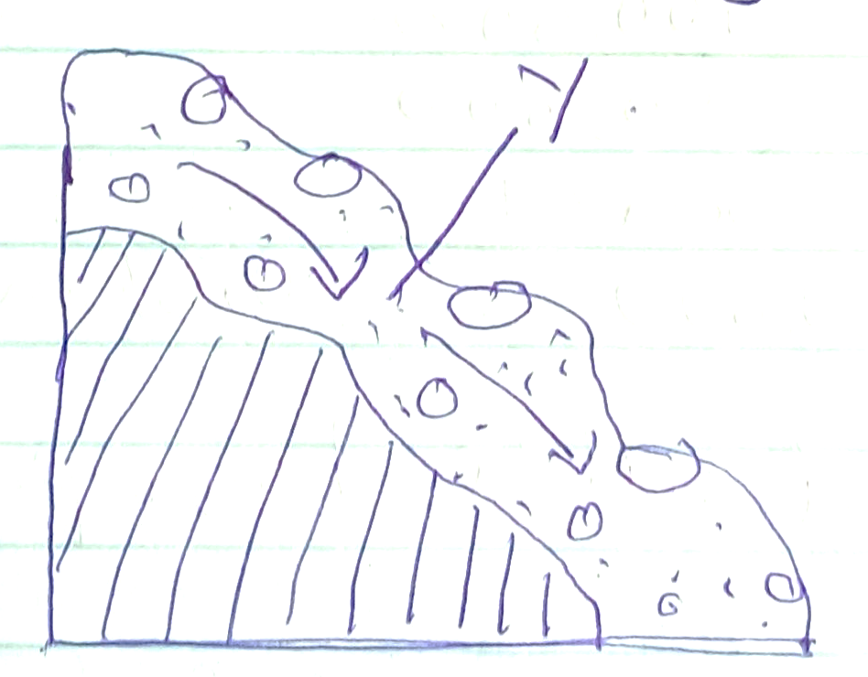

- Identify the process. (1mk)
ii) Name the feature marked Y. (1mk)
- State three conditions which may influence occurrences of landslide. (3mks)
Section B.
Answer No. 6 and any other questions.
- Study the map of Kisumu East 1:50,000 provided and answer the following questions.
- i) Convert the scale 1:50,000 into statement scale. (2mks)
ii) Name four physical features in the area covered by the map. (4mks)

- i) Give the direction and bearing of Chiga market grid 0589 from Oronge school grid 9884. (2mks)
ii) Draw a cross section from Easting 95 to Easting 01 along Northing 96. Use a vertical scale of 1cm represent 50m. (4mks)
On the cross section mark and name feature
- river Awach
- all weather road
- main track. (3mks)
- Describe the drainage of the area covered by the map. (4mks)
- Citing evidence from the map identify any three economic activities carried out in the area. (6mks)

- a) i) Name three types of faults. (3mks)
ii) Apart from compressional forces explain two other processes that may cause faulting. (4mks)
b) With a well labeled diagrams describe how compression forces, may have led to the formation of Rift Valley. (8mks)
c) Outline five ways in which faulting is of significance to human activities. (10mks)
- a) Define vegetation. (2mks)
b) Draw a well labeled diagram to show the distribution of vegetation on tropical mountain. (5mks)
c) Describe how the following factors influence vegetation:
- Aspect (2mks)
- Drainage (2mks)
d) Give five characteristics of Tundra vegetation. (5mks)
e) You carried out a field study on vegetation in the area around your school.
- Identify five characteristics of vegetation you are likely to study. (5mks)
- Give four methods you would use to collect data in the study. (4mks)
- a. i) Name two components of soil. (2mks)
ii) State three characteristics of desert soil. (3mks)
iii) State two factors that contribute to soil leaching. (2mks)
b) Describe how lateralization occurs. (6mks)
c) Explain how the following process occurs:
- Splash (2mks)
- Gulley erosion (2mks)
d) i) What is soil conservation? (2mks)
ii) Explain three ways of maintaining soil fertility. (6mks)
- a) i) What is glaciation? (2mks)
ii) Outline three types of glacier. (3mks)
b) State four factors that influence the movement of ice. (4mks)

c) The diagram below show the glaciated upland. Use it to answer questions.
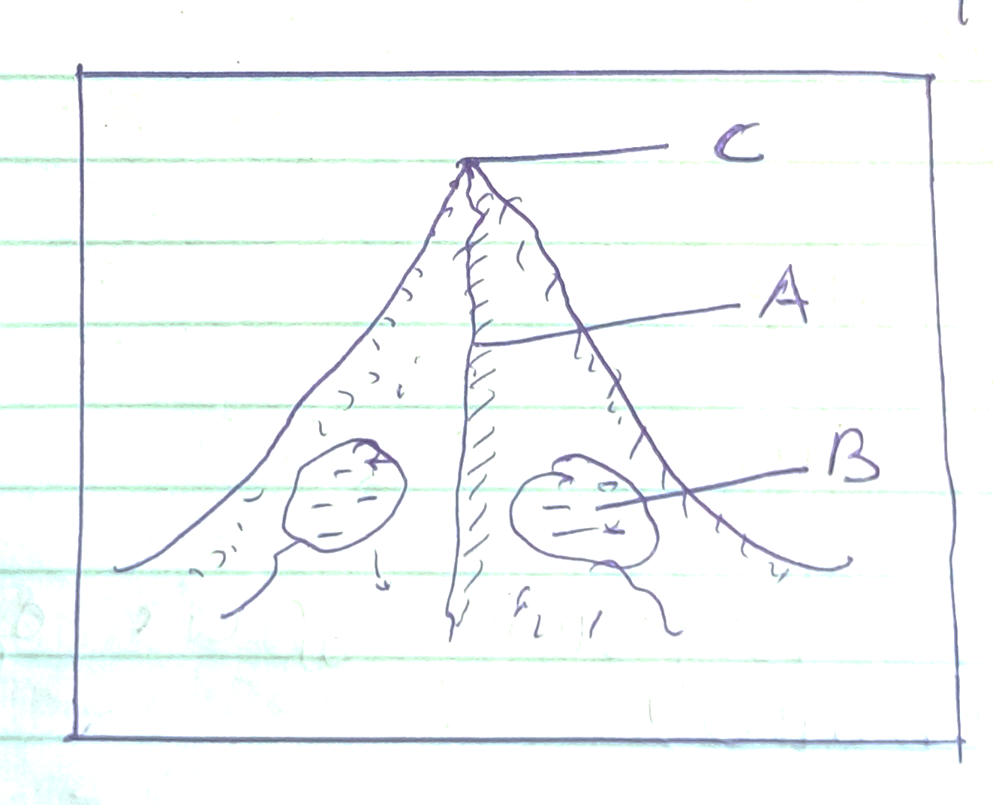

- Name the feature marked A,B, and C (3mks)
- Describe how a pyramidal peak is formed. (5mks)
- Give two depositional featured in a glaciated lowlands. (2mks)
d) Explain three negative effects of glaciations. (6mks)

