Name:……………………………………………………………..Class:………Adm No……..
TIME: 2 HOURS
OPENER EXAMINATION: TERM 1 2024
FORM 3
GEOGRAPHY

INSTRUCTIONS.
Answer all questions in the space provided.
- a) Identify two types of environment. (2 marks)

b) Give three areas of study of Human Geography. (3 marks)

- a) The diagram below shows the internal structure of the earth. (3 marks)

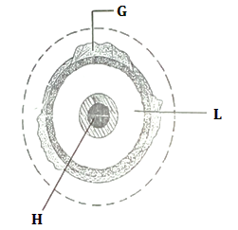

- Name the part marked G, H,I (3 marks)
G
H
I
- State three characteristics of the mantle. (3 marks)

- a) What is a weather station? (2 marks)

- State four factors for sitting a weather station. (4 marks)

- Differentiate between normal lapse rate and negative lapse rate. (2 marks)

- a) i) Define the term scale. (2 marks)

ii) Convert 1:100000 into statement scale. (2 marks)

- Students of Nyandarua High school intend to conduct a field study in a market near their school.
- State three objectives they would formulate for their study. (3 marks)

ii) Give four appropriate methods of data recording they would use (4 marks)

- Give three ways in which they will present data collected. (3 marks)

- a) What are metamorphic rocks? (2 marks)

- Give three examples of metamorphic rocks and their original rocks. (6 marks)

- Outline three underground mining methods. (3 marks)

- a) i) Define the term folding. (2 marks)

- List four types of folds. (4 marks)

c) State five significance of folding to human activities. (5 marks)

- The table below shows the productions of three crops in Kenya from 1980-1984 in 000 tonnes. Use it to answer questions that follow.
 | 1980 | 1981 | 1982 | 1983 | 1984
Coffee | 20 | 10 | 40 | 80 | 105
Tea | 40 | 30 | 35 | 60 | 90
Wheat | 10 | 30 | 15 | 25 | 15
- Use the data above draw a comparative line graph to represent the data. Use scale of 1cm rep 10,000 tonnes. (7 marks)

ii) State three advantages of comparative line graph. (3 marks)

ii) State three disadvantages of comparative line graph. (3 marks)

- a) Give two areas that experiences equatorial climate. (2 marks)

ii) State five characteristics of Equatorial climate. (5 marks)

- Name five temperate grasslands and areas where found in the world. (5 marks)

ii) Study the diagram below and answer questions that follow.

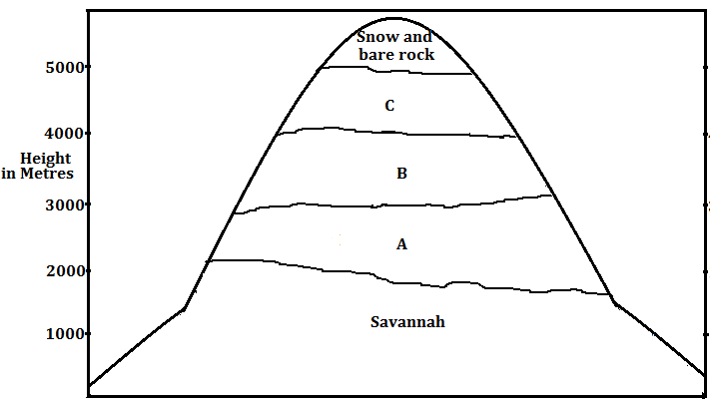

Name the vegetation type marked A, B and C. (3 marks)
A
B
C

iii) State four significance of vegetation. (4 marks)

- a) Define the term forestry. (2 marks)

b) Explain how the following factors influencing type and distribution of forests.
i) Temperature (2 marks)

ii) Rainfall (2 marks)

- State three problems facing forestry in Kenya. (3 marks)

