Name:……………………………………………………………..Class:………Adm No……..
TIME: 2 HOURS 15 MINUTES
OPENER EXAMINATION: TERM 1 2024
FORM 2
GEOGRAPHY
INSTRUCTIONS. Answer all questions in the space provided.
- a) Define the term Environment. (2 marks)
……………………………………………………………………………………………………………………………………………………………………………………………………………………………………………………………………………………………………………………………………………………………………………………………………………………………………………………………….
b) Give three subjects related with geography. (3 marks)
……………………………………………………………………………………………………………………………………………………………………………………………………………………………………………………………………………………………………………………………………………………………………………………………………………………………………………………………………………………………………………………………………………………………………………………………………………………
- (a) Name the two main braches of Geography. (2 marks)
………………………………………………………………………………………………………………………………………………………………………………………………………………………………………………………………………………………………………………………………………………………………………………………………………………………………………………………………
b) Outline the three ways in which a student benefit from learning Geography.(3 marks)
……………………………………………………………………………………………………………………………………………………………………………………………………………………………………………………………………………………………………………………………………………………………………………………………………………………………………………………………………………………………………………………………………………………………………………………………………………………
- a) Define the terms Solar system. (2 marks)
………………………………………………………………………………………………………………………………………………………………………………………………………………………………………………………………………………………………………………………………………………………………………………………………………………………………………………………………
b) State three major weakness of the passing star theory. (3 marks)
………………………………………………………………………………………………………………………………………………………………………………………………………………………………………………………………………………………………………………………………………………………………………………………………………………………………………………………………................................................................................................................................................................................................................
- a) Give four proofs that the earth is spherical. (4 marks)
…………………………………………………………………………………………………………………………………………………………………………………………………………………………………………………………………………………………………………………………………………………………………………………………………………………………………………………………………………………………………………………………………………………………………………………………………………………………………………………………………………………………………………………………………………………………………………
b) The diagram below represents the earth on its axis. Use it to answer questions.

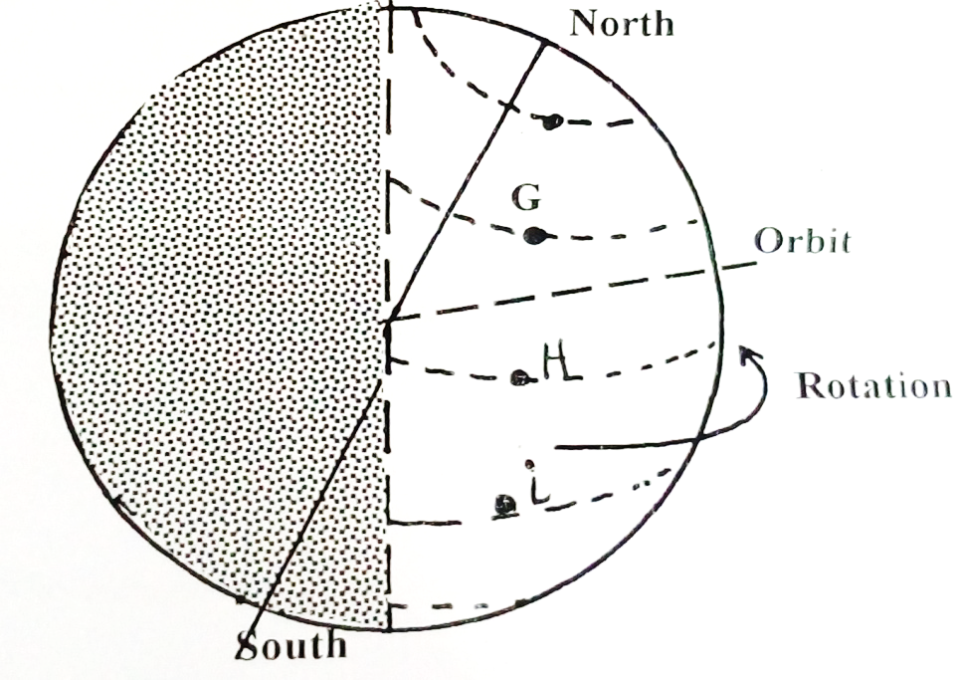

- Name the latitude marked G,H, I. (3 marks)
…………………………………………………………………………………………………………………………………………………………………………………………………………………………………………………………………………………………………………………………………………………………………………………………………………………………………………………………………………………………………………………………………………………………………………………………………………………..
- What is the angle of inclination of the earth’s axis from its orbit? (1 mark)
…………………………………………………………………………………………………………………………………………………………………………………………………………………………………………………………………………………………………………
- State four effects of the rotation of the earth. (4 marks)
…………………………………………………………………………………………………………………………………………………………………………………………………………………………………………………………………………………………………………………………………………………………………………………………………………………………………………………………………………………………………………………………………………………………………………………………………………………………………………………………………………………………………………………………………………………………………………
- The table below represents rainfall and temperature figure for a town in Kenya. Use it to answer the questions that follow.
Month | J | F | M | A | M | J | J | A | S | O | N | D
Temp ºc | 27 | 28 | 28 | 28 | 27 | 25 | 25 | 24 | 25 | 26 | 27 | 26
Rainfall (mm) | 25 | 38 | 99 | 140 | 277 | 439 | 277 | 69 | 142 | 201 | 71 | 25

- i) Calculate the annual range of temperature for the town. (2 marks)

ii) Calculate the total annual rainfall for the town. (2 marks)

- Use the scale 1cm represent 5ºC draw a simple line graph to represent the temperature data given above. (5 marks)

- A student was requested to pick out fourteen numbers randomly from a set of numbers: she picked, 20,37,1,66,42,12,6,15,12,42,100,3,82,42: Calculate:
- The mean of the data. (2 marks)

- The mode of the data. (1 mark)

- The median of the data. (2 marks)

- a) i) Name three types of maps. (3 marks)
……………………………………………………………………………………………………………………………………………………………………………………………………………………………………………………………………………………………………………………………………………………………………………………………………………………………………………………………………………………………………………………………………………………………………………………………………………………
ii) Give five characteristics of good sketch maps. (5 marks)
…………………………………………………………………………………………………………………………………………………………………………………………………………………………………………………………………………………………………………………………………………………………………………………………………………………………………………………………………………………………………………………………………………………………………………………………………………………………………………………………………………………………………………………………………………………………………………
iii) Convert 1:50,000 into statement scale. (2 marks)

- Students of Anestar Precious Girls intended to conduct a field study in Dundori market near their school.
- State three objectives for your study. (3 marks)
…………………………………………………………………………………………………………………………………………………………………………………………………………………………………………………………………………………………………………………………………………………………………………………………………………………………………………………………………………………………………………………………………………………………………………………………………………………………………………………………………………………………………………………………………………………………………………
- List three methods they would use to collect data. (3 marks)
……………………………………………………………………………………………………………………………………………………………………………………………………………………………………………………………………………………………………………………………………………………………………………………………………………………………………………………………………………………………………………………………………………………………………………………………………………………
- What are the methods used to record data? (4 marks)
…………………………………………………………………………………………………………………………………………………………………………………………………………………………………………………………………………………………………………………………………………………………………………………………………………………………………………………………………………………………………………………………………………………………………………………………………………………………………………………………………………………………………………………………………………………………………………
- State five problems are you likely to face during the study? (5 marks)
………………………………………………………………………………………………………………………………………………………………………………………………………………………………………………………………………………………………………………………………………………………………………………………………………………………………………………………………………………………………………………………………………………………………………………………………………………………………………………………………………………………………………………………………………………………………………………………………………………………………………………………………………………………………………………………………
- a) Define the term mineral. (2 marks)
………………………………………………………………………………………………………………………………………………………………………………………………………………………………………………………………………………………………………………………………………………………………………………………………………………………………………………………………
ii) State five characteristics of minerals. (5 marks)
…………………………………………………………………………………………………………………………………………………………………………………………………………………………………………………………………………………………………………………………………………………………………………………………………………………………………………………………………………………………………………………………………………………………………………………………………………………………………………………………………………………………………………………………………………………………………………
……………………………………………………………………………………………………………………………………………………

b) Define rock. (2 marks)
………………………………………………………………………………………………………………………………………………………………………………………………………………………………………………………………………………………………………………………………………………………………………………………………………………………………………………………………
ii) Give three ways in which rocks are classified. (3 marks)
……………………………………………………………………………………………………………………………………………………………………………………………………………………………………………………………………………………………………………………………………………………………………………………………………………………………………………………………………………………………………………………………………………………………………………………………………………………
c) State six contributions of rocks to the economy of Kenya. (6 marks)
…………………………………………………………………………………………………………………………………………………………………………………………………………………………………………………………………………………………………………………………………………………………………………………………………………………………………………………………………………………………………………………………………………………………………………………………………………………………………………………………………………………………………………………………………………………………………………
…………………………………………………………………………………………………………………………………………………………………………………………………………………………………………………………………………………………………………………………………………………………………………………………………………………………………………………………………………………………………………………………………………………………………………………………………………………………………………………………………………………………………………………………………………………………………………
- a) Define mining. (2 marks)
………………………………………………………………………………………………………………………………………………………………………………………………………………………………………………………………………………………………………………………………………………………………………………………………………………………………………………………………
b) Give five ways in which minerals occur. (5 marks)
…………………………………………………………………………………………………………………………………………………………………………………………………………………………………………………………………………………………………………………………………………………………………………………………………………………………………………………………………………………………………………………………………………………………………………………………………………………………………………………………………………………………………………………………………………………………………………
…………………………………………………………………………………………………………………………………………………………………………………………………………………………………………………………………………………………………………………………………………………………………………………………………………………………………………………………………………………………………………………………………………………………………………………………………………………………………………………………………………………………………………………………………………………………………………

c) List five factors influencing exploitation of minerals. (5 marks)
…………………………………………………………………………………………………………………………………………………………………………………………………………………………………………………………………………………………………………………………………………………………………………………………………………………………………………………………………………………………………………………………………………………………………………………………………………………………………………………………………………………………………………………………………………………………………………
………………………………………………………………………………………………………………………………………………………………………………………………………………………………………………………………………………………………………………………………………………………………………………………………………………………………………………………………

d) Identify four methods of underground mining. (4 marks)
…………………………………………………………………………………………………………………………………………………………………………………………………………………………………………………………………………………………………………………………………………………………………………………………………………………………………………………………………………………………………………………………………………………………………………………………………………………………………………………………………………………………………………………………………………………………………………

