**Name ………………………………………………………………. Index. No……………………………**

**School……………………………………………………………...... Date: ……………………………….**

**OPENER EXAMINATION: TERM 1 2024**

**233/2**

**Chemistry Theory**

**Paper 2**

**Time: 2 Hours**

**Form 4**

**INSTRUCTIONS**

1. Write your name and school and index number in the spaces provided at the top of this page
2. All answers should be written in the spaces provided.
3. **Non-programmable** silent electronic calculators and KNEC mathematical tables may be used.
4. Students should check the question paper to ascertain that all pages are printed as indicated and that no questions are missing.

**FOR EXAMINER’S USE ONLY**

|  |  |  |
| --- | --- | --- |
| **Questions** | **Maximum score** | **Candidates score** |
| 1 | 12 |  |
| 2 | 13 |  |
| 3 | 12 |  |
| 4 | 11 |  |
| 5 | 10 |  |
| 6 | 11 |  |
| 7 | 11 |  |
| **Total score** | **80** |  |

*This paper consists of* ***12*** *printed pages. Candidates are advised to check and to make sure all pages are as indicated and no question is missing.*

1. Study the diagram below and use it to answer the questions that follow

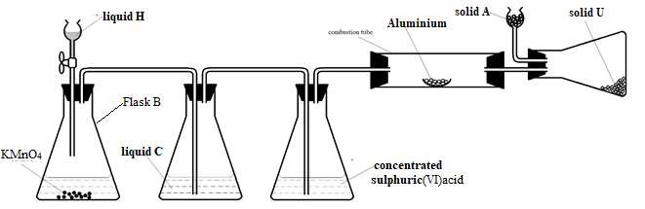

**(a)** i) Suggest a suitable reagent that can be used as **solid** **A**  ***(1 mark)***

……………………………………………………………………………………………………………...

ii) Name liquids **C** and **H.** ***(2 marks)***

**C** ……………………………………………………………………………………………………….

**H** ………………………………………………………………………………………………………

iii) Write a balanced chemical equation for the reaction in conical flask **B**  ***(1 mark)***

…………………………………………………………………………………………………..

iv) Explain why **solid** **U** collects further away from aluminium metal ***(1 mark)***

………………………………………………………………………………………………

**(b)** During a class experiment, chlorine gas was bubbled into a solution of potassium iodide.

* 1. State the observation made. ***(1 mark)***

………………………………………………………………………………………………………..

* 1. Write the ionic equation for the reaction that took place.  ***(1 mark)***

…………………………………………………………………………………………………………

**(c)** Write a balanced chemical equation for the reaction between hot concentrated sodium hydroxide and chlorine gas.  ***(1 mark)***

…………………………………………………………………………………………………………..

**(d)** Explain the difference in bleaching by chlorine and bleaching by sulphur (IV) oxide gas. ***(2 marks)***

…………………………………………………………………………………………………………..……………………………………………………………………………………………………………………………………………………………………………………………………………………..…………………………………………………………………………………………………………

**(e)** Describe how to test for the presence of chloride ions in a water sample  ***(2 marks)***

………………………………………………………………………………………………………………………………………………………………………………………………………………………………………………………………………………………………………………………………………………

1. **(a)** Give the systematic name of the following organic compound:
2. CH3CH(CH3)CH(Br)CH3 ***(1 mark)***

…………………………………………………………………………………………………………

1. CHC(CH2)2CH3 ***(1 mark)***

…………………………………………………………………………………………………………

**(b)** The following tests were carried out on some organic compound Q. Study the information in the table and use it to answer the questions that follow.

|  |  |
| --- | --- |
| **Test** | **Observation** |
| 1. Three drops of acidified potassium manganate (vii) was added to Q | The acidified potassium manganate  (vii) was decolourised |
| (ii) To a solution of Q bromine water was added. | Yellow colour of bromine was decolourised. |

1. Identify the functional group of the organic compound Q. ***(1 mark)***

…………………………………………………………………………………………………………

1. Draw the structural formula of the first member of the homologous series in which the organic compound Q belongs.  ***(1 mark)***

|  |
| --- |
|  |

|  |  |  |
| --- | --- | --- |
| ***No. of carbon atoms per***  ***molecule*** | | ***Molecular mass*** |
| ***3*** | | ***40*** |
| ***4*** | | ***54*** |
| ***5*** | ***68*** | |

1. ***Use the information in the table below to answer the question that follows.***

|  |  |
| --- | --- |
|  | |
| a) Identify the homologous series in which the above hydrocarbons belongs. (1mk)  ……………………………………………………………………………………………………………..  b) Write the general formula of this homologous series. (1mk)  ……………………………………………………………………………………………………………….  c) Name and draw the structure of the third member of this homologous series. (2mks)  ………………………………………………………………………………………………………………………  ……………………………………………………………………………………………………….  …………………………………………………………………………………………………………..  ………………………………………………………………………………………………………..  d) Predict the molecular mass of the hydrocarbon with eight carbon atoms per molecule in this series.  ………………………………………………………………………………………………… (1mk)  e) i) Name two reagents used to prepare a hydrocarbon with two carbon atoms per molecule in this  this homologous series. (1mk)  ……………………………………………………………………………………………………………..  ……………………………………………………………………………………………………………..  ii) Write chemical equation for the laboratory preparation of the first member of this homologous series.  …………………………………………………………………………………………………………  …………………………………………………………………………………………………. (1mks)  f) Give two uses of the hydrocarbons in this series. (2mks)  ………………………………………………………………………………………………………………..  ………………………………………………………………………………………… | |

…………………………………………………………………………………………………………………………………………………………………………………………………………………………………………………………………………………………………………………………………………....................

3. The figure belowreprese nts a section of the periodic table. Study it and answer the questions that follow. The letters do not represent the actual symbol of the element.

|  |  |  |  |  |  |  |  |  |
| --- | --- | --- | --- | --- | --- | --- | --- | --- |
| B |  |  | |  |  | | |  |
|  |  |  |  |  |  |  |  |  |
| C | L |  | D | E |  |  | W | G |
| H | J |  |  |  |  |  |  |
|  |  |  |  |  |  |  |  |

# 

1. Give the chemical family to which element J belongs to.  ***(1 mark)***

………………………………………………………………………………………………………….

1. Compare the reactivity of elements C and H. Explain your answer. (2 marks)……………………………………………………………………………………………………………………………………………………………………………………………………………………………………………………………………………………………………………………………
2. Give one property of elements found in the shaded region. ***(1 mark)***

…………………………………………………………………………………………………………

1. Write the chemical formula of the chloride of D. ***(1 mark)***

………………………………………………………………………………………………………

1. i) Name the type of structure of the chloride in (d) above. ***(1 mark)***

……………………………………………………………………………………….………………….

ii) Identify the bonds that exist in the compound in (d) above. ***(1 mark)***

………………………………………………………………………………………

………………………………………………………………………………………

iii) Using dots and crosses to represent the valence electrons show the bonding in the compound formed in (d) above. ***(2 marks)***

1. State and explain the difference in atomic and ionic radius of element W.  ***(2 marks)***

……………………………………………………………………………………………………………………………………………………………………………………………………………………………………………………………………………………………………………………………

1. Give one observation made when element C is placed in water.  ***(1 mark)***

………………………………………………………………………………………………………..

1. 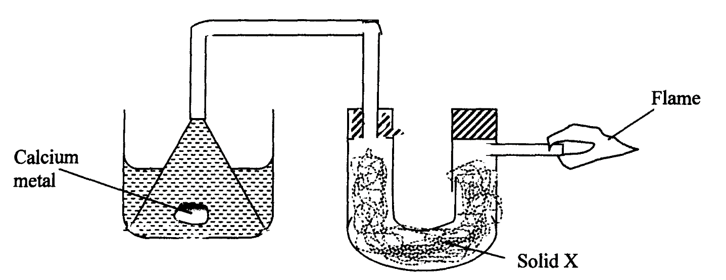**(a)** The setup below was used to investigate the reaction between metals and water.

**Water**

1. Identify solid **X** and state its purpose.

Solid X ……………………………………………………………. ***(½ mark)***

Purpose …………………………………………………………… ***(½ mark)*** ii) Write a chemical equation for the reaction that produces the flame. ***(1 mark)***

…………………………………………………………………………………………………………..

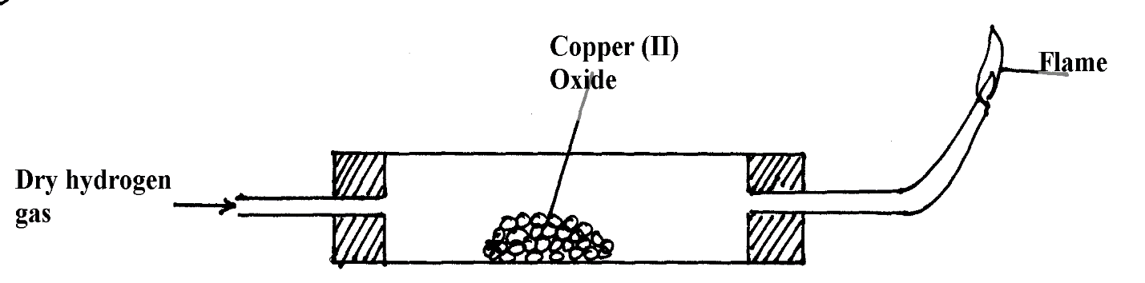**(b)** The set-up below was used to investigate the properties of hydrogen.

1. On the diagram, indicate what should be done for the reaction to occur. ***(1 mark)***
2. Hydrogen gas is allowed to pass through the tube for some time before it is lit. Explain. ***(1 mark)***

………………………………………………………………………………………………………………………………………………………………………………

1. Write an equation for the reaction that occurs in the combustion tube. ***(1 mark)***

…………………………………………………………………………………………………

1. When the reaction is complete, hydrogen gas is passed through the apparatus until it cools down. Explain. ***(2 marks)***

……………………………………………………………………………………………………………………………………………………………………………………………………………………

1. What property of hydrogen is being investigated? ***(1 mark)***

…………………………………………………………………………………………………………..

1. What observation confirms the property stated in (**v)** above?  ***(1 mark)***

…………………………………………………………………………………………………………

1. Why is zinc oxide not used to investigate this property of hydrogen gas? ***(2 marks)***

………………………………………………………………………………………………………………………………………………………………………………………………………………

**5.** The flow chart below shows some reactions starting with copper (II) nitrate. Study it and answer questions that follow.



a) State the condition necessary in step 1. (1mark)

. ......................................................................................................................................................... …….

1. Identify (1mark)

Reagent **M**

...............................................................................................................................................................

Gas **S**  (1mark)

...............................................................................................................................................................

Acidic products (2marks)

**T**............................................................................................................................................................

**V**............................................................................................................................................................

1. Write the formula of the complex ion formed in step 3. (1mark)

...............................................................................................................................................................

1. Write the equations for the reaction in, (2marks)

**Step 1**

...............................................................................................................................................................

**Step 2**

...............................................................................................................................................................

1. Write an ionic equation for that occurs in step 5. (1mark)

...............................................................................................................................................................

1. State any **one** observation made in STEP 1, (1mark)

………................................................................................................................................................

6. The diagram below illustrates the contact process for the manufacture of sulphuric (VI) acid.

Study it and answer the questions that follow.



a) Name **three** possible identities of solid A. (1½ marks)

.......................................................................................................................................................

.......................................................................................................................................................

.......................................................................................................................................................

  b) i) Name **two** impurities removed by the purifier. (1 mark)

..............................................................................................................................................

................................................................................................................................................

ii) Why is it necessary to remove the impurities? (1 mark)

................................................................................................................................................

c) Write down the equation for the reaction that takes place in the catalytic converter.

(1 mark)

................................................................................................................................................

d) i) Name **two** catalysts that can be used in the converter. (2 marks)

................................................................................................................................................

................................................................................................................................................

ii) Which of the **two** catalysts is most commonly used and why? (1 mark)

................................................................................................................................................

................................................................................................................................................

e) Why is sulphur (VI) oxide not absorbed directly into water? (1 mark)

................................................................................................................................................

f) Give the equation for the reaction that takes place in the absorption chamber. (1 mark)

................................................................................................................................................

g) Name the main pollutant in the contact process. (½ mark)

...................................................................................................................................................

h) Name **one** method by which the pollution is controlled in the contact process. (1 mark)

................................................................................................................................................

7.The diagram below shows an experiment to demonstrate the properties of hydrogen as a reducing agent. Study it and answer the questions that follow.



 a) Before lighting hydrogen gas at the jet, it is important to drive off all the air in the combustion tube. Explain. (1 mark)

.......................................................................................................................................................

b) State what would be observed in the boat containing lead (II) oxide at the end of the experiment. (1 mark)

.......................................................................................................................................................

c) Write chemical equations for the reaction taking place;

i) In the combustion tube. (1 mark)

 ……………………………………………………………………………………………………….

ii) At the jet as the flame burns. (1 mark)

  .......................................................................................................................................................

d) Why should the supply of hydrogen continue until the apparatus are cool? (1 mark)

.......................................................................................................................................................

e) Why is it important to clamp the glass tube or combustion tube in a slanting position?

(1 mark)

.......................................................................................................................................................

f) i) Cars in Mombasa rust faster than in Kisumu. Explain. (1 mark)

....................................................................................................................................................

....................................................................................................................................................

ii) Give the factors that are necessary for rusting. (1 mark)

................................................................................................................................................

  iii) Name **two** methods used to prevent rusting. (1 mark)

................................................................................................................................................

................................................................................................................................................

iv) Explain why a nail paced in a sealed tube containing tap water rusts while a nail placed in a sealed tube containing boiled water fails to rust. (1 mark)

.................................................................................................................................................

...............................................................................................................................................

v) State **two** industrial uses of oxygen gas. (1 mark)

.........................................................................................................................................................

............................................................................................................................................................